Table of Contents
​
UNITED STATES
SECURITIES AND EXCHANGE COMMISSION
Washington, D.C. 20549
​
​
FORM 10-K
​

​ | ​
​ | ​
(Mark One)
☒ | ANNUAL REPORT PURSUANT TO SECTION 13 OR 15(d) OF THE SECURITIES EXCHANGE ACT OF 1934
For the fiscal year ended
December 31, 2025
OR
☐ | TRANSITION REPORT PURSUANT TO SECTION 13 OR 15(d) OF THE SECURITIES EXCHANGE ACT OF 1934
For the transition period from to
​
Commission File No. 001-15371
​
Safehold Inc.
(Exact name of registrant as specified in its charter)
​

​ | ​ | ​ | ​ | ​
Maryland |  |  | ​ | 95-6881527
(State or other jurisdiction of  incorporation or organization) |  |  |  | (I.R.S. Employer  Identification Number)
1114 Avenue of the Americas, 39th Floor | ​ | ​ | ​ | ​
New York, NY | ​ | ​ | ​ | 10036
(Address of principal executive offices) |  |  |  | (Zip code)
​
Registrant’s telephone number, including area code: (212) 930-9400
​
​
Securities registered pursuant to Section 12(b) of the Act:
​

​ | ​ | ​ | ​ | ​
Title of each class: | ​ | Trading Symbol(s) |  | Name of Exchange on which registered:
Common Stock, $0.01 par value | ​ | SAFE |  | New York Stock Exchange
​
Indicate by check mark if the registrant is a well-known seasoned issuer, as defined in Rule 405 of the Securities Act. Yes ☒ No ☐
​
Indicate by check mark if the registrant is not required to file reports pursuant to Section 13 or Section 15(d) of the Act. Yes ☐ No ☒
​
Indicate by check mark whether the registrant: (i) has filed all reports required to be filed by Section 13 or 15(d) of the Securities Exchange Act of 1934 during the preceding twelve months (or for such shorter period that the registrant was required to file such reports); and (ii) has been subject to such filing requirements for the past 90 days. Yes ☒ No ☐
​
Indicate by check mark whether the registrant has submitted electronically every Interactive Data File required to be submitted pursuant to Rule 405 of Regulation S-T (§ 232.405 of this chapter) during the preceding 12 months (or for such shorter period that the registrant was required to submit such files). Yes ☒ No ☐
​
Indicate by check mark whether the registrant is a large accelerated filer, an accelerated filer, a non-accelerated filer, smaller reporting company, or an emerging growth company. See definitions of "large accelerated filer," "accelerated filer," "smaller reporting company," and "emerging growth company" in Rule 12b-2 of the Exchange Act.
​

​  ​ | ​ | ​  ​ | ​ | ​  ​ | ​ | ​  ​ | ​ | ​  ​
Large accelerated  filer | ​ | Accelerated  filer | ​ | Non-accelerated  filer | ​ | Smaller reporting  company | ​ | Emerging growth  company
☒ |  | ☐  ​ |  | ☐  ​ |  | ☐  ​ | ​ | ☐  ​
If an emerging growth company, indicate by check mark if the registrant has elected not to use the extended transition period for complying with any new or revised financial accounting standards provided pursuant to Section 13(a) of the Exchange Act. ☐
​
Indicate by check mark whether the registrant has filed a report on and attestation to its management’s assessment of the effectiveness of its internal controls over financial reporting under Section 404(b) of the Sarbanes-Oxley Act (15 U.S.C. 7262(b)) by the registered public accounting firm that prepared or issued its audit report.☒
​
If securities are registered pursuant to Section 12(b) of the Act, indicate by check mark whether the financial statements of the registrant included in the filing reflect the correction of an error to previously issued financial statements. ☐
​
Indicate by check mark whether any of those error corrections are restatements that required a recovery analysis of incentive-based compensation received by any of the registrant’s executive officers during the relevant recovery period pursuant to §240.10D-1(b). ☐
​
Indicate by check mark whether the registrant is a shell company (as defined in Rule 12b-2 of the Act). Yes ☐ No ☒
​
As of June 30, 2025, the aggregate market value of Safehold Inc. common stock, $0.01 par value per share, held by non-affiliates of the registrant was approximately $0.8 billion, based upon the closing price of $15.19 on the New York Stock Exchange composite tape on such date.
​
As of February 10, 2026, there were 71,756,731 shares of common stock outstanding.
​
DOCUMENTS INCORPORATED BY REFERENCE
​
Portions of the registrant’s definitive proxy statement for the registrant’s 2026 Annual Meeting, to be filed within 120 days after the close of the registrant’s fiscal year, are incorporated by reference into Part III of this Annual Report on Form 10-K.
​
​
​
Table of Contents
TABLE OF CONTENTS
​ | ​ | ​
 |  | Page
PART I | ​ | 1
Item 1. | Business | 8
Item 1A. | Risk Factors | 8
Item 1B. | Unresolved Staff Comments | 27
Item 1C. | Cybersecurity | 27
Item 2. | Properties | 28
Item 3. | Legal Proceedings | 28
Item 4. | Mine Safety Disclosures | 29
PART II | ​ | 29
Item 5. | Market for Registrant’s Equity, Related Stock Matters and Issuer Purchases of Equity Securities | 29
Item 6. | RESERVED | 29
Item 7. | Management’s Discussion and Analysis of Financial Condition and Results of Operations | 30
Item 7A. | Quantitative and Qualitative Disclosures about Market Risk | 41
Item 8. | Financial Statements and Supplementary Data | 42
Item 9. | Changes and Disagreements with Registered Public Accounting Firm on Accounting and Financial Disclosure | 91
Item 9A. | Controls and Procedures | 91
Item 9B. | Other Information | 91
Item 9C. | Disclosure Regarding Foreign Jurisdictions that Prevent Inspection | 91
PART III | ​ | 92
Item 10. | Directors, Executive Officers and Corporate Governance of the Registrant | 92
Item 11. | Executive Compensation | 92
Item 12. | Security Ownership of Certain Beneficial Owners and Management and Related Stockholder Matters | 92
Item 13. | Certain Relationships, Related Transactions and Director Independence | 92
Item 14. | Principal Accountant Fees and Services | 92
PART IV | ​ | 92
Item 15. | Exhibits and Financial Statement Schedules | 92
Item 16. | Form 10-K Summary | 95
SIGNATURES |  | 96
​
​
​
​
Table of Contents
PART I
Item 1. Business
Explanatory Note for Purposes of the "Safe Harbor Provisions" of Section 21E of the Securities Exchange Act of 1934, as amended
Certain statements in this report, other than purely historical information, including estimates, projections, statements relating to our business plans, objectives and expected operating results, and the assumptions upon which those statements are based, are "forward-looking statements" within the meaning of the Private Securities Litigation Reform Act of 1995, Section 27A of the Securities Act of 1933, as amended (the "Securities Act"), and Section 21E of the Securities Exchange Act of 1934, as amended (the "Exchange Act"). Forward-looking statements are included with respect to, among other things, our current business plan, business strategy, portfolio management, prospects and liquidity. These forward-looking statements generally are identified by the words "believe," "project," "expect," "anticipate," "estimate," "intend," "strategy," "plan," "may," "should," "will," "would," "will be," "will continue," "will likely result," and similar expressions. Forward-looking statements are based on current expectations and assumptions that are subject to risks and uncertainties which may cause actual results or outcomes to differ materially from those contained in the forward-looking statements. Important factors that we believe might cause such differences are discussed in the section entitled, "Risk Factors" in Part I, Item 1A of this Form 10-K or otherwise accompany the forward-looking statements contained in this Form 10-K. We undertake no obligation to update or revise publicly any forward-looking statements, whether as a result of new information, future events or otherwise. In assessing all forward-looking statements, readers are urged to read carefully all cautionary statements contained in this Form 10-K.
Business
We are a publicly-traded company that operates our business through one reportable segment by acquiring, managing and capitalizing ground leases. We believe that our business has characteristics comparable to a high-grade, fixed income investment business, but with certain unique advantages. Relative to alternative fixed income investments generally, our ground leases typically benefit from built-in growth derived from contractual base rent increases (either at a specified percentage or consumer price index ("CPI") based, or both), and the opportunity to realize value from residual rights to take ownership of the buildings and other improvements on our land at no additional cost to us. Our CPI lookbacks are generally capped between 3.0% - 3.5% and generally start between years 11 and 21 of the lease term. In the event cumulative inflation growth for the lookback period exceeds the cap, these rent adjustments may not keep up fully with changes in inflation. We believe that these features offer us the opportunity to realize superior risk-adjusted total returns when compared to certain alternative highly-rated investments.
Ground leases generally represent the ownership of land underlying commercial real estate projects that is net leased on a long-term basis (base terms are typically 30 to 99 years, often with tenant renewal options) by the fee owner of the land (landlord) to the owners/operators of the real estate projects built thereon ("Ground Lease"), or what we refer to as a SafeholdTM. The property is generally leased on a triple net basis with the tenant generally responsible for taxes, maintenance and insurance as well as all operating costs and capital expenditures. Ground Leases typically provide that at the end of the lease term or upon tenant default and the termination of the Ground Lease upon such default, the land, building and all improvements revert to the landlord. We have become the industry leader in Ground Leases by demonstrating the value of the product to real estate investors, owners, operators and developers and expanding their use throughout major metropolitan areas.
We have a portfolio of properties diversified by property type and region. As of December 31, 2025, our portfolio is comprised of Ground Leases that provide for contractual periodic rent escalations and in some cases percentage rent participations in gross revenues generated at the relevant properties.
1
Table of Contents
We have chosen to focus on Ground Leases because we believe they meet an important need in the real estate capital markets for our customers. We also believe Ground Leases offer a unique combination of safety, income growth and the potential for capital appreciation for investors for the following reasons:
High Quality Long-Term Cash Flow: We believe that a Ground Lease represents a safe position in a property’s capital structure. The combined value of the land and buildings and improvements thereon subject to a Ground Lease (the "Combined Property Value") typically significantly exceeds the Ground Lease landlord’s investment in the Ground Lease; therefore, even if the landlord takes over the property following a tenant default or upon expiration of the Ground Lease, the landlord may recover substantially all of its Ground Lease investment, and possibly amounts in excess of its investment, depending upon prevailing market conditions. Additionally, the typical structure of a Ground Lease provides the landlord with a residual right to regain possession of its land and take ownership of the buildings and improvements thereon upon a tenant default. The landlord’s residual right provides a strong incentive for a Ground Lease tenant or its leasehold lender to make the required Ground Lease rent payments.
Income Growth: Ground Leases typically provide growing income streams through contractual base rent escalators that may compound over the duration of the lease. These rent escalators may be based on fixed increases, CPI or a combination thereof, and may also include a participation in the gross revenues of the property. We believe that this growth in the lease rate over time can mitigate the effects of inflation and capture anticipated increases in land values over time, as well as serving as a basis for growing our dividend.
Opportunity for Capital Appreciation: The opportunity for capital appreciation comes in two forms. First, as the ground rent grows over time, the value of the Ground Lease should grow under market conditions in which capitalization rates remain flat. Second, our residual right to regain possession of the land underlying the Ground Lease and take title to the buildings and other improvements thereon at lease expiration or earlier termination of the lease for no additional consideration creates additional potential value to our shareholders.
We generally target Ground Lease investments in which the initial cost of the Ground Lease represents 30% to 45% of the Combined Property Value as if the Ground Lease did not exist. If the initial cost of a Ground Lease is equal to 35% of the Combined Property Value, the remaining 65% of the Combined Property Value represents potential excess value over the amount of our investment that would be turned over to us upon the reversion of the property, assuming no intervening change in the Combined Property Value. In our view, there is a strong correlation between inflation and commercial real estate values over time, which supports our belief that the value of our owned residual portfolio should increase over time as inflation increases, although our ability to recognize value in certain cases may be limited by the rights of our tenants under some of our Ground Leases, including tenant rights to purchase our land in certain circumstances and the right of one tenant to demolish improvements prior to the expiration of the lease. See "Risk Factors" for a discussion of these tenant rights.
Owned Residual Portfolio: We believe that the residual right is a unique feature distinguishing Ground Leases from other fixed income investments and property types. We refer to the value of the land and improvements subject to a Ground Lease in excess of our investment basis as unrealized capital appreciation (“UCA”). We track the UCA in our owned residual portfolio over our basis because we believe it provides relevant information with regard to the three key investment characteristics of our Ground Leases: (1) the safety of our position in a tenant’s capital structure; (2) the quality of the long-term cash flows generated by our portfolio rent that increases over time; and (3) increases and decreases in the Combined Property Value of the portfolio that reverts to us pursuant to such residual rights.
We believe that, similar to a loan to value metric, tracking changes in the value of our owned residual portfolio is useful as an indicator of the quality of our cash flows and the safety of our position in a tenant’s capital structure, which, in turn, supports our objective to pay and grow dividends over time. Observing changes in our owned residual portfolio value also helps us monitor changes in the value of the real estate portfolio that reverts to us under the terms of the leases, either at the expiration or earlier termination of the lease. The value may be realized by us at the relevant time by entering into a new lease reflecting then current market terms and values, selling the building, selling the building with the land, or operating the building directly and leasing the spaces to tenants at prevailing market rates.
2
Table of Contents
We have engaged an independent valuation firm to prepare: (a) initial reports of the Combined Property Value associated with our Ground Lease portfolio; and (b) periodic updates of such reports, which we use, in part, to determine the current estimated value of our owned residual portfolio. We calculate this estimated value by subtracting our original aggregate cost basis in the Ground Leases from our estimated aggregate Combined Property Value based on estimates by the valuation firm and by management.
The table below shows the current estimated UCA in our owned residual portfolio as of December 31, 2025 and 2024 ($ in millions):(1)
​
​ | ​ | ​ | ​ | ​ | ​ | ​
​ | ​ ​ ​ | December 31, 2025 |  | ​ ​ ​ | December 31, 2024
Combined Property Value(2) | ​ | $ | 15,947 | ​ | $ | 15,523
Ground Lease Cost(2) | ​ |  | 6,675 | ​ |  | 6,395
Unrealized Capital Appreciation in Our Owned Residual Portfolio | ​ |  | 9,272 | ​ |  | 9,128
(1) | Please review our Current Report on Form 8-K filed on February 11, 2026 for a discussion of the valuation methodology used and important limitations and qualifications of the calculation of UCA. See "Risk Factors-Certain tenant rights under our Ground Leases may limit the value and the UCA we are able to realize upon lease expiration, sale of our land and Ground Leases or other events" for a discussion of certain tenant rights and other terms of the leases that may limit our ability to realize value from the UCA.
(2) | Combined Property Value as of December 31, 2025 and 2024 includes our applicable percentage interests in our unconsolidated Ground Lease ventures and $616.2 million and $319.8 million related to transactions with remaining unfunded commitments as of December 31, 2025 and 2024, respectively. Combined Property Value excludes the term loan to Star Holdings, the assets in the Leasehold Loan Fund (refer to Note 8 to the consolidated financial statements), the assets in the Ground Lease Plus Fund and amounts attributable to noncontrolling interests. Ground Lease Cost as of December 31, 2025 and 2024 includes our applicable percentage interests in our unconsolidated Ground Lease ventures and $142.3 million and $46.2 million of unfunded commitments as of December 31, 2025 and 2024, respectively. Ground Lease Cost excludes the term loan to Star Holdings, our leasehold loans, the assets in the Leasehold Loan Fund, the assets in the Ground Lease Plus Fund and amounts attributable to noncontrolling interests. As of December 31, 2025, our gross book value as a percentage of combined property value was 52%.
​
In 2018, Old SAFE (refer to Merger Transaction below) established the Caret program (as defined below). The Caret program is designed to recognize the two distinct components of value in our Ground Lease portfolio by separating them into:
​
 | ● | the “bond component,” which consists of the bond-like income stream we receive from contractual rent payments under our Ground Leases, plus the return of our investment basis in each asset; and
 | ● | the “Caret component,” which consists of the UCA above our investment basis in our Ground Leases due to our ownership of the land and improvements at the end of the term of the applicable Ground Lease.
​
We conduct all of our business and own all of our properties through Safehold GL Holdings LLC (“Portfolio Holdings”) and are its managing member. Portfolio Holdings’ two classes of limited liability company interests are designed to track these two components: “GL units” are intended to track the bond component and “Caret units” are designed to track the Caret component (the “Caret program”). We currently hold all of the issued and outstanding GL units of Portfolio Holdings, and the issued and outstanding Caret units are held by us, our management, our employees and former employees, affiliates of MSD Partners, L.P. (“MSD Partners”) and other outside investors.
​
In general, all of our Ground Leases are subject to the Caret program, except for non-commercial Ground Leases and pre-development Ground Leases. Holders of Caret units are generally entitled to amounts equal to the net proceeds from the disposition of a Ground Lease asset in excess of the cost borne by us to acquire such asset (including amounts paid to the tenant in connection with the initial development of improvements at the properties). However, we are entitled to deduct (i) unrecovered acquisition costs borne by Portfolio Holdings following the termination of an applicable Ground Lease by reason of defaults of tenants; (ii) accrued unpaid rent under the applicable Ground Lease; and (iii) unrecovered costs relating to the issuance, maintenance and management of Caret units as a separate security, among other costs, from the amount payable to the holders of Caret units on account of such net proceeds. See “SAFE Proposal 2: The SAFE Caret Amendment Proposal” in our Registration Statement on Form S-4, filed with the SEC on December 16, 2022, for more information on the Caret program.
​
During the third quarter of 2018, Old SAFE adopted, and in the second quarter of 2019, its stockholders approved, the Caret Performance Incentive Plan (the “Original Caret Performance Incentive Plan”). Under the Original Caret Performance Incentive Plan, 1,500,000 Caret units were reserved for grants of performance-based awards to Original Caret
3
Table of Contents
Performance Incentive Plan participants, including certain executives of the Company, or its affiliates, directors of Old SAFE and service providers of Old SAFE. Initial grants under the Original Caret Performance Incentive Plan were subject to graduated vesting based on time-based service conditions and hurdles of our common stock price, all of which have been satisfied. In connection with the Merger (refer to Merger Transaction below), each Award Agreement (as defined in the Original Caret Performance Incentive Plan) related to outstanding Caret unit awards was assigned to Portfolio Holdings, and Old SAFE amended and restated the Original Caret Performance Incentive Plan (the “Caret Performance Incentive Plan”). Following the Merger, 76,801 Caret units were awarded to executive officers and other employees under such plan that are subject to cliff vesting on March 31, 2027 if our common stock has traded at an average price of $60.00 or more for at least 30 consecutive trading days during that four-year period. In December 2025, we granted 50,000 Caret units to an employee that will vest pro rata annually over a five-year period, subject to continued employment and service conditions. As a result, as of December 31, 2025, vested and unvested Caret units beneficially owned by our officers and other employees represent approximately 14.9% of the outstanding Caret units and 11.9% of the authorized Caret units, including 6.1% held directly and indirectly by Jay Sugarman, our Chairman and Chief Executive Officer.
​
In addition to the Caret units awarded or reserved for issuance under our Caret Performance Incentive Plan, we have sold 122,500 Caret units to third-party investors, including affiliates of MSD Partners that remain outstanding as of December 31, 2025. As of December 31, 2025, the Company owned 83.8% of the outstanding Caret units. In connection with the sale of 137,142 Caret units in February 2022 (28,571 of which were committed to be purchased at the time, but did not close), Old SAFE agreed to use commercially reasonable efforts to provide public market liquidity for such Caret units by seeking to provide a listing of the Caret units (or securities into which they may be exchanged) on a public exchange within two years of the sale. Because public market liquidity was not achieved by February 2024, the investors in the February 2022 transaction had the right to cause their Caret units purchased in February 2022 to be redeemed by Portfolio Holdings at such purchase price less the amount of distributions previously made on such units. In April 2024, all of the investors in the February 2022 transaction exercised this right and elected to have their Caret units redeemed at the original purchase price less the amount of distributions previously made on such units.
​
On March 31, 2023, Old SAFE sold 100,000 Caret units to affiliates of MSD Partners for an aggregate purchase price of $20.0 million pursuant to a subscription agreement entered into on August 10, 2022 and sold an aggregate of 22,500 Caret units to third-party investors for an aggregate $4.5 million pursuant to a subscription agreement entered into in November 2022.
​
Market Opportunity: We believe that there is a significant market opportunity for a dedicated provider of Ground Lease capital like us. We believe that the market for existing Ground Leases is fragmented with ownership comprised primarily of high-net-worth individuals, pension funds, life insurance companies, estates and endowments. However, while we intend to pursue acquisitions of existing Ground Leases, our investment thesis is predicated, in part, on what we believe is an untapped market opportunity to expand the use of Ground Leases to a broader component of the approximately $7.0 trillion institutional commercial property market in the U.S. We intend to capture this market opportunity by utilizing multiple sourcing and origination channels, including manufacturing new Ground Leases with third-party owners and developers of commercial real estate and originating Ground Leases to provide capital for development and redevelopment. We further believe that Ground Leases generally represent an attractive source of capital for our tenants and may allow them to generate superior returns on their invested equity as compared to utilizing alternative sources of capital.
Additionally, we have created additional channels and products that allow us to build a larger, captive pipeline. We have interests in two Ground Lease ecosystem funds, the Ground Lease Plus Fund and the Leasehold Loan Fund (refer to Note 8 to the consolidated financial statements), and in 2025, we also began originating leasehold loans individually. The Ground Lease Plus Fund includes two assets and targets high quality projects in pre-construction development phase with institutional developers. The Leasehold Loan Fund currently includes three assets and allows customers to receive their full capital structure needs in one place. Customers are able to receive a mortgage leasehold loan as well as a Ground Lease through us. We also created “SAFExSWAP,” which is a program that allows real estate investors with existing ground leases to swap into one of our Ground Leases. Additionally, our product “SAFExSELL” provides clients with an opportunity to enter into a Ground Lease at the time of the sale of a real estate asset, generating greater proceeds than would normally be expected in connection with a fee simple sale.
​
4
Table of Contents
Merger Transaction: On August 10, 2022, Safehold Inc. (“Old SAFE”) entered into an Agreement and Plan of Merger (the “Merger Agreement”) with iStar Inc. (“iStar”), and on March 31, 2023, in accordance with the terms of the Merger Agreement, Old SAFE merged with and into iStar, at which time Old SAFE ceased to exist, and iStar continued as the surviving corporation and changed its name to “Safehold Inc.” (the “Merger”). Immediately before the closing of the Merger, iStar separated its remaining legacy non-ground lease assets and businesses, approximately $50.0 million of cash, exclusive of working capital reserves and restricted cash, and approximately 13.5 million shares of Old SAFE common stock into Star Holdings, a Maryland statutory trust (“Star Holdings”), by distributing to iStar’s stockholders, on a pro rata basis, the issued and outstanding equity interests of Star Holdings (the “Spin-Off”). Following the Merger, the Company, through its subsidiary, Safehold Management Services Inc. (“SpinCo Manager”), a Delaware corporation, serves as external manager to Star Holdings. SpinCo Manager is party to a management agreement with Star Holdings pursuant to which SpinCo Manager operates and pursues the orderly monetization of Star Holding’s assets. Star Holdings was capitalized in part with an 8.0% term loan from the Company having an initial principal amount of $115.0 million (refer to Note 7 to the consolidated financial statements). The Company and Star Holdings also entered into a governance agreement that places certain restrictions on the transfer and voting of the shares of the Company owned by Star Holdings, and a registration rights agreement under which the Company agreed to register such shares for resale in accordance with applicable securities laws.
​
We are a Maryland corporation and our common stock is listed on the New York Stock Exchange under the symbol "SAFE." The Company, then known as iStar, elected to be taxed as a real estate investment trust ("REIT") for U.S. federal income tax purposes, commencing with the tax year ended December 31, 1998.
​
Investment Strategy
Our primary investment objective is to construct a diversified portfolio of Ground Leases that will generate attractive high-quality risk-adjusted returns and support stable and growing distributions to our shareholders. We have identified several channels for pursuing Ground Lease investment opportunities which include:
 | ● | Create a Ground Lease with a Third Party at Acquisition or Recapitalization. We seek to pursue opportunities where a third party acquiror or existing owner of a commercial property may be interested in utilizing a Ground Lease structure to facilitate its options with respect to its interests in the property. We will create the Ground Lease by splitting ownership of the property into an ownership interest and Ground Lease on the land, and a separate leasehold interest of the building and improvements thereon. We will acquire the ownership interest and Ground Lease on the land from the third party.
 | ● | Originate Ground Leases to Provide Capital for Development or Value-Add Redevelopment or Repositioning. We seek opportunities where we can purchase land and simultaneously lease it pursuant to a new Ground Lease to a tenant who plans to develop a new, or significantly improve an existing, commercial property on the land.
 | ● | Acquire Existing Ground Leases. We seek to acquire existing Ground Leases or options to acquire existing Ground Leases that are marketed for sale and actively solicit potential sellers and related property brokers of existing Ground Leases to engage in off-market transactions. Our structure as a holding company gives us the ability to acquire Ground Leases from owners, particularly estates and high net worth individuals, using GL units or Caret units that may provide the seller with tax advantages, as well as liquidity, portfolio diversification and professional management.
​
We generally intend to target Ground Leases that meet some or all of the following investment criteria:
 | ● | Properties of any type that are located in the top 30 metropolitan areas;
 | ● | Properties that we believe are well located in markets with high barriers to entry and that have durable cash flow;
 | ● | Transaction sizes between $10 million and $500 million or more;
 | ● | Average remaining initial lease terms that are typically 30 to 99 years;
 | ● | Periodic contractual rent escalators or percentage rent participations;
5
Table of Contents
 | ● | Ground Rent Coverage, defined as the ratio of the Property’s NOI to the annualized rental payment due us, of approximately 2.0x to 4.5x. Property NOI is defined as the trailing twelve month net operating income of the building and improvements being operated at the property without giving effect to any rent paid or payable under our Ground Lease, and for this purpose we use estimates of the stabilized Property NOI if we don’t receive current tenant information and for properties under construction or in transition, in each case based on leasing activity at the property and available market information, including leasing activity at comparable properties in the relevant market;
 | ● | Value of approximately 30% to 45% of the Combined Property Value at the commencement of the lease or the acquisition date; and
 | ● | First year cash return on assets of between 2.5% and 5.5% and effective yields between 4.5% and 7.5%.
Financing Strategy
We utilize and expect to continue to utilize leverage. Our current strategy is to generally target overall leverage at an amount that is approximately 25% of the aggregate Combined Property Value of our portfolio, but not to exceed an overall ratio of 2:1 relative to our total equity. However, our organizational documents do not limit the amount of indebtedness that we may incur. We will consider a number of factors in evaluating our level of indebtedness from time to time, as well as the amount of such indebtedness that will be either fixed or floating rate. Our board of directors may from time to time modify our leverage policies in light of the then-current economic conditions, relative costs of debt and equity capital, market values of our properties, general market conditions for debt and equity issuances, fluctuations in the market price of our common stock, growth and acquisition opportunities and other factors, including the restrictive covenants under our debt obligations. Subject to our qualification as a REIT, we seek to manage our exposure to interest rate volatility by using interest rate hedging arrangements.
To the extent our board of directors determines to obtain additional capital, we may, without stockholder approval, borrow funds or issue debt or equity securities, including additional GL units or Caret units, retain earnings (subject to the distribution requirements applicable to REITs under the Code) or pursue a combination of these methods.
Hedging Strategy
We may enter into hedging transactions to manage interest rate risk. Hedging transactions could take a variety of forms, including interest rate swap agreements, interest rate cap agreements, treasury locks, options, futures contracts, forward rate agreements or similar financial instruments. We intend to structure hedging transactions in a manner that does not jeopardize our qualification as a REIT.
Conflict of Interest Policies
Conflicts of interest may exist or could arise in the future with any member of Portfolio Holdings or in our relationship with Star Holdings. Conflicts may include, without limitation: conflicts between the interests of our stockholders and the management holders of Caret units; conflicts arising from the enforcement of agreements between us and Star Holdings; conflicts in the amount of time that our officers and employees will spend on the affairs of Star Holdings versus our affairs; conflicts in determining whether to seek reimbursement from Star Holdings of certain expenses we incur on its behalf; and conflicts between the interests of our stockholders and members of our management who hold Star Holdings common stock. We have adopted a policy that all transactions between Star Holdings and us must be approved by our Audit Committee (the “Committee”). However, we cannot assure you this policy or other policies and provisions of law will always succeed in eliminating the influence of such conflicts. If they are not successful, decisions could be made that might fail to reflect the best interest of all shareholders. See "Risk Factors – Risks Related to Our Relationship with Star Holdings – “There are various potential conflicts of interest in our relationship with Star Holdings, which could result in decisions that are not in the best interest of our shareholders.”
​
6
Table of Contents
Competition
We compete with numerous commercial developers, real estate companies (including other REITs), financial institutions (such as banks and insurance companies) and other investors (such as pension funds, investment funds, private companies and individuals) for investment opportunities and tenants. This competition may result in higher costs for properties, lower returns and impact our ability to grow. Some of these competitors have greater financial and other resources and access to more attractive capital than we do. However, due to our focus on Ground Leases located throughout the U.S., and because some of our competitors are locally and/or regionally focused, we do not always encounter the same competitors in each market.
Regulation
We believe that we have been organized and have operated in a manner that has enabled us to maintain our qualification as a REIT and our exemption from regulation as an investment company under the Investment Company Act of 1940, as amended, and we intend to continue to do so. In addition, our properties are subject to various laws, ordinances and regulations. Our tenants are generally responsible under our Ground Leases for taxes, maintenance and insurance as well as all operating costs and capital expenditures, including capital expenditures that may result from compliance with environmental and other laws and regulations. Although our tenants are primarily responsible for any damages and claims arising from the leased properties’ compliance with applicable environmental and other laws and regulations, a tenant’s bankruptcy or inability to satisfy its obligations for these types of damages or claims could require us to satisfy such liabilities. In addition, we may be held directly liable for any such damages or claims irrespective of the provisions of any lease.
Code of Ethics and Conduct
The Company has adopted a Code of Ethics and Conduct that applies to our directors, officers and employees (the "Code of Conduct"). The Code of Conduct sets forth the principles of conduct and ethics to be followed by our directors, officers and employees. The purpose of the Code of Conduct is to promote honest and ethical conduct; full, fair, accurate, timely and understandable disclosure; compliance with applicable governmental laws, rules and regulations; prompt internal reporting of violations of law or the Code of Conduct; accountability for adherence to the Code of Conduct; consistent enforcement of the Code of Conduct; protection for persons reporting any questionable behavior; protection of the Company’s legitimate business interests; and confidentiality of information entrusted to our directors, officers and employees. A copy of the Code of Conduct has been provided to each of our directors, officers and employees, who are required to acknowledge that they have received and will comply with the Code of Conduct. The Code of Conduct is available on the Company’s website at www.safeholdinc.com. The Company will post on its website all disclosures that are required under the Exchange Act or NYSE listing standards concerning any amendments to, or waivers from, any provision of the Code of Conduct.
Human Capital Resources
Central to our business strategy is attracting, developing and retaining a talented, diverse and engaged workforce to drive our success. As of December 31, 2025, the Company had 72 employees. The Company believes it has good relationships with its employees. Substantially all of our employees are full-time employees and they are not represented by any collective bargaining agreements.
As we focus on our business of growing our Ground Lease platform, we seek to recruit new talent and provide training to existing employees to support our business strategy. In our recruiting efforts, we generally strive to draw from the largest feasible pool of candidates to consider for roles. We have designed a compensation structure, including an array of benefits, that we believe is attractive to current and prospective personnel. We also offer our professionals the opportunity to participate in a variety of development programs, including discussions led by outside speakers on topics of interest and a learning management tool that enables employees and their managers to select courses that enhance professional development.
We maintain a number of health and wellness programs to support the welfare of our people. These programs include an employee assistance program that offers confidential assessment, counseling and referral services at no cost to
7
Table of Contents
the employee. We seek to provide a safe workplace for our employees and have established emergency procedures that address emergency health and safety situations.
Additional Information
We maintain a website at www.safeholdinc.com. The information on our website is not incorporated by reference in this Annual Report on Form 10-K, and our web address is included only as an inactive textual reference. In addition to this Annual Report on Form 10-K, we file quarterly and special reports, proxy statements and other information with the SEC. Through our website, we make available free of charge our annual proxy statement, annual reports to shareholders, annual reports on Form 10-K, quarterly reports on Form 10-Q, current reports on Form 8-K, and amendments to those reports filed or furnished pursuant to Section 13(a) or 15(d) of the Exchange Act as soon as reasonably practicable after we electronically file such material with, or furnish it to, the SEC. These documents also may be accessed through the SEC’s electronic data gathering, analysis and retrieval system via electronic means, including on the SEC’s homepage, which can be found at www.sec.gov.
Item 1A. Risk Factors
In addition to the other information in this report, you should carefully consider the following risk factors in evaluating an investment in the Company’s securities. Any of these risks or the occurrence of any one or more of the uncertainties described below could have a material adverse effect on the Company’s business, financial condition, results of operations, cash flows, ability to service our indebtedness, ability to pay distributions and the market price of the Company’s common stock. The risks set forth below speak only as of the date of this report and the Company disclaims any duty to update them except as required by law. For purposes of these risk factors, the terms "our Company," "we," "our" and "us" refer to Safehold Inc. and its consolidated subsidiaries, unless the context indicates otherwise.
​
8
Table of Contents
Summary Risk Factors –
 | ● | The market for Ground Lease transactions and the availability of investment opportunities may not meet our growth objectives.
 | ● | Our operating performance and the market value of our properties are subject to risks associated with real estate assets.
 | ● | The rental payments under our leases may not keep up with changes in market value and inflation.
 | ● | We may be unable to renew expiring Ground Leases, re-lease the land or sell the properties on favorable terms or at all.
 | ● | Counterparty, geographic and industry concentrations may expose us to financial credit risk.
 | ● | A lack of recourse to creditworthy counterparties may adversely affect us and our tenants.
 | ● | Percentage rent payable under our master lease relating to the Park Hotels Portfolio is calculated on an aggregate portfolio-wide basis.
 | ● | Certain tenant rights under our Ground Leases may limit the value and the UCA we are able to realize upon lease expiration, sale of our land and Ground Leases or other events.
 | ● | We rely on Property NOI as reported to us by our tenants.
 | ● | Our estimates of Ground Rent Coverage for properties in development or transition, or for which we do not receive current tenant financial information, may prove to be incorrect.
 | ● | Our estimates of Combined Property Value are based on various assumptions and information supplied to us by our tenants and accordingly may not be indicative of actual values.
 | ● | There can be no assurance that we will realize any incremental value from the UCA in our owned residual portfolio or that the market price of our common stock will reflect any value attributable thereto.
 | ● | Ground Leases with developers expose us to risks associated with property development and redevelopment that could materially and adversely affect us.
 | ● | We may be materially and adversely affected by the exercise of leasehold mortgagee protections.
 | ● | We are subject to the risk of bankruptcy of our tenants.
 | ● | We may directly own one or more commercial properties, which will expose us to the risks of ownership of operating properties.
 | ● | Competition may adversely affect our ability to acquire and originate investments.
 | ● | Cybersecurity risk and cyber incidents may adversely affect our business.
 | ● | Our business and growth prospects could be adversely affected by future epidemics, pandemics or other health crises.
 | ● | Our estimated UCA, Combined Property Value and Ground Rent Coverage, may not reflect current market values, including the decline in office values, and may decline materially in future periods.
 | ● | Our success depends in part on our ability to attract, retain and develop talented employees, and our failure to do so, including the loss of any of our key employees, could adversely impact our business.
 | ● | We may decide to further expand our operations through acquisitions, development opportunities and other strategic transactions.
 | ● | We are party to several agreements with Star Holdings and may be unable to collect amounts to which we are contractually entitled, which could negatively affect our performance, financial condition, results of operations and cash flow.
9
Table of Contents
 | ● | Star Holdings owns a significant amount of our common stock, all of which serves as collateral for a margin loan.
 | ● | The concentration of our voting power may adversely affect the ability of investors to influence our policies.
 | ● | There are various potential conflicts of interest in our relationship with Star Holdings, which could result in decisions that are not in the best interest of our shareholders.
 | ● | Our debt obligations will reduce cash available for distribution and expose us to the risk of default.
 | ● | Our failure to hedge interest rates effectively could materially and adversely affect us.
 | ● | Joint venture investments could be adversely affected by our lack of sole decision-making authority, our reliance on partners’ or co-venturers’ financial position and liquidity and disputes between us and our co-venturers.
 | ● | Our depreciation expenses are expected to be limited for financial and tax reporting purposes, with the result that we will be highly dependent on external capital sources to fund our growth.
 | ● | Our credit ratings will impact our borrowing costs and our access to debt capital markets.
 | ● | We are a holding company and will rely on funds from Portfolio Holdings to pay our obligations and distributions to our shareholders.
 | ● | Certain provisions of Maryland law and our organizational documents could inhibit changes in control of our company.
 | ● | Certain provisions of our organizational documents limit shareholder recourse and access to judicial fora.
 | ● | Cash available for distribution may not be sufficient to make distributions to our shareholders at expected levels, or at all.
 | ● | The availability of shares for future sale could adversely affect the market price of our common stock.
 | ● | Distributions to holders of Caret units will reduce distributions to us upon certain transactions, and sales of additional Caret units may dilute the economic interests of our common stockholders.
 | ● | The design of the Caret program may not result in the recognition of SAFE’s two distinct components of value by market participants.
 | ● | The terms of Caret units could result in conflicts of interest between holders of our common stock and holders of Caret units. Our management’s ownership of Caret units creates potential conflicts of interest.
 | ● | The Portfolio Holdings LLCA sets forth certain limitations on our ability to make changes to such agreement that could be beneficial to us and our stockholders without the consent of certain of the Caret unitholders.
 | ● | The Portfolio Holdings LLCA contains provisions that may delay, defer or prevent a change in control.
 | ● | Future issuances of debt or preferred equity securities could adversely affect our common shareholders and result in conflicts of interest.
 | ● | Our failure to remain qualified as a REIT would subject us to taxes, which would reduce the amount of cash available for distribution to our shareholders.
 | ● | The REIT distribution requirements could require us to borrow funds or take other actions that may be disadvantageous to our shareholders.
 | ● | Even if we qualify as a REIT, we may incur tax liabilities that reduce our cash flow.
10
Table of Contents
​
Risks Related to Our Portfolio and Our Business
The market for Ground Lease transactions and the availability of investment opportunities may not meet our growth objectives.
The achievement of our investment objectives depends, in part, on our ability to continue to grow our portfolio. We cannot assure you that the market for Ground Leases will enable us to meet our growth objectives. Potential tenants may prefer to own the land underlying the improvements they intend to develop, rehabilitate or own. Negative publicity about the experience of tenants with non-Safehold Ground Leases may also discourage potential tenants. In addition, elevated or increasing interest rates have and may continue to result in a reduction in the availability or an increase in costs of leasehold financing, which is critical to the growth of a robust Ground Lease market. These and other factors outside our control may materially adversely affect the market for our leases and our ability to grow and meet our investment objectives.
Our operating performance and the market value of our properties are subject to risks associated with real estate assets.
Real estate investments are subject to various risks and fluctuations and cycles in value and demand, many of which are beyond our control. Certain events may adversely affect our operating results and decrease cash available for distributions to our shareholders, as well as the market value of our properties. These events include, but are not limited to:
 | ● | adverse changes in international, national, regional or local economic and demographic conditions;
 | ● | adverse changes in the financial position or liquidity of tenants and potential buyers of properties;
 | ● | competition from other real estate investors with significant capital, including real estate operating companies, other publicly traded REITs, institutional investment funds, banks, insurance companies and individuals;
 | ● | potential liability under environmental laws as an owner of real property;
 | ● | our tenants’ failures to maintain adequate insurance on their properties as is typically required by our leases and the inability to insure against certain events, including acts of God; and
 | ● | changes in, and changes in enforcement of, laws, regulations and governmental policies, including, without limitation, health, safety, environmental, zoning and tax laws and governmental fiscal policies.
In addition, periods of economic slowdown or recession, elevated interest rates or declining demand for real estate, or the public perception that such events may occur or have occurred, could result in a general decline in attractive investment opportunities, the availability of financing for buyers and lessees of our properties or an increased incidence of defaults under our existing leases. As a result of the foregoing, there can be no assurance that we can achieve our investment objectives.
The rental payments under our leases may not keep up with changes in market value and inflation.
The leases at most of our properties provide for rental payments that are CPI-Linked or fixed with future CPI adjustments. Many of our Ground Leases include a periodic rent increase based on prior years’ cumulative CPI growth, with the initial lookback year generally starting between years 11 and 21 of the lease term. These CPI lookbacks are generally capped between 3.0% - 3.5%. In the event cumulative inflation growth for the lookback period exceeds the cap, these rent adjustments may not keep up fully with changes in inflation. They may also not keep up with increases in market rental rates. As a result, we may not capture the full value of the land underlying our leases at given points in time or the UCA at lease expiration. Future leases that we enter into are likely to contain similar or other limitations on rent increases, which may limit the appreciation in value of our land, our net asset value and our UCA.
We may be unable to renew expiring Ground Leases, re-lease the land or sell the properties on favorable terms or at all.
Above-market lease rates at some of the properties in our portfolio at the time of any Ground Lease renewal or re-lease may force us to renew some expiring leases or re-lease properties at lower rates. We cannot assure you existing tenants will exercise any extension options or that our expiring leases will be renewed or that our properties will be re-leased at lease rates equal to or above their then weighted average lease rates. For example, the tenant under our Park Hotels Portfolio master lease elected to not extend the leases underlying two of the five hotels past December 2025. In
11
Table of Contents
addition, tenants may fail to properly maintain their improvements, and certain improvements may become obsolete over the long terms of our Ground Leases, which may impair the value and the UCA that we are able to realize upon a sale or re-leasing, or require us to make significant investments in order to restore the property to a suitable condition.
A lack of recourse to creditworthy counterparties may adversely affect us and our tenants.
The tenants under our Ground Leases are typically special purpose entities formed to enter into our leases and own the improvements built on our land. Likewise, our tenants’ lenders are often special purpose entities formed to enter into their debt arrangements. If we have to take action to enforce our leases, we may not have access to tenants’ assets other than our lease and the tenant’s improvements. If our tenants have to take action to enforce their debt arrangements, they may not have access to the lenders’ assets. We may have limited or no recourse against a separate creditworthy guarantor. Disputes may arise that result in the tenant withholding rent payments, possibly for an extended period. If a tenant fails to maintain our land and their improvements in accordance with our lease terms, their value may decline materially. Any of these situations may result in extended periods with a significant decline in revenues or no revenues generated by a property or may impair the value of our properties and the UCA that we may realize from them.
Counterparty, geographic and industry concentrations may expose us to financial credit risk.
For the year ended December 31, 2025, our two largest tenants by revenues each accounted for approximately 4.3% of our total revenues. For the year ended December 31, 2025, 41% of our total revenues came from multifamily properties, 35% came from office properties and 10% came from hotel properties. We could be materially and adversely affected by negative factors affecting such concentration. For example, our office assets and business growth prospects may be adversely affected, including adverse impacts on our rents collected, Ground Rent Coverage and UCA as a result of reduced demand for office space and/or reduction in rents at our office properties as a result of an economic downturn or permanent shift in office space demand following the COVID-19 pandemic or other health crises. We have entered into a forbearance agreement with a tenant under a significant New York office asset. If the tenant defaults on such agreement, we may experience delays in enforcing our rights as a landlord, may suffer losses and may incur substantial costs in protecting our investment. Moreover, certain office assets currently have material vacancies. If our Ground Lease tenants at such assets fail to re-tenant the building such Ground Leases may default and we may suffer losses.
In addition, as of December 31, 2025, our portfolio had regional geographic concentrations based on gross book value (refer to “Our Portfolio” in Item 7. Management’s Discussion and Analysis of Financial Condition and Results of Operations).
Percentage rent payable under our master lease relating to the Park Hotels Portfolio is calculated on an aggregate portfolio-wide basis.
The tenant under our Park Hotels Portfolio master lease pays us percentage rent equal to 7.5% of the positive difference between the aggregate annual operating revenues of the five hotels in the portfolio for any year and a threshold amount of approximately $81.4 million. We received $3.9 million of percentage rent payments from our Park Hotels Portfolio in 2025 (which reflect 2024 operations), $3.5 million of percentage rent payments from our Park Hotels Portfolio in 2024 (which reflect 2023 operations) and $2.8 million of percentage rent payments from our Park Hotels Portfolio in 2023 (which reflect 2022 operations). Our tenant elected to not extend the master lease in connection with two of the five hotels past December 2025. The two hotels not extended were responsible for $1.2 million of the $3.9 million percentage rent received in 2025. On October 22, 2025, we sent the tenant under the Park Hotels master lease (“Park Tenant”) a termination notice for all five hotels and commenced litigation against the Park Tenant and Park Intermediate Holdings LLC, guarantor under the master lease, for certain breaches, among other things, related to the maintenance and operations of the hotels. The litigation is captioned In re Park Hotels Litigation, C.A. No. 2025-1210-LWW, pending in the Delaware Court of Chancery. The Park Tenant has disputed our right to terminate the lease, and that issue, among others, is subject to the litigation, which includes counterclaims filed by the Park Tenant. Although we believe our claims are meritorious, there are no assurances that we will prevail in our litigation. Any deterioration in the operating performance at any of the remaining hotels in the Park Hotels Portfolio for so long as they remain under the master lease would adversely affect our ability to earn percentage rent under such hotels, and it is possible that poor operating performance at one or more such hotels could reduce or eliminate percentage rent for any annual period notwithstanding stable or improving operating performance at other hotels included in the Park Hotels Portfolio.
12
Table of Contents
We are subject to various risks common to the hotel industry with respect to any hotels that we are responsible for operating.
We recently became responsible for operating two hotel properties that reverted to us on January 1, 2026. The hotel properties we are responsible for operating are subject to various risks common to the hotel industry, many of which are beyond our control, including the following: ​
 | ● | competition from other hotel properties in our markets;
 | ● | adverse effects of international, national, regional and local economic and market conditions;
 | ● | unforeseen events beyond our control, such as terrorist attacks, travel related health or safety concerns (including pandemics and epidemics), political instability, governmental restrictions on travel, regional hostilities, imposition of taxes or surcharges by regulatory authorities, climate change and unusual weather patterns (including natural disasters such as hurricanes, wildfires, tsunamis or earthquakes);
 | ● | adverse effects of a downturn in global or local hotel industries; and
 | ● | risks generally associated with the ownership of hotel properties and real estate, as discussed elsewhere in this Risk Factors section.
​
These risks could reduce our net operating profits and the value of any assets classified as held for sale, which in turn could adversely affect our ability to meet our obligations and make distributions to our shareholders.
​
We depend on the ability of independent hotel operators to operate and manage the hotels that we are responsible for operating.
​
We contract with independent hotel operators that manage the day-to-day operations of the hotel properties that we are responsible for operating. We may be limited in our ability to direct the actions of the independent hotel operators, particularly with respect to daily operations. Thus, even if we believe that our hotel properties are being operated in an unsatisfactory manner, we may not have sufficient rights under a particular property operating agreement to force the property operator to change its method of operation. Replacing a property operator may also result in significant disruptions at the affected hotels.
​
We are the tenant of a Ground Lease underlying a majority of our Doubletree Seattle Airport property.
A majority of the land underlying our Doubletree Seattle Airport property, which is one of the hotels we recently became responsible for operating, is owned by a third party and is ground leased to us. We are obligated to pay the third-party owner of the Ground Lease $0.5 million, subject to adjustment for changes in the CPI, per year through 2044. If the underlying Ground Lease is not renewed by the landlord on or before its expiration in 2044, we would lose the income from this hotel as well as any UCA that had not been realized by that time.
Certain tenant rights under our Ground Leases may limit the value and the UCA we are able to realize upon lease expiration, sale of our land and Ground Leases or other events.
Certain tenant rights under our Ground Leases may limit the value we are able to realize upon lease expiration, sale of our land or other events, including, among others: (i) our Park Hotels Portfolio master lease gives the tenant the right to purchase one or more of the hotels at fair market value if the hotel suffers a major casualty or condemnation event, as defined under the master lease; (ii) prior to the expiration of the Ground Lease relating to an office property that represents 1.0% of the gross book value of our portfolio as of December 31, 2025, the tenant has the right to demolish the building and improvements on the property, although it cannot do so during the last five years of the lease without our prior consent and rent under our Ground Lease must continue to be paid through the end of the lease, even if the tenant demolishes the building and any improvements on the property; (iii) the tenant under one of our Ground Leases has a buy-out option in year 49 of the lease; (iv) the Lock Up Self Storage Facility lease gives the tenant the right to purchase our interest in the underlying land at fair market value as of the expiration of the lease in 2037; (v) the tenants under certain of our Ground Leases have a right of first offer or a right of first refusal to purchase the land underlying the Ground Lease should we decide to sell the land together with the Ground Lease to a third party; and (vi) the third party ownership of a majority of the land underlying our Doubletree Seattle Airport property, as described above. The existence of these rights in existing and future leases may adversely affect the value and the UCA we are able to realize upon a sale of our Ground Leases and/or make it more difficult to re-let a property after the expiration of a lease.
13
Table of Contents
We rely on Property NOI as reported to us by our tenants.
In evaluating Ground Rent Coverages and estimating Combined Property Values as indicators of the security of the rent owed to us pursuant to, and the safety of our investment in, a Ground Lease, we rely, to a significant degree, on Property NOI as reported to us by our tenants, or as otherwise publicly available, without independent investigation or verification on our part. Our tenants do not, nor do we expect that future tenants will, provide us with full financial statements prepared in accordance with generally accepted accounting principles in the United States of America (“GAAP”) or audited or reviewed by an independent registered public accounting firm. Our leases generally do not specify the detail upon which such financial information must be prepared or require notice to us or our approval for rent concessions or abatements given by our tenants to their subtenants. We assume the accuracy and completeness of information provided to us by our tenants or that is publicly available and the appropriateness of the accounting methodology or principles, assumptions, estimates and judgments used in its preparation. Accordingly, no assurance can be given that the information provided to us by our tenants, or that is otherwise publicly available, is accurate or complete, which could materially and adversely affect our underwriting decisions. Tenants may also restrict our ability to disclose publicly their Property NOI. In addition, with respect to properties under development or renovation, Ground Rent Coverage reflects our estimated annual rent coverage at the expected stabilization or completion of renovation at the applicable property. There can be no assurance our estimates will prove to be correct.
Our estimates of Ground Rent Coverage for properties in development or transition, or for which we do not receive current tenant financial information, may prove to be incorrect.
Certain Ground Leases in our portfolio relate to properties that are under development or in transition. In such cases, our underwriting and monitoring of the property during development or transition is based on our estimate of the initial net operating income of the building at an assumed stabilization date. Similarly, we use estimates of Property NOI in cases where our tenant is not required to report the actual amount to us on a current basis. Our estimates are based on leasing activity at the building and available market information, including leasing activity at comparable properties in the market. Estimates are inherently uncertain. While we intend to use assumptions that we believe are reasonable when making estimates, our assumptions may prove to be incorrect. No assurance can be given regarding the accuracy of our estimates and assumptions and it is possible that the actual Ground Rent Coverage of these assets may be materially lower than our estimates.
Our estimates of Combined Property Value are based on various assumptions and information supplied to us by our tenants and accordingly may not be indicative of actual values.
When underwriting a potential investment and monitoring our portfolio, our estimate of Combined Property Value is based on expected lease terms, information supplied to us by our prospective tenant or tenant and numerous assumptions made by us. We do not independently investigate or verify the information provided to us by our tenants and no assurance can be given that the information is accurate. See "—We rely on Property NOI as reported to us by our tenants." The use of different information or assumptions could result in valuations that are materially lower than those used in our underwriting and portfolio monitoring processes. Our estimates of Combined Property Values represent our opinion and may not accurately reflect the current market value of the properties relating to our Ground Leases. Such estimates are based on numerous estimates and assumptions and not on contractual sale terms or third-party appraisals and, therefore, are inherently uncertain, and no assurance can be given regarding the accuracy or appropriateness of such estimates and assumptions. The application of alternative estimates or assumptions could result in valuations, by us or others, which are materially lower than those used in our underwriting and portfolio monitoring processes.
There can be no assurance that we will realize any incremental value from the UCA in our owned residual portfolio or that the market price of our common stock will reflect any value attributable thereto.
Pursuant to the typical terms of a Ground Lease, we regain possession of the land and generally take title to the building and any improvements thereon, without the payment of any additional consideration by us. We regard the difference between the initial Ground Lease value and the Combined Property Value as UCA in our owned residual portfolio that we may realize at the end of the lease through a releasing or sale transaction, or by operating the property directly. To the extent we choose to operate a property directly, we will be subject to additional risks associated with leasing commercial real estate, including responsibility for property operating costs, such as taxes, insurance and maintenance, that previously were paid for by our tenant pursuant the Ground Lease. Though we estimate Combined Property Value using one or more valuation methodologies that we consider appropriate, there can be no assurance that this estimate or the amount of any UCA in our owned residual portfolio is accurate at the time we invest in a Ground
14
Table of Contents
Lease. Even if we estimate that a UCA exists initially, we will generally not be able to realize that appreciation through a near term transaction, as the property is leased to a tenant pursuant to a long-term lease. While the value of commercial real estate as a broad class has generally increased over extended periods of time and is believed by some to exhibit a positive correlation with rates of inflation, the value of a particular commercial real estate asset is primarily a function of its location, overall quality and the terms of relevant leases. Since our leases are typically long-term (base terms ranging from 30 to 99 years), it is possible that the UCA in our owned residual portfolio will increase in value, but over long periods of time. However, the Combined Property Value of a particular property at the end of a Ground Lease will be highly dependent on its unique attributes and there can be no assurance that it will exceed the amount of our initial investment in the Ground Lease. There can also be no assurance that estimated UCA for properties we acquire in the future will be proportionate with estimated UCA for our current portfolio. Moreover, no assurance can be given that the market price of our common stock will include any value attributable to the UCA in our owned residual portfolio. There is no active market for our Caret units, and our last third-party sale was several years ago. There can be no assurances as to the value that may be attributed to Caret units in the future. In addition, our ability to recognize value through reversion rights may be limited by the rights of our tenants under some of our Ground Leases. See "—Certain tenant rights under our Ground Leases may limit the value and the UCA we are able to realize upon lease expiration, sale of our land and Ground Leases or other events." Moreover, the market price of our common stock may not reflect any value ascribed to the UCA in our owned residual portfolio, as it is difficult and highly speculative to estimate the value of a commercial real estate portfolio that may be realized at a distant point in time.
Ground Leases with developers expose us to risks associated with property development and redevelopment that could materially and adversely affect us.
In Ground Lease transactions with developers, rent may not commence until construction is completed, which would subject us to risks that the developer will be unable to complete the project and have it begin paying rent to us. Risks associated with development transactions include, without limitation: (i) the availability and pricing of financing for the developer on favorable terms or at all, due to elevated or rising interest rates or otherwise; (ii) counterparty risk with leasehold lenders that have future funding obligations; (iii) the availability and timely receipt by the developer of zoning and other regulatory approvals; (iv) the potential for the fluctuation of occupancy rates and rents, which could affect any percentage rents that we may receive; (v) development, repositioning and redevelopment costs may be higher than anticipated by the developer, which may cause the developer to abandon the project; and (vi) cost overruns and untimely completion of construction (including due to risks beyond the developer’s control, such as weather or labor conditions, inflationary pressures, increases in the cost of imported goods and materials due to threatened or implemented tariffs and/or international trade disputes, supply chain disruptions or material shortages). In addition, if our tenant has obtained leasehold financing to complete construction, and the construction lender forecloses on the mortgage following a default, there is a risk that the mortgagee or a new tenant may not have necessary or sufficient development experience to complete the project or to do so to the same standards as the original developer. These risks could result in substantial unanticipated delays or expenses and could prevent the initiation or the completion of development, repositioning or redevelopment activities, any of which could materially and adversely affect us.
We may be materially and adversely affected by the exercise of leasehold mortgagee protections.
We typically permit tenants to obtain mortgage financing secured by their leasehold interest and to assign the lease and the tenant’s rights under the lease to the mortgagee as collateral. The leasehold mortgagee typically has the right to (i) receive notices and cure tenant defaults under the lease, (ii) require us to enter into a new lease with a successor tenant on the same terms as the existing lease and (iii) consent to certain actions. We may grant a leasehold mortgagee additional time to cure certain non-monetary defaults and may agree to defer certain remedies while the leasehold mortgagee is endeavoring to cure a default. In addition, some leasehold mortgage lenders may insist, should a casualty, loss or condemnation occur, upon using insurance proceeds to reduce the tenant’s debt to it rather than restoring or repairing the casualty, loss or condemnation, although the tenant would likely not be able to generate sufficient revenues from the resulting property to pay ground rent to us. There can be no assurance that we will not be materially and adversely affected by a leasehold mortgagee’s exercise of such mortgagee protections.
We are subject to the risk of bankruptcy of our tenants.
We have had, and may in the future have, tenants file for bankruptcy protection. The bankruptcy or insolvency of a tenant may materially and adversely affect the income produced by our properties or could force us to "take back" a property as a result of a default or a rejection of the lease by a tenant in bankruptcy, any of which could materially and
15
Table of Contents
adversely affect us. If any tenant becomes a debtor in a case under federal bankruptcy law, we cannot evict the tenant and assume ownership of the building and improvements thereon solely because of the bankruptcy if the tenant continues to comply with the terms of our lease. In addition, the bankruptcy court might permit the tenant to reject and terminate its lease with us. Our claim against the tenant for unpaid and future rent would be a general unsecured claim subject to a statutory cap that might be substantially less than the rent actually owed to us under the lease. We may also be unable to re-lease a terminated or rejected space or re-lease it on comparable or more favorable terms. Although our tenants are primarily responsible for any environmental damages and claims related to the properties, a tenant’s bankruptcy or inability to satisfy its obligations for these types of damages or claims could require us to satisfy such liabilities. In addition, we may be held directly liable for any such damages or claims irrespective of the provisions of any lease. It is also possible that a bankruptcy court could re-characterize our Ground Leases as secured lending transactions depending on its interpretation of the terms of the lease. If a lease were judicially recharacterized as a secured lending transaction, we would not be treated as the owner of the property subject to the lease and could lose the legal as well as economic attributes of the owners of the property, which could have a material adverse effect on us.
We may directly own one or more commercial properties, which will expose us to the risks of ownership of operating properties.
There may be instances where we take ownership of a commercial property for a period of time prior to separating it into fee and leasehold interests. In addition, we may own and operate commercial properties that revert to us upon the expiration or termination of a Ground Lease. For example, on January 1, 2026 we became responsible for operating two hotel properties. The ownership and operation of commercial properties will expose us to risks, including, without limitation, the risks described above under "—Our operating performance and the market value of our properties are subject to risks associated with real estate assets," “—We are subject to various risks common to the hotel industry with respect to any hotels that we are responsible for operating” and “—We depend on the ability of independent hotel operators to operate and manage the hotels that we are responsible for operating.” Additionally, we may be required to hold a commercial property in a taxable REIT subsidiary ("TRS"), and any gain from the subsequent sale of the property or a leasehold interest in it would be subject to corporate income tax.
Competition may adversely affect our ability to acquire and originate investments.
We compete with commercial developers, other REITs, real estate companies, financial institutions, such as banks and insurance companies, funds, and other investors, such as pension funds, private companies and individuals, for investment opportunities. Our competitors include both competitors seeking to originate or acquire Ground Lease transactions or acquire properties in their entirety and competitors offering debt financing as an alternative to a Ground Lease. Some of our competitors have greater financial and other resources and access to capital than we do. Due to our focus on Ground Leases throughout the U.S., and because most competitors are often locally and/or regionally focused, we do not always encounter the same competitors in each market. Additionally, elevated or rising interest rates and increased investment spreads to treasury bonds in the Ground Lease market may attract new competitors, which may result in higher costs for properties, lower returns and impact our ability to grow our business.
Cybersecurity risk and cyber incidents may adversely affect our business.
We rely on computer systems, hardware, software, technology infrastructure and online sites for the operation of our business and our ability to perform day-to-day operations. We own and manage some of these systems but also rely on third parties for a range of products and services. We also collect, maintain and process confidential, sensitive, and proprietary information about investors, tenants, employees, and others, including personally identifiable information, as well as confidential, sensitive, and proprietary information belonging to our business. We face numerous and evolving cybersecurity risks that threaten the confidentiality, integrity and availability of our information technology systems and confidential information. A cyber incident may be an intentional attack or unintentional event and could involve gaining unauthorized access to our information systems for purposes of misappropriating assets, stealing confidential information, corrupting data or causing operational disruption. The result of these incidents may include disrupted operations, misstated or unreliable financial data, liability for stolen assets or information, increased cybersecurity protection and insurance cost, litigation and damage to our business relationships. As have many companies, we and our third-party vendors have been impacted by cyber incidents in the past and will likely continue to experience cyber incidents of varying degrees. While we do not believe these incidents have had a material impact to date, as reliance on technology and the number, intensity and sophistication of attempted attacks has increased, so have the risks posed to our information systems and those provided by third-party service providers. We have implemented processes, procedures and internal controls to help
16
Table of Contents
mitigate cybersecurity risks and cyber intrusions, but there can be no assurance that our cybersecurity risk management program and processes, including our policies, controls or procedures, will be fully implemented, complied with or effective in protecting our systems and information.
Our estimated UCA, Combined Property Value and Ground Rent Coverage, may not reflect current market values, including the decline in office values, and may decline materially in future periods.
Our reported estimated UCA and Combined Property Value are based, in part, on valuations associated with each Ground Lease that occur every 12 to 24 months. Certain metrics that we report and monitor may not reflect current market values, including the decline in office values. Lagging valuations may not accurately capture declines in our UCA and ratio of gross book value to Combined Property Value and such decline could be reflected in future periods, and any such decline could be material. Our estimated Ground Rent Coverage represents the ratio of the property NOI of the commercial properties being operated on our land to the Ground Lease payment due to us, as of the date of determination. With respect to properties under development or in transition or for which financial statements are not available, we use our internal underwritten estimates of Ground Rent Coverage at stabilization and third-party valuations where available, none of which may take into account current demand shifts. With respect to other properties, the property NOI available to us as of December 31, 2025 may not be indicative of future periods, depending on the direction and magnitude of demand shifts for the entire period. Given the limitations of the information used in our estimates it is possible that the actual Ground Rent Coverage may be lower than our estimate, now or in the future.
We may explore investments other than our typical Ground Leases through joint ventures or otherwise, which could materially and adversely affect us.

Pre-development Ground Leases differ from our typical Ground Leases in that they may not have all governmental approvals to commence construction and often do not have full capitalizations to fund development; these factors may expose these projects to additional time delays and cost increases. Leasehold loans differ from our typical Ground Leases in that they are serviced by the post-ground rent cash flows of the asset and, in a default scenario, only have recourse to our tenants’ leasehold interests. We have invested in leasehold loans and may pursue other investments other than our typical Ground Lease. We also have interests in the Ground Lease Plus Fund (refer to Note 8 to the consolidated financial statements), which targets the origination and acquisition of pre-development phase Ground Leases, and the Leasehold Loan Fund (refer to Note 8 to the consolidated financial statements), which provides leasehold loans behind a Ground Lease (the “Ventures”). The Ventures are with an institutional third-party partner. The combined book value of the Ventures is less than 1% of our gross book value. The assets owned by these Ventures have the potential to create higher returns but also may involve additional risks than those faced with our typical Ground Leases. We have also originated leasehold loans without a third-party partner.
​
Our success depends in part on our ability to attract, retain and develop talented employees, and our failure to do so, including the loss of any of our key employees, could adversely impact our business.
The success of our business depends, in part, on the leadership and performance of our executive management team and key employees. Our ability to attract, retain and develop talented employees, and develop talent internally, could impact our future performance. Competition for these individuals is intense, and we cannot assure you that we will retain our executive management team and other key employees, or that we will be able to attract and/or develop other qualified individuals for these positions in the future. Additionally, the compensation and benefits packages we may need to offer to remain competitive for these individuals could increase the cost of replacement and retention.
We may decide to further expand our operations through acquisitions, development opportunities and other strategic transactions.
We may decide to further expand our operations through acquisitions, development opportunities and other strategic transactions, some of which involve complex challenges. Our future success will depend, in part, upon our ability to manage our expansion opportunities and other strategic transactions, which may pose substantial challenges for us to integrate new operations into our existing business in an efficient and timely manner, and to successfully monitor our operations, costs, regulatory compliance and service quality, and to maintain other necessary internal controls. We cannot assure you that any expansion or acquisition opportunities or other strategic transactions will be successful, or that we will realize our expected operating efficiencies, cost savings, revenue enhancements, synergies or other benefits.
17
Table of Contents
The use of artificial intelligence technologies presents certain risks that may adversely affect our business and operations.
We use artificial intelligence (“AI”), machine learning, and automated decision-making technologies, including proprietary AI and machine learning algorithms and models, (collectively, “AI Technologies”) throughout our business. For example, we use AI Technologies to extract key details from financial statements and legal agreements. We expect that increased investment will be required in the future to continuously improve our use of AI Technologies. As with many technological innovations, there are significant risks involved in developing, maintaining and deploying these technologies and there can be no assurance that the usage of or our investments in such technologies will always enhance our products or services or be beneficial to our business, including our efficiency or profitability. In particular, if the models underlying our AI Technologies are: incorrectly designed or implemented; trained or reliant on incomplete, inadequate, inaccurate, biased or otherwise poor quality data, or on data to which we do not have sufficient rights or in relation to which we and/or the providers of such data have not implemented sufficient legal compliance measures; used without sufficient oversight and governance to ensure their responsible use; and/or adversely impacted by unforeseen defects, technical challenges, cybersecurity threats or material performance issues, the performance of our business, as well as our reputation, could suffer or we could incur liability resulting from the violation of laws or contracts to which we are a party or civil claims.
Risks Related to Our Relationship with Star Holdings

We are party to several agreements with Star Holdings and may be unable to collect amounts to which we are contractually entitled, which could negatively affect our performance, financial condition, results of operations and cash flow.

Concurrently with the completion of our spin-off of Star Holdings, Star Holdings entered into a management agreement with one of our subsidiaries (the “Management Agreement”). Pursuant to the Management Agreement, we have agreed to provide Star Holdings with a management team and manage Star Holdings’ assets and its subsidiaries’ day-to-day operations, subject to the supervision of Star Holdings’ board of trustees. In consideration for our management services, Star Holdings paid us an annual management fee of $15.0 million for the one-year term ended March 31, 2025 and will pay us a management fee of $10.0 million and $7.5 million for the terms ending March 31, 2026 and 2027, respectively. The annual management fee adjusts to 2.0% of the gross book value of Star Holdings’ assets, excluding shares of the Company’s common stock held by Star Holdings, thereafter. The management fee is payable in cash quarterly, in arrears.

Additionally, on March 31, 2023, we, as a lender and an administrative agent, and Star Holdings, as a borrower, entered into a senior secured term loan facility, which was amended on October 4, 2023 and March 28, 2025, in an aggregate principal amount of $115.0 million (the “Secured Term Loan Facility”) and an additional commitment amount of up to $25.0 million (the “Incremental Term Loan Facility, and together with the Secured Term Loan Facility, as amended, the “Term Loan Facility”) at Star Holdings’ election. Borrowings under the Term Loan Facility bear interest at a fixed rate of 8.00% per annum, which may increase to 10.00% per annum if any loans remain outstanding under the Incremental Term Loan Facility. The Term Loan Facility has certain prepayment obligations, and a maturity of March 31, 2028. As of December 31, 2025, the Term Loan Facility had an outstanding principal balance of $115.0 million and no borrowing had been made under the Incremental Term Loan Facility.

If Star Holdings terminates the Management Agreement, fails to comply with its covenants or is otherwise in default under the Term Loan Facility, or fails to pay cash amounts when due under the Management Agreement or Term Loan Facility, our cash flow may be adversely affected. Any significant and negative impact on our cash flow could in turn negatively impact our compliance with covenants under our debt instruments or result in our default thereof, which could materially and adversely affect our performance, financial condition and results of operations.

Star Holdings owns a significant amount of our common stock, all of which serves as collateral for a margin loan.

As of December 31, 2025, Star Holdings owned approximately 18.8% of the outstanding shares of our common stock. Future sales in the public market by Star Holdings, or the perception in the market that Star Holdings intends to sell shares, could reduce the market price of our common stock.

18
Table of Contents
Additionally, Star Holdings has entered into a margin loan facility in an aggregate principal amount of $140.0 million with Morgan Stanley Bank, N.A., as lender, Morgan Stanley Senior Funding, Inc., as administrative agent, and Morgan Stanley & Co. LC, as sole custodian, calculation agent and collateral agent (the “Margin Loan Facility”). As of September 30, 2025, the outstanding principal balance was $89.3 million. As of December 31, 2025, the Margin Loan Facility is secured by the shares of our common stock held by Star Holdings. If the market value of our common stock held by Star Holdings drops below certain specified levels, Star Holdings will be required to post additional collateral or, at certain levels, repay the outstanding margin loan amount as well as all accrued and unpaid interest, and a make whole amount. If Star Holdings is unable to satisfy any collateral calls or does not have sufficient funds to repay amounts owed under the Margin Loan Facility, Star Holdings may be forced to sell shares of our common stock or the lender may foreclose on the shares of our common stock held as collateral, which could reduce the market price of our common stock. Moreover, a collateral call or mandatory repayment may occur at a time when Star Holdings is subject to contractual or statutory prohibitions from selling.

The concentration of our voting power may adversely affect the ability of investors to influence our policies.

As of December 31, 2025, Star Holdings owned approximately 18.8% of the outstanding shares of our common stock. Therefore, subject to the terms of our Governance Agreement with Star Holdings, Star Holdings has the ability to influence the outcome of matters presented to our shareholders, including the election of our board of directors and approval of significant corporate transactions, including business combinations, consolidations and mergers. The concentration of voting power in Star Holdings might also have the effect of delaying, deferring or preventing a change of control that our other shareholders may view as beneficial.

We entered into a Governance Agreement with Star Holdings, pursuant to which, among other things, Star Holdings and its subsidiaries agreed to certain lockup and standstill provisions, and to vote all shares of our common stock owned by them (i) in favor of all persons nominated to serve as our directors by our board of directors or our nominating and corporate governance committee, (ii) against any stockholder proposal that is not recommended by our board of directors and (iii) in accordance with the recommendations of our board on all other proposals brought before our stockholders, in each case until the earliest to occur of (a) the termination of our management agreement with Star Holdings, (b) the date on which both (1) Star Holdings ceases to beneficially own at least 7.5% of our outstanding common stock and (2) Star Holdings is no longer managed by us or our affiliates, or (c) a “change of control” of us, as defined in the Governance Agreement. As a result, the ability of other stockholders to influence the election of directors and other matters submitted to stockholders for approval will be limited. For example, this voting agreement may have the effect of delaying or preventing a transaction that would result in a change of control, if our board of directors does not recommend that our stockholders vote in favor of the transaction, even if certain other stockholders believe that the transaction is in our or their interests.

There are various potential conflicts of interest in our relationship with Star Holdings, which could result in decisions that are not in the best interest of our shareholders.

Potential conflicts of interest in our relationship with Star Holdings include, without limitation: conflicts arising from the enforcement of agreements between us and Star Holdings; conflicts in the amount of time that our officers and employees spend on Star Holdings’ affairs vs. our other affairs; conflicts in determining whether to seek reimbursement from Star Holdings of certain expenses we incur on its behalf; and conflicts between the interests of our shareholders and members of our management who hold Star Holdings common stock. Transactions between Star Holdings and us are subject to certain approvals of our independent directors; however, there can be no assurance that such approval will be successful in achieving terms and conditions as favorable to us as would be available from a third party.

Certain of our executive officers are also Star Holdings’ executive officers. Our executive officers have duties to our company under applicable Maryland law, and our executive officers who are also officers of Star Holdings have duties to Star Holdings under applicable Maryland law. Those duties may come into conflict from time to time. We also have duties as the manager of Star Holdings which may come into conflict with our duties to our shareholders from time to time.

19
Table of Contents
The agreements between Safehold and Star Holdings entered into in connection with the Spin-Off may not reflect terms that would have resulted from arm’s-length negotiations with unaffiliated third parties.

The agreements related to the Spin-Off, including the separation and distribution agreement, the management agreement, the governance agreement, the registration rights agreement and the secured term loan were negotiated prior to the consummation of the Spin-Off. As a result, although those agreements are intended to reflect arm’s-length terms, they may not reflect terms that would have resulted from arm’s-length negotiations between unaffiliated third parties.
​
Financing and Investment Risks
Our debt obligations will reduce cash available for distribution and expose us to the risk of default.
As of December 31, 2025, we had approximately $4.6 billion principal amount of outstanding indebtedness (which includes $100 million of trust preferred securities of a consolidated subsidiary that bear interest at a per annum rate equal to three-month adjusted term SOFR plus 1.50%, but excludes $270 million of mortgage debt, representing our pro rata share of debt associated with our non-consolidated joint ventures (equity method investments)), and $1.2 billion of borrowing capacity available (subject to customary conditions) under our unsecured credit facility. Payments of principal and interest on borrowings may leave us with insufficient cash resources to fund investment activities or to make distributions currently contemplated or necessary for us to maintain our qualification as a REIT. If interest rates, and therefore, the costs of our debt rise faster and by greater amounts than any rent escalations and percentage rents under our leases, we may not generate sufficient cash to pay amounts due under our borrowings. Additionally, given the long term of our Ground Leases and the comparatively shorter term of our debt, there may be a misalignment between interest rates at the time of a refinancing and our expected revenue stream under a Ground Lease. Our organizational documents do not contain any limitation on the amount of indebtedness we may incur. Our level of debt, the costs of our debt and the limitations imposed on us by our debt agreements could have significant adverse consequences, including, without limitation, the following:
 | ● | our cash flow may be insufficient to meet our required principal and interest payments;
 | ● | we may be unable to borrow additional funds as needed on favorable terms, or at all;
 | ● | we may be unable to refinance our indebtedness at maturity or the refinancing terms may be less favorable than the terms of our original indebtedness;
 | ● | increases in interest rates could materially increase our interest expense and adversely affect our growth by significantly increasing the costs of future investments;
 | ● | we may be forced to dispose of one or more of our assets, possibly on disadvantageous terms;
 | ● | restricting us from making strategic acquisitions, developing properties, or exploiting business opportunities;
 | ● | our credit agreements prohibit us from paying distributions if there is a default thereunder, subject to limited exceptions relating to the maintenance of our REIT qualification;
 | ● | the actions or omissions of our tenants over which we have no direct control, such as a failure to pay required taxes, may trigger an event of default under certain of our mortgages (refer to Note 10 to the consolidated financial statements);
 | ● | our default under debt agreements could trigger cross-default or cross acceleration of our other debt;
 | ● | exposing us to potential credit rating downgrades;
 | ● | increasing our vulnerability to a downturn in general economic conditions; and
 | ● | limiting our ability to react to changing market conditions in our industry.
Our failure to hedge interest rates effectively could materially and adversely affect us.
Subject to our qualification as a REIT, we seek to manage our exposure to interest rate volatility by using interest rate hedging arrangements that involve risk, such as the risk that counterparties may fail to honor their obligations under these arrangements, and that these arrangements may not be effective in reducing our exposure to interest rate changes. Moreover, there can be no assurance that our hedging arrangements will qualify for hedge accounting. Should we desire to terminate a hedging arrangement, we may incur significant costs. When a hedging arrangement is required under the terms of a mortgage loan, it is often a condition that the hedge counterparty maintains a specified credit rating. If the credit rating of a counterparty were downgraded and we were unable to renegotiate the credit rating condition with the lender or find an alternative counterparty with acceptable credit rating, we would be in default under the loan and the lender could seize that property securing the loan through foreclosure.
20
Table of Contents
Joint venture investments could be adversely affected by our lack of sole decision-making authority, our reliance on partners’ or co-venturers’ financial position and liquidity and disputes between us and our co-venturers.
We hold certain of our Ground Leases through ventures owned by us and a third party, and we may co-invest in the future with third parties through partnerships, joint ventures or other entities. Under our stockholder’s agreement with an institutional investor, we have agreed that it will have the right to participate as a co-investor in real estate investments for which we are seeking joint venture partners. In a joint venture, we may not be in a position to exercise sole decision-making authority regarding material decisions. Investments in partnerships, joint ventures or other entities may, under certain circumstances, involve risks not present were a third party not involved, including the possibility that partners or co-venturers might become bankrupt or fail to fund their share of required capital contributions. Partners or co-venturers may have economic or other business interests or goals which are inconsistent with our business interests or goals, and they may have competing interests that could create conflict of interest issues. Such investments may also have the potential risk of impasses on decisions, such as a sale. In addition, prior consent of our partners or co-venturers may be required for a sale or transfer to a third party of our interests in the partnership or joint venture, which would restrict our ability to dispose of our interest. Disputes between us and partners or co-venturers may result in litigation or arbitration that would increase our expenses and create distractions for our executive officers and/or directors. In addition, we may in certain circumstances be liable for the actions of our partners or co-venturers. Our partnerships or joint ventures may be subject to debt and we could be forced to fund our partners’ or co-venturers’ share of such debt if they fail to make the required payments in order to preserve our investment. As of December 31, 2025, we had an aggregate $280.9 million of carrying value in joint venture investments.
Our depreciation expenses are expected to be limited for financial and tax reporting purposes, with the result that we will be highly dependent on external capital sources to fund our growth.
As an owner of land, we expect to record limited depreciation expenses for either financial reporting or tax reporting purposes. As a result, we will not have significant depreciation expenses that will reduce our net taxable income and the payment ratio of our distributions to our cash available for distribution to our shareholders or other metrics is likely to be higher than at many other REITs. This also means that we will be highly dependent on external capital sources to fund our growth. If capital markets are experiencing disruption or are otherwise unfavorable, we may not have access to capital on attractive terms, or at all, which could prevent us from achieving our investment objectives.
Our credit ratings will impact our borrowing costs and our access to debt capital markets.
Our borrowing costs on our credit facilities and our access to debt capital markets will depend significantly on our credit ratings, which are based on our operating performance, liquidity and leverage ratios, financial condition and prospects, and other factors. Our unsecured corporate credit ratings from major national credit rating agencies are currently investment grade. However, there can be no assurance that our credit ratings or outlook will not be lowered in the future in response to adverse changes in these metrics caused by our operating results or by actions that we take that may reduce our profitability or that require us to incur additional indebtedness. Any downgrade in our credit ratings will increase our borrowing costs under our credit facilities and could have a material adverse effect on our ability to raise capital in the debt capital markets, which could in turn have a material adverse effect on our business, liquidity and the market price of our common stock.
Risks Related to Our Organization and Structure
We are a holding company and will rely on funds from Portfolio Holdings to pay our obligations and distributions to our shareholders.
We conduct substantially all of our operations through Portfolio Holdings. As a holding company, claims of shareholders are structurally subordinated to all existing and future creditors and preferred equity holders of Portfolio Holdings and its subsidiaries. Therefore, in the event of a bankruptcy, insolvency, liquidation or reorganization of Portfolio Holdings or its subsidiaries, assets of Portfolio Holdings or the applicable subsidiary will be available to satisfy our claims to us as an equity owner therein only after all of their liabilities and preferred equity have been paid in full and only to the extent of the Portfolio Holdings’ interests in the subsidiaries.
21
Table of Contents
Certain provisions of Maryland law and our organizational documents could inhibit changes in control of our company.
Certain provisions of Maryland law, including the Maryland General Corporation Law (the “MGCL”), and our organizational documents could inhibit changes in control of our company that might involve a premium price for our common stock or that our shareholders otherwise believe to be in their best interest, including, among others, the following:​
 | ● | Although our board of directors has by resolution exempted business combinations between us and any other person from the business combination provisions of the MGCL, and our bylaws exempt from the control share acquisition statute any and all acquisitions by any person of shares of our stock, there can be no assurance that these exemptions will not be amended or eliminated at any time in the future;
 | ● | Our ability as managing member of Portfolio Holdings to make certain amendments to the Portfolio Holdings LLCA is limited. See “Risks Related to Our Common Stock—The Portfolio Holdings LLCA contains provisions that may delay, defer or prevent a change in control;”
 | ● | Our charter generally prohibits any person from directly or indirectly owning more than 9.8% in value or number of shares, whichever is more restrictive, of the outstanding shares of all classes and series of our capital stock or more than 9.8% in value or number of shares, whichever is more restrictive, of the outstanding shares of our common stock; and
 | ● | Our board of directors, without stockholder approval, has the power under our charter to amend our charter from time to time to increase or decrease the aggregate number of shares of stock or the number of shares of stock of any class or series that we are authorized to issue, to authorize us to issue authorized but unissued shares of our common stock or preferred stock and to classify or reclassify any unissued shares of our common stock or preferred stock into one or more classes or series of stock and set the terms of such newly classified or reclassified shares. As a result, our board of directors could establish a class or series of preferred stock that could, depending on the terms of such series, delay, defer or prevent a transaction or a change of control that might involve a premium price for our common stock or that our shareholders otherwise believe to be in their best interest.
​
These provisions may frustrate or prevent attempts by stockholders to cause a change in control of our company or to replace members of our board of directors.
Certain provisions of our organizational documents limit shareholder recourse and access to judicial fora.
Our charter limits the liability of our present and former directors and executive officers to us and our shareholders for money damages to the maximum extent permitted under Maryland law. The Portfolio Holdings LLCA also limits the liability of our directors, officers and others. Additionally, our bylaws provide that, unless we consent in writing to the selection of an alternative forum, the sole and exclusive forum for: (i) any derivative action or proceeding brought on our behalf; (ii) any action asserting a claim of breach of any duty owed by us or by any director or officer or other employee to us or to our shareholders; (iii) any action asserting a claim against us or any director or officer or other employee arising pursuant to any provision of the MGCL or our charter or bylaws; or (iv) any action asserting a claim against us or any director or officer or other employee that is governed by the internal affairs doctrine shall be the Circuit Court for Baltimore City, Maryland, or, if that Court does not have jurisdiction, the United States District Court for the District of Maryland, Baltimore Division. These provisions of our organizational documents may limit shareholder recourse for actions of our present and former directors and executive officers and limit their ability to obtain a judicial forum that they find favorable for disputes with our company or our directors, officers, employees, if any, or other shareholders.
Risks Related to Our Common Stock
Cash available for distribution may not be sufficient to make distributions to our shareholders at expected levels, or at all.
All future distributions will be made at the discretion of our board of directors and will depend on a number of factors, including our actual or anticipated results of operations, cash flows and financial position, our qualification as a REIT, restrictions in our financing agreements, economic and market conditions, applicable law, and other factors as our board of directors may deem relevant from time to time. Our credit agreements prohibit us from paying distributions if there is a default thereunder, subject to limited exceptions relating to the maintenance of our REIT qualification. If sufficient cash is not available for distribution from our operations, we may have to fund distributions from working capital
22
Table of Contents
or borrow funds, issue equity or sell assets to pay for such distribution, or eliminate or otherwise reduce the amount of such distribution. Any distributions we make in the future could differ materially from our past distributions or current expectations. If we fail to meet the market’s expectations with regard to future operating results and cash distributions, the market price of our common stock could be adversely affected. Stockholders of the Company have no contractual or other legal right to dividends that have not been declared by our board of directors.
The availability of shares for future sale could adversely affect the market price of our common stock.
We cannot predict whether future issuances of shares of our common stock or the availability of shares for resale in the open market will decrease the market price of our common stock. Under the terms of registration rights agreements, MSD Partners, L.P. (“MSD Partners”), Star Holdings and SFTY Venture LLC each received rights to have shares of common stock issued from time to time registered for resale under the Securities Act. We may also issue shares of common stock in connection with future acquisitions. Issuances or resales of substantial amounts of shares of our common stock, or the perception that such issuances or resales might occur could adversely affect the market price of our common stock. This potential adverse effect may be increased by the large number of shares of our common stock that are or will be owned by Star Holdings to the extent that it resells, or there is a perception that it may resell, a significant portion of its holdings. In addition, future issuances of shares of our common stock may be dilutive to holders of shares of our common stock and may reduce the market price of our common stock. Pursuant to agreements with us, each of MSD Partners and SFTY Venture LLC have certain rights to maintain their percentage interest in us, but other existing shareholders have no preemptive rights.
Distributions to holders of Caret units will reduce distributions to us upon certain transactions, and sales of additional Caret units may dilute the economic interests of our common stockholders.
Caret units generally entitle holders to a share of the net proceeds from the disposition of Ground Lease Assets in excess of our investment basis in such assets. “Ground Lease Asset” means the fee or other interest in real property that is or (while Portfolio Holdings or we directly or indirectly owned all or a portion of such fee or other interest) was subject to a Ground Lease together with the lessor’s interest under such Ground Lease and, if applicable, the direct or indirect owner of all or part of a Ground Lease Asset, which, for the avoidance of doubt, only includes commercial Ground Lease Assets.
The number of authorized Caret units is currently fixed at 12,000,000 units. Issuances of additional shares of our common stock will reduce an individual stockholder’s indirect interest in Caret units, while the interests of Caret unit holders are subject to limited dilution. We have established an equity incentive plan (the “Plan”) providing for grants of Caret units to our directors, officers and employees and other eligible participants representing up to 1,500,000 Caret units, 1,421,004 of which are currently outstanding. In addition to the Caret units reserved for issuance under the Plan, we have sold 122,500 Caret units to third-party investors, including affiliates of MSD Partners, that remain outstanding as of December 31, 2025. As a result, we currently own the remaining 83.8% of the outstanding Caret units. We may choose to issue new Caret units or sell outstanding Caret units to third parties in the future. Any such issuances or sales will not require approval from our common stockholders and would reduce our current percentage interest (and indirectly the interest of our common stockholders) in cash distributions in respect of Caret units. Moreover, the price at which additional Caret units are sold may not be commensurate to the cash distributions we or our common stockholders would have received if we had retained such Caret units.
Certain other aspects of the Caret program could further impact the economic interests of our common stockholders, including the following:
 | ● | A lease extension (other than in accordance with the original terms of a Ground Lease) or other “GL Material Change,” as defined in the Portfolio Holdings LLCA, will result in accelerating the amounts SAFE is entitled to on account of the GL units it owns;
 | ● | Portfolio Holdings may be obligated to sell Ground Lease Assets (thereby triggering a distribution to holders of Caret units and GL units) upon any Ground Lease expiration or termination, as well as upon SAFE’s receipt of all amounts it is entitled to after a lease extension or other GL Material Change, and will be required to sell either to an affiliate via an arm’s length marketed process (and, following specified liquidity transactions, as agreed by a majority of a committee of independent directors) or to an unaffiliated third party;
 | ● | SAFE, as owner of the GL units, does not have a redemption right with respect to GL units; and
23
Table of Contents
 | ● | Caret distributions are not reduced for interest and principal repayment obligations of indebtedness (other than certain debt defined in the Portfolio Holdings LLCA as a “Caret Financing”). Therefore, cash available for distribution to GL unit holders will be reduced by all payments with respect to debt by Portfolio Holdings.
​
Thus, holders of our common stock bear the risk that Caret units will dilute their economic interests and other attributes of ownership in us and may materially and adversely affect the market price of shares of our common stock.
The design of the Caret program may not result in the recognition of the two distinct components of value by market participants.

The Caret program was designed to recognize the two distinct components of value in our Ground Lease portfolio: the “bond component,” which consists of the bond-like income stream we receive from contractual rent payments under our Ground Leases and the return of invested capital, and the “Caret component,” which consists of the unrealized capital appreciation above our investment basis in our Ground Leases due to our ownership of the land and improvements at the end of the term of the applicable Ground Lease. While the Caret program is designed to allow for the recognition of these two components, particularly the Caret component, by market participants, there can be no assurances that this will happen or that such recognition will be accretive to the market price of shares of our common stock.
​
The terms of Caret units could result in conflicts of interest between holders of our common stock and holders of Caret units. Our management’s ownership of Caret units creates potential conflicts of interest.
Given the disparate economic rights belonging to holders of Caret units in Portfolio Holdings and holders of GL units in Portfolio Holdings with respect to ground lease assets owned directly or indirectly by Portfolio Holdings, there are inherent conflicts of interest between such groups and, accordingly, between holders of Caret units, which includes members of our management, and holders of our common stock due to our ownership of all outstanding GL units but not all outstanding Caret units. Such conflicts may arise with respect to investment, management, capital and operating decisions, including:
​
 | ● | whether to invest in ground leases that hold greater potential for future distributions to Caret unit holders versus current distributions to GL units and therefore common stockholders;
 | ● | whether to extend, sell, hold or refinance a ground lease asset in the future;
 | ● | whether to issue new shares of common stock; and
 | ● | whether to issue or sell additional Caret units.
​
While our management and its board of directors may consider our interest as a Caret unit holder, neither is obligated to separately consider the interests of Caret unit holders when making such decisions. Our board of directors intends to exercise its judgment from time to time, depending on the circumstances, as it believes the advantage of retaining flexibility in determining how to fulfill its responsibilities in any such circumstances as they may arise outweigh any perceived advantages of adopting additional specific procedures.
​
Additionally, our management’s ownership of Caret units creates potential conflicts of interest. Pursuant to the Plan, 1,500,000 Caret units were reserved for grants of performance-based awards under the Plan to Plan participants, including certain of our executives. Initial grants under the Plan were subject to vesting based on time-based service conditions and hurdles relating to our common stock price, all of which have been satisfied. Immediately following the Merger, 76,801 Caret units were awarded to executive officers and other employees that are subject to cliff vesting on the fourth anniversary of their grant date if our common stock has traded at an average per share price of $60.00 or more for at least 30 consecutive trading days during that four-year period.
​
As a result, as of December 31, 2025, vested and unvested Caret units beneficially owned by our officers and other employees represent approximately 11.9% of the authorized Caret units, including 6.1% held directly and indirectly by Jay Sugarman, our Chairman and Chief Executive Officer. This creates potential conflicts of interest when management is faced with decisions that could have different implications for holders of Caret units and holders of our common stock, as management may be incentivized to make decisions that benefit holders of Caret units as opposed to holders of our common stock.
​
24
Table of Contents
The Portfolio Holdings LLCA sets forth certain limitations on our ability to make changes to such agreement that could be beneficial to us and our stockholders without the consent of certain of the Caret unitholders.
The Portfolio Holdings LLCA sets forth certain limitations on our ability to make changes to such agreement that could be beneficial to us and our common stockholders. Subject to certain agreed exceptions, any material amendment adverse to the interest of Caret unit holders with respect to: (i) capital contributions, (ii) the designation and number of membership interests in Portfolio Holdings, (iii) economics, (iv) restrictions on the authority of Portfolio Holdings’ managing member, us, (v) certain decisions with respect to Ground Leases and the fee or other interest in real property subject to a Ground Lease, (vi) our commitment that, subject to certain exceptions, all commercial Ground Leases, including any improvements built thereon, that are directly or indirectly owned by us must be owned through Portfolio Holdings, (vii) the use of proceeds from the issuance of Caret units by Portfolio Holdings or Caret Financings, (viii) drag-along rights, or (ix) amendments to the Portfolio Holdings LLCA, as well as any definitions related to such matters, require the consent of (1) prior to a Liquidity Transaction (as defined in the Portfolio Holdings LLCA), a majority of Caret unit holders other than us and persons employed by us or any of our subsidiaries (“Outside Unitholders”) and (2) following a Liquidity Transaction, the majority of the members of a committee of independent directors and, for certain amendments, Outside Unitholders holding a majority of Caret units held by Outside Unitholders. This provision in the Portfolio Holdings LLCA could delay or impede any proposed amendment to the Portfolio Holdings LLCA that might be beneficial to us or our common stockholders, unless such amendment is approved by the Outside Unitholders.
The Portfolio Holdings LLCA contains provisions that may delay, defer or prevent a change in control.
The Portfolio Holdings LLCA contains provisions, including limitations on our authority to amend the agreement by granting certain approval rights to holders of Caret units, that may delay, defer or prevent a change in control. Under the terms of the Portfolio Holdings LLCA, we have the sole discretion, prior to specified liquidity transactions, to acquire all Caret units to consummate a change of control in us or the sale of our ground lease business. However, we do not have such drag-along right after a liquidity transaction. The Portfolio Holdings LLCA further provides that prior to specified liquidity transactions, any amendment or modification of the terms of our drag-along right requires the consent of Caret unit holders (other than us or any person that is employed by us or our subsidiaries) holding a majority of Caret units held by such persons. The absence of the drag-along right after a liquidity transaction could make us a less attractive target for acquisition and therefore delay, deter or prevent a transaction or a change in control that might involve a premium price for our common stock or otherwise be in the best interests of our common stockholders.
Future issuances of debt or preferred equity securities could adversely affect our common shareholders and result in conflicts of interest.
We may issue additional debt or equity securities in the future. Upon liquidation, holders of our debt and preferred stock will receive a distribution of our available assets before holders of our common stock. Our preferred stock, if issued, would also likely have a preference on periodic dividends, which could limit our ability to make distributions to holders of shares of our common stock. We cannot predict or estimate the amount, timing, nature or impact of our future capital raising efforts. Thus, holders of shares of our common stock bear the risk that our future issuances or sales of debt or equity securities or our incurrence of other borrowings may materially and adversely affect the market price of shares of our common stock and may result in conflicts of interest.
There can be no assurance that we will repurchase shares pursuant to our share repurchase program consistent with historical amounts or at all.
Our share repurchase program may change from time to time, and we may not repurchase shares in any particular amounts, in amounts consistent with historical practice, or at all. Our repurchase program does not obligate the Company to repurchase any specific dollar amount or to acquire any specific number of shares and the timing and amount of repurchases, if any, will depend on several factors, including market and business conditions, applicable debt covenants, the timing and amount of cash proceeds from asset dispositions, the timing and amount of any like-kind exchange transactions and other tax-planning matters, the trading price of our common stock, the nature of other investment opportunities, and other factors as our Board may deem relevant from time to time. Repurchase activity could have a negative effect on our stock price, increase volatility, or fail to enhance stockholder value.
25
Table of Contents
Tax Risks Related to Ownership of Our Shares
Legislative, regulatory or administrative changes could adversely affect us, our stockholders or holders of our debt.
Legislative, regulatory or administrative changes could be enacted or promulgated at any time, either prospectively or with retroactive effect, and may adversely affect us, our stockholders or our holders of our debt. The One Big Beautiful Bill Act, which was signed into law on July 4, 2025, made significant changes to the U.S. federal income tax laws in various areas. Among the notable changes, the One Big Beautiful Bill Act permanently extended certain tax provisions that were enacted in the Tax Cuts and Jobs Act of 2017, many of which were set to expire after December 31, 2025. State tax legislatures are in different stages of proposing or passing legislation to either conform or decouple from the One Big Beautiful Bill Act. The varying rules among the states may adversely affect us or our stockholders located in those jurisdictions. Further changes to the tax laws are possible. In particular, the federal income taxation of REITs may be modified, possibly with retroactive effect, by legislative, administrative or judicial action at any time.
Our failure to remain qualified as a REIT would subject us to taxes, which would reduce the amount of cash available for distribution to our shareholders.
We believe we have been organized and operated and intend to continue to operate in a manner that will enable us to qualify as a REIT for U.S. federal income tax purposes commencing with our taxable year ended December 31, 1998. We have not requested and do not intend to request a ruling from the Internal Revenue Service, or the IRS, that we qualify as a REIT. Qualification as a REIT involves the application of highly technical and complex Code provisions and Treasury Regulations promulgated thereunder for which there are limited judicial and administrative interpretations. The complexity of these provisions and of applicable Treasury Regulations is greater in the case of a REIT that, like us, holds its assets through entities treated as partnerships for U.S. federal income tax purposes. To qualify as a REIT, we must meet, on an ongoing basis, various tests regarding the nature and diversification of our assets and our income, the ownership of our outstanding shares, and the amount of our distributions. Our ability to satisfy these asset tests depends upon the characterization and fair market values of our assets, some of which are not susceptible to a precise determination, and for which we will not obtain independent appraisals. Our compliance with the REIT income and quarterly asset requirements also depends upon our ability to manage successfully the composition of our income and assets on an ongoing basis. Furthermore, we own a direct or indirect interest in certain subsidiaries that have elected to be taxed as REITs for U.S. federal income tax purposes under the Code. Provided that each subsidiary REIT qualifies as a REIT, our interest in such subsidiary REIT will be treated as a qualifying real estate asset for purposes of the REIT asset tests. To qualify as a REIT, the subsidiary REIT must independently satisfy all of the REIT qualification requirements. The failure of a subsidiary REIT to qualify as a REIT could have an adverse effect on our ability to comply with the REIT income and asset tests, and thus our ability to qualify as a REIT. Thus, while we believe we have been organized and operated and intend to continue to operate so that we will qualify as a REIT, given the highly complex nature of the rules governing REITs, the ongoing importance of factual determinations, and the possibility of future changes in our circumstances, no assurance can be given that we have qualified or will continue to so qualify for any particular year. These considerations also might restrict the types of assets that we can acquire or services that we can directly provide to our tenants in the future.
If we fail to qualify as a REIT in any taxable year, and we do not qualify for certain statutory relief provisions, we would be required to pay U.S. federal income tax on our taxable income at the regular corporate rate, distributions to our shareholders would not be deductible by us in determining our taxable income, we could be subject to the one percent excise tax on stock repurchases imposed by the 2022 Inflation Reduction Act, and we may not elect to be taxed as a REIT for four taxable years following the year in which we were disqualified. In such a case, we might need to borrow money, sell assets, or reduce or even cease making distributions in order to pay our taxes. Our payment of income tax would reduce significantly the amount of cash available for distribution to our shareholders. Furthermore, if we fail to qualify or maintain our qualification as a REIT, we no longer would be required to distribute substantially all of our net taxable income to our shareholders.
The REIT distribution requirements could require us to borrow funds or take other actions that may be disadvantageous to our shareholders.
In order to qualify as a REIT, we must distribute to our shareholders, on an annual basis, at least 90% of our REIT taxable income, determined without regard to the deduction for dividends paid and excluding net capital gains. In addition, we will be subject to U.S. federal income tax at regular corporate rates to the extent that we distribute less than 100% of our net taxable income (including net capital gains) and will be subject to a 4% nondeductible excise tax on the amount by which our distributions in any calendar year are less than a minimum amount specified under U.S. federal income tax
26
Table of Contents
laws. We intend to distribute our net taxable income to our shareholders in a manner intended to satisfy the REIT 90% distribution requirement and to eliminate U.S. federal income tax and the 4% nondeductible excise tax.
Our taxable income may exceed our net income as determined by GAAP because, for example, realized capital losses will be deducted in determining our GAAP net income, but may not be deductible in computing our taxable income. In addition, we may incur nondeductible capital expenditures or be required to make debt or amortization payments. Also, certain Ground Lease transactions we enter into may be determined to have a financing component, which may result in a timing difference between the receipt of cash and the recognition of income for U.S. federal income tax purposes. In addition, we may be required to take certain amounts into income no later than the time such amounts are reflected on our financial statements. As a result of the foregoing, we may generate less cash flow than taxable income in a particular year and we may incur U.S. federal income tax and the 4% nondeductible excise tax on that income if we do not distribute such income to shareholders in that year. In that event, we may be required to use cash reserves, incur debt, issue equity or liquidate assets at rates or times that we regard as unfavorable or make a taxable distribution of our shares in order to satisfy the REIT 90% distribution requirement and to eliminate U.S. federal income tax and the 4% nondeductible excise tax in that year.
Even if we qualify as a REIT, we may incur tax liabilities that reduce our cash flow.
Even if we qualify as a REIT, we may be subject to certain U.S. federal, state and local taxes on our income and assets, including taxes on any undistributed income, taxes on income from some activities conducted as a result of a foreclosure, and state or local income, franchise, property and transfer taxes. In order to meet the REIT qualification requirements, or to avoid the imposition of a 100% tax that applies to certain gains derived by a REIT from sales of inventory or property held primarily for sale to customers in the ordinary course of business, we may hold some of our assets through taxable C corporations, including TRSs. Such subsidiary corporations will be subject to U.S. federal, state and local corporate income taxes, including potential penalty taxes, which would decrease the cash available for distribution to our shareholders.
​
Item 1B. Unresolved Staff Comments
None.
Item 1C. Cybersecurity
Cybersecurity Risk Management and Strategy
​
We have developed and implemented a cybersecurity risk management program intended to protect the confidentiality, integrity and availability of our critical systems and information. Our cybersecurity risk management program includes a cybersecurity incident response plan.
​
We design and assess our program based on the National Institute of Standards and Technology Cybersecurity Framework (“NIST CSF 2.0”). This does not imply that we meet any particular technical standards, specifications, or requirements, only that we use the NIST CSF 2.0 as a guide to help us identify, assess, and manage cybersecurity risks relevant to our business.
​
Our cybersecurity risk management program is integrated into our overall enterprise risk management program, and shares common methodologies, reporting channels and governance processes that apply across the enterprise risk management program to other legal, compliance, strategic, operational, and financial risk areas.
​
Our cybersecurity risk management program includes:
​
 | ● | risk assessments designed to help identify material cybersecurity risks to our critical systems, information, products, services, and our broader enterprise IT environment;
 | ● | a security team principally responsible for managing (1) our cybersecurity risk assessment processes, (2) our security controls, and (3) our response to cybersecurity incidents;
 | ● | the use of external service providers to assess, test or otherwise assist with aspects of our security controls;
27
Table of Contents
 | ● | cybersecurity awareness training of our employees, incident response personnel, and senior management;
 | ● | a cybersecurity incident response plan that includes procedures for responding to cybersecurity incidents;
 | ● | simulated cyber-attack and penetration attempts along with phishing tests; and
 | ● | a third-party risk management process for service providers, suppliers, and vendors.
​
We have not identified risks from known cybersecurity threats, including as a result of any prior cybersecurity incidents, that have materially affected or are reasonably likely to materially affect us, including our operations, business strategy, results of operations, or financial condition.
​
Cybersecurity Governance
​
Our Board considers cybersecurity risk as part of its risk oversight function and has delegated to the Audit Committee (the “Committee”) oversight of cybersecurity and other information technology risks. The Committee oversees management’s implementation of our cybersecurity risk management program.
​
The Committee receives periodic reports from management on our cybersecurity risks. In addition, management updates the Committee, as necessary, regarding any material cybersecurity incidents, as well as any incidents with lesser impact potential.
​
The Committee reports to the full Board regarding its activities, including those related to cybersecurity. The full Board also receives briefings from management on our cyber risk management program. Board members receive presentations on cybersecurity topics from our Head of IT, internal technology staff or external experts as part of the Board’s continuing education on topics that impact public companies.
​
Certain members of our management team, including our Head of IT who has more than 20 years experience in IT infrastructure and information security, are responsible for assessing and managing our material risks from cybersecurity threats. These individuals have primary responsibility for our overall cybersecurity risk management program and supervise both our internal cybersecurity personnel and our retained external cybersecurity consultants.
​
Our management team supervises efforts to prevent, detect, mitigate, and remediate cybersecurity risks and incidents through various means, which may include briefings from internal security personnel; threat intelligence and other information obtained from governmental, public or private sources, including external consultants engaged by us; and alerts and reports produced by security tools deployed in the IT environment.
​
Item 2. Properties
Our principal executive offices are located at 1114 Avenue of the Americas, New York, New York, 10036. See Item 8—Financial Statements and Supplementary Data—Schedule III for a listing of properties held by us for investment purposes.
Item 3. Legal Proceedings
On October 22, 2025, we sent the tenant under the Park Hotels master lease (“Park Tenant”) a termination notice for all five hotels and commenced litigation against the Park Tenant and Park Intermediate Holdings LLC, guarantor under the master lease, for certain breaches, among other things, related to the maintenance and operations of the hotels. The litigation is captioned In re Park Hotels Litigation, C.A. No. 2025-1210-LWW, pending in the Delaware Court of Chancery. The Park Tenant has disputed our right to terminate the lease, and that issue, among others, is subject to the litigation, which includes counterclaims filed by the Park Tenant. Although we believe our claims are meritorious, there are no assurances that we will prevail in our litigation.
​
We are not currently party to any other pending legal proceedings, nor is any property of the Company subject to any pending legal proceedings, that we believe could have a material adverse effect on our business or financial condition. However, we may be subject to various claims and legal actions arising in the ordinary course of business from time to time.
28
Table of Contents
​
Item 4. Mine Safety Disclosures
Not applicable.
PART II
Item 5. Market for Registrant’s Equity, Related Stock Matters and Issuer Purchases of Equity Securities
Our common stock trades on the NYSE under the symbol "SAFE." Computershare is the transfer agent and registrar for our common stock. We had 1,431 holders of record of common stock as of February 10, 2026. This figure does not represent the actual number of beneficial owners of our common stock because shares of our common stock are frequently held in “street name” by securities dealers and others for the benefit of beneficial owners who may vote the shares and who would report dividends paid by us in their taxable income.
Unregistered Sales of Equity Securities
We did not have any sales of unregistered shares of our common stock during the three months ended December 31, 2025.
Issuer Purchases of Equity Securities
We did not purchase any shares of our common stock during the three months ended December 31, 2025.
On February 4, 2025, our Board authorized the repurchase of up to $50 million of our common stock. Repurchases may be made from time to time at management’s discretion at prices management considers to be attractive through open market purchases or through privately negotiated transactions, or otherwise, including pursuant to a Rule 10b5-1 plan, subject to availability. Open market purchases will be conducted in accordance with the limitations set forth in Rule 10b-18 of the Exchange Act and other applicable legal requirements. We have no obligation to repurchase additional shares, and the timing, actual number and value of the shares that are repurchased, if any, will be at the discretion of management and will depend on a number of factors, including market conditions, the cost of repurchasing shares, the availability of alternative investment opportunities, liquidity, and other factors deemed appropriate. Repurchases may be suspended, terminated or modified at any time for any reason. The share repurchase program does not have an expiration date. Any repurchased shares shall be returned to the status of authorized but unissued shares of common stock.
​
Item 6. RESERVED
​
29
Table of Contents
Item 7. Management’s Discussion and Analysis of Financial Condition and Results of Operations
Please read the following discussion of our consolidated operating results, financial condition and liquidity together with our consolidated financial statements and related notes included elsewhere in this Annual Report on Form 10-K. Our discussion related to the results of operations and changes in financial condition for 2024 compared to 2023 is included in Part II, Item 7 of our Annual Report on Form 10-K for the year ended December 31, 2024. These historical financial statements may not be indicative of our future performance.
Business Overview
We acquire, manage and capitalize Ground Leases and report our business as a single reportable segment. We believe owning a portfolio of Ground Leases affords our investors the opportunity for safe, growing income. Safety is derived from a Ground Lease’s senior position in the commercial real estate capital structure. Growth is realized through long-term leases with contractual periodic increases in rent. Capital appreciation is realized though appreciation in the value of the land over time and through our typical rights as landlord to acquire the commercial buildings on our land at the end of a Ground Lease, which may yield substantial value to us. As of December 31, 2025, the percentage breakdown of the gross book value of our portfolio was 42% multi-family, 39% office, 11% hotels, 6% life science and 2% mixed use and other. The diversification by geographic location, property type and sponsor in our portfolio further reduces risk and enhances potential upside.
In 2022, the Consumer Price Index (“CPI”) rose to its highest rate in over 40 years. Many of our Ground Leases have CPI lookbacks, generally starting between years 11 and 21 of the lease term, to mitigate the effects of inflation that are typically capped between 3.0% - 3.5%; however, in the event cumulative inflation growth for the lookback period exceeds the cap, these rent adjustments may not keep up fully with changes in inflation. To combat the increase in inflation over the past few years, the Federal Reserve raised interest rates and has kept interest rates generally high, although recently they began to reduce rates. The Federal Reserve has indicated that the economic outlook, which could include any potential impact on the economy from changes to U.S. trade policy, is uncertain and it will continue to monitor incoming data on unemployment and inflation before adjusting monetary policy; however, high interest rates have, and any future increase in interest rates may continue to result in a reduction in the availability or an increase in costs of leasehold financing for Ground Lease tenants, which is critical to the growth of a robust Ground Lease market. The rise in interest rates and increased investment spreads to treasury bonds in the Ground Lease market may also attract new competitors, which may result in higher costs for properties, lower returns and impact our ability to grow.
The rise in interest rates has also adversely affected the U.S. office sector, along with office vacancies and a decline in market liquidity that began with the onset of the COVID-19 pandemic, all of which could negatively impact our tenants, Ground Rent Coverages and estimated Combined Property Values. Moreover, certain office assets currently have material vacancies. If our Ground Lease tenants at such assets fail to re-tenant the building, such Ground Leases may default and we may suffer losses. We have entered into a forbearance agreement with a tenant under a significant New York office asset. If the tenant defaults on such agreement, we may experience delays in enforcing our rights as a landlord, may suffer losses and may incur substantial costs in protecting our investment. See the "Risk Factors" section of this 10-K for additional discussion of certain potential risks to our business related to competition and industry concentrations.
​
On January 1, 2026, we became responsible for operating two hotel properties that reverted to us. We have not previously operated any hotel properties. We expect that going forward we will have revenues and expenses associated with room occupancy, food and beverage services and other ancillary income and expenses from hotel operations.
​
Our Portfolio
Our portfolio of properties is diversified by property type and region. Our portfolio is comprised of Ground Leases, leasehold loans and a master lease (relating to an initial five hotel assets that we refer to as our “Park Hotels Portfolio”) that has many of the characteristics of a Ground Lease. The tenant under our Park Hotels Portfolio master lease elected to extend the leases underlying three of the five hotels past the initial lease maturity of December 2025 (see the "Risk Factors -We may be unable to renew expiring Ground Leases, re-lease the land or sell the properties on favorable terms or at all, -Percentage rent payable under our master lease relating to the Park Hotels Portfolio is calculated on an
30
Table of Contents
aggregate portfolio-wide basis, -We are the tenant of a Ground Lease underlying a majority of our Doubletree Seattle Airport property" in this Form 10-K for a discussion of our Park Hotels Portfolio). On October 22, 2025, we sent the tenant under the Park Hotels master lease a termination notice for all five hotels and commenced litigation against our tenant and Park Intermediate Holdings LLC, guarantor under the master lease, for certain breaches, among other things, related to the maintenance and operations of the hotels. There are no assurances that we will be able to terminate the master lease or prevail in our litigation. As of December 31, 2025, our estimated portfolio Ground Rent Coverage was 3.4x (see the "Risk Factors -Our estimated UCA, Combined Property Value and Ground Rent Coverage, may not reflect current market values, including the decline in office values, and may decline materially in future periods, -We rely on Property NOI as reported to us by our tenants, -Our estimates of Ground Rent Coverage for properties in development or transition, or for which we do not receive current tenant financial information, may prove to be incorrect" in this Form 10-K for a discussion of our estimated Ground Rent Coverage).
31
Table of Contents
Below is an overview of the top 10 Ground Leases in our portfolio as of December 31, 2025 (based on gross book value and excluding unfunded commitments):(1)
​ | ​ | ​ | ​ | ​ | ​ | ​ | ​ | ​ | ​ | ​ | ​
​ | ​ | ​ | ​ | ​ | ​ | Lease | ​ | ​ | ​ | ​
​ | ​ | Property | ​ | ​ | ​ | Expiration / | ​ | Rent Escalation | ​ | % of Gross | ​
Property Name | ​ ​ ​ | Type | ​ ​ ​ | Location | ​ ​ ​ | As Extended | ​ ​ ​ | Structure | ​ ​ ​ | Book Value | ​
425 Park Avenue(2) |  | Office |  | New York, NY |  | 2090 / 2090 |  | Fixed with Inflation Adjustments |  | 5.3 | %
135 West 50th Street |  | Office |  | New York, NY |  | 2123 / 2123 |  | Fixed with Inflation Adjustments |  | 4.6 | %
195 Broadway |  | Office |  | New York, NY |  | 2118 / 2118 |  | Fixed with Inflation Adjustments |  | 4.4 | %
20 Cambridgeside | ​ | Life Science | ​ | Cambridge, MA | ​ | 2121 / 2121 | ​ | Fixed with Inflation Adjustments | ​ | 4.3 | %
Alohilani |  | Hotel |  | Honolulu, HI |  | 2118 / 2118 |  | Fixed with Inflation Adjustments |  | 3.2 | %
Park Hotels Portfolio(3) |  | Hotel |  | Various |  | 2025 / 2035 |  | % Rent |  | 3.2 | %
685 Third Avenue |  | Office |  | New York, NY |  | 2123 / 2123 |  | Fixed with Inflation Adjustments |  | 2.9 | %
Columbia Center | ​ | Office | ​ | Washington, DC | ​ | 2120 / 2120 | ​ | Fixed | ​ | 2.2 | %
1111 Pennsylvania Avenue |  | Office |  | Washington, DC |  | 2117 / 2117 |  | Fixed with Inflation Adjustments |  | 2.2 | %
100 Cambridgeside | ​ | Mixed Use and Other | ​ | Cambridge, MA | ​ | 2121 / 2121 | ​ | Fixed with Inflation Adjustments | ​ | 2.1 | %
(1) | Gross book value represents the historical purchase price plus accrued interest on sales-type leases.
(2) | Gross book value for this property represents our pro rata share of the gross book value of our unconsolidated venture (refer to Note 8 to the consolidated financial statements).
(3) | The Park Hotels Portfolio consists of five properties as of December 31, 2025 and is subject to a single master lease, but with individual asset extension rights. A majority of the land underlying one of these properties is owned by a third party and is ground leased to us through 2044 subject to changes in the CPI; however, our tenant at the property pays this cost directly to the third party. The tenant under the Park Hotels master lease elected to extend the leases underlying three of the five hotels past the initial lease maturity of December 2025. On October 22, 2025, we sent the tenant a termination notice for all five hotels and commenced litigation against our tenant and Park Intermediate Holdings LLC, guarantor under the master lease, for certain breaches, among other things, related to the maintenance and operations of the hotels. There are no assurances that we will be able to terminate the master lease or prevail in our litigation.
The following tables show our portfolio by top 10 markets and property type as of December 31, 2025, excluding unfunded commitments:
​ | ​ | ​ | ​
​ | ​ | % of Gross
Market | ​ ​ ​ | Book Value | ​
Manhattan(1) |  | 21 | %
Washington, DC |  | 10 | ​
Boston |  | 8 | ​
Los Angeles |  | 7 | ​
San Francisco |  | 4 | ​
Denver | ​ | 4 | ​
Honolulu | ​ | 3 | ​
Nashville | ​ | 3 | ​
Miami | ​ | 3 | ​
Atlanta |  | 2 | ​
(1) | Total New York metropolitan statistical area including areas outside of Manhattan makes up 27% of gross book value.
​
​ | ​ | ​ | ​
​ | ​ | % of Gross
Property Type | ​ ​ ​ | Book Value | ​
Multifamily |  | 42 | %
Office |  | 39 | ​
Hotel |  | 11 | ​
Life Science | ​ | 6 | ​
Mixed Use and Other |  | 2 | ​
​
Unfunded Commitments
We have unfunded commitments to certain of our Ground Lease tenants related to leasehold improvement allowances that we expect to fund upon the completion of certain conditions. As of December 31, 2025, we had $142.3 million of such commitments, excluding commitments to be funded by noncontrolling interests.
​
32
Table of Contents
We also fund construction and development loans and build-outs of space in real estate assets over a period of time, both individually and through the Leasehold Loan Fund, if and when the borrowers and tenants meet established milestones and other performance criteria. We refer to these arrangements as performance-based commitments. As of December 31, 2025, we had $154.8 million of such commitments.
Results of Operations for the Year Ended December 31, 2025 compared to the Year Ended December 31, 2024
​ | ​ | ​ | ​ | ​ | ​ | ​ | ​ | ​
​ | ​ |  |  |  |  | ​ ​ ​ | ​ ​ ​ | ​
​ | For the Years Ended December 31, |  |  |  |  | ​ | ​ | ​
​ | 2025 |  | ​ | 2024 |  | ​ | $ Change
​ | (in thousands)
Revenues: | ​ | ​ |  | ​ | ​ |  | ​ | ​
Interest income from sales-type leases | $ | 286,077 | ​ | $ | 264,250 | ​ | $ | 21,827
Operating lease income | ​ | 72,072 | ​ | ​ | 71,061 | ​ | ​ | 1,011
Interest income | ​ | 11,227 | ​ | ​ | 9,482 | ​ | ​ | 1,745
Other income |  | 16,176 | ​ |  | 20,892 | ​ |  | (4,716)
Total revenues |  | 385,552 | ​ |  | 365,685 | ​ |  | 19,867
Costs and expenses: |  | ​ | ​ |  | ​ | ​ |  | ​
Interest expense |  | 206,686 | ​ |  | 198,042 | ​ |  | 8,644
Real estate expense |  | 4,761 | ​ |  | 4,224 | ​ |  | 537
Depreciation and amortization |  | 8,546 | ​ |  | 9,947 | ​ |  | (1,401)
General and administrative(1) |  | 54,337 | ​ |  | 54,917 | ​ |  | (580)
Provision for (recovery of) credit losses | ​ | 6,564 | ​ | ​ | 9,489 | ​ | ​ | (2,925)
Other expense |  | 3,760 | ​ |  | 1,983 | ​ |  | 1,777
Total costs and expenses |  | 284,654 | ​ |  | 278,602 | ​ |  | 6,052
Loss on early extinguishment of debt |  | (2,224) | ​ |  | — | ​ |  | (2,224)
Earnings (losses) from equity method investments |  | 18,889 | ​ |  | 22,977 | ​ |  | (4,088)
Net income (loss) before income taxes | ​ | 117,563 | ​ | ​ | 110,060 | ​ | ​ | 7,503
Income tax expense | ​ | (2,933) | ​ | ​ | (3,445) | ​ | ​ | 512
Net income (loss) | $ | 114,630 | ​ | $ | 106,615 | ​ | $ | 8,015
(1) | For the years ended December 31, 2025, 2024 and 2023, general and administrative was partially offset by $11.7 million, $16.8 million and $19.4 million, respectively, of management fees earned from Star Holdings, which are included in “Other income” in our consolidated statements of operations.
​
Interest income from sales-type leases increased to $286.1 million for the year ended December 31, 2025 from $264.3 million for the year ended December 31, 2024. The increase was due primarily to originations of Ground Leases and additional fundings on existing Ground Leases classified as sales-type leases and Ground Lease receivables.
Operating lease income increased to $72.1 million during the year ended December 31, 2025 from $71.1 million for the year ended December 31, 2024. Operating lease income consists of rent from our operating leases and percentage rent from certain properties, including our Park Hotels Portfolio. The increase was primarily the result of a $0.3 million increase in percentage rent from our Park Hotels Portfolio.
Interest income was $11.2 million and $9.5 million for the years ended December 31, 2025 and 2024, respectively, and relates to the Star Holdings Term Loan Facility and leasehold loans we originated during the year ended December 31, 2025 in connection with Ground Leases. The increase in 2025 was due primarily to the origination and funding of leasehold loans.
Other income for the years ended December 31, 2025 and 2024 primarily includes $11.7 million and $16.8 million, respectively, of management fees from Star Holdings. Other income for the years ended December 31, 2025 and 2024 also includes $0.5 million and $0.5 million, respectively, of other income relating to a Ground Lease in which we are the lessee but our tenant at the property pays this expense directly under the terms of a master lease, and $4.0 million and $3.6 million, respectively, of other ancillary income from our investments and interest income earned on our cash balances. Other ancillary income primarily includes sublease income, recoverable expenses and interest income earned on our cash balances.
33
Table of Contents
During the year ended December 31, 2025, we incurred interest expense from our debt obligations of $206.7 million compared to $198.0 million during the year ended December 31, 2024. The increase in 2025 was primarily the result of increased indebtedness to fund acquisition activity, which was partially offset by lower interest rates.
Real estate expense during the years ended December 31, 2025 and 2024 was $4.8 million and $4.2 million, respectively, and consisted primarily of the amortization of an operating lease right-of-use asset, property taxes, legal fees, property appraisal fees and insurance expense. In addition, during the years ended December 31, 2025 and 2024, we also recorded $0.5 million and $0.5 million, respectively, of real estate expense relating to a Ground Lease in which we are the lessee but our tenant at the property pays this expense directly under the terms of a master lease.
Depreciation and amortization was $8.5 million and $9.9 million during the years ended December 31, 2025 and 2024, respectively. Depreciation and amortization primarily relates to our ownership of the Park Hotels Portfolio and a multi-family property, the amortization of in-place lease assets and depreciation of corporate fixed assets. The decrease in 2025 was primarily the result of the tenant under our Park Hotels Portfolio electing to extend the leases underlying three of the five hotels under the lease past the initial lease maturity of December 2025.
General and administrative expense primarily includes public company costs such as compensation (including equity-based compensation), occupancy and other costs. The following table presents our general and administrative expenses for the years ended December 31, 2025 and 2024 ($ in thousands):
​ | ​ | ​ | ​ | ​ | ​ | ​
​ | ​ | For the Year Ended
​ | ​ | December 31,
​ | ​ ​ ​ | 2025 |  | ​ ​ ​ | 2024
Public company and other costs(1) | ​ | $ | 41,788 | ​ | $ | 41,160
Stock-based compensation | ​ |  | 12,549 | ​ |  | 13,757
Total general and administrative expenses(2) | ​ | $ | 54,337 | ​ | $ | 54,917
(1) | For the years ended December 31, 2025 and 2024, public company and other costs primarily includes compensation, occupancy, audit, legal, insurance and other office related costs.
(2) | For the years ended December 31, 2025 and 2024, general and administrative expenses were partially offset by $11.7 million and $16.8 million, respectively, of management fees earned from Star Holdings, which are included in “Other income” in our consolidated statements of operations.
During the year ended December 31, 2025, we recorded a provision for credit losses of $6.6 million. The provision for credit losses was due primarily to growth in the carrying value of the Ground Lease portfolio during the period and current market conditions, including an increase in our Ground Lease cost to value ratios on certain of our assets, and the origination of leasehold loans (refer to Note 6 to the consolidated financial statements) during the year ended December 31, 2025. During the year ended December 31, 2024, we recorded a provision for credit losses of $9.5 million. The provision for credit losses was due primarily to enhancements to our general provision for credit loss methodology in the third quarter of 2024, current market conditions and growth in the portfolio during the period.
During the year ended December 31, 2025, other expense consists primarily of a full write-off of a $1.9 million preferred equity investment in an entity that owned the leasehold interest under one of our Ground Leases (refer to Note 15 to the consolidated financial statements) and costs related to our debt obligations. During the year ended December 31, 2024, other expense consists primarily of costs related to our debt obligations.
During the year ended December 31, 2025, we recorded a $2.2 million loss on early extinguishment of debt in connection with the defeasance of $227.0 million principal amount of debt obligations (refer to Note 10 to the consolidated financial statements).
During the year ended December 31, 2025, earnings from equity method investments (refer to Note 8 to the consolidated financial statements) decreased to $18.9 million from $23.0 million for the year ended December 31, 2024. The decrease in 2025 was due primarily to loan repayments at the Leasehold Loan Fund and us buying one asset from the Ground Lease Plus Fund in January 2024.
34
Table of Contents
During the year ended December 31, 2025, we recorded income tax expense of $2.9 million. The provision for income taxes consists of current federal and state income taxes in the amount of $1.2 million and deferred federal and state taxes in the amount of $1.7 million with respect to our TRS. During the year ended December 31, 2024, we recorded income tax expense of $3.4 million. The provision for income taxes consists of current federal and state income taxes in the amount of $1.1 million and deferred federal and state taxes in the amount of $2.3 million with respect to our TRS.
Liquidity and Capital Resources
Liquidity is a measure of our ability to meet potential cash requirements, including to pay interest and repay borrowings, fund and maintain our assets and operations, complete acquisitions and originations of investments, make distributions to our shareholders and meet other general business needs. In order to qualify as a REIT, we are required under the Internal Revenue Code of 1986 to distribute to our shareholders, on an annual basis, at least 90% of our REIT taxable income, determined without regard to the deduction for dividends paid and excluding net capital gains. We expect to make quarterly cash distributions to our shareholders sufficient to meet REIT qualification requirements.
In November 2025, we received a credit ratings upgrade from S&P Global Ratings to A- (from BBB+). We believe the strong credit profile we have established utilizing our modern Ground Leases and our current investment-grade credit ratings from Moody's Investors Services of A3, Fitch Ratings of A- and S&P Global Ratings of A- facilitates our ability to bring commercial real estate owners, developers and sponsors more efficiently priced capital and allows us significant operational and financial flexibility and supports our ability to scale our Ground Lease platform.
​
Also in November 2025, we closed on a $400.0 million unsecured term loan with an extended maturity date of November 15, 2030, inclusive of two one-year extension options (the “2025 Unsecured Term Loan”). The 2025 Unsecured Term Loan replaced the $227.0 million principal amount of debt obligations we defeased in October 2025 that was scheduled to mature in April 2027 (refer to Note 10 to the consolidated financial statements) and partially repaid the 2024 Unsecured Revolver (as defined below). The 2025 Unsecured Term Loan has a borrowing rate of SOFR plus 0.90%, subject to our credit ratings. The 2025 Unsecured Term Loan also includes an accordion feature to increase the loan up to a maximum amount of $600.0 million, subject to certain conditions.
​
On February 4, 2025, our Board authorized the repurchase of up to $50.0 million of our common stock. We have no obligation to repurchase additional shares, and the timing, actual number and value of the shares that are repurchased, if any, will be at the discretion of management and will depend on a number of factors, including market conditions, the cost of repurchasing shares, the availability of alternative investment opportunities, liquidity, and other factors deemed appropriate. Repurchases may be suspended, terminated or modified at any time for any reason. The share repurchase program does not have an expiration date. Any repurchased shares will be returned to the status of authorized but unissued shares of common stock.
​
In November 2024 and February 2024, Portfolio Holdings (as issuer) and we (as guarantor), issued an aggregate $700.0 million principal amount of senior notes. In November 2024, we issued $400.0 million aggregate principal amount of 5.65% senior notes due January 2035 (the “5.65% Notes”). The 5.65% Notes were issued at 98.812% of the principal amount. In February 2024, we issued $300.0 million aggregate principal amount of 6.10% senior notes due April 2034 (the “6.10% Notes”). The 6.10% Notes were issued at 98.957% of the principal amount.
​
In June 2024, we entered into a U.S. commercial paper program (the “Commercial Paper Program”) on a private placement basis, pursuant to which we may issue up to $750.0 million of short-term, unsecured commercial paper notes outstanding at any time, which are guaranteed by us. Under the Commercial Paper Program, we may issue the commercial paper notes from time to time and intend to use the proceeds for general corporate purposes. The Commercial Paper Program is backed by our 2024 Unsecured Revolver (see below). As of December 31, 2025, we had no outstanding balance under the Commercial Paper Program. Borrowings under the Commercial Paper Program reduce amounts otherwise available under the 2024 Unsecured Revolver.
In April 2024, we closed on a $2.0 billion unsecured revolving credit facility (the “2024 Unsecured Revolver”). The 2024 Unsecured Revolver has an extended maturity date of May 1, 2029, inclusive of two six-month extension options. On September 12, 2025, we entered into an amendment to the 2024 Unsecured Revolver that modified the applicable
35
Table of Contents
interest rate thereunder by removing the credit spread adjustment to SOFR. As a result of that amendment, the 2024 Unsecured Revolver has a borrowing rate of SOFR plus 0.85%, subject to our credit ratings. The 2024 Unsecured Revolver replaced our nearest term maturities, reduced the overall facility cost and increased our liquidity by $150 million. Additionally, we gained greater financial flexibility through changes to certain financial covenants. As of December 31, 2025, there was $1.2 billion of undrawn capacity on the 2024 Unsecured Revolver.
​
In April 2023, we entered into an at-the-market equity offering (the “ATM”) pursuant to which we may sell shares of our common stock up to an aggregate purchase price of $300.0 million. We may sell such shares in amounts and at times to be determined by us from time to time, but we have no obligation to sell any of the shares. Actual sales, if any, will depend on a variety of factors to be determined by us from time to time, including, among other things, market conditions, the trading price of our common stock, capital needs, and our determinations of the appropriate sources of funding. As of December 31, 2025, we had not sold any shares under the ATM.
As of December 31, 2025, we had $21.7 million of unrestricted cash. We also have an aggregate $1.2 billion of undrawn capacity on our 2024 Unsecured Revolver (refer to Note 10 to the consolidated financial statements). We refer to this unrestricted cash and additional borrowing capacity on our 2024 Unsecured Revolver as our “equity” liquidity which can be used for general corporate purposes or leveraged to acquire or originate new Ground Lease assets. Our primary sources of cash to date have been proceeds from equity offerings and private placements, proceeds from our initial capitalization by iStar and two institutional investors and borrowings from our debt facilities, unsecured notes, Commercial Paper Program and mortgages. Our primary uses of cash to date have been the acquisition/origination of Ground Leases, repayments on our debt facilities and distributions to our shareholders.
We expect our short-term liquidity requirements to include debt service on our debt obligations (refer to Note 10 to the consolidated financial statements), distributions to our shareholders, working capital, new acquisitions and originations of Ground Lease and leasehold loan investments and additional fundings on existing Ground Leases and leasehold loan investments. We expect our long-term liquidity requirements to include debt service on our debt obligations (refer to Note 10 to the consolidated financial statements), distributions to our shareholders, working capital, new acquisitions and originations of Ground Lease and leasehold loan investments (including in respect of unfunded commitments – refer to Note 11 to the consolidated financial statements) and debt maturities. Our primary sources of liquidity going forward will generally consist of cash on hand and cash flows from operations, new financings, asset sales, funds from our joint venture partners, unused borrowing capacity under our 2024 Unsecured Revolver (subject to the conditions set forth in the applicable loan agreement) and Commercial Paper Program, and common and/or preferred equity issuances. We expect that we will be able to meet our liquidity requirements over the next 12 months and beyond.
​
The following table outlines our cash flows provided by operating activities, cash flows used in investing activities and cash flows provided by financing activities for the years ended December 31, 2025 and 2024 ($ in thousands):
​ | ​ | ​ | ​ | ​ | ​ | ​ | ​
​ | ​ | For the Year Ended |  |  |  |  | ​
​ | ​ | December 31, |  |  |  |  | ​
​ | ​ ​ ​ | 2025 |  | ​ ​ ​ | 2024 |  | ​ ​ ​
Cash flows provided by (used in) operating activities | ​ | $ | 47,814 | ​ | $ | 37,855 | ​
Cash flows provided by (used in) investing activities | ​ |  | (237,178) | ​ |  | (212,370) | ​
Cash flows provided by (used in) financing activities | ​ |  | 202,982 | ​ |  | 144,893 | ​
​
The increase in cash flows provided by operating activities during 2025 was due primarily to proceeds received from the settlement of derivatives, which was partially offset by a decrease in distributions from equity method investments. The increase in cash flows used in investing activities during 2025 was due primarily to the origination of leasehold loans in 2025, a decrease in proceeds received from derivative transactions in 2025 and a decrease in distributions from equity method investments in 2025, which were all partially offset by a decrease in the origination of Ground Leases in 2025. The increase in cash flows provided by financing activities during 2025 was due primarily to net cash used in 2024 for the acquisition and redemption of noncontrolling interests and the payment of finance costs.
Mortgages—Mortgages consist of asset specific non-recourse borrowings that are secured by our real estate and Ground Leases. As of December 31, 2025, our mortgages are full term interest only, bear interest at a weighted average
36
Table of Contents
interest rate of 4.03% and have maturities between August 2027 and November 2069. In October 2025, we defeased $227.0 million principal amount of debt obligations scheduled to mature in April 2027.
Unsecured Notes—In May 2021, Portfolio Holdings, then known as Safehold Operating Partnership LP, (as issuer) and the Company (as guarantor), issued $400.0 million aggregate principal amount of 2.80% senior notes due June 2031 (the “2.80% Notes”). The 2.80% Notes were issued at 99.127% of par. We may redeem the 2.80% Notes in whole at any time or in part from time to time prior to March 15, 2031, at our option and sole discretion, at a redemption price equal to the greater of: (i) 100% of the principal amount of the 2.80% Notes being redeemed; and (ii) a make-whole premium calculated in accordance with the indenture, plus, in each case, accrued and unpaid interest thereon to, but not including, the applicable redemption date. If the 2.80% Notes are redeemed on or after March 15, 2031, the redemption price will be equal to 100% of the principal amount of the 2.80% Notes being redeemed, plus accrued and unpaid interest thereon to, but not including, the applicable redemption date.
​
In November 2021, Portfolio Holdings, then known as Safehold Operating Partnership LP, (as issuer) and us (as guarantor), issued $350.0 million aggregate principal amount of 2.85% senior notes due January 2032 (the “2.85% Notes”). The 2.85% Notes were issued at 99.123% of par. We may redeem the 2.85% Notes in whole at any time or in part from time to time prior to October 15, 2031, at our option and sole discretion, at a redemption price equal to the greater of: (i) 100% of the principal amount of the 2.85% Notes being redeemed; and (ii) a make-whole premium calculated in accordance with the indenture, plus, in each case, accrued and unpaid interest thereon to, but not including, the applicable redemption date. If the 2.85% Notes are redeemed on or after October 15, 2031, the redemption price will be equal to 100% of the principal amount of the 2.85% Notes being redeemed, plus accrued and unpaid interest thereon to, but not including, the applicable redemption date.
​
In January 2022, Portfolio Holdings, then known as Safehold Operating Partnership LP, (as issuer) and us (as guarantor), issued $475.0 million aggregate principal amount of privately-placed 3.98% senior notes due February 2052 (the “3.98% Notes”). Safehold Operating Partnership LP elected to draw these funds in March 2022. We may, at our option, prepay at any time all, or from time to time any part of, the 3.98% Notes, in an amount not less than 5% of the aggregate principal amount of the 3.98% Notes then outstanding in the case of a partial prepayment, at 100% of the principal amount so prepaid, and the applicable make-whole amount calculated in accordance with the indenture, for such tranche determined for the prepayment date with respect to such principal amount; provided, that, so long as no default or event of default shall then exist, at any time on or after November 15, 2051, we may, at our option, prepay all or any part of the 3.98% Notes at 100% of the principal amount so prepaid, together with, in each case, accrued interest to the prepayment date, without any make-whole amount.
​
In May 2022, Portfolio Holdings, then known as Safehold Operating Partnership LP, (as issuer) and us (as guarantor), issued $150.0 million aggregate principal amount of privately-placed 5.15% senior notes due May 2052 (the “5.15% Notes”). The structure of the 5.15% Notes features a stairstep coupon rate in which we will pay cash interest at a rate of 2.50% in years 1 through 10, 3.75% in years 11 through 20, and 5.15% in years 21 through 30. The difference between the 5.15% stated rate and the cash interest rate will accrue in each semi-annual payment period and be paid in kind by adding such accrued interest to the outstanding principal balance, to be repaid at maturity in May 2052. We may, at our option, prepay at any time all, or from time to time any part of, the 5.15% Notes, in an amount not less than 5% of the aggregate principal amount of the 5.15% Notes then outstanding in the case of a partial prepayment, at 100% of the principal amount so prepaid, and the applicable make-whole amount calculated in accordance with the indenture; provided, that, so long as no default or event of default shall then exist, at any time on or after February 13, 2052, we may, at our option, prepay all or any part of the 5.15% Notes at 100% of the principal amount so prepaid, together with, in each case, accrued interest to the prepayment date, without any make-whole amount.
​
In February 2024, Portfolio Holdings (as issuer) and us (as guarantor) issued $300.0 million aggregate principal amount of 6.10% Notes. The 6.10% Notes were issued at 98.957% of the principal amount. We may redeem the 6.10% Notes in whole at any time or in part from time to time prior to January 1, 2034, at our option and sole discretion, at a redemption price equal to the greater of: (i) 100% of the principal amount of the 6.10% Notes being redeemed; and (ii) a make-whole premium calculated in accordance with the indenture, plus, in each case, accrued and unpaid interest thereon to, but not including, the applicable redemption date. If the 6.10% Notes are redeemed on or after January 1, 2034, the
37
Table of Contents
redemption price will be equal to 100% of the principal amount of the 6.10% Notes being redeemed, plus accrued and unpaid interest thereon to, but not including, the applicable redemption date.
​
In November 2024, Portfolio Holdings (as issuer) and us (as guarantor) issued $400.0 million aggregate principal amount of the 5.65% Notes (together with the 2.80% Notes, the 2.85% Notes, the 3.98% Notes, the 5.15% Notes and the 6.10% Notes, the “Senior Notes”). The 5.65% Notes were issued at 98.812% of the principal amount. We may redeem the 5.65% Notes in whole at any time or in part from time to time prior to October 15, 2034, at our option and sole discretion, at a redemption price equal to the greater of: (i) 100% of the principal amount of the 5.65% Notes being redeemed; and (ii) a make-whole premium calculated in accordance with the indenture, plus, in each case, accrued and unpaid interest thereon to, but not including, the applicable redemption date. If the 5.65% Notes are redeemed on or after October 15, 2034, the redemption price will be equal to 100% of the principal amount of the 5.65% Notes being redeemed, plus accrued and unpaid interest thereon to, but not including, the applicable redemption date.
​
2024 Unsecured Revolver—In April 2024, we entered into a $2.0 billion unsecured revolving credit facility (the “2024 Unsecured Revolver”), which replaced our 2021 Unsecured Revolver (see below) and 2023 Unsecured Revolver (see below), each of which were terminated. At the time of termination, $916 million was drawn on the 2021 Unsecured Revolver, all of which rolled over into the 2024 Unsecured Revolver. On September 12, 2025, we entered into an amendment to the 2024 Unsecured Revolver that modified the applicable interest rate thereunder by removing the credit spread adjustment to SOFR. As a result of that amendment, the 2024 Unsecured Revolver has a borrowing rate of SOFR plus 0.85%, subject to our credit ratings, with an extended maturity date of May 1, 2029, inclusive of two six-month extension options. We also pay a facility fee of 0.10%, subject to our credit ratings. The 2024 Unsecured Revolver replaced our nearest term maturities, reduced the overall facility cost and increased our liquidity by $150 million. Additionally, we
gained greater financial flexibility through changes to certain financial covenants. As of December 31, 2025, there was $1.2 billion of undrawn capacity on the 2024 Unsecured Revolver.
​
2021 Unsecured Revolver—In March 2021, Portfolio Holdings, then known as Safehold Operating Partnership LP, (as borrower) and us (as guarantor), entered into an unsecured revolving credit facility with an initial maximum aggregate principal amount of up to $1.0 billion (the “2021 Unsecured Revolver”), which amount was increased to $1.35 billion in December 2021. The 2021 Unsecured Revolver had an initial maturity of March 2024 with two 12-month extension options exercisable by us, subject to certain conditions, and accrued interest at an annual rate of applicable SOFR plus 0.90%, subject to our credit ratings. In March 2024, we exercised one of our options to extend the maturity to March 2025. The 2024 Unsecured Revolver replaced the 2021 Unsecured Revolver.
2023 Unsecured Revolver—In January 2023, Portfolio Holdings, then known as Safehold Operating Partnership LP (as borrower) and us (as guarantor) entered into a $500 million unsecured revolving credit facility (the “2023 Unsecured Revolver”). The 2023 Unsecured Revolver accrued interest at a rate of Adjusted SOFR, as defined in the applicable agreement, plus 0.90%, subject to our credit ratings. The 2024 Unsecured Revolver replaced the 2023 Unsecured Revolver.
2025 Unsecured Term Loan—In November 2025, Portfolio Holdings, as borrower, and us (as guarantor) entered into a $400.0 million unsecured term loan. The 2025 Unsecured Term Loan has a borrowing rate of SOFR plus 0.90%, subject to our credit ratings, with an extended maturity date of November 15, 2030, inclusive of two one-year extension options. The 2025 Unsecured Term Loan also includes an accordion feature to increase the loan up to a maximum amount of $600.0 million, subject to certain conditions.
​
Trust Preferred Securities—We assumed trust preferred securities from iStar in connection with Merger (refer to Note 1 to the consolidated financial statements). The trust preferred securities bear interest at three-month Adjusted Term SOFR plus 1.50% and mature in October 2035.
Debt Covenants—We are subject to financial covenants under the 2024 Unsecured Revolver and 2025 Unsecured Term Loan, including maintaining: (i) a ratio of total unencumbered assets to total unsecured debt of at least 1.25x; (ii) a consolidated fixed charge coverage ratio of at least 1.15x, as such terms are defined in the documents governing the 2024 Unsecured Revolver and 2025 Unsecured Term Loan, as applicable; and (iii) limiting the incurrence of any secured debt that would cause the Company’s secured debt to total assets ratio to exceed 50%. In addition, the 2024
38
Table of Contents
Unsecured Revolver and 2025 Unsecured Revolver contain customary affirmative and negative covenants. Among other things, these covenants may restrict us or certain of our subsidiaries’ ability to incur additional debt or liens, engage in certain mergers, consolidations and other fundamental changes, make other investments or pay dividends. Our 2.80% Notes, 2.85% Notes, 3.98% Notes, 5.15% Notes, 6.10% Notes and 5.65% Notes are subject to a financial covenant requiring a ratio of unencumbered assets to unsecured debt of at least 1.25x and contain customary affirmative and negative covenants. Our 6.10% Notes and 5.65% Notes are also subject to a financial covenant limiting the incurrence of any secured debt that would cause our secured debt to total assets ratio to exceed 50%. Our 3.98% Notes and 5.15% Notes contain a provision whereby they will be deemed to include additional financial covenants and negative covenants to the extent such covenants are incorporated into Portfolio Holdings’ and/or our existing or future material credit facilities, including the 2024 Unsecured Revolver, and to the extent such covenants are more favorable to the lenders under such material credit facilities than the covenants contained in the 3.98% Notes and 5.15% Notes. Our mortgages contain no significant maintenance or ongoing financial covenants. As of December 31, 2025, we were in compliance with all of our financial covenants.
Supplemental Guarantor Disclosure
In March 2020, the Securities and Exchange Commission (“SEC”) adopted amendments to Rule 3-10 of Regulation S-X and created Rule 13-01 to simplify disclosure requirements related to certain registered securities. The amendments became effective on January 4, 2021. In April 2023, we and Portfolio Holdings filed a registration statement on Form S-3 with the SEC registering, among other securities, debt securities of Portfolio Holdings, which will be fully and unconditionally guaranteed by us. As of December 31, 2025, Portfolio Holdings had issued and outstanding four tranches of unsecured senior notes with varying fixed-rates and maturities ranging from June 2031 to January 2035, which were registered on the Form S-3 filed in April 2023 or on a Form S-3 filed by Safehold Inc. and Portfolio Holdings (then known as Safehold Operating Partnership LP) prior to its merger with the Company (then known as iStar Inc.). The obligations of Portfolio Holdings to pay principal, premiums, if any, and interest on these unsecured senior notes are guaranteed on a senior basis by us. The guarantee is full and unconditional, and Portfolio Holdings is a consolidated subsidiary of ours.
As a result of the amendments to Rule 3-10 of Regulation S-X, subsidiary issuers of obligations guaranteed by the parent are not required to provide separate financial statements, provided that the subsidiary obligor is consolidated into the parent company’s consolidated financial statements, the parent guarantee is “full and unconditional” and, subject to certain exceptions as set forth below, the alternative disclosure required by Rule 13-01 is provided, which includes narrative disclosure and summarized financial information. Accordingly, separate consolidated financial statements of Portfolio Holdings have not been presented. Furthermore, as permitted under Rule 13-01(a)(4)(vi) of Regulation S-X, we have excluded the summarized financial information for Portfolio Holdings because the assets, liabilities and results of operations of Portfolio Holdings are not materially different than the corresponding amounts in our consolidated financial statements, and management believes such summarized financial information would be repetitive and would not provide incremental value to investors.
Critical Accounting Estimates
Allowance for credit losses on net investment in sales-type leases, Ground Lease receivables, loan receivable – related party and loans receivable, net—Effective January 1, 2023, upon the adoption of ASU 2016-13, we implemented procedures to estimate our allowance for credit losses on net investment in sales-type leases and Ground Lease receivables, including unfunded commitments, using a quantitative analysis to estimate expected loss rates for our portfolio of net investment in sales-type leases and Ground Lease receivables. ASU 2016-13 replaced the incurred loss impairment methodology in prior GAAP with a methodology that reflects expected credit losses over the life of the investment and requires consideration of a broader range of reasonable and supportable information to inform credit loss estimates. We analyzed historical data provided by Trepp (“Trepp”) for single asset borrower loans and considered comparable loan to value ratios, loss rates, timing of losses, vintage, property type and other statistics. We updated our analysis for current market conditions and reasonable and supportable forecasts of unemployment rates to develop an estimate of credit losses. We also inform credit loss estimates by analyzing historical loss data for high-credit rated long-duration bonds, which we believe have similar risk profiles to our Ground Leases, provided by external third parties along with the historical data provided by Trepp. We continue to consider comparable loan to value ratios, loss rates, timing of losses,
39
Table of Contents
vintage, property type and other statistics in its estimate of credit losses. We also continue to analyze our portfolio of Ground Leases in two categories, based on whether the underlying property is a stabilized property or a development project (projects with unfunded commitments that are under development or in transition). Our development properties are assigned a higher loss rate due to the higher potential risk for deals under construction. We may adopt alternative approaches to estimate our credit losses in the future based on factors such as, but not limited to, the loan to value ratios, property type and the availability of relevant historical market loss data for similar type financial instruments.
​
We perform a quarterly analysis of our loans receivable that incorporates management’s current judgments about credit quality based on all known and relevant internal and external factors that may affect collectability. We consider, among other things, payment status, lien position, borrower financial resources and investment collateral, collateral type, project economics and other economic factors. We estimate the expected loss on our loans receivable (including unfunded commitments) based on relevant information including current market conditions and reasonable and supportable forecasts that affect the collectability of our investments. The estimate of our expected loss requires significant judgment. We calculate our expected loss through the use of third-party historical market data for loans with similar characteristics to our loan portfolio. We also utilize a third-party to provide forecasts to incorporate current and future economic conditions that may impact the performance of the commercial real estate assets securing our investments.
​
Real estate—Real estate assets are recorded at cost less accumulated depreciation and amortization, as follows:
Purchase price allocation—Our acquisitions of properties are generally accounted for as an acquisition of assets. For asset acquisitions, we recognize and measure identifiable assets acquired, liabilities assumed and any noncontrolling interest in the acquiree based on their relative fair values and acquisition-related costs are capitalized and recorded in "Real estate, net," "Real estate-related intangible assets, net" and "Real estate-related intangible liabilities, net" on our consolidated balance sheets.
We account for our acquisition of properties by recording the purchase price of tangible and intangible assets and liabilities acquired based on their relative fair values. The value of tangible assets, consisting of land, buildings, building improvements and tenant improvements is determined as if these assets are vacant, using estimated cash flow projections of the properties acquired which incorporate market rent, growth, discount and terminal capitalization rates. Intangible assets may include the value of lease incentive assets, above-market leases, below-market Ground Lease assets and in-place leases, which are each recorded at their relative fair values determined using current market rents and leasing costs as inputs and included in "Real estate-related intangible assets, net" on our consolidated balance sheets. Intangible liabilities may include the value of below-market leases, which are recorded at their relative fair values and included in "Real estate-related intangible liabilities, net" on our consolidated balance sheets. In-place leases are amortized over the remaining non-cancelable term of the lease and the amortization expense is included in "Depreciation and amortization" in our consolidated statements of operations. Lease incentive assets and above-market (or below-market) lease value are amortized as a reduction of (or increase to) operating lease income over the remaining non-cancelable term of each lease. Below-market Ground Lease assets are amortized to real estate expense over the remaining non-cancelable term of the lease. We may also engage in sale/leaseback transactions whereby we execute a net lease with the occupant simultaneously with the purchase of the asset. These transactions are accounted for as asset acquisitions.
Impairments—We review real estate assets for impairment in value whenever events or changes in circumstances indicate that the carrying amount of such assets may not be recoverable. The value of a long-lived asset held for use is impaired if management’s estimate of the aggregate future cash flows (undiscounted and without interest charges) to be generated by the asset (taking into account the anticipated holding period of the asset) are less than its carrying value. Such estimate of cash flows considers factors such as expected future operating income trends, as well as the effects of demand, competition and other economic factors. To the extent impairment has occurred, the loss will be measured as the excess of the carrying amount of the asset over the estimated fair value of the asset and reflected as an adjustment to the basis of the asset. Impairments of real estate assets, if any, are recorded in "Impairment of assets" in our consolidated statements of operations.
For a discussion of other significant accounting policies, refer to Note 3 to the consolidated financial statements.
​
40
Table of Contents
Item 7A. Quantitative and Qualitative Disclosures about Market Risk
Market Risks
Our future income, cash flows and fair values relevant to financial instruments are dependent upon prevalent market prices and interest rates. Market risk refers to the risk of loss from adverse changes in market prices and interest rates. One of the principal market risks facing us is interest rate risk on our floating rate indebtedness.
Subject to qualifying and maintaining our qualification as a REIT for U.S. federal income tax purposes, we may mitigate the risk of interest rate volatility through the use of hedging instruments, such as interest rate swap agreements and interest rate cap agreements. Our primary objectives when undertaking hedging transactions will be to reduce our floating rate exposure and to fix a portion of the interest rate for anticipated financing and refinancing transactions. However, we can provide no assurances that our efforts to manage interest rate volatility will successfully mitigate the risks of such volatility on our portfolio. Our current portfolio is not subject to foreign currency risk.
Our objectives with respect to interest rate risk are to limit the impact of interest rate changes on operations and cash flows and to lower our overall borrowing costs. To achieve these objectives, we may borrow at fixed rates and may enter into hedging instruments such as interest rate swap agreements and interest rate cap agreements in order to mitigate our interest rate risk on a related floating rate financial instrument. We do not enter into derivative or interest rate transactions for speculative purposes.
As of December 31, 2025, we had $3.4 billion principal amount of fixed-rate debt outstanding and $1.3 billion principal amount of floating-rate debt outstanding. The following table quantifies the potential changes in annual net income should interest rates decrease or increase by 10, 50 and 100 basis points, assuming no change in our interest earning assets, interest bearing liabilities or the shape of the yield curve (i.e., relative interest rates). Actual results could differ significantly from those estimated in the table.
Estimated Change In Net Income
($ in thousands)(1)
​ | ​ | ​ | ​
Change in Interest Rates | ​ ​ ​ | Net Income (Loss)
-100 Basis Points | ​ | $ | 7,656
-50 Basis Points | ​ | ​ | 3,756
-10 Basis Points | ​ | ​ | 703
Base Interest Rate | ​ |  | —
+10 Basis Points | ​ |  | (703)
+ 50 Basis Points | ​ |  | (3,516)
+100 Basis Points | ​ |  | (6,985)
​

(1) | The table above includes the effect of our floating-rate debt obligations, interest rate swaps, floating-rate loans receivable and our share of the impact of floating-rate loans in our Leasehold Loan Fund.
​
41
Table of Contents
Item 8. Financial Statements and Supplementary Data
Index to Financial Statements
​ | ​
​ | Page
Reports of Independent Registered Public Accounting Firm (PCAOB ID No. 34) | 43
Financial Statements: | ​
Consolidated Balance Sheets as of December 31, 2025 and 2024 | 46
Consolidated Statements of Operations for the years ended December 31, 2025, 2024 and 2023 | 47
Consolidated Statements of Comprehensive Income (Loss) for the years ended December 31, 2025, 2024 and 2023 | 48
Consolidated Statements of Changes in Equity for the years ended December 31, 2025, 2024 and 2023 | 49
Consolidated Statements of Cash Flows for the years ended December 31, 2025, 2024 and 2023 | 50
Notes to Consolidated Financial Statements | 52
Financial Statement Schedule: | ​
Schedule III—Real Estate and Accumulated Depreciation as of December 31, 2025 with reconciliations for the years ended December 31, 2025, 2024 and 2023 | 89
​
All other schedules are omitted because they are not applicable or the required information is shown in the financial statements or notes thereto.
​
42
Table of Contents
REPORT OF INDEPENDENT REGISTERED PUBLIC ACCOUNTING FIRM
To the shareholders and the Board of Directors of Safehold Inc.
Opinion on the Financial Statements
We have audited the accompanying consolidated balance sheets of Safehold Inc. and subsidiaries (the “Company”) as of December 31, 2025 and 2024, the related consolidated statements of operations, comprehensive income (loss), changes in equity, and cash flows, for each of the three years in the period ended December 31, 2025, and the related notes and the schedule listed in the Index at Item 15 (collectively referred to as the “financial statements”). In our opinion, the financial statements present fairly, in all material respects, the financial position of the Company as of December 31, 2025 and 2024, and the results of its operations and its cash flows for each of the three years in the period ended December 31, 2025, in conformity with accounting principles generally accepted in the United States of America.
We have also audited, in accordance with the standards of the Public Company Accounting Oversight Board (United States) (PCAOB), the Company’s internal control over financial reporting as of December 31, 2025, based on criteria established in Internal Control — Integrated Framework (2013) issued by the Committee of Sponsoring Organizations of the Treadway Commission and our report dated February 12, 2026, expressed an unqualified opinion on the Company’s internal control over financial reporting.
Basis for Opinion
These financial statements are the responsibility of the Company’s management. Our responsibility is to express an opinion on the Company’s financial statements based on our audits. We are a public accounting firm registered with the PCAOB and are required to be independent with respect to the Company in accordance with the U.S. federal securities laws and the applicable rules and regulations of the Securities and Exchange Commission and the PCAOB.
We conducted our audits in accordance with the standards of the PCAOB. Those standards require that we plan and perform the audit to obtain reasonable assurance about whether the financial statements are free of material misstatement, whether due to error or fraud. Our audits included performing procedures to assess the risks of material misstatement of the financial statements, whether due to error or fraud, and performing procedures that respond to those risks. Such procedures included examining, on a test basis, evidence regarding the amounts and disclosures in the financial statements. Our audits also included evaluating the accounting principles used and significant estimates made by management, as well as evaluating the overall presentation of the financial statements. We believe that our audits provide a reasonable basis for our opinion.
Critical Audit Matter
The critical audit matter communicated below is a matter arising from the current-period audit of the financial statements that was communicated or required to be communicated to the audit committee and that (1) relates to accounts or disclosures that are material to the financial statements and (2) involved our especially challenging, subjective, or complex judgments. The communication of critical audit matters does not alter in any way our opinion on the financial statements, taken as a whole, and we are not, by communicating the critical audit matter below, providing a separate opinion on the critical audit matter or on the accounts or disclosures to which it relates.
Allowance for credit losses on net investment in sales-type leases and Ground Lease receivables – Refer to Notes 3 and 4 of the financial statements
Critical Audit Matter Description
The Company estimates its allowance for credit losses on net investment in sales-type leases and Ground Lease receivables, including unfunded commitments, based on whether the underlying property is a stabilized property or a development project, using a quantitative analysis to estimate expected loss rates by analyzing historical data for single asset borrower loans along with high-credit rated long-duration bonds, and considering comparable loan to value ratios, loss rates, timing of losses, vintage, property type, current market conditions and reasonable and supportable forecasts of unemployment rates. The Company uses third-party historical market data for loans with similar characteristics to its
43
Table of Contents
portfolio of net investment in sales-type leases and Ground Lease receivables, as well as third-party forecasts, to incorporate current and future economic conditions that may impact the performance of the commercial real estate assets that exist on its investments subject to these ground leases. The estimate of the Company's allowance for credit loss requires judgment when determining the current and future economic conditions that may impact the performance of the net investment in sales-type leases and Ground Lease receivables.
The determination of the Company’s allowance for credit losses, including the projection of current and future economic conditions, represents a critical audit matter given the level of subjectivity and judgement involved. Performing audit procedures to evaluate the allowance for credit losses required a high degree of auditor judgment, and an increased extent of effort to evaluate whether management reasonably and appropriately quantified the macroeconomic risks associated with the Company’s portfolio.
How the Critical Audit Matter Was Addressed in the Audit
Our audit procedures assess the estimate applied by management to the allowance for credit losses to account for current and future economic conditions included, among others:
​
 | ● | We tested the design and effectiveness of controls implemented by the Company in relation to the calculation of the allowance for credit losses, including management’s judgements involved in the determination of the macroeconomic factors applied to the loss rate.
​
 | ● | With the assistance of our credit specialists, we evaluated the reasonableness of the methodology and significant assumptions used to develop the macroeconomic factors by considering relevant industry trends and economic conditions, including whether the methodology and significant assumptions were appropriate and consistent with what market participants would use.
​
 | ● | We evaluated management’s expected loss rate by performing a peer benchmarking analysis.
​
 | ● | We tested the accuracy and completeness of quantitative data used by management to estimate the current and future economic conditions.
​
/s/ DELOITTE & TOUCHE LLP
New York, New York
February 12, 2026
We have served as the Company’s auditor since 2018.
​
44
Table of Contents
REPORT OF INDEPENDENT REGISTERED PUBLIC ACCOUNTING FIRM
To the shareholders and the Board of Directors of Safehold Inc.
​
Opinion on Internal Control over Financial Reporting
​
We have audited the internal control over financial reporting of Safehold Inc. and subsidiaries (the “Company”) as of December 31, 2025, based on criteria established in Internal Control — Integrated Framework (2013) issued by the Committee of Sponsoring Organizations of the Treadway Commission (COSO). In our opinion, the Company maintained, in all material respects, effective internal control over financial reporting as of December 31, 2025, based on criteria established in Internal Control — Integrated Framework (2013) issued by COSO.
​
We have also audited, in accordance with the standards of the Public Company Accounting Oversight Board (United States) (PCAOB), the consolidated financial statements as of and for the year ended December 31, 2025, of the Company and our report dated February 12, 2026, expressed an unqualified opinion on those financial statements.
​
Basis for Opinion
​
The Company’s management is responsible for maintaining effective internal control over financial reporting and for its assessment of the effectiveness of internal control over financial reporting, included in the accompanying Management’s Report on Internal Control over Financial Reporting. Our responsibility is to express an opinion on the Company’s internal control over financial reporting based on our audit. We are a public accounting firm registered with the PCAOB and are required to be independent with respect to the Company in accordance with the U.S. federal securities laws and the applicable rules and regulations of the Securities and Exchange Commission and the PCAOB.
​
We conducted our audit in accordance with the standards of the PCAOB. Those standards require that we plan and perform the audit to obtain reasonable assurance about whether effective internal control over financial reporting was maintained in all material respects. Our audit included obtaining an understanding of internal control over financial reporting, assessing the risk that a material weakness exists, testing and evaluating the design and operating effectiveness of internal control based on the assessed risk, and performing such other procedures as we considered necessary in the circumstances. We believe that our audit provides a reasonable basis for our opinion.
​
Definition and Limitations of Internal Control over Financial Reporting
​
A company’s internal control over financial reporting is a process designed to provide reasonable assurance regarding the reliability of financial reporting and the preparation of financial statements for external purposes in accordance with generally accepted accounting principles. A company’s internal control over financial reporting includes those policies and procedures that (1) pertain to the maintenance of records that, in reasonable detail, accurately and fairly reflect the transactions and dispositions of the assets of the company; (2) provide reasonable assurance that transactions are recorded as necessary to permit preparation of financial statements in accordance with generally accepted accounting principles, and that receipts and expenditures of the company are being made only in accordance with authorizations of management and directors of the company; and (3) provide reasonable assurance regarding prevention or timely detection of unauthorized acquisition, use, or disposition of the company’s assets that could have a material effect on the financial statements.
​
Because of its inherent limitations, internal control over financial reporting may not prevent or detect misstatements. Also, projections of any evaluation of effectiveness to future periods are subject to the risk that controls may become inadequate because of changes in conditions, or that the degree of compliance with the policies or procedures may deteriorate.
​
​
/s/ DELOITTE & TOUCHE LLP
New York, New York
February 12, 2026
45
Table of Contents
Safehold Inc.
Consolidated Balance Sheets(1)
(In thousands, except per share data)

​ | ​ | ​ | ​ | ​ | ​ | ​
​ | ​ | December 31, |  | ​ | December 31,
​ | ​ ​ ​ | 2025 |  | ​ ​ ​ | 2024
ASSETS |  | ​ | ​ |  | ​ | ​
Net investment in sales-type leases ($10,750 and $6,821 of allowances as of December 31, 2025 and 2024, respectively) | ​ | $ | 3,563,675 | ​ | $ | 3,454,953
Ground Lease receivables, net ($4,872 and $3,664 of allowances as of December 31, 2025 and 2024, respectively) | ​ |  | 2,003,931 | ​ |  | 1,833,398
Real estate |  | ​ | ​ |  | ​ | ​
Real estate, at cost | ​ | ​ | 740,971 | ​ | ​ | 740,971
Less: accumulated depreciation | ​ |  | (52,222) | ​ |  | (46,428)
Real estate, net | ​ |  | 688,749 | ​ |  | 694,543
Real estate-related intangible assets, net | ​ |  | 204,016 | ​ |  | 208,731
Real estate available and held for sale | ​ | ​ | 2,028 | ​ | ​ | 7,233
Total real estate, net and real estate-related intangible assets, net and real estate available and held for sale | ​ |  | 894,793 | ​ |  | 910,507
Loans receivable, net ($328 of allowances as of December 31, 2025) | ​ | ​ | 46,088 | ​ | ​ | —
Loans receivable, net - related party ($2,223 and $2,311 of allowances as of December 31, 2025 and 2024, respectively) | ​ | ​ | 112,556 | ​ | ​ | 112,359
Equity investments | ​ |  | 280,850 | ​ |  | 250,034
Cash and cash equivalents | ​ |  | 21,705 | ​ |  | 8,346
Restricted cash | ​ |  | 9,031 | ​ |  | 8,772
Deferred tax asset, net | ​ | ​ | 3,516 | ​ | ​ | 5,222
Deferred operating lease income receivable | ​ |  | 241,100 | ​ |  | 210,773
Deferred expenses and other assets, net(2) | ​ |  | 72,030 | ​ |  | 105,015
Total assets | ​ | $ | 7,249,275 | ​ | $ | 6,899,379
LIABILITIES AND EQUITY | ​ |  | ​ | ​ |  | ​
Liabilities: | ​ |  | ​ | ​ |  | ​
Accounts payable, accrued expenses and other liabilities | ​ | $ | 161,420 | ​ | $ | 144,991
Real estate-related intangible liabilities, net | ​ |  | 62,089 | ​ |  | 62,922
Debt obligations, net | ​ |  | 4,585,887 | ​ |  | 4,317,439
Total liabilities | ​ |  | 4,809,396 | ​ |  | 4,525,352
Commitments and contingencies (refer to Note 11) | ​ |  | ​ | ​ |  | ​
Equity: | ​ |  | ​ | ​ |  | ​
Safehold Inc. shareholders' equity: | ​ |  | ​ | ​ |  | ​
Common stock, $0.01 par value, 400,000 shares authorized, 71,756 and 71,440 shares issued and outstanding as of December 31, 2025 and 2024, respectively | ​ |  | 717 | ​ |  | 714
Additional paid-in capital | ​ |  | 2,199,265 | ​ |  | 2,191,840
Retained earnings | ​ |  | 165,737 | ​ |  | 102,472
Accumulated other comprehensive income (loss) | ​ |  | 42,592 | ​ |  | 48,992
Total Safehold Inc. shareholders' equity | ​ |  | 2,408,311 | ​ |  | 2,344,018
Noncontrolling interests | ​ |  | 31,568 | ​ |  | 30,009
Total equity | ​ |  | 2,439,879 | ​ |  | 2,374,027
Total liabilities and equity | ​ | $ | 7,249,275 | ​ | $ | 6,899,379
(1) | Refer to Note 2 for details on the Company’s consolidated variable interest entities ("VIEs").
(2) | As of December 31, 2025 and 2024, includes $3.0 million and $3.8 million, respectively, due from related parties.
​
The accompanying notes are an integral part of the consolidated financial statements.
​
46
Table of Contents
Safehold Inc.
Consolidated Statements of Operations
(In thousands, except per share data)

​ | ​ | ​ | ​ | ​ | ​ | ​ | ​ | ​ | ​
​ | ​ | For the Years Ended December 31,
​ | ​ ​ ​ | 2025 |  | ​ ​ ​ | 2024 |  | ​ ​ ​ | 2023
Revenues: |  | ​ | ​ |  | ​ | ​ |  | ​ | ​
Interest income from sales-type leases | ​ | $ | 286,077 | ​ | $ | 264,250 | ​ | $ | 235,503
Operating lease income | ​ | ​ | 72,072 | ​ | ​ | 71,061 | ​ | ​ | 71,287
Interest income(1) | ​ | ​ | 11,227 | ​ | ​ | 9,482 | ​ | ​ | 7,143
Other income(2) | ​ |  | 16,176 | ​ |  | 20,892 | ​ |  | 38,645
Total revenues | ​ |  | 385,552 | ​ |  | 365,685 | ​ |  | 352,578
Costs and expenses: | ​ |  | ​ | ​ |  | ​ | ​ |  | ​
Interest expense | ​ |  | 206,686 | ​ |  | 198,042 | ​ |  | 181,011
Real estate expense | ​ |  | 4,761 | ​ |  | 4,224 | ​ |  | 4,653
Depreciation and amortization | ​ |  | 8,546 | ​ |  | 9,947 | ​ |  | 9,936
General and administrative(3) | ​ |  | 54,337 | ​ |  | 54,917 | ​ |  | 68,569
Impairment of goodwill | ​ | ​ | — | ​ | ​ | — | ​ | ​ | 145,365
Provision for (recovery of) credit losses | ​ | ​ | 6,564 | ​ | ​ | 9,489 | ​ | ​ | 2,704
Other expense | ​ |  | 3,760 | ​ |  | 1,983 | ​ |  | 17,862
Total costs and expenses | ​ |  | 284,654 | ​ |  | 278,602 | ​ |  | 430,100
Gain on sale of Ground Leases | ​ | ​ | — | ​ | ​ | — | ​ | ​ | 447
Income (loss) from operations before other items | ​ |  | 100,898 | ​ |  | 87,083 | ​ |  | (77,075)
Loss on early extinguishment of debt | ​ |  | (2,224) | ​ |  | — | ​ |  | —
Earnings (losses) from equity method investments | ​ |  | 18,889 | ​ |  | 22,977 | ​ |  | 24,229
Net income (loss) before income taxes | ​ |  | 117,563 | ​ |  | 110,060 | ​ |  | (52,846)
Income tax expense | ​ | ​ | (2,933) | ​ | ​ | (3,445) | ​ | ​ | (1,719)
Net income (loss) | ​ | ​ | 114,630 | ​ | ​ | 106,615 | ​ | ​ | (54,565)
Net (income) loss attributable to noncontrolling interests | ​ |  | (161) | ​ |  | (852) | ​ |  | (408)
Net income (loss) attributable to Safehold Inc. common shareholders | ​ | $ | 114,469 | ​ | $ | 105,763 | ​ | $ | (54,973)
​ | ​ | ​ | ​ | ​ | ​ | ​ | ​ | ​ | ​
Per common share data: | ​ |  | ​ | ​ |  | ​ | ​ |  | ​
Net income (loss) | ​ |  | ​ | ​ |  | ​ | ​ |  | ​
Basic | ​ | $ | 1.60 | ​ | $ | 1.48 | ​ | $ | (0.82)
Diluted | ​ | $ | 1.59 | ​ | $ | 1.48 | ​ | $ | (0.82)
Weighted average number of common shares: | ​ |  | ​ | ​ |  | ​ | ​ |  | ​
Basic | ​ |  | 71,694 | ​ |  | 71,370 | ​ |  | 66,690
Diluted | ​ |  | 71,786 | ​ |  | 71,451 | ​ |  | 66,690

(1) | For the years ended December 31, 2025, 2024 and 2023, includes $9.4 million, $9.5 million and $7.1 million, respectively, of interest income from related parties (refer to Note 7).
(2) | For the years ended December 31, 2025, 2024 and 2023, includes $11.7 million, $16.8 million and $19.4 million, respectively, of management fees from related parties (refer to Note 15).
(3) | For the year ended December 31, 2023, includes $31.6 million of general and administrative expenses incurred to related parties that includes management fees and expense reimbursements to the Former Manager (refer to Note 1).
​
The accompanying notes are an integral part of the consolidated financial statements.
​
47
Table of Contents
Safehold Inc.
Consolidated Statements of Comprehensive Income (Loss)
(In thousands)

​ | ​ | ​ | ​ | ​ | ​ | ​ | ​ | ​ | ​
​ | ​ | For the Years Ended December 31,
​ | ​ ​ ​ | 2025 |  | ​ ​ ​ | 2024 |  | ​ ​ ​ | 2023
Net income (loss) | ​ | $ | 114,630 | ​ | $ | 106,615 | ​ | $ | (54,565)
Other comprehensive income (loss): | ​ |  | ​ | ​ |  | ​ | ​ |  | ​
Reclassification of (gains) losses on derivatives into earnings(1) | ​ |  | (1,739) | ​ |  | (5,959) | ​ |  | (18,239)
Unrealized gain (loss) on derivatives | ​ |  | (4,661) | ​ |  | 56,288 | ​ |  | 13,621
Other comprehensive income (loss): | ​ |  | (6,400) | ​ |  | 50,329 | ​ |  | (4,618)
Comprehensive income (loss) | ​ |  | 108,230 | ​ |  | 156,944 | ​ |  | (59,183)
Comprehensive (income) loss attributable to noncontrolling interests | ​ |  | (161) | ​ |  | (852) | ​ |  | (408)
Comprehensive income (loss) attributable to Safehold Inc. | ​ | $ | 108,069 | ​ | $ | 156,092 | ​ | $ | (59,591)
(1) | During the year ended December 31, 2023, $15.2 million was reclassified to “Other income” in the Company’s consolidated statements of operations due to a hedge forecasted for permanent debt that did not occur (refer to Note 12).
​
The accompanying notes are an integral part of the consolidated financial statements.
​
48
Table of Contents
Safehold Inc.
Consolidated Statements of Changes in Equity
(In thousands)
​

​ | ​ | ​ | ​ | ​ | ​ | ​ | ​ | ​ | ​ | ​ | ​ | ​ | ​ | ​ | ​ | ​ | ​ | ​ | ​ | ​ | ​ | ​
​ | ​ | ​ | ​ | ​ | ​ | ​ |  | ​ | ​ | ​ | ​ | Retained |  | ​ | Accumulated |  | ​ | ​ | ​ | ​ | ​ | ​
​ | ​ | Redeemable |  | ​ | ​ | Common |  | ​ | Additional |  | ​ | Earnings / |  | ​ | Other |  | ​ | ​ | ​ | ​ | ​ | ​
​ | ​ | Noncontrolling |  | ​ | ​ | Stock at |  | ​ | Paid-In |  | ​ | Accumulated |  | ​ | Comprehensive |  | ​ | Noncontrolling |  | ​ | Total
​ | ​ ​ ​ | Interests(1) |  | ​ ​ ​ | ​ ​ ​ | Par |  | ​ ​ ​ | Capital |  | ​ ​ ​ | (Deficit) |  | ​ ​ ​ | Income (Loss) |  | ​ ​ ​ | Interests |  | ​ ​ ​ | Equity
​ | ​ | ​ | ​ | ​ | ​ | ​ | ​ | ​ | ​ | ​ | ​ | ​ | ​ | ​ | ​ | ​ | ​ | ​ | ​ | ​ | ​ | ​
Balance at December 31, 2022 | ​ | $ | 19,011 | ​ | ​ | $ | 624 | ​ | $ | 1,986,417 | ​ | $ | 151,226 | ​ | $ | 3,281 | ​ | ​ | 4,056 | ​ | $ | 2,145,604
Impact from adoption of new accounting standard (refer to Note 3) | ​ | ​ | — | ​ | ​ | ​ | — | ​ | ​ | — | ​ | ​ | (640) | ​ | ​ | — | ​ | ​ | — | ​ | ​ | (640)
Net income (loss) | ​ |  | — | ​ | ​ |  | — | ​ |  | — | ​ |  | (54,973) | ​ |  | — | ​ |  | 408 | ​ |  | (54,565)
Issuance of common stock, net / amortization | ​ |  | — | ​ | ​ |  | 75 | ​ |  | 163,749 | ​ |  | — | ​ |  | — | ​ |  | 1,467 | ​ |  | 165,291
Dividends declared ($0.708 per share) | ​ |  | — | ​ | ​ |  | — | ​ |  | — | ​ |  | (48,033) | ​ |  | — | ​ |  | — | ​ |  | (48,033)
Change in accumulated other comprehensive income (loss) | ​ |  | — | ​ | ​ |  | — | ​ |  | — | ​ |  | — | ​ |  | (4,618) | ​ |  | — | ​ |  | (4,618)
Distributions to noncontrolling interests | ​ |  | — | ​ | ​ |  | — | ​ |  | — | ​ |  | — | ​ |  | — | ​ |  | (651) | ​ |  | (651)
Contributions from noncontrolling interests | ​ |  | — | ​ | ​ |  | — | ​ | ​ | (1,443) | ​ | ​ | — | ​ | ​ | — | ​ | ​ | 40,132 | ​ |  | 38,689
Merger consideration (refer to Note 1 and Note 3) | ​ |  | — | ​ | ​ |  | 12 | ​ | ​ | 35,576 | ​ | ​ | — | ​ | ​ | — | ​ | ​ | — | ​ |  | 35,588
Balance at December 31, 2023 | ​ | $ | 19,011 | ​ | ​ | $ | 711 | ​ | $ | 2,184,299 | ​ | $ | 47,580 | ​ | $ | (1,337) | ​ | $ | 45,412 | ​ | $ | 2,276,665
Net income (loss) | ​ |  | (576) | ​ | ​ |  | — | ​ |  | — | ​ |  | 105,763 | ​ |  | — | ​ |  | 1,428 | ​ |  | 107,191
Issuance of common stock, net / amortization | ​ |  | — | ​ | ​ |  | 3 | ​ |  | 10,124 | ​ |  | — | ​ |  | — | ​ |  | 786 | ​ |  | 10,913
Dividends declared ($0.708 per share) | ​ |  | — | ​ | ​ |  | — | ​ |  | — | ​ |  | (50,871) | ​ |  | — | ​ |  | — | ​ |  | (50,871)
Change in accumulated other comprehensive income (loss) | ​ |  | — | ​ | ​ |  | — | ​ |  | — | ​ |  | — | ​ |  | 50,329 | ​ |  | — | ​ |  | 50,329
Contributions from noncontrolling interests | ​ | ​ | — | ​ | ​ | ​ | — | ​ | ​ | — | ​ | ​ | — | ​ | ​ | — | ​ | ​ | 29,124 | ​ | ​ | 29,124
Distributions to noncontrolling interests | ​ |  | — | ​ | ​ |  | — | ​ |  | — | ​ |  | — | ​ |  | — | ​ |  | (925) | ​ |  | (925)
Acquisition of noncontrolling interest | ​ | ​ | — | ​ | ​ | ​ | — | ​ | ​ | (2,583) | ​ | ​ | — | ​ | ​ | — | ​ | ​ | (45,816) | ​ | ​ | (48,399)
Redemption of noncontrolling interests | ​ | ​ | (18,435) | ​ | ​ | ​ | — | ​ | ​ | — | ​ | ​ | — | ​ | ​ | — | ​ | ​ | — | ​ | ​ | —
Balance at December 31, 2024 | ​ | $ | — | ​ | ​ | $ | 714 | ​ | $ | 2,191,840 | ​ | $ | 102,472 | ​ | $ | 48,992 | ​ | $ | 30,009 | ​ | $ | 2,374,027
Net income (loss) | ​ |  | — | ​ | ​ |  | — | ​ |  | — | ​ |  | 114,469 | ​ |  | — | ​ |  | 161 | ​ |  | 114,630
Issuance of common stock, net / amortization | ​ |  | — | ​ | ​ |  | 3 | ​ |  | 7,534 | ​ |  | — | ​ |  | — | ​ |  | 1,493 | ​ |  | 9,030
Dividends declared ($0.708 per share) | ​ |  | — | ​ | ​ |  | — | ​ |  | — | ​ |  | (51,204) | ​ |  | — | ​ |  | — | ​ |  | (51,204)
Change in accumulated other comprehensive income (loss) | ​ |  | — | ​ | ​ |  | — | ​ |  | — | ​ |  | — | ​ |  | (6,400) | ​ |  | — | ​ |  | (6,400)
Distributions to noncontrolling interests | ​ |  | — | ​ | ​ |  | — | ​ |  | — | ​ |  | — | ​ |  | — | ​ |  | (79) | ​ | ​ | (79)
Redemption of noncontrolling interest | ​ | ​ | — | ​ | ​ | ​ | — | ​ | ​ | (109) | ​ | ​ | — | ​ | ​ | — | ​ | ​ | (16) | ​ | ​ | (125)
Balance at December 31, 2025 | ​ | $ | — | ​ | ​ | $ | 717 | ​ | $ | 2,199,265 | ​ | $ | 165,737 | ​ | $ | 42,592 | ​ | $ | 31,568 | ​ | $ | 2,439,879
(1) | Refer to Note 3.
​
The accompanying notes are an integral part of the consolidated financial statements.
​
49
Table of Contents
Safehold Inc.
Consolidated Statements of Cash Flows
(In thousands)

​ | ​ | ​ | ​ | ​ | ​ | ​ | ​ | ​ | ​
​ | ​ | For the Years Ended December 31,
​ | ​ ​ ​ | 2025 |  | ​ ​ ​ | 2024 |  | ​ ​ ​ | 2023
​ | ​ | ​ | ​ | ​ | ​ | ​ | ​ | ​ | ​
Cash flows from operating activities: |  | ​ | ​ |  | ​ | ​ |  | ​ | ​
Net income (loss) | ​ | $ | 114,630 | ​ | $ | 106,615 | ​ | $ | (54,565)
Adjustments to reconcile net income to cash flows from operating activities: | ​ |  | ​ | ​ |  | ​ | ​ |  | ​
Depreciation and amortization | ​ |  | 8,546 | ​ |  | 9,947 | ​ |  | 9,936
Stock-based compensation expense | ​ |  | 12,549 | ​ |  | 13,757 | ​ |  | 23,230
Deferred operating lease income | ​ |  | (30,330) | ​ |  | (30,740) | ​ |  | (31,163)
Non-cash interest income from sales-type leases | ​ |  | (101,503) | ​ |  | (91,855) | ​ |  | (83,780)
Non-cash interest expense | ​ |  | 13,985 | ​ |  | 14,701 | ​ |  | 15,070
Amortization of real estate-related intangibles, net | ​ |  | 2,310 | ​ |  | 2,310 | ​ |  | 2,306
Write-off of investment in preferred equity | ​ | ​ | 1,945 | ​ | ​ | — | ​ | ​ | —
Impairment of goodwill | ​ | ​ | — | ​ | ​ | — | ​ | ​ | 145,365
Provision for credit losses | ​ | ​ | 6,564 | ​ | ​ | 9,489 | ​ | ​ | 2,704
Loss on early extinguishment of debt | ​ |  | 2,224 | ​ |  | — | ​ |  | —
Earnings from equity method investments | ​ |  | (18,889) | ​ |  | (22,977) | ​ |  | (24,229)
Distributions from operations of equity method investments | ​ |  | 7,424 | ​ |  | 12,870 | ​ |  | 8,003
Gain on sale of Ground Leases | ​ | ​ | — | ​ | ​ | — | ​ | ​ | (447)
Amortization of premium, discount and deferred financing costs on debt obligations, net | ​ |  | 8,281 | ​ |  | 7,426 | ​ |  | 7,288
Non-cash management fees | ​ |  | — | ​ |  | — | ​ |  | 5,199
Other income recognized from derivative transactions | ​ | ​ | — | ​ | ​ | — | ​ | ​ | (15,191)
Proceeds paid (received) from derivative transactions | ​ | ​ | 13,127 | ​ | ​ | — | ​ | ​ | —
Other operating activities | ​ |  | (3,510) | ​ |  | (7,021) | ​ |  | (1,448)
Changes in assets and liabilities: | ​ |  | ​ | ​ |  | ​ | ​ |  | ​
Changes in deferred expenses and other assets, net | ​ |  | 2,403 | ​ |  | 5,263 | ​ |  | 13,080
Changes in accounts payable, accrued expenses and other liabilities | ​ |  | 8,058 | ​ |  | 8,070 | ​ |  | (5,967)
Cash flows provided by (used in) operating activities | ​ |  | 47,814 | ​ |  | 37,855 | ​ |  | 15,391
Cash flows from investing activities: | ​ |  | ​ | ​ |  | ​ | ​ |  | ​
Acquisitions of real estate | ​ |  | — | ​ |  | — | ​ |  | (13,078)
Origination/acquisition of net investment in sales-type leases and Ground Lease receivables | ​ |  | (182,531) | ​ |  | (304,283) | ​ |  | (316,755)
Origination of loans receivable, net | ​ | ​ | (46,279) | ​ | ​ | — | ​ | ​ | (114,450)
Payment for merger consideration | ​ | ​ | — | ​ | ​ | — | ​ | ​ | (88,685)
Cash and cash equivalents acquired upon merger | ​ | ​ | — | ​ | ​ | — | ​ | ​ | 3,213
Contributions to equity method investments | ​ | ​ | (28,879) | ​ | ​ | (10,049) | ​ | ​ | (52,479)
Distributions from equity method investments | ​ | ​ | 9,528 | ​ | ​ | 52,425 | ​ | ​ | —
Funding reserves received from Ground Lease tenant net of disbursements | ​ | ​ | — | ​ | ​ | — | ​ | ​ | (297)
Net proceeds from sale of Ground Leases | ​ | ​ | — | ​ | ​ | — | ​ | ​ | 4,200
Net proceeds received from sale of real estate available and held for sale | ​ | ​ | 4,107 | ​ | ​ | 5,764 | ​ | ​ | 1,631
Return of deposits on Ground Lease investments | ​ |  | — | ​ |  | 2,049 | ​ |  | 1,171
Funding of cash collateral for debt obligations | ​ | ​ | — | ​ | ​ | 19,112 | ​ | ​ | —
Return of cash collateral for debt obligations | ​ | ​ | — | ​ | ​ | (19,112) | ​ | ​ | —
Payments to acquire derivative transactions | ​ | ​ | — | ​ | ​ | — | ​ | ​ | (8,780)
Proceeds received from derivative transactions | ​ | ​ | 6,337 | ​ | ​ | 11,067 | ​ | ​ | 8,022
Proceeds received from the settlement of derivative transactions | ​ | ​ | — | ​ | ​ | 32,052 | ​ | ​ | —
Other investing activities | ​ |  | 539 | ​ |  | (1,395) | ​ |  | (285)
Cash flows provided by (used in) investing activities | ​ |  | (237,178) | ​ |  | (212,370) | ​ |  | (576,572)
Cash flows from financing activities: | ​ |  | ​ | ​ |  | ​ | ​ |  | ​
Proceeds from issuance of common stock | ​ |  | — | ​ |  | — | ​ |  | 151,940
Proceeds from debt obligations | ​ |  | 2,011,335 | ​ |  | 2,271,584 | ​ |  | 577,000
Repayments of debt obligations | ​ |  | (1,523,000) | ​ |  | (2,008,000) | ​ |  | (150,000)
Purchase of marketable securities in connection with the defeasance of mortgage notes payable | ​ | ​ | (228,876) | ​ | ​ | — | ​ | ​ | —
Payments for debt prepayment or extinguishment costs | ​ |  | (407) | ​ |  | — | ​ |  | —
Payments for deferred financing costs | ​ |  | (967) | ​ |  | (24,192) | ​ |  | (4,615)
Dividends paid to common shareholders | ​ |  | (50,924) | ​ |  | (50,589) | ​ |  | (46,039)
Payment of offering costs | ​ |  | — | ​ |  | (51) | ​ |  | (8,099)
Payments for withholding taxes upon vesting for stock-based compensation | ​ | ​ | (3,975) | ​ | ​ | (5,102) | ​ | ​ | —
Redemption of noncontrolling interests | ​ | ​ | (125) | ​ | ​ | (18,435) | ​ | ​ | —
Distributions to noncontrolling interests | ​ |  | (79) | ​ |  | (925) | ​ |  | (651)
Contributions from noncontrolling interests | ​ |  | — | ​ |  | 29,002 | ​ |  | 40,132
Acquisition of noncontrolling interest | ​ | ​ | — | ​ | ​ | (48,399) | ​ | ​ | —
Other financing activities | ​ |  | — | ​ |  | — | ​ |  | (137)
Cash flows provided by (used in) financing activities | ​ |  | 202,982 | ​ |  | 144,893 | ​ |  | 559,531
Changes in cash, cash equivalents and restricted cash | ​ |  | 13,618 | ​ |  | (29,622) | ​ |  | (1,650)
Cash, cash equivalents and restricted cash at beginning of period | ​ |  | 17,118 | ​ |  | 46,740 | ​ |  | 48,390
Cash, cash equivalents and restricted cash at end of period | ​ | $ | 30,736 | ​ | $ | 17,118 | ​ | $ | 46,740
50
Table of Contents
​

​ | ​ | ​ | ​ | ​ | ​ | ​ | ​ | ​ | ​
Reconciliation of cash and cash equivalents and restricted cash presented on the consolidated statements of cash flows | ​ | ​ | ​ | ​ | ​ | ​ | ​ | ​ | ​
Cash and cash equivalents | ​ | $ | 21,705 | ​ | $ | 8,346 | ​ | $ | 18,761
Restricted cash | ​ | ​ | 9,031 | ​ | ​ | 8,772 | ​ | ​ | 27,979
Total cash and cash equivalents and restricted cash | ​ | $ | 30,736 | ​ | $ | 17,118 | ​ | $ | 46,740
​ | ​ | ​ | ​ | ​ | ​ | ​ | ​ | ​ | ​
Supplemental disclosure of cash flow information: | ​ |  | ​ | ​ |  | ​ | ​ |  | ​
Cash paid for interest | ​ | $ | 173,749 | ​ | $ | 162,375 | ​ | $ | 151,263
Supplemental disclosure of non-cash investing and financing activity: | ​ |  | ​ | ​ |  | ​ | ​ |  | ​
Debt obligations assumed | ​ | $ | — | ​ | $ | — | ​ | $ | 99,995
Issuance of common stock for acquisition of assets | ​ |  | — | ​ |  | — | ​ |  | 35,588
Marketable securities transferred in connection with the defeasance of mortgage notes payable | ​ |  | 228,876 | ​ |  | — | ​ |  | —
Defeasance of mortgage notes payable | ​ |  | 227,000 | ​ |  | — | ​ |  | —
Dividends declared to common shareholders | ​ |  | 13,118 | ​ |  | 12,954 | ​ |  | 13,033
Non-cash interest accrued to debt balances | ​ | ​ | 4,274 | ​ | ​ | 4,163 | ​ | ​ | 4,055
Accrued acquisition costs | ​ |  | 1,270 | ​ |  | — | ​ |  | —
Accrued finance costs | ​ |  | 173 | ​ |  | 691 | ​ |  | —
Accrued offering costs | ​ |  | — | ​ |  | — | ​ |  | 64
Real estate transferred to real estate available and held for sale | ​ |  | — | ​ |  | 3,366 | ​ |  | —
​
The accompanying notes are an integral part of the consolidated financial statements.
​
51
Table of Contents
Safehold Inc.
Notes to Consolidated Financial Statements
Note 1—Business and Organization
Business— On March 31, 2023, Safehold Inc. (“Old SAFE”) merged with and into iStar (see Merger Transaction below), at which time Old SAFE ceased to exist and iStar continued as the surviving corporation and changed its name to “Safehold Inc.” (the “Merger”). References to iStar refer to iStar prior to the Merger. For accounting purposes, the Merger is treated as a “reverse acquisition” in which iStar is considered the legal acquirer and Old SAFE is considered the accounting acquirer. Unless context otherwise requires, references to the “Company” refer to the business and operations of Old SAFE and its consolidated subsidiaries prior to the Merger and to Safehold Inc. (formerly known as iStar) and its consolidated subsidiaries following the consummation of the Merger.
The Company operates its business through one reportable segment by acquiring, managing and capitalizing ground leases. The Company also manages entities focused on ground leases (refer to Note 8) and a wholly-owned subsidiary of the Company serves as external manager to Star Holdings (“Star Holdings”), a Maryland statutory trust that holds the legacy non-ground lease assets previously held by iStar. Ground leases are long-term contracts between the landlord (the Company) and a tenant or leaseholder. Ground leases generally represent ownership of the land underlying commercial real estate projects that is net leased by the fee owner of the land to the owners/operators of the real estate projects built thereon (“Ground Leases”). Under a Ground Lease, the tenant is generally responsible for all property operating expenses, such as maintenance, real estate taxes and insurance and is also responsible for development costs and capital expenditures. Ground Leases are typically long-term (base terms ranging from 30 to 99 years, often with tenant renewal options) and have contractual base rent increases (either at a specified percentage or consumer price index (“CPI”) based, or both) and sometimes include percentage rent participations. The Company’s CPI lookbacks are generally capped between 3.0% - 3.5% and generally start between years 11 and 21 of the lease term. In the event cumulative inflation growth for the lookback period exceeds the cap, these rent adjustments may not keep up fully with changes in inflation.
The Company intends to target investments in long-term Ground Leases in which: (i) the initial cost of its Ground Lease represents 30% to 45% of the combined value of the land and buildings and improvements thereon as if there was no Ground Lease on the land ("Combined Property Value"); (ii) the ratio of property net operating income to the Ground Lease payment due the Company ("Ground Rent Coverage") is between 2.0x to 4.5x , and for this purpose the Company uses estimates of the stabilized property net operating income if it does not receive current tenant information and for properties under construction or in transition, in each case based on leasing activity at the property and available market information, including leasing activity at comparable properties in the relevant market; and (iii) the Ground Lease contains contractual rent escalation clauses or percentage rent that participates in gross revenues generated by the commercial real estate on the land. A Ground Lease lessor (the Company) typically has the right to regain possession of its land and take ownership of the buildings and improvements thereon upon tenant default and the termination of the Ground Lease on account of such default. The Company believes that the Ground Lease structure provides an opportunity for potential value accretion through the reversion to the Company, as the Ground Lease owner, of the buildings and improvements on the land at the expiration or earlier termination of the lease, for no additional consideration from the Company.
Prior to the Merger, Old SAFE was managed by SFTY Manager, LLC (the “Former Manager”), a wholly-owned subsidiary of iStar, pursuant to a management agreement. Old SAFE had no employees, as the Former Manager provided all services to it. Old SAFE relied on the extensive investment origination and sourcing platform of its Former Manager to actively promote the benefits of the Ground Lease structure to prospective Ground Lease tenants. Subsequent to the Merger, the Company is internally managed.
Organization— The Company is a Maryland corporation and its common stock is listed on the New York Stock Exchange (“NYSE”) under the symbol “SAFE.” The Company (then known as iStar) elected to be treated as a real estate investment trust (“REIT”) for U.S. federal income tax purposes, commencing with the tax year ended December 31, 1998.
As part of a restructuring in connection with the Merger (the “Caret Restructuring”), Safehold Operating Partnership LP converted into a Delaware limited liability company and renamed itself “Safehold GL Holdings LLC” (“Portfolio Holdings”), with the Company as its managing member. The Company conducts all of its business and owns
52
Table of Contents
all of its properties through Portfolio Holdings. In addition, holders of Caret units in Old SAFE’s subsidiary, Caret Ventures LLC (“Caret Ventures”), contributed their interests in Caret Ventures to Portfolio Holdings in return for Caret units issued by Portfolio Holdings. Following the restructuring, 100% of the equity interests in Caret Ventures is held by Portfolio Holdings. The Company, management of the Company, employees and former employees of the Company, affiliates of MSD Partners, L.P. (“MSD Partners”) and other outside investors own the issued and outstanding equity of Portfolio Holdings.
​
Merger Transaction—On August 10, 2022, Old SAFE entered into an Agreement and Plan of Merger (the “Merger Agreement”) with iStar, and on March 31, 2023, the Merger was completed in accordance with the terms of the Merger Agreement. For accounting purposes, the Merger was accounted for as a business combination using the acquisition method of accounting under Accounting Standards Codification (“ASC”) 805, Business Combinations (“ASC 805”) and treated as a “reverse acquisition” in which iStar is considered the legal acquirer and Old SAFE is considered the accounting acquirer. As a result, the historical financial statements of Old SAFE become the historical financial statements of the Company.
​
Immediately before the closing of the Merger, iStar separated its remaining legacy non-ground lease assets and businesses, approximately $50.0 million of cash, exclusive of working capital reserves and restricted cash, and approximately 13.5 million shares of Old SAFE common stock into Star Holdings by distributing to iStar’s stockholders, on a pro rata basis, the issued and outstanding equity interests of Star Holdings (the “Spin-Off”). Star Holdings was capitalized in part with an 8.0%, initial four-year term loan from the Company having an initial principal amount of $115.0 million.
​
In connection with the Spin-Off, Safehold Management Services Inc. (“SpinCo Manager”), a Delaware corporation and a subsidiary of the Company, entered into a management agreement with Star Holdings effective as of March 31, 2023, pursuant to which SpinCo Manager is operating and pursuing the orderly monetization of Star Holding’s assets (refer to Note 15).
​
Note 2—Basis of Presentation and Principles of Consolidation
Basis of Presentation—The accompanying consolidated financial statements have been prepared in conformity with generally accepted accounting principles in the United States of America ("GAAP"). The preparation of these consolidated financial statements in conformity with GAAP requires management to make estimates and assumptions that affect the reported amounts of assets and liabilities and disclosure of contingent assets and liabilities at the dates of the financial statements and the reported amounts of revenues and expenses during the reporting periods. Actual results could differ from those estimates. Certain prior year amounts have been reclassified in the Company's consolidated financial statements and the related notes to conform to the current period presentation.
Principles of Consolidation—The consolidated financial statements include the accounts and operations of the Company, its wholly-owned subsidiaries and VIEs for which the Company is the primary beneficiary. All intercompany balances and transactions have been eliminated in consolidation.
Consolidated VIEs—The Company consolidates VIEs for which it is considered the primary beneficiary. As of December 31, 2025, the total assets of these consolidated VIEs were $79.0 million and total liabilities were $30.2 million. The classifications of these assets are primarily within “Net investment in sales-type leases,” "Real estate, net," "Real estate-related intangible assets, net" and "Deferred operating lease income receivable" on the Company’s consolidated balance sheets. The classifications of liabilities are primarily within "Debt obligations, net" and "Accounts payable, accrued expenses and other liabilities" on the Company’s consolidated balance sheets. The liabilities of these VIEs are non-recourse to the Company and can only be satisfied from each VIE’s respective assets. The Company has provided no financial support to VIEs that it was not previously contractually required to provide and did not have any unfunded commitments related to consolidated VIEs as of December 31, 2025.
53
Table of Contents
Note 3—Summary of Significant Accounting Policies
Significant Accounting Policies
Net Investment in Sales-type Leases and Ground Lease Receivables—Net investment in sales-type leases and Ground Lease receivables are recognized when the Company’s Ground Leases qualify as sales-type leases. The net investment in sales-type leases is initially measured at the present value of the fixed and determinable lease payments, including any guaranteed or unguaranteed residual value of the asset at the end of the lease, discounted at the rate implicit in the lease. Acquisition-related costs are capitalized and recorded in "Net investment in sales-type leases" and "Ground lease receivables" on the Company’s consolidated balance sheets. For newly originated or acquired Ground Leases, the Company’s estimate of residual value equals the fair value of the land at lease commencement. If a lease qualifies as a sales-type lease, it is further evaluated to determine whether the transaction is considered a sale leaseback transaction. When the Company acquires land and enters into a Ground Lease directly with the seller that qualifies as a sales-type lease, the lease does not qualify as a sale leaseback transaction and the lease is considered a financing receivable and is recognized in accordance with ASC 310 - Receivables and included in "Ground Lease receivables" on the Company’s consolidated balance sheets (refer to Note 4).
Allowance for credit losses on net investment in sales-type leases and Ground Lease receivables—Effective January 1, 2023, upon the adoption of ASU 2016-13, the Company implemented procedures to estimate its allowance for credit losses on net investment in sales-type leases and Ground Lease receivables, including unfunded commitments, using a quantitative analysis to estimate expected loss rates for its portfolio of net investment in sales-type leases and Ground Lease receivables. ASU 2016-13 replaced the incurred loss impairment methodology in prior GAAP with a methodology that reflects expected credit losses over the life of the investment and requires consideration of a broader range of reasonable and supportable information to inform credit loss estimates. The Company analyzed historical data provided by Trepp (“Trepp”) for single asset borrower loans and considered comparable loan to value ratios, loss rates, timing of losses, vintage, property type and other statistics. The Company updates its analysis for current market conditions and reasonable and supportable forecasts of unemployment rates to develop an estimate of credit losses. The Company also informs credit loss estimates by analyzing historical loss data for high-credit rated long-duration bonds, which the Company believes have similar risk profiles to its Ground Leases, provided by external third parties along with the historical data provided by Trepp. The Company continues to consider comparable loan to value ratios, loss rates, timing of losses, vintage, property type and other statistics in its estimate of credit losses. The Company also continues to analyze its portfolio of Ground Leases in two categories, based on whether the underlying property is a stabilized property or a development project (projects with unfunded commitments that are under development or in transition). The Company’s development properties are assigned a higher loss rate due to the higher potential risk for deals under construction. The Company may adopt alternative approaches to estimate its credit losses in the future based on factors such as, but not limited to, the loan to value ratios, property type and the availability of relevant historical market loss data for similar type financial instruments. The Company did not have any charge-offs of its net investment in sales-type leases or Ground Lease receivables for any of the periods presented.
​
Interest receivable is not included in the Company’s allowance for credit losses on net investment in sales-type leases and Ground Lease receivables as the Company performs timely write-offs, if any, of aged interest receivables. The Company has also made a policy election to write off aged interest receivables through interest income from sales-type leases as opposed to through the provision for credit losses.
​
Real estate—Real estate assets are recorded at cost less accumulated depreciation and amortization, as follows:
Capitalization and depreciation—Certain improvements and replacements are capitalized when they extend the useful life of the asset. Repair and maintenance costs are expensed as incurred. Depreciation is computed using the straight-line method over the estimated useful life, which is generally 40 years for facilities, the shorter of the remaining lease term or expected life for tenant improvements and the remaining useful life of the facility for facility improvements.
Purchase price allocation—The Company’s acquisitions of properties are generally accounted for as an acquisition of assets. For asset acquisitions, the Company recognizes and measures identifiable assets acquired, liabilities assumed and any noncontrolling interest in the acquiree based on their relative fair values and acquisition-related costs are
54
Table of Contents
capitalized and recorded in "Real estate, net," "Real estate-related intangible assets, net" and "Real estate-related intangible liabilities, net" on the Company’s consolidated balance sheets.
The Company accounts for its acquisition of properties by recording the purchase price of tangible and intangible assets and liabilities acquired based on their relative fair values. The value of tangible assets, consisting of land, buildings, building improvements and tenant improvements is determined as if these assets are vacant, using estimated cash flow projections of the properties acquired which incorporate market rent, growth, discount and terminal capitalization rates. Intangible assets may include the value of lease incentive assets, above-market leases, below-market Ground Lease assets and in-place leases, which are each recorded at their relative fair values determined using current market rents and leasing costs as inputs and included in "Real estate-related intangible assets, net" on the Company’s consolidated balance sheets. Intangible liabilities may include the value of below-market leases, which are recorded at their relative fair values and included in "Real estate-related intangible liabilities, net" on the Company’s consolidated balance sheets. In-place leases are amortized over the remaining non-cancelable term of the lease and the amortization expense is included in "Depreciation and amortization" in the Company’s consolidated statements of operations. Lease incentive assets and above-market (or below-market) lease value are amortized as a reduction of (or increase to) operating lease income over the remaining non-cancelable term of each lease. Below-market Ground Lease assets are amortized to real estate expense over the remaining non-cancelable term of the lease. The Company may also engage in sale/leaseback transactions whereby the Company executes a net lease with the occupant simultaneously with the purchase of the asset. These transactions are accounted for as asset acquisitions.
Impairments—The Company reviews real estate assets for impairment in value whenever events or changes in circumstances indicate that the carrying amount of such assets may not be recoverable. The value of a long-lived asset held for use is impaired if management’s estimate of the aggregate future cash flows (undiscounted and without interest charges) to be generated by the asset (taking into account the anticipated holding period of the asset) are less than its carrying value. Such estimate of cash flows considers factors such as expected future operating income trends, as well as the effects of demand, competition and other economic factors. To the extent impairment has occurred, the loss will be measured as the excess of the carrying amount of the asset over the estimated fair value of the asset and reflected as an adjustment to the basis of the asset. Impairments of real estate assets, if any, are recorded in the Company’s consolidated statements of operations. The Company did not record any impairments for the periods presented.
Loans receivable, net—Loans receivable, net includes senior mortgages that the Company originated to certain of its Ground Lease tenants in connection with Ground Leases (refer to Note 6). The Company’s loans receivable are classified as held-for-investment and are reported at their outstanding unpaid principal balance net of any unamortized acquisition premiums or discounts, unamortized deferred loan costs or fees and credit loss allowances.
​
The Company performs a quarterly analysis of its loans receivable that incorporates management’s current judgments about credit quality based on all known and relevant internal and external factors that may affect collectability. The Company considers, among other things, payment status, lien position, borrower financial resources and investment collateral, collateral type, project economics and other economic factors. The Company estimates its expected loss on its loans receivable (including unfunded commitments) based on relevant information including current market conditions and reasonable and supportable forecasts that affect the collectability of its investments. The estimate of the Company’s expected loss requires significant judgment. The Company calculates its expected loss through the use of third-party historical market data for loans with similar characteristics to the Company’s loan portfolio. The Company also utilizes a third-party to provide forecasts to incorporate current and future economic conditions that may impact the performance of the commercial real estate assets securing its investments.
​
The Company will consider a loan to be non-performing and place it on non-accrual status at such time as: (1) interest payments become 90 days delinquent; (2) it has a maturity default; or (3) management determines it is probable that it will be unable to collect all amounts due according to the contractual terms of the loan. Non-accrual loans will be returned to accrual status when they have become contractually current and management believes all amounts contractually owed will be received.
​
The Company made the accounting policy election to record accrued interest on its loans receivable separate from its loans receivable and to exclude accrued interest from its amortized cost basis disclosures. Any accrued interest
55
Table of Contents
receivable is recorded in “Deferred expenses and other assets, net” on the Company’s consolidated balance sheets. As of December 31, 2025, the Company had $0.2 million of accrued interest on its consolidated balance sheet. The Company will place its loans on non-accrual status once interest on the loan becomes 90 days delinquent and will reverse any accrued interest as a reduction to interest income or recognize a credit loss expense at such time. As such, the Company elected the practical expedient to not record an allowance against accrued interest receivable. During the year ended December 31, 2025, the Company did not reverse any accrued interest on its loans receivable.
​
Real estate available and held for sale—The Company reports real estate assets to be sold at the lower of their carrying amount or estimated fair value less costs to sell and classifies them as “Real estate available and held for sale” on the Company’s consolidated balance sheets. If the estimated fair value less costs to sell is less than the carrying value, the difference will be recorded as an impairment charge. Impairment for real estate assets disposed of or classified as held for sale are included in "Impairment of assets" in the Company’s consolidated statements of operations. Once a real estate asset is classified as held for sale, depreciation expense is no longer recorded.
The Company classifies its real estate assets as held for sale in the period in which all of the following conditions are met: (i) the Company commits to a plan and has the authority to sell the asset; (ii) the asset is available for sale in its current condition; (iii) the Company has initiated an active marketing plan to locate a buyer for the asset; (iv) the sale of the asset is both probable and expected to qualify for full sales recognition within a period of 12 months; (v) the asset is being actively marketed for sale at a price that is reflective of its current fair value; and (vi) the Company does not anticipate changes to its plan to sell the asset.
If circumstances arise that were previously considered unlikely and, as a result the Company decides not to sell a property previously classified as held for sale, the property is reclassified as held and used and included in "Real estate, net" on the Company’s consolidated balance sheets. The Company measures and records a property that is reclassified as held and used at the lower of: (i) its carrying amount before the property was classified as held for sale, adjusted for any depreciation expense that would have been recognized had the property been continuously classified as held and used; or (ii) the estimated fair value at the date of the subsequent decision not to sell.
Interest Income from Sales-type Leases—Interest income from sales-type leases is recognized under the effective interest method. The effective interest method produces a constant yield on the net investment in the sales-type lease and Ground Lease receivable over the term of the lease. Rent payments that are not fixed and determinable at lease inception, such as percentage rent and CPI adjustments, are not included in the effective interest method calculation and are recognized in the Company’s consolidated statements of operations in the period earned. A Ground Lease receivable is placed on non-accrual status if and when it becomes 90-days past due or if the Company considers the Ground Lease receivable impaired.
Interest Income—Interest income on the Company’s loans receivable (refer to Note 6) and loan receivable-related party (refer to Note 7) is recognized on an accrual basis using the effective interest method and is recorded in “Interest income” in the Company’s consolidated statements of operations.
56
Table of Contents
Loans receivable, net – related party—Loans receivable, net – related party includes the term loan that the Company originated to Star Holdings (refer to Note 7). Loans receivable classified as held-for-investment are reported at their outstanding unpaid principal balance net of any unamortized acquisition premiums or discounts and unamortized deferred loan costs or fees and credit loss allowances.
The Company performs a quarterly analysis of its loan receivable that incorporates management’s current judgments about credit quality based on all known and relevant internal and external factors that may affect collectability. The Company considers, among other things, payment status, lien position, borrower financial resources and investment collateral, collateral type, project economics and other economic factors. The Company estimates its expected loss on its loans receivable (including unfunded commitments) based on relevant information including current market conditions and reasonable and supportable forecasts that affect the collectability of its investments. The estimate of the Company’s expected loss requires significant judgment. The Company calculated its expected loss through the use of third-party market data that provided current and future economic conditions that may impact the performance of the commercial real estate assets securing its investments.
The Company will consider a loan to be non-performing and place it on non-accrual status at such time as: (1) interest payments become 90 days delinquent; (2) it has a maturity default; or (3) management determines it is probable that it will be unable to collect all amounts due according to the contractual terms of the loan. Non-accrual loans will be returned to accrual status when they have become contractually current and management believes all amounts contractually owed will be received.
​
The Company made the accounting policy election to record accrued interest on its loan asset separate from its loans receivable and to exclude accrued interest from its amortized cost basis disclosures. Any accrued interest receivable is recorded in “Deferred expenses and other assets, net” on the Company’s consolidated balance sheets. As of December 31, 2025 and 2024, the Company did not have any accrued interest outstanding on its loan receivable – related party. The Company will place its loan on non-accrual status once interest on the loan becomes 90 days delinquent and will reverse any accrued interest as a reduction to interest income or recognizes a credit loss expense at such time. As such, the Company elected the practical expedient to not record an allowance against accrued interest receivable. During the years ended December 31, 2025, 2024 and 2023, the Company did not reverse any accrued interest on its loan assets.
Equity Investments—Equity investments are accounted for pursuant to the equity method of accounting if the Company can significantly influence the operating and financial policies of the investee. The Company has noncontrolling equity interests in multiple ventures (refer to Note 8) and determined the entities to be voting interest entities. As such, its equity interests in these ventures are accounted for pursuant to the equity method of accounting. The Company’s periodic share of earnings and losses in equity method investees are included in "Earnings from equity method investments" in the Company’s consolidated statements of operations. Equity investments are included in "Equity investments" on the Company’s consolidated balance sheets. The Company acquired two equity interests from iStar in connection with the Merger. In connection with the acquisition, the Company has basis differences in these equity interests that are amortized to income over the life of the underlying assets (refer to Note 8).
The Company periodically reviews equity method investments for impairment in value whenever events or changes in circumstances indicate that the carrying amount of such investments may not be recoverable. The Company will record an impairment charge to the extent that the estimated fair value of an investment is less than its carrying value and the Company determines the impairment is other-than-temporary. Impairment charges, if applicable, are recorded in "Earnings from equity method investments" in the Company’s consolidated statements of operations.
Cash and cash equivalents—Cash and cash equivalents include cash held in banks or invested in money market funds, if applicable, with original maturity terms of less than 90 days.
Restricted cash—Restricted cash primarily includes property escrow balances, investment deposits and cash balances required to be maintained under certain of the Company’s derivative transactions, if any.
Operating lease income—Operating lease income includes rent earned from leases of land and buildings owned by the Company to its tenants. Operating lease income is recognized on the straight-line method of accounting, generally from the later of the date the lessee takes possession of the space and it is ready for its intended use or the date of acquisition
57
Table of Contents
of the asset subject to existing leases. Accordingly, increases in contractual lease payments are recognized evenly over the term of the lease. The periodic difference between operating lease income recognized under this method and contractual lease payment terms is recorded as deferred operating lease income receivable and is included in "Deferred operating lease income receivable" on the Company’s consolidated balance sheets. The Company is also entitled to percentage rent, representing a portion of the lessee’s gross revenues from the properties, pursuant to some of its leases and records percentage rent as operating lease income when earned. During the years ended December 31, 2025, 2024 and 2023, the Company recorded $5.3 million, $5.3 million and $4.4 million, respectively, of percentage rent from operating leases. Operating lease income also includes the amortization of finite lived intangible assets and liabilities, which are amortized over the period during which the assets or liabilities are expected to contribute directly or indirectly to the future cash flows of the property acquired.
The Company moves to cash basis operating lease income recognition in the period in which collectability of all lease payments is no longer considered probable. At such time, any deferred operating lease income receivable balance will be written off. If and when lease payments that were previously not considered probable of collection become probable, the Company will move back to the straight-line method of income recognition and record an adjustment to operating lease income in that period as if the lease was always on the straight-line method of income recognition.
Other income—Other income primarily includes management fees (see below) from Star Holdings effective with the Merger and also includes interest income earned on the Company’s cash balances and other ancillary income.
Management fees—The Company earns management fees through SpinCo Manager’s management agreement with Star Holdings pursuant to which SpinCo Manager operates and pursues the orderly monetization of Star Holding’s assets (refer to Note 15). Star Holdings paid SpinCo Manager an annual management fee of $25.0 million for the term ended March 31, 2024 and $15.0 million for the term ended March 31, 2025. The annual fee declines to $10.0 million and $7.5 million, respectively, for each of the following annual terms, and adjusts to 2.0% of the gross book value of Star Holdings’ assets, excluding shares of the Company’s common stock held by Star Holdings, thereafter. Management fees are paid quarterly in arrears. The Company recognizes management fee income in accordance with ASC 606: Revenue from Contracts with Customers (“ASC 606”). Upon the Company’s initial evaluation of the management contract, the Company evaluated the payment terms and termination clauses and it determined the estimated term of the contract to be three years and the total transaction price to be $50.0 million. The Company determined that the termination fees payable by Star Holdings in year one through year three upon termination of the management agreement would be substantive and therefore termination of the management agreement would be unlikely before year four. The Company will continue to evaluate the anticipated term and total transaction price of the management agreement as it executes its performance obligations under the management agreement. Pursuant to ASC 606, the Company allocated the transaction price to its performance obligations under the management agreement. The Company determined that the management contract represents a single continuing performance obligation and tracks its progress toward satisfying its performance obligation using an input method to measure the level of effort expended during the period and time budgeted to complete its obligations, which is subject to variability based on market conditions. The Company recognizes management fee income as it satisfies the performance obligations of the contract and records management fees in “Other income” in the Company’s consolidated statements of operations.
Earnings per share—The Company has one class of common stock. Earnings per share ("EPS") is calculated by dividing net income attributable to common shareholders by the weighted average number of common shares outstanding. Diluted earnings per share is calculated similarly, however, it reflects the potential dilution that could occur if securities or other contracts to issue common stock were exercised or converted into common stock, where such exercise or conversion would result in a lower earnings per share amount.
Deferred expenses and other assets—Deferred expenses and other assets (refer to Note 9) includes operating lease right-of-use assets, purchase deposits, deferred financing fees associated with the Company’s unsecured revolver (refer to Note 10), derivative assets, deferred costs, leasing costs such as brokerage, legal and other costs which are amortized over the life of the respective leases and presented as an operating activity in the Company’s consolidated statements of cash flows. Amortization of leasing costs is included in "Depreciation and amortization" in the Company’s consolidated statements of operations.
58
Table of Contents
Deferred financing fees—Deferred financing fees associated with the Company’s mortgages and unsecured notes are recorded in ‘‘Debt obligations, net’’ on the Company’s consolidated balance sheets. The amortization of deferred financing fees is included in ‘‘Interest expense’’ in the Company’s consolidated statements of operations.
Stock-based compensation—The Company’s equity compensation plans (refer to Note 13) are designed to provide incentive compensation for officers, key employees, directors and advisors of the Company. Compensation cost for stock-based awards is measured on the grant date and adjusted over the period of the employees’ services to reflect: (i) estimated forfeitures; and (ii) the service conditions through the requisite service period. The awards generally vest ratably over a four-year service period. Compensation costs are recognized ratably over the applicable vesting/service period and recorded in "General and administrative" in the Company’s consolidated statements of operations.
Income taxes—The Company (then known as iStar) elected to be taxed as a REIT under sections 856 through 859 of the Internal Revenue Code of 1986, as amended (the "Code") beginning with its taxable year ended December 31, 1998. The Company operates its business in a manner consistent with its election to be taxed as a REIT. As such, the consolidated financial statements of the Company have been prepared consistent with the Company’s qualification as a REIT for the periods presented. The Company will be subject to federal and state income taxation at corporate rates on its net taxable income; the Company, however, may claim a deduction for the amount of dividends paid to its shareholders. Amounts distributed as dividends by the Company will be subject to taxation at the stockholder level only. While the Company must distribute at least 90% of its net taxable income to qualify as a REIT, the Company intends to distribute all of its net taxable income, if any, and eliminate federal and state taxes on undistributed net taxable income. Certain states may impose minimum franchise taxes. In addition, the Company is allowed certain other non-cash deductions or adjustments, such as depreciation expense, when computing its net taxable income and distribution requirement. These deductions permit the Company to reduce its dividend payout requirement under federal tax laws. The Company’s tax years from 2019 through 2023 remain subject to examination by major tax jurisdictions. The Company has two taxable REIT subsidiaries (“TRS”), one of which was formed during the year ended December 31, 2018 and until the year ended December 31, 2023 had no material activity. The second TRS provides management services to Star Holdings and internally to the REIT. The second TRS was acquired in the Company’s acquisition of iStar and first had activity during the three months ended June 30, 2023.
The Company recorded the following provision for income tax expense (benefit) for the years ended December 31, 2025 and 2024 ($ in thousands): (1)(2)
​ | ​ | ​ | ​ | ​ | ​ | ​ | ​ | ​ | ​
​ | ​ | Years Ended December 31,
​ | ​ | 2025 |  | ​ | 2024 |  | ​ | 2023
Current tax expense | ​ | ​ | ​ | ​ | ​ | ​ | ​ | ​ | ​
Federal | ​ | $ | 544 | ​ | $ | 938 | ​ | $ | 1,452
State | ​ | ​ | 683 | ​ | ​ | 110 | ​ | ​ | 1,593
Total current income tax expense | ​ | ​ | 1,227 | ​ | ​ | 1,048 | ​ | ​ | 3,045
Deferred income tax expense (benefit) | ​ | ​ | ​ | ​ | ​ | ​ | ​ | ​ | ​
Federal | ​ | ​ | 1,003 | ​ | ​ | 890 | ​ | ​ | (528)
State and local | ​ | ​ | 703 | ​ | ​ | 1,507 | ​ | ​ | (798)
Total deferred income tax expense (benefit) | ​ | ​ | 1,706 | ​ | ​ | 2,397 | ​ | ​ | (1,326)
Income tax (benefit) expense | ​ | $ | 2,933 | ​ | $ | 3,445 | ​ | $ | 1,719
(1) | During the years ended December 31, 2025, 2024 and 2023, the Company paid $1.6 million, $3.4 million and $5.4 million, respectively, in taxes.
(2) | During the year ended December 31, 2025, the Company paid federal income taxes, net of refunds, in the amount of $0.3 million and state income taxes, net of refunds in the amount of $0.4 million. State income taxes paid includes $0.5 million paid to New York State and New York City and refunds of incomes taxes paid in previous years of $0.2 million from Utah.
​
59
Table of Contents
The Company’s reconciliation of the income tax expense (benefit) if computed at the U.S. federal statutory income tax rate to the Company’s reported income tax expense (benefit) for the years ended December 31, 2025, 2024 and 2023 is as follows ($ in thousands):
​ | ​ | ​ | ​ | ​ | ​ | ​ | ​ | ​ | ​ | ​ | ​ | ​
​ | ​ | Years Ended December 31,
​ | ​ | 2025 |  |  | ​ | 2024 |  |  | ​ | 2023
Income tax expense (benefit) of taxable subsidiaries at statutory rates | ​ | $ | 1,382 | 21% | ​ | $ | 1,929 | 21% | ​ | $ | 3,029 | 21%
State income taxes, net of federal benefit | ​ | ​ | 1,027 | 16% | ​ | ​ | 1,318 | 14% | ​ | ​ | 2,107 | 15%
Unrecognized tax benefit limited by section 162(m) | ​ | ​ | 1,314 | 20% | ​ | ​ | — | 0% | ​ | ​ | — | 0%
Equity-based compensation and other permanent items | ​ | ​ | 796 | 12% | ​ | ​ | 1,339 | 15% | ​ | ​ | — | 0%
Basis adjustments | ​ | ​ | — | 0% | ​ | ​ | — | 0% | ​ | ​ | (3,415) | -24%
Goodwill write off at taxable subsidiary | ​ | ​ | — | 0% | ​ | ​ | — | 0% | ​ | ​ | (2,694) | -19%
Miscellaneous | ​ | ​ | 12 | 0% | ​ | ​ | 7 | 0% | ​ | ​ | (49) | 0%
Return to (benefit) provision | ​ | ​ | (170) | -3% | ​ | ​ | (544) | -6% | ​ | ​ | 171 | 1%
Increase (decrease) to valuation allowance | ​ | ​ | (1,428) | -22% | ​ | ​ | (604) | -7% | ​ | ​ | 2,570 | 18%
Income tax (benefit) expense | ​ | $ | 2,933 | 45% | ​ | $ | 3,445 | 38% | ​ | $ | 1,719 | 12%
​
The Company evaluates whether its deferred tax assets are realizable and recognizes a valuation allowance if, based on the available evidence, both positive and negative, it is more likely than not that some portion or all of its deferred tax assets will not be realized. When evaluating whether its deferred tax assets are realizable, the Company considers, among other matters, estimates of expected future taxable income, nature of current and cumulative losses, existing and projected book/tax differences, tax planning strategies available, and the general and industry specific economic outlook. This analysis is inherently subjective and requires the Company to forecast its business and general economic environment in future periods. Changes in estimates of the Company’s valuation allowance, if any, are included in “Income tax (expense) benefit” in the consolidated statements of operations. The Company recognizes interest expense and penalties related to uncertain tax positions, if any, as “Income tax (expense) benefit” in the Company’s consolidated statements of operations.
​
The Company had the following deferred tax assets (liabilities) as of December 31, 2025 and 2024 ($ in thousands):
​ | ​ | ​ | ​ | ​ | ​ | ​
​ | ​ | December 31, 2025 |  | ​ | December 31, 2024
Basis differences | ​ | $ | 1,915 | ​ | $ | 1,941
Deferred expense | ​ | ​ | (259) | ​ | ​ | 1,869
Deferred revenue | ​ | ​ | (6) | ​ | ​ | (11)
Net operating loss carryforwards(1) | ​ | ​ | 2,491 | ​ | ​ | 3,475
Valuation allowance | ​ | ​ | (625) | ​ | ​ | (2,052)
Deferred tax asset, net | ​ | $ | 3,516 | ​ | $ | 5,222
(1) | The net operating loss carryforwards carry forward indefinitely and do not expire. Net operating loss deductions, however, are limited to 80% of taxable income when utilized.
​
​
Derivative instruments and hedging activity—The Company’s use of derivative financial instruments is associated with debt issuances and primarily limited to the utilization of interest rate swaps and interest rate caps to manage interest rate risk exposure. The Company does not enter into derivatives for trading purposes. Refer to Note 12 for more information on the Company’s derivative activity.
Variable interest entities—The Company evaluates its investments and other contractual arrangements to determine if they constitute variable interests in a VIE. A VIE is an entity where a controlling financial interest is achieved through means other than voting rights. A VIE is consolidated by the primary beneficiary, which is the party that has the power to direct matters that most significantly impact the activities of the VIE and has the obligation to absorb losses or the right to receive benefits of the VIE that could potentially be significant to the VIE. This overall consolidation assessment includes a review of, among other factors, which interests create or absorb variability, contractual terms, the key decision-making powers, their impact on the VIE’s economic performance, and related party relationships. Where qualitative assessment is not conclusive, the Company performs a quantitative analysis. The Company reassesses its
60
Table of Contents
evaluation of the primary beneficiary of a VIE on an ongoing basis and assesses its evaluation of an entity as a VIE upon certain reconsideration events.
Fair Values—The Company is required to disclose fair value information with regard to its financial instruments, whether or not recognized in the consolidated balance sheets, for which it is practical to estimate fair value. The Financial Accounting Standards Board ("FASB") guidance defines fair value as the price that would be received to sell an asset or paid to transfer a liability in an orderly transaction between market participants on the measurement date. The following fair value hierarchy prioritizes the inputs to be used in valuation techniques to measure fair value: Level 1: unadjusted quoted prices in active markets that are accessible at the measurement date for identical, unrestricted assets or liabilities; Level 2: quoted prices in markets that are not active, or inputs which are observable, either directly or indirectly, for substantially the full term of the asset or liability; and Level 3: prices or valuation techniques that require inputs that are both significant to the fair value measurement and unobservable (i.e., supported by little or no market activity). The Company determines the estimated fair values of financial assets and liabilities based on a hierarchy that distinguishes between market participant assumptions based on market data obtained from sources independent of the Company and the Company’s own assumptions about market participant assumptions.
The following table presents the carrying value and fair value for the Company’s financial instruments ($ in millions):
​ | ​ | ​ | ​ | ​ | ​ | ​ | ​ | ​ | ​ | ​ | ​ | ​
​ | ​ | As of December 31, 2025 |  |  |  |  | ​ | As of December 31, 2024
​ | ​ | Carrying |  | ​ | Fair |  | ​ | Carrying |  | ​ | Fair
​ | ​ ​ ​ | Value |  | ​ ​ ​ | Value |  | ​ ​ ​ | Value |  | ​ ​ ​ | Value
Assets | ​ | ​ | ​ | ​ | ​ | ​ | ​ | ​ | ​ | ​ | ​ | ​
Net investment in sales-type leases(1) | ​ | $ | 3,564 | ​ | $ | 3,576 | ​ | $ | 3,455 | ​ | $ | 3,680
Ground Lease receivables(1) | ​ |  | 2,004 | ​ |  | 2,159 | ​ |  | 1,833 | ​ |  | 2,043
Loans receivable, net(1) | ​ | ​ | 46 | ​ | ​ | 46 | ​ | ​ | — | ​ | ​ | —
Loans receivable, net - related party(1) | ​ | ​ | 113 | ​ | ​ | 116 | ​ | ​ | 112 | ​ | ​ | 115
Cash and cash equivalents(2) | ​ |  | 22 | ​ |  | 22 | ​ |  | 8 | ​ |  | 8
Restricted cash(2) | ​ |  | 9 | ​ |  | 9 | ​ |  | 9 | ​ |  | 9
​ | ​ | ​ | ​ | ​ | ​ | ​ | ​ | ​ | ​ | ​ | ​ | ​
Liabilities | ​ | ​ | ​ | ​ | ​ | ​ | ​ | ​ | ​ | ​ | ​ | ​
Debt obligations, net(1) | ​ |  | ​ | ​ | ​ | ​ | ​ | ​ | ​ | ​ | ​ | ​
Level 1 | ​ | ​ | 1,429 | ​ | ​ | 1,414 | ​ | ​ | 1,426 | ​ | ​ | 1,335
Level 3 | ​ | ​ | 3,157 | ​ | ​ | 2,656 | ​ | ​ | 2,891 | ​ | ​ | 2,351
Total debt obligations, net | ​ | ​ | 4,586 | ​ |  | 4,070 | ​ |  | 4,317 | ​ |  | 3,686
(1) | The fair value of the Company’s net investment in sales-type leases, Ground Lease receivables, loans receivable, net and loans receivable, net – related party are classified as Level 3 within the fair value hierarchy. The fair value of the Company’s debt obligations traded in secondary markets are classified as Level 1 within the fair value hierarchy and the fair value of the Company’s debt obligations not traded in secondary markets are classified as Level 3 within the fair value hierarchy.
(2) | The Company determined the carrying values of its cash and cash equivalents and restricted cash approximated their fair values and are classified as Level 1 within the fair value hierarchy.
​
Redeemable Noncontrolling Interests—In February 2022, the Company sold 108,571 Caret units (refer to Note 13) for $19.0 million to third-party investors and received a commitment from an existing shareholder (which was affiliated with one of the Company’s former independent directors) for the purchase of 28,571 Caret units for $5.0 million (which did not close). As part of the sale, the Company agreed to use commercially reasonable efforts to provide public market liquidity for such Caret units by seeking to provide a listing of the Caret units, or securities into which they may be exchanged, within two years of the sale. Because public market liquidity was not achieved by February 2024, the investors in the February 2022 transaction had the right to cause their Caret units purchased in February 2022 to be redeemed by Portfolio Holdings at their original purchase price less the amount of distributions previously made on such units. During the three months ended March 31, 2024, the redemption option was extended to April 2024. In April 2024, all of the investors in the February 2022 transaction exercised this right and elected to have their Caret units redeemed at the original purchase price less the amount of distributions previously made on such units.
The Company classified these redeemable Caret units in accordance with Accounting Standards Codification (“ASC”) 480: Distinguishing Liabilities from Equity. ASC 480-10-S99-3A requires that equity securities redeemable at
61
Table of Contents
the option of the holder be classified outside of permanent stockholders’ equity. The Company classified redeemable Caret units as “Redeemable noncontrolling interests” in its consolidated balance sheets and consolidated statements of changes in equity. The redeemable noncontrolling interest’s carrying amount was equal to the higher of (i) the initial carrying amount, increased or decreased for the redeemable noncontrolling interest’s share of net income or loss and dividends; or (ii) the redemption value.
Acquisitions—The Company evaluates each acquisition transaction to determine whether the acquired asset meets the definition of a business. Under ASC 805, an acquisition does not qualify as a business when (i) substantially all of the fair value is concentrated in a single identifiable asset or group of similar identifiable assets; (ii) the acquisition does not include a substantive process in the form of an acquired workforce; or (iii) there is an acquired contract that cannot be replaced without significant cost, effort or delay. Acquisitions of a business are accounted for as business combinations and other acquisition transactions are accounted for as asset acquisitions. Transaction costs related to asset acquisitions are capitalized as part of the cost basis of the acquired assets, while transaction costs related to business combinations are expensed as incurred.
​
The Company’s acquisition of iStar in 2023 was accounted for as a business combination. For business combinations, the Company recognizes and measures identifiable assets acquired, liabilities assumed and any noncontrolling interest in the acquiree at their fair values on the Company’s consolidated balance sheets. In a business combination, the difference, if any, between the purchase consideration and the fair value of identifiable net assets acquired is either recorded as goodwill or as a bargain purchase gain. During the three months ended September 30, 2023, the Company experienced a precipitous and sustained decline in the price per share of its common stock, which it identified as an indicator of goodwill impairment. As a result, the Company performed an interim goodwill evaluation. At that time, the Company determined that its current operations are carried out through a single reporting unit with a carrying value of approximately $2.4 billion. The estimated fair value of the Company was determined to be the Company’s market capitalization adjusted for a control premium estimated by the Company representing an amount a market participant would pay to obtain a controlling interest in the Company. The Company determined that its carrying value exceeded its estimated fair value and therefore recorded an impairment of goodwill. The Company recorded a $145.4 million full impairment of the goodwill recognized as a result of the Merger, which is recorded as a non-cash charge in “Impairment of goodwill” in the Company’s consolidated statements of operations. Goodwill did not have any tax impact on the Company’s financial statements.
​
Fair values are based on available information including discounted cash flow analysis or similar fair value models. Fair value estimates are also made using significant assumptions such as capitalization rates, discount rates, fair market lease rates and other market data. The fair value of the Company’s interests in equity investments acquired is calculated using the fair value of the investments held by the venture, which are valued using methods as described above, and considers the Company’s economics in the venture.
​
The fair value of financial instruments, which could include loans receivable or net investment in sales-type leases, is based on current market conditions and loan or lease agreements in place. The fair value of tangible assets, which could include land, buildings, building improvements and tenant improvements is determined as if these assets are vacant. Intangible assets may include the value of right of use lease assets, above-market leases and in-place leases. As lessee, right of use lease assets and lease liabilities are measured at the present value of lease payments not yet paid, discounted at the implied rate charged by the lessor if that rate is readily determinable, or if that rate is not readily determinable, the Company's incremental borrowing rate, as of the date of the acquisition. As lessee, operating lease right of use assets are included in “Deferred expenses and other assets, net” and operating lease liabilities are recorded in “Accounts payable, accrued expenses and other liabilities” on the Company’s consolidated balance sheets. As lessee, above-market operating lease intangibles and below-market lease assets are each recorded at their fair values and included in “Deferred expenses and other assets, net” on the Company’s consolidated balance sheets.
​
​
62
Table of Contents
Note 4—Net Investment in Sales-type Leases and Ground Lease Receivables
The Company classifies certain of its Ground Leases as sales-type leases and records the leases within "Net investment in sales-type leases" on the Company’s consolidated balance sheets and records interest income in "Interest income from sales-type leases" in the Company’s consolidated statements of operations. In addition, the Company may enter into transactions whereby it acquires land and enters into Ground Leases directly with the seller. These Ground Leases qualify as sales-type leases and, as such, do not qualify for sale leaseback accounting and are accounted for as financing receivables in accordance with ASC 310 - Receivables and are included in "Ground Lease receivables" on the Company’s consolidated balance sheets. The Company records interest income from Ground Lease receivables in "Interest income from sales-type leases" in the Company’s consolidated statements of operations.
In May 2023, the Company entered into a joint venture with a sovereign wealth fund, which was and is also an existing shareholder, focused on new acquisitions for certain Ground Lease investments. The Company committed approximately $275 million for a 55% controlling interest in the joint venture and the sovereign wealth fund committed approximately $225 million for a 45% noncontrolling interest in the joint venture. Each party’s commitment is discretionary. The joint venture is a voting interest entity and the Company consolidates the joint venture in its financial statements due to its controlling interest. The Company receives a management fee, measured on an asset-by-asset basis, equal to 25 basis points on invested equity for such asset for the first five years following its acquisition, and 15 basis points on invested equity thereafter. The Company will also receive a promote of 15% over a 9% internal rate of return, subject to a 1.275x multiple on invested capital. Since formation through August 30, 2024, the joint venture acquired nine Ground Leases for an aggregate purchase price of $170.4 million, of which $101.2 million had been funded as of August 30, 2024. On August 30, 2024, the Company acquired its partners’ share of the outstanding commitment for all existing Ground Leases in the venture for $48.3 million. The excess of the purchase price and related transaction costs over the carrying value of $46.0 million was recorded as a reduction to additional paid-in capital in the Company’s consolidated statement of changes in equity. The venture remains in place, and the partner's participation right in certain qualifying Ground Lease investment opportunities expired on September 30, 2024.
​
In November 2023, the Company sold a Ground Lease to a third-party for $4.2 million and recognized a gain of $0.4 million in “Gain on sale of Ground Leases” in the Company’s consolidated statements of operations for the year ended December 31, 2023.
​
In January 2024, the Company acquired a Ground Lease from the Ground Lease Plus Fund for $38.3 million, excluding amounts funded by the Company pursuant to a leasehold improvement allowance (refer to Note 8 and Note 15).
​
The Company’s net investment in sales-type leases were comprised of the following ($ in thousands):
​ | ​ | ​ | ​ | ​ | ​ | ​
​ | ​ ​ ​ | December 31, 2025 |  | ​ ​ ​ | December 31, 2024
Total undiscounted cash flows(1) | ​ | $ | 34,314,838 | ​ | $ | 32,934,705
Unguaranteed estimated residual value(1) | ​ |  | 3,099,768 | ​ |  | 3,039,649
Present value discount | ​ |  | (33,840,181) | ​ |  | (32,512,580)
Allowance for credit losses | ​ | ​ | (10,750) | ​ | ​ | (6,821)
Net investment in sales-type leases | ​ | $ | 3,563,675 | ​ | $ | 3,454,953
(1) | As of December 31, 2025, total discounted cash flows were approximately $3,541 million and the discounted unguaranteed estimated residual value was $33.7 million. As of December 31, 2024, total discounted cash flows were approximately $3,430 million and the discounted unguaranteed estimated residual value was $32.0 million.
​
63
Table of Contents
The following table presents a rollforward of the Company’s net investment in sales-type leases and Ground Lease receivables for the year ended December 31, 2025 ($ in thousands):
​ | ​ | ​ | ​ | ​ | ​ | ​ | ​ | ​ | ​
​ | ​ ​ ​ | Net Investment in |  | ​ ​ ​ | Ground Lease |  | ​ ​ ​ | ​ | ​
​ | ​ | Sales-type Leases |  | ​ | Receivables |  | ​ | Total
Beginning balance | ​ | $ | 3,454,953 | ​ | $ | 1,833,398 | ​ | $ | 5,288,351
Origination/acquisition/fundings(1) | ​ |  | 47,209 | ​ |  | 135,680 | ​ |  | 182,889
Accretion | ​ |  | 65,442 | ​ |  | 36,061 | ​ |  | 101,503
Provision for credit losses | ​ | ​ | (3,929) | ​ | ​ | (1,208) | ​ | ​ | (5,137)
Ending balance(2) | ​ | $ | 3,563,675 | ​ | $ | 2,003,931 | ​ | $ | 5,567,606
(1) | The net investment in sales-type leases is initially measured at the present value of the fixed and determinable lease payments, including any guaranteed or unguaranteed estimated residual value of the asset at the end of the lease, discounted at the rate implicit in the lease. For newly originated or acquired Ground Leases, the Company’s estimate of residual value equals the fair value of the land at lease commencement.
(2) | As of December 31, 2025 and 2024, all of the Company’s net investment in sales-type leases and Ground Lease receivables were current in their payment status. As of December 31, 2025, the Company’s weighted average accrual rate for its net investment in sales-type leases and Ground Lease receivables was 5.3% and 5.7%, respectively. As of December 31, 2025, the weighted average remaining life of the Company’s 55 Ground Lease receivables was 96.3 years.
64
Table of Contents
Allowance for Credit Losses—Changes in the Company’s allowance for credit losses on net investment in sales-type leases and Ground Lease receivables for the years ended December 31, 2025, 2024 and 2023 were as follows ($ in thousands):
​ | ​ | ​ | ​ | ​ | ​ | ​ | ​ | ​ | ​ | ​ | ​ | ​
​ | ​ ​ ​ | Net investment in sales-type leases
​ | ​ | Stabilized |  | ​ | Development |  | ​ | Unfunded |  | ​ | ​
Year Ended December 31, 2025 | ​ | Properties |  | ​ | Properties |  | ​ | Commitments |  | ​ | Total
Allowance for credit losses at beginning of period | ​ | $ | 6,385 | ​ | $ | 436 | ​ | $ | — | ​ | $ | 6,821
Provision for (recovery of) credit losses(1) | ​ | ​ | 3,829 | ​ |  | 100 | ​ |  | 32 | ​ |  | 3,961
Allowance for credit losses at end of period(2) | ​ | $ | 10,214 | ​ | $ | 536 | ​ | $ | 32 | ​ | $ | 10,782
​ | ​ | ​ | ​ | ​ | ​ | ​ | ​ | ​ | ​ | ​ | ​ | ​
Year Ended December 31, 2024 | ​ | ​ |  | ​ | ​ |  | ​ | ​ |  | ​ | ​
Allowance for credit losses at beginning of period | ​ | $ | 387 | ​ | $ | 78 | ​ | $ | — | ​ | $ | 465
Provision for (recovery of) credit losses(1) | ​ | ​ | 5,998 | ​ |  | 358 | ​ |  | — | ​ |  | 6,356
Allowance for credit losses at end of period(2) | ​ | $ | 6,385 | ​ | $ | 436 | ​ | $ | — | ​ | $ | 6,821
​ | ​ | ​ | ​ | ​ | ​ | ​ | ​ | ​ | ​ | ​ | ​ | ​
Year Ended December 31, 2023 | ​ | ​ |  | ​ | ​ |  | ​ | ​ |  | ​ | ​
Allowance for credit losses at beginning of period | ​ | $ | — | ​ | $ | — | ​ | $ | — | ​ | $ | —
Impact from adoption of new accounting standard (refer to Note 3)(3) | ​ | ​ | 280 | ​ | ​ | 71 | ​ | ​ | 6 | ​ | ​ | 357
Provision for (recovery of) credit losses(1) | ​ | ​ | 107 | ​ |  | 7 | ​ |  | (6) | ​ |  | 108
Allowance for credit losses at end of period(2) | ​ | $ | 387 | ​ | $ | 78 | ​ | $ | — | ​ | $ | 465
​
​ | ​ | ​ | ​ | ​ | ​ | ​ | ​ | ​ | ​ | ​ | ​ | ​
​ | ​ ​ ​ | Ground Lease receivables
​ | ​ | Stabilized |  | ​ | Development |  | ​ | Unfunded |  | ​ | ​
Year Ended December 31, 2025 | ​ | Properties |  | ​ | Properties |  | ​ | Commitments |  | ​ | Total
Allowance for credit losses at beginning of period | ​ | $ | 2,652 | ​ | $ | 1,012 | ​ | $ | 37 | ​ | $ | 3,701
Provision for (recovery of) credit losses(1) | ​ | ​ | 935 | ​ |  | 273 | ​ |  | 47 | ​ |  | 1,255
Allowance for credit losses at end of period(2) | ​ | $ | 3,587 | ​ | $ | 1,285 | ​ | $ | 84 | ​ | $ | 4,956
​ | ​ | ​ | ​ | ​ | ​ | ​ | ​ | ​ | ​ | ​ | ​ | ​
Year Ended December 31, 2024 | ​ | ​ |  | ​ | ​ |  | ​ | ​ |  | ​ | ​
Allowance for credit losses at beginning of period | ​ | $ | 123 | ​ | $ | 246 | ​ | $ | 37 | ​ | $ | 406
Provision for (recovery of) credit losses(1) | ​ | ​ | 2,529 | ​ |  | 766 | ​ |  | — | ​ |  | 3,295
Allowance for credit losses at end of period(2) | ​ | $ | 2,652 | ​ | $ | 1,012 | ​ | $ | 37 | ​ | $ | 3,701
​ | ​ ​ ​ | ​
Year Ended December 31, 2023 | ​ | ​ |  | ​ | ​ |  | ​ | ​ |  | ​ | ​
Allowance for credit losses at beginning of period | ​ | $ | — | ​ | $ | — | ​ | $ | — | ​ | $ | —
Impact from adoption of new accounting standard (refer to Note 3)(3) | ​ | ​ | 102 | ​ | ​ | 97 | ​ | ​ | 84 | ​ | ​ | 283
Provision for (recovery of) credit losses(1) | ​ | ​ | 21 | ​ |  | 149 | ​ |  | (47) | ​ |  | 123
Allowance for credit losses at end of period(2) | ​ | $ | 123 | ​ | $ | 246 | ​ | $ | 37 | ​ | $ | 406
(1) | The provision for credit losses for the year ended December 31, 2025 was due primarily to growth in the portfolio during the period. The provision for credit losses for the year ended December 31, 2024 was due primarily to enhancements to the Company’s general provision for credit loss methodology in the third quarter of 2024 (refer to Note 3), current market conditions and growth in the portfolio during the period. During the year ended December 31, 2023, the Company recorded a provision for credit losses on net investment in sales-type leases and Ground Lease receivables of $0.1 million and $0.2 million, respectively. The provision for credit losses was due primarily to a declining macroeconomic forecast since December 31, 2022.
(2) | Allowance for credit losses on unfunded commitments is recorded in “Accounts payable and accrued expenses” on the Company’s consolidated balance sheets.
(3) | On January 1, 2023, the Company recorded an allowance for credit losses on net investment in sales-type leases of $0.4 million and an allowance for credit losses on Ground Lease receivables of $0.2 million upon the adoption of ASU 2016-13. The Company also recorded an allowance for credit losses of $0.1 million related to expected credit losses for unfunded commitments and was recorded in "Accounts payable, accrued expenses and other liabilities."
​
​
​
65
Table of Contents
The Company’s amortized cost basis in net investment in sales-type leases and Ground Lease receivables, presented by year of origination and by stabilized or development status, was as follows as of December 31, 2025 ($ in thousands):
​
​ | ​ | ​ | ​ | ​ | ​ | ​ | ​ | ​ | ​ | ​ | ​ | ​ | ​ | ​ | ​ | ​ | ​ | ​ | ​ | ​ | ​
​ | ​ ​ ​ | Year of Origination |  |  |  |  |  |  |  |  |  |  |  |  |  |  |  |  | ​ ​ ​ | ​ ​ ​ | ​
​ | ​ ​ ​ | 2025 |  | ​ ​ ​ | 2024 |  | ​ ​ ​ | 2023 |  | ​ ​ ​ | 2022 |  | ​ ​ ​ | 2021 |  | ​ ​ ​ | Prior to 2021 |  | ​ ​ ​ | Total
Net investment in sales-type leases | ​ | ​ | ​ | ​ | ​ | ​ | ​ | ​ | ​ | ​ | ​ | ​ | ​ | ​ | ​ | ​ | ​ | ​ | ​ | ​ | ​
Stabilized properties | ​ | $ | 22,955 | ​ | $ | 36,488 | ​ | $ | 51,253 | ​ | $ | 665,105 | ​ | $ | 1,119,446 | ​ | $ | 1,329,290 | ​ | $ | 3,224,537
Development properties | ​ |  | 21,606 | ​ |  | 114,401 | ​ |  | 22,498 | ​ |  | 39,194 | ​ |  | 123,669 | ​ |  | 28,520 | ​ |  | 349,888
Total | ​ | $ | 44,561 | ​ | $ | 150,889 | ​ | $ | 73,751 | ​ | $ | 704,299 | ​ | $ | 1,243,115 | ​ | $ | 1,357,810 | ​ | $ | 3,574,425
​
​ | ​ | ​ | ​ | ​ | ​ | ​ | ​ | ​ | ​ | ​ | ​ | ​ | ​ | ​ | ​ | ​ | ​ | ​ | ​ | ​ | ​
​ | ​ ​ ​ | Year of Origination |  |  |  |  |  |  |  |  |  |  |  |  |  |  |  |  | ​ ​ ​ | ​ ​ ​ | ​
​ | ​ ​ ​ | 2025 |  | ​ ​ ​ | 2024 |  | ​ ​ ​ | 2023 |  | ​ ​ ​ | 2022 |  | ​ ​ ​ | 2021 |  | ​ ​ ​ | Prior to 2021 |  | ​ ​ ​ | Total
Ground Lease receivables | ​ | ​ | ​ | ​ | ​ | ​ | ​ | ​ | ​ | ​ | ​ | ​ | ​ | ​ | ​ | ​ | ​ | ​ | ​ | ​ | ​
Stabilized properties | ​ | $ | 38,076 | ​ | $ | — | ​ | $ | 19,950 | ​ | $ | 158,930 | ​ | $ | 204,531 | ​ | $ | 655,451 | ​ | $ | 1,076,938
Development properties | ​ |  | 58,861 | ​ |  | 128,497 | ​ |  | 24,890 | ​ |  | 639,514 | ​ |  | 80,103 | ​ |  | — | ​ |  | 931,865
Total | ​ | $ | 96,937 | ​ | $ | 128,497 | ​ | $ | 44,840 | ​ | $ | 798,444 | ​ | $ | 284,634 | ​ | $ | 655,451 | ​ | $ | 2,008,803
​
The Company’s amortized cost basis in net investment in sales-type leases and Ground Lease receivables, presented by year of origination and by stabilized or development status, was as follows as of December 31, 2024 ($ in thousands):
​
​ | ​ | ​ | ​ | ​ | ​ | ​ | ​ | ​ | ​ | ​ | ​ | ​ | ​ | ​ | ​ | ​ | ​ | ​ | ​ | ​ | ​
​ | ​ ​ ​ | Year of Origination |  |  |  |  |  |  |  |  |  |  |  |  |  |  |  |  | ​ ​ ​ | ​ ​ ​ | ​
​ | ​ ​ ​ | 2024 |  | ​ ​ ​ | 2023 |  | ​ ​ ​ | 2022 |  | ​ ​ ​ | 2021 |  | ​ ​ ​ | 2020 |  | ​ ​ ​ | Prior to 2020 |  | ​ ​ ​ | Total
Net investment in sales-type leases | ​ | ​ | ​ | ​ | ​ | ​ | ​ | ​ | ​ | ​ | ​ | ​ | ​ | ​ | ​ | ​ | ​ | ​ | ​ | ​ | ​
Stabilized properties | ​ | $ | 35,730 | ​ | $ | 50,191 | ​ | $ | 653,702 | ​ | $ | 1,096,444 | ​ | $ | 214,396 | ​ | $ | 1,089,992 | ​ | $ | 3,140,455
Development properties | ​ |  | 111,329 | ​ |  | 22,062 | ​ |  | 38,488 | ​ |  | 121,412 | ​ |  | — | ​ |  | 28,028 | ​ |  | 321,319
Total | ​ | $ | 147,059 | ​ | $ | 72,253 | ​ | $ | 692,190 | ​ | $ | 1,217,856 | ​ | $ | 214,396 | ​ | $ | 1,118,020 | ​ | $ | 3,461,774
​
​ | ​ | ​ | ​ | ​ | ​ | ​ | ​ | ​ | ​ | ​ | ​ | ​ | ​ | ​ | ​ | ​ | ​ | ​ | ​ | ​ | ​
​ | ​ ​ ​ | Year of Origination |  |  |  |  |  |  |  |  |  |  |  |  |  |  |  |  | ​ ​ ​ | ​ ​ ​ | ​
​ | ​ ​ ​ | 2024 |  | ​ ​ ​ | 2023 |  | ​ ​ ​ | 2022 |  | ​ ​ ​ | 2021 |  | ​ ​ ​ | 2020 |  | ​ ​ ​ | Prior to 2020 |  | ​ ​ ​ | Total
Ground Lease receivables | ​ | ​ | ​ | ​ | ​ | ​ | ​ | ​ | ​ | ​ | ​ | ​ | ​ | ​ | ​ | ​ | ​ | ​ | ​ | ​ | ​
Stabilized properties | ​ | $ | — | ​ | $ | 19,524 | ​ | $ | 155,921 | ​ | $ | 200,819 | ​ | $ | 184,071 | ​ | $ | 458,982 | ​ | $ | 1,019,317
Development properties | ​ |  | 87,601 | ​ |  | 23,487 | ​ |  | 628,029 | ​ |  | 78,628 | ​ |  | — | ​ |  | — | ​ |  | 817,745
Total | ​ | $ | 87,601 | ​ | $ | 43,011 | ​ | $ | 783,950 | ​ | $ | 279,447 | ​ | $ | 184,071 | ​ | $ | 458,982 | ​ | $ | 1,837,062
​
Future Minimum Lease Payments under Sales-type Leases—Future minimum lease payments to be collected under sales-type leases accounted for under ASC 842 - Leases, excluding lease payments that are not fixed and determinable, in effect as of December 31, 2025, are as follows by year ($ in thousands):
​ | ​ | ​ | ​ | ​ | ​ | ​ | ​ | ​ | ​ | ​ | ​ | ​
​ | ​ | ​ | ​ | ​ ​ ​ | ​ | ​ | ​ ​ ​ | Fixed Bumps |  | ​ ​ ​ | ​ | ​
​ | ​ | Fixed Bumps |  | ​ | ​ | ​ | ​ | with |  | ​ | ​ | ​
​ | ​ | with Inflation |  | ​ | Fixed |  | ​ | Percentage |  | ​ | ​ | ​
​ | ​ ​ ​ | Adjustments |  | ​ ​ ​ | Bumps |  | ​ ​ ​ | Rent |  | ​ ​ ​ | Total
2026 | ​ | $ | 110,761 | ​ | $ | 8,580 | ​ | $ | 1,545 | ​ | $ | 120,886
2027 | ​ |  | 113,326 | ​ |  | 9,320 | ​ |  | 1,695 | ​ |  | 124,341
2028 | ​ |  | 115,657 | ​ |  | 9,595 | ​ |  | 1,746 | ​ |  | 126,998
2029 | ​ |  | 118,241 | ​ |  | 9,785 | ​ |  | 1,753 | ​ |  | 129,779
2030 | ​ | ​ | 121,406 | ​ | ​ | 11,005 | ​ | ​ | 1,753 | ​ | ​ | 134,164
Thereafter | ​ |  | 29,880,753 | ​ |  | 3,513,757 | ​ |  | 284,160 | ​ |  | 33,678,670
Total undiscounted cash flows | ​ | $ | 30,460,144 | ​ | $ | 3,562,042 | ​ | $ | 292,652 | ​ | $ | 34,314,838
​
66
Table of Contents
During the years ended December 31, 2025, 2024 and 2023, the Company recognized interest income from sales-type leases in its consolidated statements of operations as follows ($ in thousands):
​ | ​ | ​ | ​ | ​ | ​ | ​ | ​ | ​ | ​
​ | ​ | Net Investment |  | ​ ​ ​ | Ground |  | ​ ​ ​ | ​ | ​
​ | ​ | in Sales-type |  | ​ | Lease |  | ​ | ​ | ​
Year Ended December 31, 2025 | ​ ​ ​ | Leases |  | ​ ​ ​ | Receivables |  | ​ ​ ​ | Total
Cash | ​ | $ | 115,853 | ​ | $ | 68,721 | ​ | $ | 184,574
Non-cash | ​ |  | 65,442 | ​ |  | 36,061 | ​ |  | 101,503
Total interest income from sales-type leases | ​ | $ | 181,295 | ​ | $ | 104,782 | ​ | $ | 286,077
​ | ​ | ​ | ​ | ​ | ​ | ​ | ​ | ​ | ​
Year Ended December 31, 2024 | ​ |  | ​ | ​ |  | ​ | ​ |  | ​
Cash | ​ | $ | 111,909 | ​ | $ | 60,486 | ​ | $ | 172,395
Non-cash | ​ |  | 61,090 | ​ |  | 30,765 | ​ |  | 91,855
Total interest income from sales-type leases | ​ | $ | 172,999 | ​ | $ | 91,251 | ​ | $ | 264,250
​ | ​ | ​ | ​ | ​ | ​ | ​ | ​ | ​ | ​
Year Ended December 31, 2023 | ​ |  | ​ | ​ |  | ​ | ​ |  | ​
Cash | ​ | $ | 101,306 | ​ | $ | 50,417 | ​ | $ | 151,723
Non-cash | ​ |  | 57,913 | ​ |  | 25,867 | ​ |  | 83,780
Total interest income from sales-type leases | ​ | $ | 159,219 | ​ | $ | 76,284 | ​ | $ | 235,503
​
​
Note 5—Real Estate, Real Estate-Related Intangibles and Real Estate Available and Held for Sale
The Company’s real estate assets consist of the following ($ in thousands):
​ | ​ | ​ | ​ | ​ | ​ | ​
​ | ​ | As of
​ | ​ ​ ​ | December 31, 2025 |  | ​ ​ ​ | December 31, 2024
Land and land improvements, at cost | ​ | $ | 547,739 | ​ | $ | 547,739
Buildings and improvements, at cost | ​ |  | 193,232 | ​ |  | 193,232
Less: accumulated depreciation | ​ |  | (52,222) | ​ |  | (46,428)
Total real estate, net | ​ | $ | 688,749 | ​ | $ | 694,543
Real estate-related intangible assets, net | ​ |  | 204,016 | ​ |  | 208,731
Real estate available and held for sale | ​ | ​ | 2,028 | ​ | ​ | 7,233
Total real estate, net and real estate-related intangible assets, net and real estate available and held for sale | ​ | $ | 894,793 | ​ | $ | 910,507
​
67
Table of Contents
Real estate-related intangible assets, net consist of the following items ($ in thousands):
​ | ​ | ​ | ​ | ​ | ​ | ​ | ​ | ​ | ​
​ | ​ ​ ​ | As of December 31, 2025
​ | ​ | Gross |  | ​ | Accumulated |  | ​ | Carrying
​ | ​ | Intangible |  | ​ | Amortization |  | ​ | Value
Above-market lease assets, net(1) | ​ | $ | 186,002 | ​ | $ | (24,658) | ​ | $ | 161,344
In-place lease assets, net(2) | ​ |  | 70,445 | ​ |  | (28,463) | ​ |  | 41,982
Other intangible assets, net | ​ |  | 750 | ​ |  | (60) | ​ |  | 690
Total | ​ | $ | 257,197 | ​ | $ | (53,181) | ​ | $ | 204,016
​
​ | ​ | ​ | ​ | ​ | ​ | ​ | ​ | ​ | ​
​ | ​ | As of December 31, 2024
​ | ​ | Gross |  | ​ | Accumulated |  | ​ | Carrying
​ | ​ ​ ​ | Intangible |  | ​ ​ ​ | Amortization |  | ​ ​ ​ | Value
Above-market lease assets, net(1) | ​ | $ | 186,002 | ​ | $ | (21,524) | ​ | $ | 164,478
In-place lease assets, net(2) | ​ |  | 69,631 | ​ |  | (26,076) | ​ |  | 43,555
Other intangible assets, net | ​ |  | 750 | ​ |  | (52) | ​ |  | 698
Total | ​ | $ | 256,383 | ​ | $ | (47,652) | ​ | $ | 208,731
(1) | Above-market lease assets are recognized during asset acquisitions when the present value of market rate rental cash flows over the term of a lease is less than the present value of the contractual in-place rental cash flows. Above-market lease assets are amortized over the non-cancelable term of the leases.
(2) | In-place lease assets are recognized during asset acquisitions and are estimated based on the value associated with the costs avoided in originating leases comparable to the acquired in-place leases as well as the value associated with lost rental revenue during the assumed lease-up period. In-place lease assets are amortized over the non-cancelable term of the leases.
The amortization of real estate-related intangible assets had the following impact on the Company’s consolidated statements of operations for the years ended December 31, 2025, 2024 and 2023 ($ in thousands):
​ | ​ | ​ | ​ | ​ | ​ | ​ | ​ | ​ | ​ | ​ | ​
​ | ​ | Income Statement | ​ | For the Years Ended December 31,
Intangible asset | ​ ​ ​ | Location | ​ | 2025 |  | ​ ​ ​ | 2024 |  | ​ ​ ​ | 2023
Above-market lease assets (decrease to income) |  | Operating lease income | ​ | $ | 3,135 | ​ | $ | 3,135 | ​ | $ | 3,135
In-place lease assets (decrease to income) |  | Depreciation and amortization | ​ |  | 2,386 | ​ |  | 3,526 | ​ |  | 3,540
Other intangible assets (decrease to income) |  | Operating lease income | ​ |  | 8 | ​ |  | 8 | ​ |  | 8
​
68
Table of Contents
The estimated expense from the amortization of real estate-related intangible assets for each of the five succeeding fiscal years is as follows ($ in thousands):(1)
​ | ​ | ​ | ​
Year | ​ ​ ​ | Amount
2026 | ​ | $ | 3,538
2027 | ​ | ​ | 3,538
2028 | ​ |  | 3,530
2029 | ​ |  | 3,530
2030 | ​ |  | 3,530
(1) | As of December 31, 2025, the weighted average amortization period for the Company’s real estate-related intangible assets was approximately 81.6 years.
Real estate-related intangible liabilities, net consist of the following items ($ in thousands):
​ | ​ | ​ | ​ | ​ | ​ | ​ | ​ | ​ | ​
​ | ​ ​ ​ | As of December 31, 2025
​ | ​ | Gross |  | ​ | Accumulated |  | ​ | Carrying
​ | ​ | Intangible |  | ​ | Amortization |  | ​ | Value
Below-market lease liabilities(1) | ​ | $ | 68,618 | ​ | $ | (6,529) | ​ | $ | 62,089
​
​ | ​ | ​ | ​ | ​ | ​ | ​ | ​ | ​ | ​
​ | ​ ​ ​ | As of December 31, 2024
​ | ​ | Gross |  | ​ | Accumulated |  | ​ | Carrying
​ | ​ | Intangible |  | ​ | Amortization |  | ​ | Value
Below-market lease liabilities(1) | ​ | $ | 68,618 | ​ | $ | (5,696) | ​ | $ | 62,922
(1) | Below-market lease liabilities are recognized during asset acquisitions when the present value of market rate rental cash flows over the term of a lease exceeds the present value of the contractual in-place rental cash flows. Below-market lease liabilities are amortized over the non-cancelable term of the leases.
The amortization of real estate-related intangible liabilities had the following impact on the Company’s consolidated statements of operations for the years ended December 31, 2025, 2024 and 2023 ($ in thousands):
​ | ​ | ​ | ​ | ​ | ​ | ​ | ​ | ​ | ​ | ​ | ​
​ | ​ | Income Statement | ​ | For the Years Ended December 31,
Intangible liability | ​ ​ ​ | Location | ​ ​ ​ | 2025 |  | ​ ​ ​ | 2024 |  | ​ ​ ​ | 2023
Below-market lease liabilities (increase to income) |  | Operating lease income | ​ | $ | 833 | ​ | $ | 833 | ​ | $ | 837
​
Future Minimum Operating Lease Payments—Future minimum lease payments to be collected under non-cancelable operating leases, excluding lease payments that are not fixed and determinable, in effect as of December 31, 2025, are as follows by year ($ in thousands):
​ | ​ | ​ | ​ | ​ | ​ | ​ | ​ | ​ | ​ | ​ | ​ | ​ | ​ | ​ | ​ | ​ | ​ | ​
​ | ​ | ​ | ​ | ​ ​ ​ | Fixed Bumps |  | ​ ​ ​ | ​ | ​ | ​ ​ ​ | ​ | ​ | ​ ​ ​ | Fixed |  | ​ ​ ​ | ​ | ​
​ | ​ | ​ | ​ | ​ | with |  | ​ | ​ | ​ | ​ | ​ | ​ | ​ | Bumps with |  | ​ | ​ | ​
​ | ​ | Inflation- |  | ​ | Inflation |  | ​ | Fixed |  | ​ | Percentage |  | ​ | Percentage |  | ​ | ​ | ​
Year | ​ ​ ​ | Linked |  | ​ ​ ​ | Adjustments |  | ​ ​ ​ | Bumps |  | ​ ​ ​ | Rent(1) |  | ​ ​ ​ | Rent |  | ​ ​ ​ | Total
2026 | ​ | $ | 7,599 | ​ | $ | 18,469 | ​ | $ | 2,357 | ​ | $ | 5,807 | ​ | $ | 421 | ​ | $ | 34,653
2027 | ​ |  | 7,599 | ​ |  | 18,856 | ​ |  | 2,388 | ​ |  | 5,807 | ​ |  | 421 | ​ |  | 35,071
2028 | ​ |  | 7,599 | ​ |  | 19,203 | ​ |  | 2,421 | ​ | ​ | 5,807 | ​ |  | 304 | ​ |  | 35,334
2029 | ​ |  | 7,599 | ​ |  | 19,558 | ​ | ​ | 2,453 | ​ | ​ | 5,807 | ​ | ​ | — | ​ |  | 35,417
2030 | ​ | ​ | 7,599 | ​ | ​ | 19,918 | ​ | ​ | 2,490 | ​ | ​ | 5,807 | ​ | ​ | — | ​ | ​ | 35,814
Thereafter | ​ |  | 425,575 | ​ |  | 4,267,323 | ​ |  | 425,745 | ​ |  | 13,643 | ​ |  | — | ​ |  | 5,132,286
(1) | The tenant under the Park Hotels master lease elected to extend the leases underlying three of the five hotels past the initial lease maturity of December 2025. On October 22, 2025, the Company sent the tenant under the Park Hotels master lease a termination notice for all five hotels and commenced litigation against its tenant and Park Intermediate Holdings LLC, guarantor under the master lease, for certain breaches, among other things, related to the maintenance and operations of the hotels. There are no assurances that the Company will be able to terminate the master lease or prevail in its litigation.
​
69
Table of Contents
Note 6—Loans Receivable, net
In the second quarter of 2025, the Company originated leasehold loans in conjunction with its Ground Leases. These leasehold loans allow the Company’s Ground Lease tenants to receive their full capital structure needs from one source. As of December 31, 2025, the Company had four senior mortgages with an aggregate outstanding principal balance of $46.0 million and an aggregate carrying value of $46.1 million. The Company’s four leasehold loans have initial maturities that range from May 2028 to December 2029, excluding all extension options that can be exercised by the borrower subject to certain conditions, and accrue interest at a weighted average rate of 6.17%, assuming a SOFR rate of 3.69% as of December 31, 2025 for the Company’s three floating rate loans.
​
Credit Characteristics—As part of the Company’s process for monitoring the credit quality of its leasehold loans, it performs a quarterly loan portfolio assessment and assigns risk ratings to each of its performing loans. Risk ratings, which range from 1 (lower risk) to 5 (higher risk), are based on judgments which are inherently uncertain, and there can be no assurance that actual performance will be similar to current expectations. The Company designates loans as non-performing at such time as: (1) interest payments become 90 days delinquent; (2) the loan has a maturity default; or (3) management determines it is probable that we will be unable to collect all amounts due according to the contractual terms of the loan. All non-performing loans, if any, are placed on non-accrual status and income is only recognized in certain cases upon actual cash receipt. As of December 31, 2025, all of the Company’s leasehold loans were current in their payment status and had a risk rating of 3.
Allowance for Credit Losses—During the year ended December 31, 2025, the Company recorded a provision for credit losses (refer to Note 3) of $1.4 million on its leasehold loans, including $1.1 million related to unfunded commitments. Allowances on unfunded commitments are recorded in “Accounts payable and accrued expenses” on the Company’s consolidated balance sheets. The provision for credit losses during the year ended December 31 was due to the origination of new loans during the period.
Unfunded Commitments—The Company has commitments to fund construction and development loans over a period of time if and when its borrowers meet established milestones and other performance criteria. The Company refers to these arrangements as performance-based commitments. As of December 31, 2025, the Company had $137.7 million of such commitments.
​
Note 7—Loan Receivable, net — Related Party
On March 31, 2023, the Company, as lender and as administrative agent, and Star Holdings, as borrower, entered into a senior secured term loan facility, which was amended on October 4, 2023 and March 28, 2025, in an aggregate principal amount of $115.0 million (the “Secured Term Loan Facility”) and an additional commitment amount of up to $25.0 million at Star Holding’s election (the “Incremental Term Loan Facility”, together with the Secured Term Loan Facility, as amended, the “Star Holdings Term Loan Facility”). During the years ended December 31, 2025, 2024 and 2023, the Company recorded $9.4 million, $9.5 million and $7.1 million, respectively, of interest income on the Star Holdings Term Loan Facility, which is recorded in “Interest income – related party” in the Company’s consolidated statements of operations. As of both December 31, 2025 and 2024, the Star Holdings Term Loan Facility had a principal balance of $115.0 million.

The Star Holdings Term Loan Facility is a secured credit facility. Borrowings under the Star Holdings Term Loan Facility bear interest at a fixed rate of 8.00% per annum, which may increase to 10.00% per annum if any loans remain outstanding under the Incremental Term Loan Facility. On March 28, 2025, the Company and Star Holdings entered into an amendment to the Star Holdings Term Loan Facility that extended the maturity date by one year to March 31, 2028, provides that Star Holdings may re-borrow amounts that have been repaid on the Incremental Term Loan Facility and permits Star Holdings to repurchase up to $10.0 million in shares of its common stock, subject to certain conditions. The Star Holdings Term Loan Facility is secured by a first-priority perfected security pledge of all the equity interests in Star Holding’s primary real estate subsidiary. Since the first quarter of 2024, within five business days after Star Holdings has delivered its unaudited quarterly financial statements, Star Holdings has been required to apply any unrestricted cash on its balance sheet in excess of the aggregate of (i) an operating reserve; and (ii) $50 million, to prepay the Star Holdings Term Loan Facility or alternatively, with the consent of the Company, Star Holdings may apply such cash to prepay its margin loan facility with Morgan Stanley Bank, N.A., which is secured by Star Holdings’ shares of the Company’s
70
Table of Contents
common stock, in lieu of any prepayment of the Star Holdings Term Loan Facility. The operating reserve is calculated on a quarterly basis and is equal to the aggregate of projected operating expenses (including payments to the Star Holdings local property consultants but excluding management fees and public company costs), projected land carry costs, projected capital expenditure and projected interest expense on the margin loan facility and the Star Holdings Term Loan Facility for the next twelve months; less the projected operating revenues for the next twelve months consistent with the operating budget approved by the Company.
​
The Star Holdings Term Loan Facility contains certain customary covenants, including affirmative covenants on reporting, maintenance of property, continued ownership of interests in the Company as well as negative covenants relating to investments, indebtedness and liens, fundamental changes, asset dispositions, repayments, distributions and affiliate transactions. Furthermore, the Star Holdings Term Loan Facility contains customary events of default, including payment defaults, failure to perform covenants, cross-default and cross acceleration to other indebtedness, including the margin loan facility, impairment of security interests and change of control.
​
During the years ended December 31, 2025, 2024 and 2023, the Company recorded a provision for (recovery of) credit losses of ($0.1) million, ($0.1) million and $2.4 million, respectively, on the Star Holdings Term Loan Facility which was originated at the time of the Merger in conjunction with the Spin-Off.
​
Note 8—Equity Investments
The Company’s equity investments and its proportionate share of earnings (losses) from equity investments were as follows ($ in thousands):
​
​ | ​ | ​ | ​ | ​ | ​ | ​ | ​ | ​ | ​ | ​ | ​ | ​ | ​ | ​ | ​
​ | ​ | ​ | ​ | ​ | ​ | ​ | ​ | Earnings from
​ | ​ | Carrying Value |  |  |  |  | ​ | Equity Method Investments(1)
​ | ​ | as of |  |  |  |  | ​ | For The Years Ended
​ | ​ | December 31, |  | ​ | December 31, |  | ​ | December 31,
​ | ​ | 2025 |  | ​ ​ ​ | 2024 |  | ​ ​ ​ | 2025 |  | ​ ​ ​ | 2024 |  | ​ | 2023
Equity investment | ​ | ​ | ​ |  | ​ | ​ | ​ | ​ | ​ | ​ | ​ | ​ | ​ | ​ | ​
425 Park Avenue | ​ | $ | 139,592 | ​ | $ | 137,348 | ​ | $ | 3,617 | ​ | $ | 3,245 | ​ | $ | 3,536
32 Old Slip | ​ |  | 67,865 | ​ |  | 57,574 | ​ |  | 4,747 | ​ |  | 5,662 | ​ |  | 5,670
Ground Lease Plus Fund(1) | ​ | ​ | 30,787 | ​ | ​ | 30,103 | ​ | ​ | 1,261 | ​ | ​ | 2,271 | ​ | ​ | 5,415
Leasehold Loan Fund(2) | ​ | ​ | 42,606 | ​ | ​ | 25,009 | ​ | ​ | 9,264 | ​ | ​ | 11,799 | ​ | ​ | 9,608
Total | ​ | $ | 280,850 | ​ | $ | 250,034 | ​ | $ | 18,889 | ​ | $ | 22,977 | ​ | $ | 24,229
(1) | As of December 31, 2025, the Company has a basis difference of $12.4 million in the Ground Lease Plus Fund. During the years ended December 31, 2025, 2024 and 2023, $7.0 million, ($0.1) million and $2.4 million, respectively, of the basis difference was recognized as an increase (decrease) to earnings from equity method investments.
(2) | As of December 31, 2025, the Company has a basis difference of $2.7 million in the Leasehold Loan Fund that will be amortized over a weighted average remaining term of 0.5 years using the effective interest method. During the years ended December 31, 2025, 2024 and 2023, $3.8 million, $4.8 million and $3.0 million, respectively, of the basis difference was amortized as an increase to earnings from equity method investments.
​
425 Park Avenue—In August 2019, the Company formed a venture with a sovereign wealth fund that was and is an existing shareholder of the Company to acquire the existing Ground Lease at 425 Park Avenue in New York City. The venture acquired the Ground Lease in November 2019. The Company has a 54.8% noncontrolling equity interest in the venture and is the manager of the venture.
​
32 Old Slip—In June 2021, the Company acquired a 29.2% noncontrolling equity interest in a Ground Lease at an office property in New York City.
​
Ground Lease Plus Fund—The Company manages a fund that targets the origination and acquisition of Ground Leases for commercial real estate projects that are in a pre-development phase (the “Ground Lease Plus Fund”). The Company owns a 53.2% noncontrolling equity interest in the Ground Lease Plus Fund. The Company does not have a controlling interest in the Ground Lease Plus Fund due to the substantive participating rights of its partner and accounts for this investment as an equity method investment. The Company receives a fee from its partner in exchange for managing the entity and is also entitled to a promote payment on investments in the Ground Lease Plus Fund.
71
Table of Contents
In November 2021, iStar acquired land for $33.3 million and simultaneously structured and entered into a Ground Lease on which a multi-family project would be constructed (refer also to Note 15). In December 2021, iStar sold the Ground Lease to the Ground Lease Plus Fund and recognized no gain or loss on the sale. At the time of iStar’s acquisition in November 2021, the Company and iStar entered into an agreement pursuant to which the Company would acquire the land and related Ground Lease from the Ground Lease Plus Fund if certain construction related conditions were met by a specified time period. In January 2024, the Company acquired the Ground Lease from the Ground Lease Plus Fund for $38.3 million, excluding amounts funded by the Company pursuant to a leasehold improvement allowance (refer to Note 15).
Leasehold Loan Fund—The Company manages a fund that targets customers that may require a mortgage leasehold loan as well as a Ground Lease (the “Leasehold Loan Fund”). The Company owns a 53.2% noncontrolling equity interest in the Leasehold Loan Fund. The Company does not have a controlling interest in the Leasehold Loan Fund due to the substantive participating rights of its partner. The Company accounts for this investment as an equity method investment and receives a fixed annual administrative fee and an asset management fee from its partner in exchange for managing the entity. The Company is also entitled to a promote payment on certain investments in the Leasehold Loan Fund.
In February 2022, the Leasehold Loan Fund committed to provide a $130.0 million loan to the ground lessee of a Ground Lease originated by the Company. The loan was for the Ground Lease tenant’s recapitalization of a life science property. In August 2025, the loan commitment was reduced to $30.0 million. As of December 31, 2025, the Leasehold Loan Fund funded $19.9 million of the commitment.
In June 2022, the Leasehold Loan Fund committed to provide a $105.0 million loan to the ground lessee of a Ground Lease originated by the Company. The loan was for the Ground Lease tenant’s recapitalization of a mixed-use property. In July 2025, the loan commitment was reduced to $55.5 million. As of December 31, 2025, the Leasehold Loan Fund funded $44.5 million of the commitment.
In July 2024, the Leasehold Loan Fund committed to provide a $31.5 million loan to the ground lessee of a Ground Lease originated by the Company. The loan was for the Ground Lease tenant’s construction of a student housing property. As of December 31, 2025, the Leasehold Loan Fund funded $20.4 million of the commitment.
Summarized investee financial information—The following table presents the investee level summarized financial information of the Company’s equity method investments as of December 31, 2025 and 2024 and for the years ended December 31, 2025, 2024 and 2023 ($ in thousands):
​
​ | ​ | ​ | ​ | ​ | ​ | ​ | ​ | ​ | ​
​ | ​ | As of December 31, |  |  |  |  | ​ | ​ | ​
​ | ​ | 2025 |  | ​ | 2024 |  | ​ | ​ | ​
Total assets | ​ | $ | 1,214,543 | ​ | $ | 1,026,071 | ​ | ​ | ​
Total liabilities | ​ | ​ | 592,555 | ​ | ​ | 602,428 | ​ | ​ | ​
Noncontrolling interests | ​ | ​ | 552 | ​ | ​ | 552 | ​ | ​ | ​
Total equity attributable to parent entities | ​ | ​ | 621,436 | ​ | ​ | 423,091 | ​ | ​ | ​
​ | ​ | ​ | ​ | ​ | ​ | ​ | ​ | ​ | ​
​ | ​ | Year Ended December 31,
​ | ​ | 2025 |  | ​ | 2024 |  | ​ | 2023
Total revenues | ​ | $ | 60,326 | ​ | $ | 65,094 | ​ | $ | 64,728
Total expenses | ​ | ​ | 42,176 | ​ | ​ | 24,860 | ​ | ​ | 23,451
Net income | ​ | ​ | 18,150 | ​ | ​ | 40,234 | ​ | ​ | 41,277
Net income attributable to parent entities | ​ | ​ | 18,076 | ​ | ​ | 40,095 | ​ | ​ | 40,856
​
​
​
​
​
72
Table of Contents
Note 9—Deferred Expenses and Other Assets, Net and Accounts Payable, Accrued Expenses and Other Liabilities
Deferred expenses and other assets, net, consist of the following items ($ in thousands):
​ | ​ | ​ | ​ | ​ | ​ | ​
​ | ​ | As of
​ | ​ ​ ​ | December 31, 2025 |  | ​ ​ ​ | December 31, 2024
Operating lease right-of-use asset(1) | ​ | $ | 26,085 | ​ | $ | 29,707
Interest rate hedge assets | ​ |  | 21,315 | ​ |  | 45,439
Deferred finance costs, net(2) | ​ |  | 11,536 | ​ |  | 16,471
Other assets(3) | ​ |  | 12,211 | ​ |  | 12,278
Purchase deposits | ​ |  | — | ​ |  | 42
Leasing costs, net | ​ |  | 422 | ​ |  | 431
Corporate furniture, fixtures and equipment, net | ​ | ​ | 461 | ​ | ​ | 647
Deferred expenses and other assets, net | ​ | $ | 72,030 | ​ | $ | 105,015
(1) | Operating lease right-of-use asset (and operating lease liability below) relates primarily to a property that is majority-owned by a third party and is ground leased to the Company. The Company is obligated to pay the owner of the property $0.5 million, subject to adjustment for changes in the CPI, per year through 2044; however, the Company’s Ground Lease tenant at the property pays this expense directly under the terms of a master lease. Operating lease right-of-use asset is amortized on a straight-line basis over the term of the lease and is recorded in "Real estate expense" in the Company’s consolidated statements of operations. During the years ended December 31, 2025, 2024 and 2023, the Company recognized $0.5 million, $0.5 million and $0.5 million, respectively, in "Real estate expense" and $0.5 million, $0.5 million and $0.5 million, respectively, in "Other income" from its operating lease right-of-use asset. The related operating lease liability (see table below) equals the present value of the minimum rental payments due under the lease discounted at the Company’s incremental secured borrowing rate for a similar asset estimated to be 5.5%. The Company also has operating leases for office space.
(2) | Accumulated amortization of deferred finance costs was $8.4 million and $3.5 million as of December 31, 2025 and 2024, respectively.
(3) | As of December 31, 2025 and 2024, includes $2.9 million and $3.7 million, respectively, of management fees due from Star Holdings. Through December 31, 2025, the Company has earned $47.9 million of management fees from Star Holdings and as of December 31, 2025, $2.1 million of the transaction price is attributable to performance obligations that remain unsatisfied.
Accounts payable, accrued expenses and other liabilities consist of the following items ($ in thousands):
​ | ​ | ​ | ​ | ​ | ​ | ​
​ | ​ ​ ​ | As of
​ | ​ ​ ​ | December 31, 2025 |  | ​ ​ ​ | December 31, 2024
Interest payable | ​ | $ | 103,656 | ​ | $ | 87,854
Other liabilities | ​ |  | 19,495 | ​ |  | 17,105
Dividends declared and payable | ​ |  | 13,559 | ​ |  | 13,307
Operating lease liabilities(1) | ​ |  | 5,622 | ​ |  | 10,374
Accrued expenses(2) | ​ |  | 19,088 | ​ |  | 16,351
Accounts payable, accrued expenses and other liabilities | ​ | $ | 161,420 | ​ | $ | 144,991
(1) | Refer to Note 11.
(2) | As of December 31, 2025 and 2024, accrued expenses primarily includes accrued compensation, legal, audit and property expenses.
​
73
Table of Contents
Note 10—Debt Obligations, net
The Company’s outstanding debt obligations consist of the following ($ in thousands):
​ | ​ | ​ | ​ | ​ | ​ | ​ | ​ | ​ | ​ | ​
​ | ​ | As of |  |  |  |  | ​ ​ ​ | Interest | ​ ​ ​ | Scheduled
​ | ​ ​ ​ | December 31, 2025 |  | ​ ​ ​ | December 31, 2024 |  | ​ ​ ​ | Rate(1) | ​ ​ ​ | Maturity Date(2)
Secured credit financing: |  | ​ | ​ |  | ​ | ​ |  | ​ |  | ​
Mortgages | ​ | $ | 1,271,113 | ​ | $ | 1,498,113 |  | 4.03 | % | August 2027 to November 2069
Total secured credit financing(3) | ​ |  | 1,271,113 | ​ |  | 1,498,113 |  | ​ |  | ​
Unsecured financing: | ​ | ​ | ​ | ​ | ​ | ​ | ​ | ​ | ​ | ​
2.80% senior notes | ​ | ​ | 400,000 | ​ | ​ | 400,000 | ​ | 2.80 | % | June 2031
2.85% senior notes | ​ | ​ | 350,000 | ​ | ​ | 350,000 | ​ | 2.85 | % | January 2032
6.10% senior notes | ​ | ​ | 300,000 | ​ | ​ | 300,000 | ​ | 6.10 | % | April 2034
5.65% senior notes | ​ | ​ | 400,000 | ​ | ​ | 400,000 | ​ | 5.65 | % | January 2035
3.98% senior notes | ​ | ​ | 475,000 | ​ | ​ | 475,000 | ​ | 3.98 | % | February 2052
5.15% senior notes | ​ | ​ | 164,478 | ​ | ​ | 160,204 | ​ | 5.15 | % | May 2052
2024 Unsecured Revolver | ​ | ​ | 780,000 | ​ | ​ | 689,000 | ​ | SOFR  plus 0.85 | % | May 2029
2025 Unsecured Term Loan | ​ | ​ | 400,000 | ​ | ​ | — | ​ | SOFR  plus 0.90 | % | November 2030
Trust preferred securities | ​ | ​ | 100,000 | ​ | ​ | 100,000 | ​ | Adjusted SOFR  plus 1.50 | % | October 2035
Total unsecured financing | ​ | ​ | 3,369,478 | ​ | ​ | 2,874,204 | ​ | ​ | ​ | ​
Total debt obligations | ​ |  | 4,640,591 | ​ |  | 4,372,317 |  | ​ |  | ​
Debt premium, discount and deferred financing costs, net | ​ |  | (54,704) | ​ |  | (54,878) |  | ​ |  | ​
Total debt obligations, net | ​ | $ | 4,585,887 | ​ | $ | 4,317,439 |  | ​ |  | ​
(1) | For mortgages, represents the weighted average stated interest rate over the term of the debt from funding through maturity based on the contractual payments owed excluding the effect of debt premium, discount and deferred financing costs. As of December 31, 2025, the weighted average cash interest rate for the Company’s consolidated mortgage debt, based on interest rates in effect at that date, was 3.38%. The difference between the weighted average interest rate and the weighted average cash interest rate is recorded to interest payable within "Accounts payable, accrued expenses, and other liabilities" on the Company’s consolidated balance sheets. As of December 31, 2025, the Company’s combined weighted average stated interest rate and combined weighted average cash interest rate of the Company’s consolidated mortgage debt, the mortgage debt of the Company’s unconsolidated ventures (applying the Company’s percentage interest in the ventures - refer to Note 8), unsecured senior notes, 2025 Unsecured Term Loan and trust preferred securities were 4.26% and 3.91%, respectively.
(2) | Represents the extended maturity date for all debt obligations.
(3) | As of December 31, 2025, $1.8 billion of real estate, at cost, net investment in sales-type leases and Ground Lease receivables served as collateral for the Company’s debt obligations.
​
Mortgages—Mortgages consist of asset specific non-recourse borrowings that are secured by the Company’s real estate and Ground Leases. As of December 31, 2025, the Company’s mortgages are full term interest only, bear interest at a weighted average interest rate of 4.03% and have maturities between August 2027 and November 2069. In October 2025, the Company defeased $227.0 million principal amount of debt obligations scheduled to mature in April 2027. The Company incurred $2.2 million of costs in connection with the defeasance which is recognized in “Loss on early extinguishment of debt” in the Company’s consolidated statement of operations.
Unsecured Notes—In May 2021, Portfolio Holdings, then known as Safehold Operating Partnership LP, (as issuer) and the Company (as guarantor), issued $400.0 million aggregate principal amount of 2.80% senior notes due June 2031 (the “2.80% Notes”). The 2.80% Notes were issued at 99.127% of par. The Company may redeem the 2.80% Notes in whole at any time or in part from time to time prior to March 15, 2031, at the Company’s option and sole discretion, at a redemption price equal to the greater of: (i) 100% of the principal amount of the 2.80% Notes being redeemed; and (ii) a make-whole premium calculated in accordance with the indenture, plus, in each case, accrued and unpaid interest thereon to, but not including, the applicable redemption date. If the 2.80% Notes are redeemed on or after March 15, 2031, the redemption price will be equal to 100% of the principal amount of the 2.80% Notes being redeemed, plus accrued and unpaid interest thereon to, but not including, the applicable redemption date.
74
Table of Contents
In November 2021, Portfolio Holdings, then known as Safehold Operating Partnership LP, (as issuer) and the Company (as guarantor), issued $350.0 million aggregate principal amount of 2.85% senior notes due January 2032 (the “2.85% Notes”). The 2.85% Notes were issued at 99.123% of par. The Company may redeem the 2.85% Notes in whole at any time or in part from time to time prior to October 15, 2031, at the Company’s option and sole discretion, at a redemption price equal to the greater of: (i) 100% of the principal amount of the 2.85% Notes being redeemed; and (ii) a make-whole premium calculated in accordance with the indenture, plus, in each case, accrued and unpaid interest thereon to, but not including, the applicable redemption date. If the 2.85% Notes are redeemed on or after October 15, 2031, the redemption price will be equal to 100% of the principal amount of the 2.85% Notes being redeemed, plus accrued and unpaid interest thereon to, but not including, the applicable redemption date.
In January 2022, Portfolio Holdings, then known as Safehold Operating Partnership LP, (as issuer) and the Company (as guarantor), issued $475.0 million aggregate principal amount of privately-placed 3.98% senior notes due February 2052 (the “3.98% Notes”). Safehold Operating Partnership LP elected to draw these funds in March 2022. The Company may, at its option, prepay at any time all, or from time to time any part of, the 3.98% Notes, in an amount not less than 5% of the aggregate principal amount of the 3.98% Notes then outstanding in the case of a partial prepayment, at 100% of the principal amount so prepaid, and the applicable make-whole amount calculated in accordance with the indenture, for such tranche determined for the prepayment date with respect to such principal amount; provided, that, so long as no default or event of default shall then exist, at any time on or after November 15, 2051, the Company may, at its option, prepay all or any part of the 3.98% Notes at 100% of the principal amount so prepaid, together with, in each case, accrued interest to the prepayment date, without any make-whole amount.
​
In May 2022, Portfolio Holdings, then known as Safehold Operating Partnership LP, (as issuer) and the Company (as guarantor), issued $150.0 million aggregate principal amount of privately-placed 5.15% senior notes due May 2052 (the “5.15% Notes”). The structure of the 5.15% Notes features a stairstep coupon rate in which the Company will pay cash interest at a rate of 2.50% in years 1 through 10, 3.75% in years 11 through 20, and 5.15% in years 21 through 30. The difference between the 5.15% stated rate and the cash interest rate will accrue in each semi-annual payment period and be paid in kind by adding such accrued interest to the outstanding principal balance, to be repaid at maturity in May 2052. The Company may, at its option, prepay at any time all, or from time to time any part of, the 5.15% Notes, in an amount not less than 5% of the aggregate principal amount of the 5.15% Notes then outstanding in the case of a partial prepayment, at 100% of the principal amount so prepaid, and the applicable make-whole amount calculated in accordance with the indenture; provided, that, so long as no default or event of default shall then exist, at any time on or after February 13, 2052, the Company may, at its option, prepay all or any part of the 5.15% Notes at 100% of the principal amount so prepaid, together with, in each case, accrued interest to the prepayment date, without any make-whole amount.
​
In February 2024, Portfolio Holdings (as issuer) and the Company (as guarantor) issued $300.0 million aggregate principal amount of 6.10% senior notes due April 2034 (the “6.10% Notes”). The 6.10% Notes were issued at 98.957% of the principal amount. The Company may redeem the 6.10% Notes in whole at any time or in part from time to time prior to January 1, 2034, at the Company’s option and sole discretion, at a redemption price equal to the greater of: (i) 100% of the principal amount of the 6.10% Notes being redeemed; and (ii) a make-whole premium calculated in accordance with the indenture, plus, in each case, accrued and unpaid interest thereon to, but not including, the applicable redemption date. If the 6.10% Notes are redeemed on or after January 1, 2034, the redemption price will be equal to 100% of the principal amount of the 6.10% Notes being redeemed, plus accrued and unpaid interest thereon to, but not including, the applicable redemption date.
​
In November 2024, Portfolio Holdings (as issuer) and the Company (as guarantor) issued $400.0 million aggregate principal amount of 5.65% senior notes due January 2035 (the “5.65% Notes”). The 5.65% Notes were issued at 98.812% of the principal amount. The Company may redeem the 5.65% Notes in whole at any time or in part from time to time prior to October 15, 2034, at the Company’s option and sole discretion, at a redemption price equal to the greater of: (i) 100% of the principal amount of the 5.65% Notes being redeemed; and (ii) a make-whole premium calculated in accordance with the indenture, plus, in each case, accrued and unpaid interest thereon to, but not including, the applicable redemption date. If the 5.65% Notes are redeemed on or after October 15, 2034, the redemption price will be equal to 100% of the principal amount of the 5.65% Notes being redeemed, plus accrued and unpaid interest thereon to, but not including, the applicable redemption date.
​
75
Table of Contents
2024 Unsecured Revolver—In April 2024, the Company entered into a $2.0 billion unsecured revolving credit facility (the “2024 Unsecured Revolver”), which replaced the Company’s 2021 Unsecured Revolver (see below) and 2023 Unsecured Revolver (see below), each of which were terminated. At the time of termination, $916 million was drawn on the 2021 Unsecured Revolver, all of which rolled over into the 2024 Unsecured Revolver. The 2024 Unsecured Revolver has an extended maturity date of May 1, 2029, inclusive of two six-month extension options. On September 12, 2025, the Company entered into an amendment to the 2024 Unsecured Revolver that modified the applicable interest rate thereunder by removing the credit spread adjustment to SOFR. As a result of that amendment, the 2024 Unsecured Revolver has a borrowing rate of SOFR plus 0.85%, subject to the Company’s credit ratings. The Company also pays a facility fee of 0.10%, subject to the Company’s credit ratings. As of December 31, 2025, there was $1.2 billion of undrawn capacity on the 2024 Unsecured Revolver.
​
2021 Unsecured Revolver— In March 2021, Portfolio Holdings, then known as Safehold Operating Partnership LP, (as borrower) and the Company (as guarantor), entered into an unsecured revolving credit facility with an initial maximum aggregate principal amount of up to $1.0 billion (the “2021 Unsecured Revolver”), which amount was increased to $1.35 billion in December 2021. The 2021 Unsecured Revolver had an initial maturity of March 2024 with two 12-month extension options exercisable by the Company, subject to certain conditions, and accrued interest at an annual rate of applicable SOFR plus 0.90%, subject to the Company’s credit ratings. In March 2024, the Company exercised one of its options to extend the maturity to March 2025. The 2024 Unsecured Revolver replaced the 2021 Unsecured Revolver.
2023 Unsecured Revolver—In January 2023, Portfolio Holdings, then known as Safehold Operating Partnership LP (as borrower) and the Company (as guarantor) entered into a $500 million unsecured revolving credit facility (the “2023 Unsecured Revolver”). The 2023 Unsecured Revolver accrued interest at a rate of Adjusted SOFR, as defined in the applicable agreement, plus 0.90%, subject to the Company’s credit ratings. The 2024 Unsecured Revolver replaced the 2023 Unsecured Revolver.
2025 Unsecured Term Loan—In November 2025, the Company entered into a $400.0 million unsecured term loan (the “2025 Unsecured Term Loan”). The 2025 Unsecured Term Loan has an extended maturity date of November 15, 2030, inclusive of two one-year extension options. The 2025 Unsecured Term Loan has a borrowing rate of SOFR plus 0.90%, subject to the Company’s credit ratings. The 2025 Unsecured Term Loan also includes an accordion feature to increase the loan up to a maximum amount of $600.0 million, subject to certain conditions.
​
Trust Preferred Securities—The Company assumed trust preferred securities from iStar in connection with the Merger. The trust preferred securities bear interest at three-month Adjusted Term SOFR plus 1.50% and mature in October 2035.
Commercial Paper Program— In June 2024, Portfolio Holdings, as issuer, entered into a new U.S. commercial paper program (the “Commercial Paper Program”) on a private placement basis, pursuant to which the Company may issue up to $750.0 million of short-term, unsecured commercial paper notes outstanding at any time, which are guaranteed by the Company.
Under the Commercial Paper Program, the Company may issue the commercial paper notes from time to time and will use the proceeds for general corporate purposes. The Commercial Paper Program is backed by the Company’s 2024 Unsecured Revolver. The commercial paper notes will be sold under customary terms in the commercial paper market and will rank pari passu with all of Portfolio Holding’s other unsecured senior indebtedness. The interest rates will vary based on the ratings assigned to the commercial paper notes by credit rating agencies and market conditions at the time of issuance. As of December 31, 2025, the Company had no outstanding balance under the Commercial Paper Program. Borrowings reduce amounts otherwise available under the 2024 Unsecured Revolver.
The documents governing the Commercial Paper Program contain customary representations, warranties, covenants, defaults and indemnification provisions, and provide the terms under which the Notes will be sold pursuant to an exemption from the federal and state securities laws.
Debt Covenants—The Company is subject to financial covenants under the 2024 Unsecured Revolver and the 2025 Unsecured Term Loan, including maintaining: (i) a ratio of total unencumbered assets to total unsecured debt of at
76
Table of Contents
least 1.25x; (ii) a consolidated fixed charge coverage ratio of at least 1.15x, as such terms are defined in the documents governing the 2024 Unsecured Revolver and 2025 Unsecured Term Loan, as applicable; and (iii) limiting the incurrence of any secured debt that would cause the Company’s secured debt to total assets ratio to exceed 50%. In addition, the 2024 Unsecured Revolver and 2025 Unsecured Term Loan contain customary affirmative and negative covenants. Among other things, these covenants may restrict the Company or certain of its subsidiaries’ ability to incur additional debt or liens, engage in certain mergers, consolidations and other fundamental changes, make other investments or pay dividends. The Company’s 2.80% Notes, 2.85% Notes, 3.98% Notes, 5.15% Notes, 6.10% Notes and 5.65% Notes are subject to a financial covenant requiring a ratio of unencumbered assets to unsecured debt of at least 1.25x and contain customary affirmative and negative covenants. The Company’s 6.10% Notes and 5.65% Notes are also subject to a financial covenant limiting the incurrence of any secured debt that would cause the Company’s secured debt to total assets ratio to exceed 50%. The Company’s 3.98% Notes and 5.15% Notes contain a provision whereby they will be deemed to include additional financial covenants and negative covenants to the extent such covenants are incorporated into Portfolio Holdings’ and/or the Company’s existing or future material credit facilities, including the 2024 Unsecured Revolver, and to the extent such covenants are more favorable to the lenders under such material credit facilities than the covenants contained in the 3.98% Notes and 5.15% Notes. The Company’s mortgages contain no significant maintenance or ongoing financial covenants. As of December 31, 2025, the Company was in compliance with all of its financial covenants.
Future Scheduled Maturities—As of December 31, 2025, future scheduled maturities of outstanding debt obligations, assuming all extensions that can be exercised at the Company’s option, are as follows ($ in thousands):
​
​ | ​ | ​ | ​ | ​ | ​ | ​ | ​ | ​ | ​
​ | ​ | Secured(1) |  | ​ | Unsecured |  | ​ | Total
2026 | ​ ​ ​ | $ | — | ​ ​ ​ | $ | — | ​ ​ ​ | $ | —
2027 | ​ | ​ | 10,000 | ​ | ​ | — | ​ ​ ​ | ​ | 10,000
2028 | ​ |  | 79,193 | ​ |  | — | ​ |  | 79,193
2029 | ​ |  | — | ​ |  | 780,000 | ​ |  | 780,000
2030 | ​ |  | — | ​ |  | 400,000 | ​ |  | 400,000
Thereafter | ​ |  | 1,181,920 | ​ |  | 2,189,478 | ​ |  | 3,371,398
Total principal maturities | ​ |  | 1,271,113 | ​ |  | 3,369,478 | ​ |  | 4,640,591
Debt premium, discount and deferred financing costs, net | ​ |  | (25,790) | ​ |  | (28,914) | ​ |  | (54,704)
Total debt obligations, net | ​ | $ | 1,245,323 | ​ | $ | 3,340,564 | ​ | $ | 4,585,887
(1) | As of December 31, 2025, the Company’s weighted average maturity for its secured mortgages was 29.8 years. In October 2025, the Company defeased $227.0 million principal amount of debt obligations scheduled to mature in April 2027.
​
77
Table of Contents
Note 11—Commitments and Contingencies
Lease Commitments—Future minimum lease obligations under non-cancelable operating leases as of December 31, 2025 are as follows ($ in thousands):(1)
​ | ​ | ​ | ​
2026 | ​ | $ | 668
2027 | ​ |  | 745
2028 | ​ |  | 752
2029 | ​ |  | 772
2030 | ​ |  | 788
Thereafter | ​ |  | 7,190
Total undiscounted cash flows(1) | ​ |  | 10,915
Present value discount(2) | ​ |  | (5,293)
Lease liabilities | ​ | $ | 5,622
(1) | Includes cash flows that relate to a property that is majority-owned by a third party and is ground leased to the Company. The Company is obligated to pay the owner of the property $0.5 million, subject to adjustment for changes in the CPI, per year through 2044; however, the Company’s Ground Lease tenant at the property pays this expense directly under the terms of a master lease.
(2) | The lease liability equals the present value of the minimum rental payments due under the lease discounted at the rate implicit in the lease or the Company’s incremental secured borrowing rate for similar collateral. For operating leases, lease liabilities were discounted at the Company’s weighted average incremental secured borrowing rate for similar collateral estimated to be 5.5% and the weighted average remaining lease term is 17.0 years. The Company assumed its operating leases from iStar in connection with the Merger and therefore did not directly make any payments under its operating leases for the three months ended March 31, 2023. During the years ended December 31, 2025 and 2024 and the nine months ended December 31, 2023, the Company made payments of $5.7 million, $5.7 million and $4.3 million, respectively, related to its operating leases.
​
Unfunded Commitments— The Company has unfunded commitments to certain of its Ground Lease tenants related to leasehold improvement allowances that it expects to fund upon the completion of certain conditions. As of December 31, 2025, the Company had $142.3 million of such commitments, excluding commitments to be funded by noncontrolling interests.
Other Commitments—The Company funds construction and development loans and build-outs of space in real estate assets over a period of time, both individually and through the Leasehold Loan Fund, if and when the borrowers and tenants meet established milestones and other performance criteria. We refer to these arrangements as performance-based commitments. As of December 31, 2025, the Company had $154.8 million of such commitments.
Legal Proceedings—The Company evaluates developments in legal proceedings that could require a liability to be accrued and/or disclosed.
​
On October 22, 2025, the Company sent the tenant under the Park Hotels master lease (“Park Tenant”) a termination notice for all five hotels and commenced litigation against the Park Tenant and Park Intermediate Holdings LLC, guarantor under the master lease, for certain breaches, among other things, related to the maintenance and operations of the hotels. The litigation is captioned In re Park Hotels Litigation, C.A. No. 2025-1210-LWW, pending in the Delaware Court of Chancery. The Park Tenant has disputed the Company’s right to terminate the lease, and that issue, among others, is subject to the litigation, which includes counterclaims filed by the Park Tenant. Although the Company believes its claims are meritorious, there are no assurances that it will prevail in its litigation.
​
Based on its current knowledge, and after consultation with legal counsel, the Company believes it is not a party to, nor are any of its properties the subject of, any other pending legal proceeding that would have a material adverse effect on the Company’s consolidated financial statements.
​
Note 12—Risk Management and Derivatives
In the normal course of its ongoing business operations, the Company encounters credit risk. Credit risk is the risk of default on the Company’s leases that result from a tenant’s inability or unwillingness to make contractually required payments.
78
Table of Contents
Risk concentrations—Concentrations of credit risks arise when the Company has multiple leases with a particular tenant or credit party, or a number of the Company’s tenants are engaged in similar business activities, or activities in the same geographic region, or have similar economic features, such that their ability to meet contractual obligations, including those to the Company, could be similarly affected by changes in economic conditions.
Although the Company’s Ground Leases are geographically diverse and the tenants operate in a variety of industries and property types, to the extent the Company has a significant concentration of interest income from sales-type leases or operating lease income from any tenant, the inability of that tenant to make its payment could have a material adverse effect on the Company. The Company did not have a significant concentration of interest income from sales-type leases or operating lease income from any tenant for the periods presented.
Derivative instruments and hedging activity—The Company’s use of derivative financial instruments has been associated with debt issuances and primarily limited to the utilization of interest rate swaps, interest rate caps and treasury locks to manage interest rate risk exposure. The Company does not enter into derivatives for trading purposes.
The Company recognizes derivatives, if any, as either assets or liabilities on the Company’s consolidated balance sheets at fair value. Interest rate hedge assets are recorded in "Deferred expenses and other assets, net" and interest rate hedge liabilities are recorded in "Accounts payable, accrued expenses and other liabilities" on the Company’s consolidated balance sheets. If certain conditions are met, a derivative may be specifically designated as a hedge of the exposure to changes in the fair value of a recognized asset or liability, a hedge of a forecasted transaction or the variability of cash flows to be received or paid related to a recognized asset or liability.
For the Company’s derivatives designated and qualifying as cash flow hedges, changes in the fair value of the derivatives are reported as a component of accumulated other comprehensive income (loss) and subsequently reclassified into interest expense in the same periods during which the hedged transaction affects earnings. Amounts reported in accumulated other comprehensive income (loss) related to derivatives will be reclassified to interest expense as interest payments are made on the Company’s debt. If an interest rate hedge is terminated prior to maturity it could result in a net derivative instrument gain or loss that continues to be reported in accumulated other comprehensive (loss) and is reclassified into earnings over the period of the original forecasted hedged transaction. However, if it is probable that the original forecasted hedged transaction will not occur by the end of the original specified time period, the derivative instrument gain or loss reported in accumulated other comprehensive income (loss) will be reclassified into earnings immediately. If a derivative includes an other-than-insignificant financing element at inception, when the Company is deemed to be the lender all cash inflows and outflows of the derivative are considered cash flows from investing activities in the Company’s consolidated statements of cash flows and when the Company is deemed to be the borrower all cash inflows and outflows of the derivative are considered cash flows from financing activities in the Company’s consolidated statements of cash flows.
For the Company’s derivatives not designated as hedges, the changes in the fair value of the derivatives are reported in "Interest expense" in the Company’s consolidated statements of operations. Derivatives not designated as hedges are not speculative and are used to manage the Company’s exposure to interest rate movements and other identified risks but do not meet the strict hedge accounting requirements.
79
Table of Contents
The table below presents the Company’s derivatives as well as their classification on the consolidated balance sheets as of December 31, 2025 and 2024 ($ in thousands):(1)(2)(3)
​ | ​ | ​ | ​ | ​ | ​ | ​ | ​ | ​
​ | ​ | December 31, 2025 |  | ​ ​ ​ | December 31, 2024 |  | ​ ​ ​ | ​
​ | ​ | Fair |  | ​ | Fair |  | ​ | Balance Sheet
Derivative Type | ​ ​ ​ | Value |  | ​ | Value |  | ​ ​ ​ | Location
Assets |  | ​ | ​ | ​ ​ ​ | ​ | ​ |  | ​
Interest rate swaps | ​ | $ | 21,315 | ​ | $ | 45,439 |  | Deferred expenses and other assets, net
Total | ​ | $ | 21,315 | ​ | $ | 45,439 | ​ | ​
(1) | As of December 31, 2025, the Company has two interest rate swap derivatives outstanding that mature in April 2028 and have an aggregate $500.0 million notional amount, which hedge in-place floating-rate debt. The Company also has a designated derivative outstanding with a $150.0 million notional amount that matures in June 2026 that protects the Company against interest rate volatility with respect to future long-term debt with a tenor of approximately 30 years.
(2) | The fair value of the Company’s derivatives is estimated using valuation techniques utilized by a third-party specialist using observable inputs such as interest rates and contractual cash flow and are classified as Level 2 within the fair value hierarchy. Over the next 12 months, the Company expects that $2.7 million related to cash flow hedges will be reclassified from "Accumulated other comprehensive income (loss)" as an increase to interest expense.
(3) | During the years ended December 31, 2025, 2024 and 2023, the Company received $13.1 million, $32.1 million and $11.4 million, respectively, in settlement of certain interest rate hedges.
Credit Risk-Related Contingent Features—The Company reports derivative instruments, if any, on a gross basis in its consolidated financial statements. The Company has agreements with each of its derivative counterparties that contain a provision whereby if the Company either defaults or is capable of being declared in default on any of its indebtedness, then the Company could also be declared in default on its derivative obligations.
The table below presents the effect of the Company’s derivative financial instruments in the consolidated statements of operations and the consolidated statements of comprehensive income (loss) for the years ended December 31, 2025, 2024 and 2023 ($ in thousands):
​ | ​ | ​ | ​ | ​ | ​ | ​ | ​ | ​
​ | ​ | ​ | ​ | Amount of Gain |  | ​ | Amount of Gain
​ | ​ | ​ | ​ | (Loss) Recognized in |  | ​ | (Loss) Reclassified
​ | ​ | Location of Gain (Loss) | ​ | Accumulated Other |  | ​ | from Accumulated
​ | ​ | When Recognized | ​ | Comprehensive |  | ​ | Other Comprehensive
Derivatives Designated in Hedging Relationships | ​ ​ ​ | in Income | ​ ​ ​ | Income |  | ​ ​ ​ | Income into Earnings
For the Year Ended December 31, 2025 |  | ​ |  | ​ | ​ |  | ​ | ​
Interest rate swaps |  | Interest expense | ​ | $ | (4,661) | ​ | $ | 1,739
​ | ​ | ​ | ​ | ​ | ​ | ​ | ​ | ​
For the Year Ended December 31, 2024 |  | ​ | ​ |  | ​ | ​ |  | ​
Interest rate swaps |  | Interest expense | ​ | $ | 56,288 | ​ | $ | 5,959
​ | ​ | ​ | ​ | ​ | ​ | ​ | ​ | ​
For the Year Ended December 31, 2023 |  | ​ | ​ |  | ​ | ​ |  | ​
Interest rate swaps |  | Interest expense | ​ | $ | 13,621 | ​ | $ | 3,048
Interest rate swaps(1) | ​ | Other income | ​ | ​ | — | ​ | ​ | 15,191
(1) | For the year ended December 31, 2023, $15.2 million was reclassified to “Other income” in the Company’s consolidated statements of operations due to a hedge forecasted for permanent debt that did not occur.
​
​
​
Note 13—Equity
Common Stock—As of December 31, 2025, the Company has one class of common stock outstanding.
In April 2023, the Company filed with the U.S. Securities and Exchange Commission (the “SEC”) an automatic shelf registration statement on Form S-3ASR. In addition, the Company and Portfolio Holdings entered into an ATM Equity Offering Sales Agreement (the “Primary Sales Agreement”) with the sales agents named therein pursuant to which the Company may sell, from time to time, shares of its common stock having an aggregate gross sales price of up to $300.0 million (the “Primary Shares”) through or to the sales agents. The Company may sell the Primary Shares in amounts and at times to be determined by the Company from time to time but has no obligation to sell any of the Primary Shares. Actual
80
Table of Contents
sales, if any, will depend on a variety of factors to be determined by the Company from time to time, including, among other things, market conditions, the trading price of the Company’s common stock, capital needs and determinations by the Company of the appropriate sources of its funding. Through December 31, 2025, the Company has not sold any shares of its common stock through the Primary Sales Agreement.
​
On February 4, 2025, the Company’s board of directors authorized the repurchase of up to $50.0 million of the Company’s common stock. The Company has no obligation to repurchase additional shares, and the timing, actual number and value of the shares that are repurchased, if any, will be at the discretion of management and will depend on a number of factors, including market conditions, the cost of repurchasing shares, the availability of alternative investment opportunities, liquidity, and other factors deemed appropriate. Repurchases may be suspended, terminated or modified at any time for any reason. The share repurchase program does not have an expiration date. Any repurchased shares will be returned to the status of authorized but unissued shares of common stock. As of December 31, 2025, the Company had not repurchased any of its outstanding common stock pursuant to its share repurchase program.
​
Equity Plans—The Company has a Long-Term Incentive Program (the “LTIP”) originally adopted by iStar’s board of directors and approved by iStar’s stockholders in 2021, designed to provide incentive compensation for officers, key employees, directors and advisors of the Company. The LTIP provides for awards of stock options, shares of restricted stock, phantom shares, restricted stock units, dividend equivalent rights and other share-based performance awards. All awards under the LTIP are made at the discretion of the Company’s Board of Directors. Grants under the LTIP are recognized as compensation costs ratably over the applicable vesting period and recorded in “General and administrative” in the Company’s consolidated statements of operations. In June 2023, the Company issued an aggregate 24,336 vested shares of its common stock with a grant date fair value of $23.58 per share to its directors in consideration for their annual service as directors. In May 2024, the Company issued an aggregate 32,300 shares of its common stock with a grant date fair value of $20.78 per share to its directors that vest after one year in consideration for their annual service as directors. In May 2025, the Company issued an aggregate 39,911 shares of its common stock with a grant date fair value of $15.34 per share to its directors that vest after one year in consideration for their annual service as directors. As of December 31, 2025, an aggregate of 761,653 shares of the Company’s common stock remains available for issuance under the LTIP.
Changes in non-vested restricted stock units during the year ended December 31, 2025 were as follows (number of shares and $ in thousands, except per share amounts):
​ | ​ | ​ | ​ | ​ | ​ | ​ | ​ | ​
​ | ​ ​ ​ | ​ | ​ ​ ​ | Weighted |  | ​ ​ ​ | ​ | ​
​ | ​ | ​ | ​ | Average |  | ​ | ​ | ​
​ | ​ | ​ | ​ | Grant Date |  | ​ | Aggregate
​ | ​ | Number | ​ | Fair Value |  | ​ | Intrinsic
​ | ​ | of Shares | ​ | Per Share |  | ​ | Value
Nonvested at beginning of period | ​ | 563 | ​ | $ | 26.49 | ​ | $ | 10,403
Granted(1) | ​ | 941 | ​ | $ | 8.37 | ​ | ​ | —
Vested(1) | ​ | (147) | ​ | $ | 28.67 | ​ | ​ | —
Forfeited | ​ | (4) | ​ | $ | 21.78 | ​ | ​ | —
Nonvested at end of period |  | 1,353 | ​ | $ | 13.68 | ​ | $ | 18,529
(1) | The Company granted 349,676 shares of common stock to certain employees under the LTIP as part of annual incentive awards that included a mix of cash and equity awards. The weighted average grant date fair value per share of these share awards was $18.66 and the total fair value was $6.5 million. The shares are fully-vested and 203,151 shares were issued net of statutory minimum required tax withholdings.
​
The total fair value of restricted stock units that vested during the year ended December 31, 2025 was $2.7 million and the weighted average grant date fair value per share of restricted stock units granted during the year ended December 31, 2025 was $8.37. As of December 31, 2025, there was $10.3 million of total unrecognized compensation cost related to all unvested restricted stock units that is expected to be recognized over a weighted average remaining vesting/service period of 3.41 years.
Caret Performance Incentive Plan—During the third quarter of 2018, Old SAFE adopted, and in the second quarter of 2019, its stockholders approved, the Caret Performance Incentive Plan (the “Original Caret Performance
81
Table of Contents
Incentive Plan”). Under the Original Caret Performance Incentive Plan, 1,500,000 Caret units were reserved for grants of performance-based awards to Original Caret Performance Incentive Plan participants, including certain of executives of iStar, and Old SAFE’s directors and service providers. Grants under the Original Caret Performance Incentive Plan were subject to vesting based on time-based service conditions and hurdles relating to Old SAFE’s common stock price, all of which have been satisfied. In connection with the Merger, certain of Old SAFE’s former executive officers, entered into re-vesting agreements pursuant to which the executives agreed to subject 25% of their previously vested Caret units to additional time vesting conditions, which have also been satisfied.
In connection with the consummation of the Merger and the Caret Restructuring, Old SAFE, Caret Ventures and CARET Management Holdings LLC assigned each Award Agreement (as defined in the Original Caret Performance Incentive Plan) relating to outstanding Caret unit awards to Portfolio Holdings pursuant to the Omnibus Assignment, Assumption and Amendment Agreement, dated as of March 31, 2023 (the “Caret Assignment Agreement”).
Following the effectiveness of the Caret Assignment Agreement, Old SAFE amended and restated the Original Caret Performance Incentive Plan (the “Amended Caret Performance Incentive Plan”).
Prior to the Merger, the Old SAFE compensation committee, and following the Merger, the Company’s compensation committee, approved the award of 76,801 new Caret units with an estimated grant date fair value of $8.1 million to executive officers and other employees, other than the Company’s Chief Executive Officer and the Company’s then President and Chief Investment Officer, including 15,000 Caret units to the Company’s Chief Financial Officer. The new Caret unit awards were granted immediately following the Merger and the effectiveness of the Amended Caret Performance Incentive Plan, and cliff vest on March 31, 2027 if the Company’s common stock has traded at an average per share price of $60.00 or more for at least 30 consecutive trading days during that four-year period. In December 2025, the Company granted 50,000 Caret units to one employee that will vest pro rata annually over a five-year period, subject to continued employment and service conditions. As of December 31, 2025, there was $5.9 million of total unrecognized compensation cost related to all unvested Caret units that is expected to be recognized over a weighted average remaining vesting/service period of 2.07 years.
As of December 31, 2025, and after giving effect to the Caret Restructuring and the post-Merger Caret unit awards, Amended Caret Performance Incentive Plan participants held 1,421,004 Caret units, representing 14.9% of the then-outstanding Caret units and 11.9% of the then-authorized Caret units.
During the years ended December 31, 2025, 2024 and 2023, the Company recognized $1.5 million, $0.9 million and $1.5 million in expense from Caret units, which is recorded in “General and administrative” in the Company’s consolidated statements of operations and “Noncontrolling interests” on the Company’s consolidated balance sheets.
401(K) Plan—The Company has a savings and retirement plan (the "401(k) Plan"), which is a voluntary, defined contribution plan. All employees are eligible to participate in the 401(k) Plan following completion of three months of continuous service with the Company. Each participant may contribute on a pretax basis up to the maximum percentage of compensation and dollar amount permissible under Section 402(g) of the Internal Revenue Code not to exceed the limits of Code Sections 401(k), 404 and 415. At the discretion of the Company’s Board of Directors, the Company may make matching contributions on the participant’s behalf of up to 50% of the participant’s contributions, up to a maximum of 10% of the participants’ compensation. The Company made gross contributions of $0.6 million for the year ended December 31, 2025.
​
Accumulated Other Comprehensive Income (Loss)—Accumulated other comprehensive income (loss) consists of net unrealized gains (losses) on the Company’s derivative transactions.
Noncontrolling Interests— Noncontrolling interests includes unrelated third-party equity interests in ventures that are consolidated in the Company’s consolidated financial statements and Caret units that have been sold to third-parties (refer to Note 1) or have been granted to employees or former employees. See also “Redeemable Noncontrolling Interests” in Note 3.
82
Table of Contents
Dividends—The Company (then known as iStar) elected to be taxed as a REIT beginning with its taxable year ended December 31, 1998. To qualify as a REIT, the Company must annually distribute, at a minimum, an amount equal to 90% of its taxable income, excluding net capital gains, and must distribute 100% of its taxable income (including net capital gains) to eliminate corporate federal income taxes payable by the REIT. Because taxable income differs from cash flow from operations due to non-cash revenues and expenses (such as depreciation and other items), in certain circumstances, the Company may generate operating cash flow in excess of its dividends, or alternatively, may need to make dividend payments in excess of operating cash flows. During the year ended December 31, 2025, the Company declared cash dividends on its common stock of $51.2 million, or $0.708 per share. Dividends paid in 2025 consisted of 14.321% of ordinary dividend income, 52.965% of capital gain income and 32.714% of return of capital for tax reporting purposes. The ordinary dividends consist of 88.031% qualified dividends and 11.969% of qualified section 199A dividends. During the year ended December 31, 2024, the Company declared cash dividends on its common stock of $50.9 million, or $0.708 per share. Dividends paid in 2024 consisted of 4.795% of qualified dividend income and 95.205% of return of capital for tax reporting purposes. During the year ended December 31, 2023, the Company declared cash dividends on its common stock of $48.0 million, or $0.708 per share. Dividends paid in 2023 were a return of capital for tax reporting purposes.
​
83
Table of Contents
Note 14—Earnings Per Share
EPS is calculated by dividing net income attributable to common shareholders by the weighted average number of shares outstanding for the period. The following tables present a reconciliation of net income used in the basic and diluted EPS calculations ($ and shares in thousands, except for per share data):
​ | ​ | ​ | ​ | ​ | ​ | ​ | ​ | ​ | ​ | ​
​ | ​ | ​ | For the Years Ended December 31,
​ | ​ ​ ​ | ​ ​ ​ | 2025 |  | ​ ​ ​ | 2024 |  | ​ ​ ​ | 2023
Net income (loss) | ​ | ​ | $ | 114,630 | ​ | $ | 106,615 | ​ | $ | (54,565)
Net (income) loss attributable to noncontrolling interests | ​ | ​ |  | (161) | ​ |  | (852) | ​ |  | (408)
Net income (loss) attributable to Safehold Inc. common shareholders for basic and diluted earnings per common share | ​ | ​ | $ | 114,469 | ​ | $ | 105,763 | ​ | $ | (54,973)
​
​ | ​ | ​ | ​ | ​ | ​ | ​ | ​ | ​ | ​
​ | ​ | ​ | ​ | ​ | ​ | ​ | ​ | ​ | ​
​ | ​ | For the Years Ended December 31,
​ | ​ ​ ​ | 2025 |  | ​ ​ ​ | 2024 |  | ​ ​ ​ | 2023
Earnings attributable to common shares: |  | ​ | ​ |  | ​ | ​ |  | ​ | ​
Numerator for basic and diluted earnings per share: |  | ​ | ​ |  | ​ | ​ |  | ​ | ​
Net income (loss) attributable to Safehold Inc. common shareholders - basic | ​ | $ | 114,469 | ​ | $ | 105,763 | ​ | $ | (54,973)
Net income (loss) attributable to Safehold Inc. common shareholders - diluted | ​ | $ | 114,469 | ​ | $ | 105,763 | ​ | $ | (54,973)
​ | ​ | ​ | ​ | ​ | ​ | ​ | ​ | ​ | ​
Denominator for basic and diluted earnings per share:(1) | ​ |  | ​ | ​ |  | ​ | ​ |  | ​
Weighted average common shares outstanding for basic earnings per common share | ​ |  | 71,694 | ​ |  | 71,370 | ​ |  | 66,690
Add: Effect of assumed shares under treasury stock method for restricted stock units | ​ |  | 92 | ​ |  | 81 | ​ |  | —
Weighted average common shares outstanding for diluted earnings per common share | ​ |  | 71,786 | ​ |  | 71,451 | ​ |  | 66,690
​ | ​ | ​ | ​ | ​ | ​ | ​ | ​ | ​ | ​
Basic and diluted earnings per common share:(1) | ​ |  | ​ | ​ |  | ​ | ​ |  | ​
Net income (loss) attributable to Safehold Inc. common shareholders - basic | ​ | $ | 1.60 | ​ | $ | 1.48 | ​ | $ | (0.82)
Net income (loss) attributable to Safehold Inc. common shareholders - diluted | ​ | $ | 1.59 | ​ | $ | 1.48 | ​ | $ | (0.82)
​
(1) | For the year ended December 31, 2024, the effect of 7,803 of the Company’s restricted stock awards was antidilutive. For the year ended December 31, 2023, 31,557 of the Company’s restricted stock awards were antidilutive due to the Company having a net loss for the period.
​
Note 15—Related Party Transactions
iStar
Prior to the Merger, the Company was externally managed by an affiliate of iStar. iStar was an active real estate investor for over 20 years and had an extensive network for sourcing investments, which included relationships with brokers, corporate tenants and developers that it has established over its long operating history.
Management Agreement
The Company was managed by iStar pursuant to a management agreement prior to the Merger in March 2023. During the year ended December 31, 2023, the Company recorded $5.2 million in management fees to the Former
84
Table of Contents
Manager. These management fees are recorded in "General and administrative" in the Company’s consolidated statements of operations.
Expense Reimbursements
The Company paid, or reimbursed iStar for, certain of the Company’s operating expenses as well as the costs of personnel performing certain legal, accounting, finance, due diligence tasks and other services, in each case except those specifically required to be borne or elected not to be charged by iStar under the management agreement.
During the year ended December 31, 2023, the Company was allocated $3.1 million in expenses from iStar. These expenses are recorded in "General and administrative" in the Company’s consolidated statements of operations.
Acquisitions and Commitments
Prior to the Merger, iStar participated in certain of the Company’s investment transactions, as the Company’s tenant or either as a seller of land or by providing financing to the Company’s Ground Lease tenants. Following is a list of transactions in which the Company and iStar or other persons deemed to be related parties have participated for the periods presented. These transactions were approved by the Company’s independent directors in accordance with the Company’s policy with respect to related party transactions.
In April 2024, the Company entered into a discretionary commitment to fund up to $9.0 million of preferred equity in an entity that owned the leasehold interest under one of the Company’s office Ground Leases located in Washington, DC and through March 31, 2025, the Company funded $1.5 million of the commitment amount. At inception, the Company incurred $0.4 million of costs creating the entity formed to own the leasehold interest, which resulted in a total investment balance of $1.9 million and was included in “Deferred expenses and other assets” on the Company’s consolidated balance sheet as of December 31, 2024. In May 2025, the leasehold interest was acquired by a new sponsor and the Company determined its investment was not recoverable, which resulted in a $1.9 million write-off of the Company’s preferred equity investment as of March 31, 2025. The write-off is included in “Other expense” in the Company’s consolidated statement of operations. The Company has recognized $6.9 million of interest income from sales-type leases from the Ground Lease in its consolidated statements of operations for the year ended December 31, 2025.
The Company has a noncontrolling interest in the Ground Lease Plus Fund and an affiliate of an existing shareholder (which was affiliated with one of the Company’s former independent directors, whose term ended in May 2025) has a noncontrolling interest in the Ground Lease Plus Fund. The Company has entered into certain agreements to acquire certain land and related Ground Leases from the Ground Lease Plus Fund if certain construction-related conditions are met by a specified time period. In January 2024, the Company acquired one Ground Lease from the Ground Lease Plus Fund for $38.3 million pursuant to one such agreement. In addition, the Ground Lease documents contain future funding obligations to the Ground Lease tenant of approximately $51.8 million of leasehold improvement allowance upon achievement of certain milestones. In May 2023, certain milestones were met by the tenant as it exited the pre-development stage and the tenant began accessing the leasehold improvement allowance. As of December 31, 2025, the $51.8 million leasehold improvement allowance has been fully funded. Another such agreement had a purchase price to be paid of $42.0 million, plus an amount necessary for the Ground Lease Plus Fund to achieve the greater of a 1.25x multiple and a 9% return on its investment. In addition, the Ground Lease provided for a leasehold improvement allowance up to a maximum of $83.0 million, which obligation would be assumed by the Company upon acquisition. The Company’s commitment to acquire the Ground Lease from the Ground Lease Plus Fund expired in June 2025.
In June 2021, the Company acquired from iStar a purchase option agreement for $1.2 million, which amount was equal to the deposit previously made by iStar under such option agreement plus assumption of iStar’s out of pocket costs and expenses in connection with entering into such option agreement. Under the option agreement, the Company had the right to acquire for $215.0 million a property that is under a separate option for the benefit of a third party, whereby such third party has the right to enter into a Ground Lease and develop approximately 1.1 million square feet of office space. In September 2023, the Company terminated its acquisition right under the option agreement for $0.3 million and recognized a loss of $1.9 million, inclusive of the derecognition of previously-capitalized deal structuring costs. The loss is recorded in “Other expense” in the Company’s consolidated statements of operations.
85
Table of Contents
Caret units
​
In February 2022, Old SAFE sold an aggregate of 108,571 Caret units, 1.08% of the then-authorized Caret units, to a group of investors (refer to Note 3). In addition, an affiliate of an existing shareholder (which was affiliated with one of the Company’s former independent directors, whose term ended in May 2025) made a commitment to purchase 28,571 Caret units, or 0.29% of the then-authorized Caret units, for a purchase price of $5.0 million. As part of the sale, Old SAFE agreed to use commercially reasonable efforts to provide public market liquidity for such Caret units by seeking to provide a listing of the Caret units (or securities into which they may be exchanged) on a public exchange within two years of the sale. Because public market liquidity was not achieved by February 2024, the investors in the February 2022 transaction had the right to cause their Caret units purchased in February 2022 to be redeemed by Portfolio Holdings at such purchase price less the amount of distributions previously made on such units. In April 2024, all of the investors in the February 2022 transaction exercised this right and elected to have their Caret units redeemed.
​
On March 31, 2023, shortly before the closing of the Merger, iStar sold and affiliates of MSD Partners bought 5,405,406 shares of Old SAFE’s common stock then owned by iStar. On March 31, 2023, in conjunction with the closing of the Merger, affiliates of MSD Partners also purchased 100,000 Caret units from the Company for an aggregate purchase price of $20.0 million. Additionally, on March 31, 2023, existing third-party Caret unit holders purchased an aggregate of 22,500 Caret units from the Company for an aggregate $4.5 million.
​
Star Holdings
​
On March 31, 2023, immediately prior to the closing of the Merger, the Company (then known as iStar Inc.) completed the Spin-Off, resulting in the spin-off of its remaining legacy assets and certain other assets pursuant to a separation and distribution agreement (the “Separation and Distribution Agreement”), dated as of March 31, 2023, by and between the Company and Star Holdings. The Separation and Distribution Agreement sets forth, among other things, Star Holdings’ agreements with the Company regarding the principal transactions necessary to separate Star Holdings from the Company. It also sets forth other agreements that govern certain aspects of Star Holdings’ relationship with the Company after the Spin-Off relating to the transfer of assets and assumption of liabilities, cash assets, release of claims, insurance, non-solicitation, segregation of accounts and other matters. The Separation and Distribution Agreement also includes a mutual release by Star Holdings, on the one hand, and the Company, on the other hand, of the other party from certain specified liabilities, as well as mutual indemnification covenants pursuant to which Star Holdings and the Company have agreed to indemnify each other from certain specified liabilities.
​
SpinCo Manager is party to a management agreement with Star Holdings, pursuant to which it will operate and pursue the orderly monetization of Star Holding’s assets. On March 28, 2025, the Company and Star Holdings entered into an amendment to the Management Agreement that increased the management fee payable in year four of the contract from $5.0 million to $7.5 million and increased the termination fee payable by Star Holdings in certain circumstances from $50.0 million to $55.0 million. Pursuant to the management agreement, Star Holdings paid to SpinCo Manager an annual management fee of $25.0 million for the term ended March 31, 2024 and $15.0 million for the term ended March 31, 2025. The annual fee declines to $10.0 million and $7.5 million, respectively, in each of the following annual terms, and adjusts to 2.0% of the gross book value of Star Holding's assets, excluding shares of the Company’s common stock held by Star Holdings, thereafter. The management agreement had an initial one-year term and now automatically renews for successive one-year terms each anniversary date thereafter unless previously terminated. The management agreement may be terminated by Star Holdings without cause by not less than one hundred eighty days’ written notice to SpinCo Manager upon the affirmative vote of at least two-thirds of Star Holdings’ independent directors, provided, however, that if the date of termination occurs prior to March 31, 2027, the termination will be subject to payment of the applicable termination fee to SpinCo Manager. Star Holdings may also terminate the management agreement at any time with 30 days’ prior written notice from Star Holdings’ board of trustees for “cause,” as defined in the management agreement.
​
In the event of a termination without cause by Star Holdings prior to March 31, 2027, Star Holdings will pay SpinCo Manager a termination fee of $55.0 million minus the aggregate amount of management fees actually paid to SpinCo Manager prior to the termination date. However, if Star Holdings has completed the liquidation of its assets on or before the termination date, the termination fee will consist of any portion of the annual management fee that remained unpaid for the remainder of the then current annual term plus, if the termination date occurs on or before March 31, 2026,
86
Table of Contents
the amount of the management fee that would have been payable for the next succeeding annual term, or if the termination date occurs after March 31, 2026, zero.

In the event of a termination by the Company based on a reduction in the amount of Star Holdings’ consolidated assets below designated thresholds, Star Holdings will pay SpinCo Manager a termination fee of $5.0 million if the termination occurs in the one-year term ending March 31, 2026, plus the balance of any unpaid portion of the annual management fee for such term.
​
During the years ended December 31, 2025, 2024 and 2023, the Company recorded $11.7 million, $16.8 million and $19.4 million, respectively, in management fees from Star Holdings. The management fees are included in “Other income” in the Company’s consolidated statements of operations.
​
The Company and Star Holdings also entered into a governance agreement that places certain restrictions on the transfer and voting of the shares of the Company owned by Star Holdings, and a registration rights agreement under which the Company agreed to register such shares for resale in accordance with applicable securities laws. As of December 31, 2025, Star Holdings owned approximately 18.8% of the Company’s common stock outstanding through a wholly-owned subsidiary.
​
In April 2023, the Company, Portfolio Holdings and Star Investment Holdings SPV LLC (“Star Investment Holdings”), a subsidiary of Star Holdings, entered into an ATM Equity Offering Sales Agreement (the “Selling Stockholder Sales Agreement”) with the sales agents named therein pursuant to which Star Investment Holdings may sell, from time to time, subject to receiving the Company’s consent, up to 1,000,000 shares of the Company’s common stock (the “Selling Stockholder Shares”) through or to the sales agents. Star Investment Holdings may sell the Selling Stockholder Shares in amounts and at times to be determined by Star Investment Holdings, subject to receiving the Company’s consent, from time to time but has no obligation to sell any of the Selling Stockholder Shares. Actual sales, if any, will depend on a variety of factors to be determined by Star Investment Holdings from time to time, including, among other things, market conditions, the trading price of the Company’s common stock, capital needs and determinations by Star Investment Holdings of the appropriate sources of its funding.
​
​
Note 16—Segment Reporting
The Company conducts its business through one reportable and one operating segment by acquiring, managing and capitalizing Ground Leases, which the Company believes provides an opportunity for safe, growing income. The Company’s chief executive officer is the chief operating decision maker (“CODM”) and uses net income (loss), as reported on the consolidated statements of operations, to measure segment operating performance. All of the Company’s expenses are included in segment operating performance and are reviewed regularly. However, the CODM reviews interest expense and general and administrative expense on a more disaggregated basis. The CODM reviews interest expense in more detail because the Company uses its cost of capital to price its investments. The CODM also reviews general and administrative expense, which includes public company costs consisting of compensation, occupancy, and other corporate costs, in more detail to ensure its resources are in line with its business and operating needs. The measure of segment assets is reported on the Company’s consolidated balance sheets as total assets. The CODM also reviews assets and asset level metrics such as rent coverage, GAAP and cash asset yields, Ground Lease cost to value ratios, unrealized capital appreciation and certain other metrics on a regular basis.
​
87
Table of Contents
The following table presents the Company’s expenses that are reviewed in more detail by the CODM for the years ended December 31, 2025, 2024 and 2023 ($ in thousands):
​ | ​ | ​ | ​ | ​ | ​ | ​ | ​ | ​ | ​
​ | ​ | For the Years Ended December 31,
​ | ​ ​ ​ | 2025 |  | ​ | 2024 |  | ​ ​ ​ | 2023
Interest expense | ​ | ​ | ​ | ​ | ​ | ​ | ​ | ​ | ​
Cash | ​ | $ | 179,272 | ​ | $ | 170,315 | ​ | $ | 153,071
Non-cash | ​ | ​ | 27,414 | ​ | ​ | 27,727 | ​ | ​ | 27,940
Subtotal interest expense | ​ | ​ | 206,686 | ​ | ​ | 198,042 | ​ | ​ | 181,011
General and administrative(1) | ​ | ​ | ​ | ​ | ​ | ​ | ​ | ​ | ​
Public company and other costs | ​ | ​ | 41,788 | ​ | ​ | 41,160 | ​ | ​ | 37,015
Stock-based compensation | ​ | ​ | 12,549 | ​ | ​ | 13,757 | ​ | ​ | 23,230
Management fees | ​ | ​ | — | ​ | ​ | — | ​ | ​ | 5,199
Expense reimbursements to the Former Manager | ​ | ​ | — | ​ | ​ | — | ​ | ​ | 3,125
Subtotal general and administrative | ​ |  | 54,337 | ​ |  | 54,917 | ​ |  | 68,569
(1) | The CODM also considers management fees earned from Star Holdings (refer to Note 15) in their review of general and administrative expense because many of the Company’s employees spend time and resources performing basic functions for the management of Star Holdings. During the years ended December 31, 2025, 2024 and 2023, the Company earned $11.7 million, $16.8 million and $19.4 million, respectively, in management fees from Star Holdings. The management fees are included in “Other income” in the Company’s consolidated statements of operations.
​
​
​
​
​
88
Table of Contents
​
Safehold Inc.
Schedule III—Real Estate and Accumulated Depreciation
As of December 31, 2025
($ in thousands)
​
​
​ | ​ | ​ | ​ | ​ | ​ | ​ | ​ | ​ | ​ | ​ | ​ | ​ | ​ | ​ | ​ | ​ | ​ | ​ | ​ | ​ | ​ | ​ | ​ | ​ | ​ | ​ | ​ | ​ | ​
​ | ​ | ​ | ​ | ​ | ​ | ​ | ​ | ​ | ​ | ​ | Cost |  | ​ | Gross Amount Carried |  |  |  |  |  |  |  | ​ | ​ | ​ | ​ | ​ | ​ | ​ | ​
​ | ​ | ​ | ​ | ​ | Initial Cost to Company |  |  |  |  | ​ | Capitalized |  | ​ | at Close of Period |  |  |  |  |  |  |  | ​ | ​ | ​ | ​ | ​ | ​ | Depreciable | ​
​ | ​ | ​ | ​ | ​ | ​ | ​ | ​ | Building and |  |  | Subsequent to |  | ​ | ​ | ​ | ​ | Building and |  | ​ | ​ | ​ | ​ | Accumulated |  | ​ | Date |  | Life | ​
Location | ​ ​ ​ | Encumbrances(1) |  | ​ | Land |  | ​ ​ ​ | Improvements |  | ​ ​ ​ | Acquisition |  | ​ ​ ​ | Land |  | ​ ​ ​ | Improvements |  | ​ ​ ​ | Total(2) |  | ​ ​ ​ | Depreciation |  | ​ ​ ​ | Acquired | ​ ​ ​ | (Years) | ​
Detroit, MI | ​ | $ | — | ​ | $ | 29,086 | ​ | $ | — | ​ | $ | — | ​ | $ | 29,086 | ​ | $ | — | ​ | $ | 29,086 | ​ | $ | — |  | 2017 |  | N/A | ​
Dallas, TX | ​ |  | — | ​ |  | 1,954 | ​ |  | — | ​ |  | — | ​ |  | 1,954 | ​ |  | — | ​ |  | 1,954 | ​ |  | — |  | 2017 |  | N/A | ​
Dallas, TX | ​ |  | — | ​ |  | 2,751 | ​ |  | — | ​ |  | — | ​ |  | 2,751 | ​ |  | — | ​ |  | 2,751 | ​ |  | — |  | 2017 |  | N/A | ​
Atlanta, GA | ​ |  | — | ​ |  | 4,097 | ​ |  | — | ​ |  | — | ​ |  | 4,097 | ​ |  | — | ​ |  | 4,097 | ​ |  | — |  | 2017 |  | N/A | ​
Milwaukee, WI | ​ |  | — | ​ |  | 4,638 | ​ |  | 51,323 | ​ |  | — | ​ |  | 4,638 | ​ |  | 51,323 | ​ |  | 55,961 | ​ |  | 11,255 |  | 2017 |  | 40 | (3)
Washington, DC | ​ |  | — | ​ |  | 1,484 | ​ |  | — | ​ |  | — | ​ |  | 1,484 | ​ |  | — | ​ |  | 1,484 | ​ |  | — |  | 2017 |  | N/A | ​
Minneapolis, MN | ​ |  | — | ​ |  | 716 | ​ |  | — | ​ |  | — | ​ |  | 716 | ​ |  | — | ​ |  | 716 | ​ |  | — |  | 2017 |  | N/A | ​
Durango, CO | ​ |  | — | ​ |  | 1,415 | ​ |  | 17,080 | ​ |  | — | ​ |  | 1,415 | ​ |  | 17,080 | ​ |  | 18,495 | ​ |  | 4,718 |  | 2017 |  | 35 | (3)
Rohnert Park, CA | ​ |  | — | ​ |  | 5,869 | ​ |  | 13,752 | ​ |  | — | ​ |  | 5,869 | ​ |  | 13,752 | ​ |  | 19,621 | ​ |  | 4,679 |  | 2017 |  | 32 | (3)
Salt Lake City, UT | ​ |  | — | ​ |  | 8,573 | ​ |  | 40,583 | ​ |  | — | ​ |  | 8,573 | ​ |  | 40,583 | ​ |  | 49,156 | ​ |  | 10,415 |  | 2017 |  | 34 | (3)
San Diego, CA | ​ |  | — | ​ |  | 5,077 | ​ |  | 24,096 | ​ |  | — | ​ |  | 5,077 | ​ |  | 24,096 | ​ |  | 29,173 | ​ |  | 6,534 |  | 2017 |  | 33 | (3)
Seattle, WA | ​ |  | — | ​ |  | 7,813 | ​ |  | 45,562 | ​ |  | — | ​ |  | 7,813 | ​ |  | 45,562 | ​ |  | 53,375 | ​ |  | 14,452 |  | 2017 |  | 30 | (3)
Los Angeles, CA | ​ |  | 57,936 | ​ |  | 72,836 | ​ |  | — | ​ |  | — | ​ |  | 72,836 | ​ |  | — | ​ |  | 72,836 | ​ |  | — |  | 2017 |  | N/A | ​
Los Angeles, CA | ​ |  | 62,764 | ​ |  | 68,140 | ​ |  | — | ​ |  | — | ​ |  | 68,140 | ​ |  | — | ​ |  | 68,140 | ​ |  | — |  | 2017 |  | N/A | ​
Atlanta, GA | ​ |  | — | ​ |  | 6,300 | ​ |  | — | ​ |  | — | ​ |  | 6,300 | ​ |  | — | ​ |  | 6,300 | ​ |  | — |  | 2017 |  | N/A | ​
Washington, DC | ​ |  | 23,100 | ​ |  | 27,354 | ​ |  | — | ​ |  | — | ​ |  | 27,354 | ​ |  | — | ​ |  | 27,354 | ​ |  | — |  | 2018 |  | N/A | ​
Orlando, FL | ​ |  | 7,800 | ​ |  | 6,626 | ​ |  | — | ​ |  | — | ​ |  | 6,626 | ​ |  | — | ​ |  | 6,626 | ​ |  | — |  | 2018 |  | N/A | ​
Raleigh-Durham, NC | ​ |  | 11,940 | ​ |  | 4,502 | ​ |  | — | ​ |  | — | ​ |  | 4,502 | ​ |  | — | ​ |  | 4,502 | ​ |  | — |  | 2018 |  | N/A | ​
Atlanta, GA | ​ |  | 9,882 | ​ |  | 8,478 | ​ |  | — | ​ |  | — | ​ |  | 8,478 | ​ |  | — | ​ |  | 8,478 | ​ |  | — |  | 2018 |  | N/A | ​
San Diego, CA | ​ |  | — | ​ |  | 8,168 | ​ |  | — | ​ |  | — | ​ |  | 8,168 | ​ |  | — | ​ |  | 8,168 | ​ |  | — |  | 2018 |  | N/A | ​
Washington, DC | ​ |  | 10,000 | ​ |  | 15,217 | ​ |  | — | ​ |  | — | ​ |  | 15,217 | ​ |  | — | ​ |  | 15,217 | ​ |  | — |  | 2018 |  | N/A | ​
Phoenix, AZ | ​ |  | — | ​ |  | 5,996 | ​ |  | — | ​ |  | — | ​ |  | 5,996 | ​ |  | — | ​ |  | 5,996 | ​ |  | — |  | 2018 |  | N/A | ​
Washington, DC | ​ |  | — | ​ |  | 21,478 | ​ |  | — | ​ |  | — | ​ |  | 21,478 | ​ |  | — | ​ |  | 21,478 | ​ |  | — |  | 2018 |  | N/A | ​
Miami, FL | ​ |  | 6,000 | ​ |  | 9,170 | ​ |  | — | ​ |  | — | ​ |  | 9,170 | ​ |  | — | ​ |  | 9,170 | ​ |  | — |  | 2018 |  | N/A | ​
Miami, FL | ​ |  | 2,471 | ​ |  | 3,735 | ​ |  | — | ​ |  | — | ​ |  | 3,735 | ​ |  | — | ​ |  | 3,735 | ​ |  | — |  | 2018 |  | N/A | ​
Washington, DC | ​ |  | 95,000 | ​ |  | 121,100 | ​ |  | — | ​ |  | — | ​ |  | 121,100 | ​ |  | — | ​ |  | 121,100 | ​ |  | — |  | 2018 |  | N/A | ​
Nashville, TN | ​ |  | — | ​ |  | 13,505 | ​ |  | — | ​ |  | — | ​ |  | 13,505 | ​ |  | — | ​ |  | 13,505 | ​ |  | — |  | 2018 |  | N/A | ​
Portland, OR | ​ |  | — | ​ |  | 3,641 | ​ |  | — | ​ |  | — | ​ |  | 3,641 | ​ |  | — | ​ |  | 3,641 | ​ |  | — |  | 2019 |  | N/A | ​
San Antonio, TX | ​ |  | 10,000 | ​ |  | 2,103 | ​ |  | 836 | ​ |  | — | ​ |  | 2,103 | ​ |  | 836 | ​ |  | 2,939 | ​ |  | 169 |  | 2019 |  | 40 | ​
Riverside, CA | ​ |  | — | ​ |  | 11,399 | ​ |  | — | ​ |  | — | ​ |  | 11,399 | ​ |  | — | ​ |  | 11,399 | ​ |  | — |  | 2019 |  | N/A | ​
San Ramon, CA | ​ |  | — | ​ |  | 19,635 | ​ |  | — | ​ |  | — | ​ |  | 19,635 | ​ |  | — | ​ |  | 19,635 | ​ |  | — |  | 2020 |  | N/A | ​
Washington, DC | ​ |  | — | ​ |  | 44,883 | ​ |  | — | ​ |  | — | ​ |  | 44,883 | ​ |  | — | ​ |  | 44,883 | ​ |  | — |  | 2020 |  | N/A | ​
Real estate available and held for sale | ​ | ​ | ​ | ​ | ​ | ​ | ​ | ​ | ​ | ​ | ​ | ​ | ​ | ​ | ​ | ​ | ​ | ​ | ​ | ​ | ​ | ​ | ​ | ​ | ​ | ​ | ​ | ​ | ​
Various | ​ | ​ | — | ​ | ​ | 688 | ​ | ​ | 1,340 | ​ | ​ | — | ​ | ​ | 688 | ​ | ​ | 1,340 | ​ | ​ | 2,028 | ​ | ​ | — | ​ | 2023 | ​ | N/A | ​
Total (4) | ​ | $ | 296,893 | ​ | $ | 548,427 | ​ | $ | 194,572 | ​ | $ | — | ​ | $ | 548,427 | ​ | $ | 194,572 | ​ | $ | 742,999 | ​ | $ | 52,222 |  | ​ |  | ​ | ​
(1) | Pledged as collateral under mortgages.
(2) | The aggregate cost for Federal income tax purposes was approximately $1.1 billion as of December 31, 2025.
(3) | These properties have land improvements with depreciable lives from 7 to 12 years.
(4) | Includes real estate available and held for sale.
89
Table of Contents
​
The following table reconciles real estate and real estate available and held for sale for the years ended December 31, 2025, 2024 and 2023 (in thousands):
​ | ​ | ​ | ​ | ​ | ​ | ​ | ​ | ​ | ​
​ | ​ | For the Years Ended December 31,
​ | ​ ​ ​ | 2025 |  | ​ ​ ​ | 2024 |  | ​ ​ ​ | 2023
Beginning balance | ​ | $ | 748,204 | ​ | $ | 754,048 | ​ | $ | 740,971
Acquisitions(1) | ​ |  | — | ​ |  | — | ​ |  | 14,585
Sales(1) | ​ | ​ | (5,205) | ​ | ​ | (5,844) | ​ | ​ | (1,508)
Ending balance(2) | ​ | $ | 742,999 | ​ | $ | 748,204 | ​ | $ | 754,048
(1) | Represents real estate available and held for sale.
(2) | Includes real estate and real estate available and held for sale.
​
The following table reconciles accumulated depreciation for the years ended December 31, 2025, 2024 and 2023 (in thousands):
​ | ​ | ​ | ​ | ​ | ​ | ​ | ​ | ​ | ​
​ | ​ | For the Years Ended December 31,
​ | ​ ​ ​ | 2025 |  | ​ ​ ​ | 2024 |  | ​ ​ ​ | 2023
Beginning balance | ​ | $ | 46,428 | ​ | $ | 40,400 | ​ | $ | 34,371
Additions | ​ |  | 5,794 | ​ |  | 6,028 | ​ |  | 6,029
Ending balance | ​ | $ | 52,222 | ​ | $ | 46,428 | ​ | $ | 40,400
​
​
90
Table of Contents
Item 9. Changes and Disagreements with Registered Public Accounting Firm on Accounting and Financial Disclosure
None.
​
Item 9A. Controls and Procedures
Evaluation of Disclosure Controls and Procedures—The Company has established and maintains disclosure controls and procedures that are designed to ensure that information required to be disclosed in the Company’s Exchange Act reports is recorded, processed, summarized and reported within the time periods specified in the SEC’s rules and forms, and that such information is accumulated and communicated to the Company’s management, including its Chief Executive Officer and Chief Financial Officer, as appropriate, to allow timely decisions regarding required disclosure. The Company has formed a disclosure committee that is responsible for considering the materiality of information and determining the disclosure obligations of the Company on a timely basis. Both the Chief Executive Officer and the Chief Financial Officer are members of the disclosure committee.
Based upon their evaluation as of December 31, 2025, the Chief Executive Officer and the Chief Financial Officer concluded that the Company’s disclosure controls and procedures (as such term is defined in Rules 13a-15(e) under the Securities and Exchange Act of 1934, as amended (the "Exchange Act")) were effective.
Management’s Report on Internal Control Over Financial Reporting—Management is responsible for establishing and maintaining adequate internal control over financial reporting, as defined in Exchange Act Rule 13a-15(f). Under the supervision and with the participation of the disclosure committee and other members of management, including the Chief Executive Officer and Chief Financial Officer, management carried out its evaluation of the effectiveness of the Company’s internal control over financial reporting based on the framework in Internal Control—Integrated Framework issued in 2013 by the Committee of Sponsoring Organizations of the Treadway Commission.
Based on management’s assessment under the framework in Internal Control—Integrated Framework, management has concluded that its internal control over financial reporting was effective as of December 31, 2025.
Deloitte & Touche LLP, an independent registered public accounting firm that audited our financial statements, which are included in Item 8 of this Annual Report on Form 10-K, has issued an attestation report on the Company’s internal control over financial reporting, which is included in Item 8 of this Annual Report on Form 10-K.
Changes in Internal Controls Over Financial Reporting—There have been no changes during the last fiscal quarter in the Company’s internal controls identified in connection with the evaluation required by paragraph (d) of Exchange Act Rules 13a-15 or 15d-15 that have materially affected, or are reasonably likely to materially affect, the Company’s internal control over financial reporting.
​
Item 9B. Other Information
None.
Item 9C. Disclosure Regarding Foreign Jurisdictions that Prevent Inspections
Not applicable.
​
​
91
Table of Contents
PART III
Item 10. Directors, Executive Officers and Corporate Governance of the Registrant
Portions of the Company’s definitive proxy statement for the 2026 annual meeting of shareholders to be filed within 120 days after the close of the Company’s fiscal year are incorporated herein by reference.
​
Item 11. Executive Compensation
Portions of the Company’s definitive proxy statement for the 2026 annual meeting of shareholders to be filed within 120 days after the close of the Company’s fiscal year are incorporated herein by reference.
​
Item 12. Security Ownership of Certain Beneficial Owners and Management and Related Stockholder Matters
Portions of the Company’s definitive proxy statement for the 2026 annual meeting of shareholders to be filed within 120 days after the close of the Company’s fiscal year are incorporated herein by reference.
​
Item 13. Certain Relationships, Related Transactions and Director Independence
Portions of the Company’s definitive proxy statement for the 2026 annual meeting of shareholders to be filed within 120 days after the close of the Company’s fiscal year are incorporated herein by reference.
​
Item 14. Principal Accountant Fees and Services
Portions of the Company’s definitive proxy statement for the 2026 annual meeting of shareholders to be filed within 120 days after the close of the Company’s fiscal year are incorporated herein by reference.
​
PART IV
Item 15. Exhibits and Financial Statement Schedules
 | (a) | and (c) Financial statements and schedule—see Index to Financial Statements and Schedule included in Item 8.
 | (b) | Exhibits—see index on following page.
INDEX TO EXHIBITS
​  ​ | ​ | ​
Exhibit  Number | ​ | Document Description
2.1 | ​ | Agreement and Plan of Merger, dated as of August 10, 2022, by and between iStar Inc. and Safehold Inc. (incorporated by reference to Exhibit 2.1 of our Current Report on Form 8-K, filed August 11, 2022).
3.1 | ​ | Amended and Restated Charter of Safehold Inc. (incorporated by reference to Exhibit 3.3 to our Current Report on Form 8-K, filed April 4, 2023).  ​
3.2 | ​ | Amended and Restated Bylaws of Safehold Inc. (incorporated by reference to Exhibit 3.4 to our Current Report on Form 8-K, filed April 4, 2023).  ​
4.1 | ​ | Indenture, dated May 7, 2021, among Safehold Operating Partnership LP, as issuer, Safehold Inc., as guarantor, and U.S. Bank Trust Company, National Association (as successor to U.S. Bank National Association), as trustee (incorporated by reference to Exhibit 4.2 to our Current Report on Form 8-K, filed April 4, 2023).
4.2 | ​ | First Supplemental Indenture, dated as of May 7, 2021, among Safehold Operating Partnership LP, as issuer, Safehold Inc., as guarantor, and U.S. Bank Trust Company, National Association (as successor to U.S. Bank National Association), as trustee, including the form of the 2031 Notes and the Guarantee (incorporated by reference to Exhibit 4.3 to our Current Report on Form 8-K, filed April 4, 2023).
4.3 | ​ | Second Supplemental Indenture, dated as of November 18, 2021, among Safehold Operating Partnership LP, as issuer, Safehold Inc., as guarantor, and U.S. Bank Trust Company, National Association (as successor to U.S. Bank National Association), as trustee, including the form of the 2032 Notes and the Guarantee (incorporated by reference to Exhibit 4.4 to our Current Report on Form 8-K, filed April 4, 2023).
92
Table of Contents
4.4 | ​ | Third Supplemental Indenture, dated March 31, 2023, among Safehold GL Holdings LLC, as issuer, Safehold Inc. (then known as iStar Inc.), as guarantor, and U.S. Bank National Association, as trustee (incorporated by reference to Exhibit 4.5 to our Current Report on Form 8-K, filed April 4, 2023).
4.5 | ​ | Fourth Supplemental Indenture, dated as of March 4, 2024, among Safehold GL Holdings LLC, as issuer, Safehold Inc., as guarantor, and U.S. Bank Trust Company, National Association, as trustee (incorporated by reference to Exhibit 4.1 to our Current Report on Form 8-K, filed March 4, 2024).
4.6 | ​ | Fifth Supplemental Indenture, dated as of November 14, 2024, among Safehold GL Holdings LLC, as issuer, Safehold Inc., as guarantor, and U.S. Bank Trust Company, National Association, as trustee (incorporated by reference to Exhibit 4.1 to our Current Report on Form 8-K, filed November 14, 2024).
4.7 | ​ | Description of Capital Stock (incorporated by reference to Exhibit 4.1 to our Current Report on Form 8-K, filed April 4, 2023)
4.8 | ​ | Specimen Common Stock Certificate of Safehold Inc. (incorporated by reference to Exhibit 4.1 to our Registration Statement on Form S-3 (File no. 333-271113), filed April 4, 2023)
10.1 | ​ | Master Note Purchase Agreement, dated as of January 27, 2022, by and among Safehold Inc., Safehold Operating Partnership LP and the purchasers named therein (incorporated by reference to Exhibit 10.1 to our Current Report on Form 8-K, filed April 4, 2023).
10.2 | ​ | Assumption Agreement, dated as of March 31, 2023, to Master Note Purchase Agreement, dated January 27, 2022, by and among Safehold Inc., Safehold GL Holdings LLC and the purchasers named therein (incorporated by reference to Exhibit 10.2 to our Current Report on Form 8-K, filed April 4, 2023).
10.3 | ​ | Credit Agreement, dated as of April 12, 2024, among Safehold Inc., as guarantor, Safehold GL Holdings LLC, as borrower, JPMorgan Chase Bank, N.A., as administrative agent, and certain other financial institutions party thereto as lenders, agents, arrangers and bookrunners (incorporated by reference to Exhibit 10.1 to our Current Report on Form 8-K, filed April 15, 2024).
10.4 | ​ | First Amendment, dated September 12, 2025, to the Credit Agreement among Safehold Inc., as guarantor, Safehold GL Holdings LLC, as borrower, JPMorgan Chase Bank, N.A., as administrative agent, and certain other financial institutions party thereto as lenders, agents, arrangers and bookrunners (incorporated by reference to Exhibit 10.1 to our Form 10-Q for the quarter ended September 30, 2025, filed on November 6, 2025).
10.5 | ​ | Second Amendment to Credit Agreement, dated as of December 5, 2025, among Safehold Inc., as guarantor, Safehold GL Holdings LLC, as borrower, JPMorgan Chase Bank, N.A., as administrative agent, and certain other financial institutions party thereto as lenders, agents, arrangers and bookrunners (incorporated by reference to Exhibit 10.1 to our Current Report on Form 8-K, filed December 5, 2025).
10.6 | ​ | Loan Agreement, dated as of March 30, 2017, among Barclays Bank PLC, JPMorgan Chase Bank, National Association and Bank of America, N.A., Safehold Inc. and the Safehold Inc. subsidiaries named therein as borrower (incorporated by reference to Exhibit 10.7 to our Current Report on Form 8-K, filed April 4, 2023).
10.7 | ​ | Stockholder’s Agreement, dated as of March 31, 2023, by and among Safehold Inc., iStar Inc. and MSD Partners, L.P. (incorporated by reference to Exhibit 10.8 to our Current Report on Form 8-K, filed April 4, 2023).
10.8 | ​ | Registration Rights Agreement, dated March 31, 2023, by and between Safehold Inc. and MSD Partners, L.P. (incorporated by reference to Exhibit 10.9 to our Current Report on Form 8-K, filed April 4, 2023).
10.9 | ​ | Separation and Distribution Agreement, dated as of March 31, 2023, by and between iStar Inc. and Star Holdings (incorporated by reference to Exhibit 10.10 to our Current Report on Form 8-K, filed April 4, 2023).
10.10 | ​ | Registration Rights Agreement, dated as of March 31, 2023, by and between Safehold Inc. and Star Holdings (incorporated by reference to Exhibit 10.11 to our Current Report on Form 8-K, filed April 4, 2023).
10.11 | ​ | Management Agreement, dated as of March 31, 2023, by and between Safehold Inc. and Star Holdings (incorporated by reference to Exhibit 10.12 to our Current Report on Form 8-K, filed April 4, 2023).
10.12 | ​ | First Amendment to Management Agreement, dated as of March 28, 2025, by and between Safehold Management Services Inc. and Star Holdings (incorporated by reference to Exhibit 10.2 to our Current Report on Form 8-K, filed March 31, 2025).
10.13 | ​ | Governance Agreement, dated as of March 31, 2023, by and between Safehold Inc. and Star Holdings (incorporated by reference to Exhibit 10.13 to our Current Report on Form 8-K, filed April 4, 2023).
10.14 | ​ | Amended and Restated Credit Agreement, dated as of March 31, 2023, by and between Star Holdings, as borrower, and Safehold Inc., as lender (incorporated by reference to Exhibit 10.14 to our Current Report on Form 8-K, filed April 4, 2023).
10.15 | ​ | First Amendment to Amended and Restated Credit Agreement, dated as of October 4, 2023, by and between Star Holdings, as borrower, and Safehold Inc., as lender (incorporated by reference to Exhibit 10.1 to our Current Report on Form 8-K, filed on October 6, 2023)
10.16 | ​ | Second Amendment to Amended and Restated Credit Agreement, dated as of March 28, 2025, by and between Safehold Inc., as lender, and Star Holdings, as borrower (incorporated by reference to Exhibit 10.1 to our Current Report on Form 8-K, filed March 31, 2025).
10.17 | ​ | Stockholder’s Agreement, between Safety, Income and Growth, Inc., and SFTY Venture LLC (incorporated by reference to Exhibit 10.15 to our Current Report on Form 8-K, filed April 4, 2023).
93
Table of Contents
10.18 | ​ | Credit Agreement, dated as of November 25, 2025, among Safehold Inc., as guarantor, Safehold GL Holdings LLC, as borrower, JPMorgan Chase Bank, N.A., as administrative agent, and certain other financial institutions party thereto as lenders, arrangers and bookrunners (incorporated by reference to Exhibit 10.1 to our Current Report on Form 8-K, filed November 26, 2025).
10.19 | ​ | Registration Rights Agreement, among Safety, Income and Growth, Inc., SFTY Venture LLC and SFTY VII-B, LLC (incorporated by reference to Exhibit 10.16 to our Current Report on Form 8-K, filed April 4, 2023).
+10.20 | ​ | Form of Indemnification Agreement (incorporated by reference to Exhibit 10.17 to our Current Report on Form 8-K, filed April 4, 2023).
+10.21 | ​ | Amended and Restated 2009 Long-Term Incentive Plan (incorporated by reference to Exhibit 10.1 to our Current Report on Form 8-K filed June 22, 2023).
+10.22 | ​ | 2013 Performance Incentive Plan (incorporated by reference to our Definitive Proxy Statement filed on April 11, 2014).
+10.23 | ​ | Form of Restricted Stock Unit Award Agreement (incorporated by reference to Exhibit 10.1 to our Current Report on Form 8-K, filed on January 25, 2007).
+10.24 | ​ | Form of Restricted Stock Unit Award Agreement (Performance-Based Vesting) (incorporated by reference to Exhibit 10.1 to our Form 10-Q for the quarter ended March 31, 2008, filed on May 9, 2008).
+10.25 | ​ | Form of Award Agreement for Investment Pool (incorporated by reference to Exhibit 10.7 to our Form 10-K/A for the year ended December 31, 2014, filed on March 27, 2015).
+10.26 | ​ | Form of Restricted Stock Unit Award (incorporated by reference to Exhibit 10.19 to our Current Report on Form 8-K, filed April 4, 2023).
+10.27 | ​ | Form of Inducement Restricted Stock Units Award Agreement (Shareholder Success Plan) (incorporated by reference to Exhibit 4.2 to our Registration Statement on Form S-8, filed December 1, 2025).
+10.28 | ​ | Form of Inducement Restricted Stock Units Award Agreement (Affordable Housing Plan) (incorporated by reference to Exhibit 4.2 to our Registration Statement on Form S-8, filed December 1, 2025).
+10.29 | ​ | Form of Inducement Restricted Stock Units Award Agreement (Signing Bonus) (incorporated by reference to Exhibit 4.2 to our Registration Statement on Form S-8, filed December 1, 2025).
+10.30* | ​ | Employment Letter, dated as of October 22, 2025, between Safehold Inc. and Michael Trachtenberg
+10.31* | ​ | Safehold Inc. Executive Change in Control Severance Plan
+10.32 | ​ | Omnibus Assignment, Assumption and Amendment Agreement, dated as of March 31, 2023, by and among Safehold Inc., CARET Ventures LLC, Caret Management LLC, and Safehold GL Holdings LLC (incorporated by reference to Exhibit 10.20 to our Current Report on Form 8-K, filed April 4, 2023).
+10.33 | ​ | Amended Caret Performance Incentive Plan (incorporated by reference to Exhibit 10.21 to our Current Report on Form 8-K, filed April 4, 2023).
+10.34 | ​ | Form of Caret Performance Incentive Award (incorporated by reference to Exhibit 10.22 to our Current Report on Form 8-K, filed April 4, 2023).
10.35 | ​ | Subscription Agreement, dated as of August 10, 2022, by and among CARET Ventures LLC, Safehold Inc., the investor signatories thereto, and, solely with respect to Sections 1.1(b) and 6.1-6.18, MSD Capital, L.P. (incorporated by reference to Annex D of our Registration Statement on Form S-4/A (File No. 333-268822), filed January 26, 2023).
10.36 | ​ | Amended and Restated Limited Liability Company Agreement of Safehold GL Holdings LLC (incorporated by reference to Exhibit 10.24 to our Current Report on Form 8-K, filed April 4, 2023).
10.37 | ​ | Purchase and Sale Agreement, dated as of February 2, 2022, among iStar Net Lease I LLC, iStar Net Lease II LLC and other seller parties, and Carlyle Net Lease Income, L.P. (incorporated by reference to Exhibit 2.1 to our Current Report on Form 8-K filed February 2, 2022).
19.1 | ​ | Safehold Inc. Insider Trading Compliance Policy and Procedures (incorporated by reference to Exhibit 19.1 to our Annual Report on Form 10-K filed February 6, 2025).
21.1* | ​ | Subsidiaries of the Company
22.1* | ​ | Subsidiary Guarantors and Issuers of Guaranteed Securities.  ​
23.1* | ​ | Consent of Deloitte & Touche LLP.
31.0* | ​ | Certifications pursuant to Section 302 of the Sarbanes-Oxley Act.
32.0** | ​ | Certifications pursuant to Section 906 of the Sarbanes-Oxley Act.
97 | ​ | Safehold Inc. Policy for Recovery of Erroneously Awarded Compensation (incorporated by reference to Exhibit 97 to our Annual Report on Form 10-K filed February 13, 2024).
101** | ​ | Interactive data file
104 ∧ | ​ | Cover Page Interactive Data File (formatted in iXBRL and contained in Exhibit 101)
* | Filed herewith.
94
Table of Contents
** | Furnished herewith.
∧ In accordance with Rule 406T of Regulation S-T, the Inline XBRL related information in Exhibit 101 is deemed not filed or part of a registration statement or prospectus for purposes of sections 11 or 12 of the Securities Act of 1933, is deemed not filed for purposes of section 18 of the Exchange Act of 1934 and otherwise is not subject to liability under these sections.
+ | Management contract or compensatory plan or arrangement.
Item 16. Form 10-K Summary
None.
​
95
Table of Contents
SIGNATURES
Pursuant to the requirements of Section 13 or 15(d) of the Securities Exchange Act of 1934, as amended, the Registrant has duly caused this report to be signed on its behalf by the undersigned, thereunto duly authorized.
 | ​ | Safehold Inc.  Registrant
Date: | February 12, 2026 | /s/ JAY SUGARMAN
​ | ​ | Jay Sugarman  Chairman of the Board of Directors and Chief  Executive Officer
​
​
96
Table of Contents
Pursuant to the requirements of the Securities Exchange Act of 1934, as amended, this report has been signed below by the following persons on behalf of the registrant and in the capacities and on the dates indicated.
Date: | February 12, 2026 | /s/ JAY SUGARMAN
​ | ​ | Jay Sugarman  Chairman of the Board of Directors  Chief Executive Officer (principal executive officer)
​ | ​ | ​
Date: | February 12, 2026 | /s/ BRETT ASNAS
​ | ​ | Brett Asnas
​ | ​ | Chief Financial Officer (principal financial officer)
​ | ​ | ​
Date: | February 12, 2026 | /s/ CHRIS UHLICK
​ | ​ | Chris Uhlick
​ | ​ | Chief Accounting Officer (principal accounting officer)
​ | ​ | ​
Date: | February 12, 2026 | /s/ ROBIN JOSEPHS
​ | ​ | Robin Josephs  Director
​ | ​ | ​
Date: | February 12, 2026 | /s/ JAY S. NYDICK
​ | ​ | Jay S. Nydick  Director
​ | ​ | ​
Date: | February 12, 2026 | /s/ BARRY RIDINGS
​ | ​ | Barry Ridings  Director
​ | ​ | ​
Date: | February 12, 2026 | /s/ STEFAN M. SELIG
​ | ​ | Stefan M. Selig  Director
​
​
​
97
Exhibit 21.1
​
​ | ​ | ​
Name of Entity | ​ | State of Formation
100 Cambridgeside Lender LLC | ​ | Delaware
100 Cambridgeside Lender Member LLC | ​ | Delaware
100 Cambridgeside Pl Ground Owner LLC | ​ | Delaware
100 Cambridgeside Pl Member LLC | ​ | Delaware
1000 E Apache Blvd Ground Owner LLC | ​ | Delaware
1000 South Clark Ground Owner LLC | ​ | Delaware
1001 South Center Street Ground Owner LLC | ​ | Delaware
1007 South Congress North Unit Ground Owner LLC | ​ | Delaware
101 S Federal Highway Ground Owner LLC | ​ | Delaware
102 A Philip Randolph Blvd Ground Owner LLC | ​ | Delaware
102 Madison Avenue Ground Owner LLC | ​ | Delaware
106 Ridge Street Equity Member LLC | ​ | Delaware
106 Ridge Street Ground Owner LLC | ​ | Delaware
10721 Domain Dr Ground Owner LLC | ​ | Delaware
10953 Whipple GP LLC | ​ | Delaware
10953 Whipple Ground Owner LP | ​ | Delaware
1100 First Street Ground Owner LLC | ​ | Delaware
110-114 Ridge Street Equity Member LLC | ​ | Delaware
110-114 Ridge Street Ground Owner LLC | ​ | Delaware
1111 Church Street Ground Owner LLC | ​ | Delaware
1111 Pennsylvania Ave Ground Owner LLC | ​ | Delaware
11218 Califa GP LLC | ​ | Delaware
11218 Califa Ground Owner LP | ​ | Delaware
1130 Harvey Ground Owner GP LLC | ​ | Delaware
1130 Harvey Ground Owner LP | ​ | Delaware
1152 15th Street NW Ground Owner LLC | ​ | Delaware
1164-1172 Broadway Ground Owner LLC | ​ | Delaware
1180 Canton Street Ground Owner LLC | ​ | Delaware
1191 Devon Ln Ground Owner LLC | ​ | Delaware
120 Piedmont Avenue NE Ground Owner LLC | ​ | Delaware
1201-31 Lafayette Ground Owner LLC | ​ | Delaware
1201 Cleveland Ground Owner LLC | ​ | Delaware
1221 Division Street Ground Owner LLC | ​ | Delaware
1225 19th Street Ground Owner LLC | ​ | Delaware
1317 Tomoka Town Center Ground Owner LLC | ​ | Delaware
1325 Wilson Ground Owner LLC | ​ | Delaware
135 West 50th Street Equity Member LLC | ​ | Delaware
135 West 50th Street Ground Owner LLC | ​ | Delaware
13650 East Colfax Avenue Ground Owner LLC | ​ | Delaware
138 E 38th Street Ground Owner LLC | ​ | Delaware
14 Skylark Blvd Ground Owner GenPar LLC | ​ | Delaware
14 Skylark Blvd Ground Owner LP | ​ | Delaware
1401 Ringling Blvd Ground Owner LLC | ​ | Delaware
1430 Q Street Ground Owner GenPar LLC | ​ | Delaware
1430 Q Street Ground Owner LP | ​ | Delaware
1452 K St GP LLC | ​ | Delaware
1452 K St Lender LP | ​ | Delaware
1452 K St Ground Owner LP | ​ | Delaware
1470 NW Glisan Street Equity Member LLC | ​ | Delaware
1470 NW Glisan Street Ground Owner LLC | ​ | Delaware
1520 Irving Street Ground Owner LLC | ​ | Delaware
1551 Wewatta Street Ground Owner LLC | ​ | Delaware
1570-1578 Humboldt Street Ground Owner LLC | ​ | Delaware
1600 W Girard Avenue Ground Owner LLC | ​ | Delaware
1650 Ashbury GenPar LLC | ​ | Delaware
1650 Ashbury Ground Owner LP | ​ | Delaware
1655 Berryessa GP LLC | ​ | Delaware
1655 Berryessa Ground Owner LP | ​ | Delaware

1661 Central Avenue Ground Owner LLC | ​ | Delaware
1800 E La Veta Ave GenPar LLC | ​ | Delaware
1800 E La Veta Ave Ground Owner LP | ​ | Delaware
1865 W North Temple Ground Owner LLC | ​ | Delaware
1936 Alum Rock GenPar LLC | ​ | Delaware
1936 Alum Rock Ground Owner LP | ​ | Delaware
195 Broadway Ground Owner LLC | ​ | Delaware
2 S 400 West Ground Owner LLC | ​ | Delaware
20 Cambridgeside Lender LLC | ​ | Delaware
20 Cambridgeside Lender Member LLC | ​ | Delaware
20 Cambridgeside Place Ground Owner LLC | ​ | Delaware
20 Cambridgeside Place Member LLC | ​ | Delaware
20 Hawley Street Ground Owner LLC | ​ | Delaware
200 Elm Street Ground Owner LLC | ​ | Delaware
2000 M Street NW Ground Owner LLC | ​ | Delaware
20005 Farnsleigh Road Ground Owner LLC | ​ | Delaware
2021 N Rome Ground Owner LLC | ​ | Delaware
204 East 4th Street Ground Owner LLC | ​ | Delaware
2065 S Cherokee Street Ground Owner LLC | ​ | Delaware
218 NW 8th Street Ground Owner LLC | ​ | Delaware
22 Chapel Street Ground Owner LLC | ​ | Delaware
220 25th Ave N Ground Owner LLC | ​ | Delaware
200 S Bonnie Brae Ground Owner LLC | ​ | Delaware
2200 Wilson Boulevard Ground Owner LLC | ​ | Delaware
221 American Boulevard – Bloomington LLC | ​ | Delaware
225 E Cimarron Street Ground Owner LLC | ​ | Delaware
2360 S Main Street Ground Owner LLC | ​ | Delaware
2490 Kalakaua Ave Ground Owner LLC | ​ | Delaware
2600 Bishop Drive GenPar LLC | ​ | Delaware
2600 Bishop Drive Ground Owner LP | ​ | Delaware
274 Franklin Ground Owner LLC | ​ | Delaware
274 Franklin Member LLC | ​ | Delaware
2880 Alum Rock GenPar LLC | ​ | Delaware
2880 Alum Rock Ground Owner LP | ​ | Delaware
299 Broadway Ground Owner LLC | ​ | Delaware
299 Broadway Lender LLC | ​ | Delaware
299 Broadway Member LLC | ​ | Delaware
301 G Street Ground Owner LLC | ​ | Delaware
301 Washington Street Equity Member LLC | ​ | Delaware
301 Washington Street Landlord LLC | ​ | Delaware
3011 Hidden Forest Court Ground Owner LLC | ​ | Delaware
3025 Charlotte Avenue Ground Owner LLC | ​ | Delaware
310 S Jefferson GenPar Ground Owner LLC | ​ | Delaware
310 S Jefferson Street Ground Owner LP | ​ | Delaware
32 Old Stream, LLC | ​ | Delaware
32 Old Stream Member LLC | ​ | Delaware
32 TIC 2 JV LLC | ​ | Delaware
3275 Market GP LLC | ​ | Delaware
3275 Market Ground Owner LP | ​ | Delaware
3333 Old Milton Alpharetta LLC | ​ | Delaware
3364 Honeybrook Way GenPar LLC | ​ | Delaware
3364 Honeybrook Way Ground Owner LP | ​ | Delaware
3400 New Hyde Park Rd Ground Owner LLC | ​ | Delaware
3412 Victoria GP LLC | ​ | Delaware
3412 Victoria Ground Owner LP | ​ | Delaware
350 Rhode Island Street Ground Owner GenPar LLC | ​ | Delaware
350 Rhode Island Street Ground Owner LP | ​ | Delaware
3500 NW 24th St. Ground Owner LLC | ​ | Delaware
3549 Iowa Ave Ground Owner LLC | ​ | Delaware
3630 NW 25th St. Ground Owner LLC | ​ | Delaware
3719 Elgin Street Ground Owner LLC | ​ | Delaware
3930 Blake Street Ground Owner LLC | ​ | Delaware

3945 Connecticut Ave NW Equity Member LLC | ​ | Delaware
3945 Connecticut Ave NW Ground Owner LLC | ​ | Delaware
3981 Meier Ground Owner LP | ​ | Delaware
3981 Meier GP LLC | ​ | Delaware
4000 Brandywine Street NW Ground Owner LLC | ​ | Delaware
4000 Headwaters Way Ground Owner LLC | ​ | Delaware
400-530 112th Avenue NE Ground Owner LLC | ​ | Delaware
401 W Michigan Street – Milwaukee LLC | ​ | Delaware
403 Dexter Avenue North Ground Owner LLC | ​ | Delaware
4050 Rocky Circle Equity Member LLC | ​ | Delaware
4050 Rocky Circle Ground Owner LLC | ​ | Delaware
411 Brazos Street Ground Owner LLC | ​ | Delaware
411 Ivy Ground Owner Gp LLC | ​ | Delaware
411 Ivy St Ground Owner LP | ​ | Delaware
414 2nd Street Ground Owner GenPar LLC | ​ | Delaware
414 2nd Street Ground Owner LP | ​ | Delaware
415 E 25th Street Ground Owner LLC | ​ | Delaware
415 Herondo Street Ground Owner GenPar LLC | ​ | Delaware
415 Herondo Street Ground Owner LP | ​ | Delaware
4200 SW 54th Court Ground Owner LLC | ​ | Delaware
425 Park Ave Ground Owner LLC | ​ | Delaware
425 Park Ave Equity Member LLC | ​ | Delaware
425 Park Ave REIT LLC | ​ | Delaware
425 Park Ave Safehold Member LLC | ​ | Delaware
425 Park REIT Manager LLC | ​ | Delaware
4300 Monterey GenPar LLC | ​ | Delaware
4300 Monterey Ground Owner LP | ​ | Delaware
4345 Matilija GP LLC | ​ | Delaware
4345 Matilija Ground Owner LP | ​ | Delaware
44 Olive Street Ground Owner LLC | ​ | Delaware
4550 Explorer Ground Owner LLC | ​ | Delaware
4550 Explorer Lender LLC | ​ | Delaware
4900 Seminary Road Ground Owner LLC | ​ | Delaware
500 West 23rd Equity Member LLC | ​ | Delaware
500 West 23rd Street Ground Owner LLC | ​ | Delaware
500 Woodward LLC | ​ | Delaware
5040 Calhoun Road Ground Owner LLC | ​ | Delaware
50-90 Castilian Drive Ground Owner GenPar LLC | ​ | Delaware
50-90 Castilian Drive Ground Owner LP | ​ | Delaware
515 22nd Street NW Equity Member LLC | ​ | Delaware
515 22nd Street NW Ground Owner LLC | ​ | Delaware
515 22nd Street NW Lender LLC | ​ | Delaware
520 SW 11th Ave Ground Owner LLC | ​ | Delaware
537 N Kenmore GP LLC | ​ | Delaware
537 N Kenmore Ground Owner LP | ​ | Delaware
5300 Baltimore Avenue Ground Owner LLC | ​ | Delaware
5601 Democracy Drive Ground Owner LLC | ​ | Delaware
5625 Case GP LLC | ​ | Delaware
5625 Case Ground Owner LP | ​ | Delaware
570 Washington Ground Owner LLC | ​ | Delaware
5749 Brynhurst GP LLC | ​ | Delaware
5749 Brynhurst Ground Owner LP | ​ | Delaware
5927 Mission GP LLC | ​ | Delaware
5927 Mission Ground Owner LP | ​ | Delaware
6000 Executive Blvd Ground Owner LLC | ​ | Delaware
6033 De Soto GP LLC | ​ | Delaware
6033 De Soto Ground Owner LP | ​ | Delaware
601 W Ocean Blvd Ground Owner GenPar LLC | ​ | Delaware
601 W Ocean Blvd Ground Owner LP | ​ | Delaware
61 Bond Street Ground Owner LLC (fka Hicksville GL Owner LLC) | ​ | Delaware
62 Hundred Hollywood N GenPar LLC | ​ | Delaware

62 Hundred Hollywood North LP | ​ | Delaware
62 Hundred Hollywood S GenPar LLC | ​ | Delaware
62 Hundred Hollywood South LP | ​ | Delaware
620 8th Avenue S Ground Owner LLC | ​ | Delaware
6367 Lake Wilson Road Ground Owner LLC | ​ | Delaware
6670 Reseda Ground Owner LP | ​ | Delaware
6670 Reseda GP LLC | ​ | Delaware
67 Prince Street Ground Owner LLC | ​ | Delaware
685 Third Avenue Equity Member LLC | ​ | Delaware
685 Third Avenue Ground Owner LLC | ​ | Delaware
7401 164th Ave NE Ground Owner LLC | ​ | Delaware
7460 Warren Ground Owner LLC | ​ | Delaware
8 East 9th St Equity Member LLC | ​ | Delaware
8 East 9th Street Ground Owner LLC | ​ | Delaware
80 Saratoga Ground Owner LP | ​ | Delaware
80 Saratoga GenPar LLC | ​ | Delaware
8000 West Drive Ground Owner LLC | ​ | Delaware
8250 Meadow Road Ground Owner LLC | ​ | Delaware
8301 Anderson Drive Ground Owner LLC | ​ | Delaware
8310 Bella Grove Cir Ground Owner LLC | ​ | Delaware
8911 Ramsgate GP LLC | ​ | Delaware
8911 Ramsgate Ground Owner LP | ​ | Delaware
900 North Ninth Street Ground Owner LLC | ​ | Delaware
919 Eagle Dr Ground Owner LLC | ​ | Delaware
920 S Terrace Road Equity Member LLC | ​ | Delaware
920 S Terrace Road Ground Owner LLC | ​ | Delaware
959 Sterling Place Ground Owner LLC | ​ | Delaware
959 Sterling Pl Ground Member LLC | ​ | Delaware
9400 NW 41st Street Ground Owner LLC | ​ | Delaware
9615 Medical Center Drive Ground Owner LLC | ​ | Delaware
99 Shawan Road Ground Owner LLC | ​ | Delaware
99 193 Aiea Heights Drive Ground Owner LLC | ​ | Delaware
Biscayne View Ground Owner LLC | ​ | Delaware
CARET Management Holdings LLC | ​ | Delaware
CARET Services TRS Inc. | ​ | Delaware
CARET Ventures LLC | ​ | Delaware
Columbia Center JV LLC | ​ | Delaware
CTL I Maryland LLC | ​ | Delaware
E River Ridge Ground Owner LLC | ​ | Delaware
East Houston Ground Owner LLC | ​ | Delaware
East Houston Retail Owner LLC | ​ | Delaware
Glenridge Point Ground Owner LLC | ​ | Delaware
Great Oaks Ground Owner GenPar LLC | ​ | Delaware
Great Oaks Ground Owner LP | ​ | Delaware
Groundly Home Lessor LLC | ​ | Delaware
Groundly Home Owner LLC | ​ | Delaware
Groundly Land Owner LLC | ​ | Delaware
Harbor Bay Pkwy Ground Owner GenPar LLC | ​ | Delaware
Harbor Bay Pkwy Ground Owner LP | ​ | Delaware
Hubble Drive Lanham LLC | ​ | Delaware
iStar CTL Manager LLC | ​ | Delaware
iStar Dallas GL GenPar LLC | ​ | Delaware
iStar Dallas GL LP | ​ | Delaware
iStar DH Holdings TRS Inc. | ​ | Cayman Islands
iStar Financial Statutory Trust I | ​ | Delaware
iStar GL Plus Fund Administrator LLC | ​ | Delaware
iStar GL Plus Fund Member LLC | ​ | Delaware
iStar GL Plus REIT LLC | ​ | Delaware
iStar GL Plus Venture LLC | ​ | Delaware
iStar LH Fund LLC | ​ | Delaware
iStar LH Fund Manager LLC | ​ | Delaware
iStar LH Fund Member LLC | ​ | Delaware

iStar North Old Atlanta Road LLC | ​ | Delaware
iStar REO Holdings TRS LLC | ​ | Delaware
iStar Woodward LLC | ​ | Delaware
LH Fund REIT LLC | ​ | Delaware
Lighthouse GenPar LLC | ​ | Delaware
Lighthouse Ground Owner LP | ​ | Delaware
Madison Arizona Ground Owner LLC | ​ | Delaware
One Palm Apartment Equity Member LLC | ​ | Delaware
One Palm Apartment Owner LLC | ​ | Delaware
Pershing Point GL Venture LLC | ​ | Delaware
Promenade Ground Owner LLC | ​ | Delaware
Red Lion GP LLC | ​ | Delaware
Regency Lakeview GL GenPar LLC | ​ | Delaware
Regency Lakeview GL LP | ​ | Delaware
Regency Lakeview GL Venture LLC | ​ | Delaware
RLH GenPar II LLC | ​ | Delaware
RLH Partnership II LP | ​ | Delaware
RLH Partnership, L.P. | ​ | Delaware
SAFE GL Acquisition LLC | ​ | Delaware
SAFE Pershing Partner LLC | ​ | Delaware
SAFE Regency Partner LLC | ​ | Delaware
Safehold Columbia Center Member LLC | ​ | Delaware
Safehold Columbia Equity Member LLC | ​ | Delaware
Safehold Columbia Lender LLC | ​ | Delaware
Safehold Finco 1 LLC | ​ | Delaware
Safehold Finco 2 LLC | ​ | Delaware
Safehold GL Holdings LLC (fka Safehold Operating Partnership LP) | ​ | Delaware
Safehold GL Venture III LLC | ​ | Delaware
Safehold GL Venture III Member LLC | ​ | Delaware
Safehold GL Venture I LLC | ​ | Delaware
Safehold GL Venture REIT II LLC | ​ | Delaware
Safehold Ground Lease JV Member LLC | ​ | Delaware
Safehold Ground Lease Venture LLC | ​ | Delaware
Safehold Ground Owner Operating LLC | ​ | Delaware
Safehold Hotel OpCo Seattle LLC | ​ | Delaware
Safehold Hotel OpCo Sonoma LLC | ​ | Delaware
Safehold JV Administrator LLC | ​ | Delaware
Safehold Lender LLC | ​ | Delaware
Safehold Lender II LLC | ​ | Delaware
Safehold Management Services Inc. | ​ | Delaware
SFI I, LLC | ​ | Delaware
SFTY Manager LLC | ​ | Delaware
Silo Cinema, Inc. | ​ | New York
STAR 1111 Church Street Lender LLC | ​ | Delaware
STAR GL Plus Block 41 North REIT | ​ | Maryland
STAR GL Plus Block 41 South REIT | ​ | Maryland
University Ave GenPar LLC | ​ | Delaware
University Ave Ground Owner LP | ​ | Delaware
University Ave Lender LP | ​ | Delaware
University Ave Lender GP LLC | ​ | Delaware
West Ninth GenPar LLC | ​ | Delaware
West Ninth Ground Owner LP | ​ | Delaware
West Vue Ground Owner LLC | ​ | Delaware
Worchester Street Ground Owner LLC | ​ | Delaware
Worcester Street Member LLC | ​ | Delaware
​

Exhibit 22.1
List of Issuers of Guaranteed Securities
As of December 31, 2025, the following subsidiary was the issuer of the 2.80% senior notes due June 2031, the 2.85% senior notes due January 2032, the 6.10% senior notes due April 2034 and the 5.65% senior notes due January 2035 guaranteed by Safehold Inc.
Name of Subsidiary | Jurisdiction of Organization
Safehold GL Holdings LLC | Delaware
​

Exhibit 23.1
​
CONSENT OF INDEPENDENT REGISTERED PUBLIC ACCOUNTING FIRM
​
We consent to the incorporation by reference in Registration Statement No. 333-271113 on Form S-3 and Registration Statement Nos. 333-183465, 333-259173, 333-275899, 333-279872 and 333-291855 on Form S-8 of our reports dated February 12, 2026, relating to the financial statements of Safehold Inc. and the effectiveness of Safehold Inc.'s internal control over financial reporting appearing in this Annual Report on Form 10-K for the year ended December 31, 2025.
​
​
/s/ Deloitte & Touche LLP
New York, New York
February 12, 2026

Exhibit 31.0
​
CERTIFICATION
I, Jay Sugarman, certify that:
1. I have reviewed this annual report on Form 10-K of Safehold Inc.;
2. Based on my knowledge, this report does not contain any untrue statement of a material fact or omit to state a material fact necessary to make the statements made, in light of the circumstances under which such statements were made, not misleading with respect to the period covered by this report;
3. Based on my knowledge, the financial statements, and other financial information included in this report, fairly present in all material respects the financial condition, results of operations and cash flows of the registrant as of, and for, the periods presented in this report;
4. The registrant's other certifying officer and I are responsible for establishing and maintaining disclosure controls and procedures (as defined in Exchange Act Rules 13a-15(e) and 15d-15(e)) and internal control over financial reporting (as defined in Exchange Act Rules 13a-15(f) and 15d-15(f)) for the registrant and have:
(a) Designed such disclosure controls and procedures, or caused such disclosure controls and procedures to be designed under our supervision, to ensure that material information relating to the registrant, including its consolidated subsidiaries, is made known to us by others within those entities, particularly during the period in which this report is being prepared;
(b) Designed such internal control over financial reporting, or caused such internal control over financial reporting to be designed under our supervision, to provide reasonable assurance regarding the reliability of financial reporting and the preparation of financial statements for external purposes in accordance with generally accepted accounting principles;
(c) Evaluated the effectiveness of the registrant's disclosure controls and procedures and presented in this report our conclusions about the effectiveness of the disclosure controls and procedures, as of the end of the period covered by this report based on such evaluation; and
(d) Disclosed in this report any change in the registrant's internal control over financial reporting that occurred during the registrant's most recent fiscal quarter (the registrant's fourth fiscal quarter in the case of an annual report) that has materially affected, or is reasonably likely to materially affect, the registrant's internal control over financial reporting; and
5. The registrant's other certifying officer and I have disclosed, based on our most recent evaluation of internal control over financial reporting, to the registrant's auditors and the audit committee of the registrant's board of directors (or persons performing the equivalent functions):
(a) All significant deficiencies and material weaknesses in the design or operation of internal control over financial reporting which are reasonably likely to adversely affect the registrant's ability to record, process, summarize and report financial information; and
(b) Any fraud, whether or not material, that involves management or other employees who have a significant role in the registrant's internal control over financial reporting.
​
​ | ​ | ​ | ​
Date: | February 12, 2026 | By: | /s/ JAY SUGARMAN
​ |  | ​ | Name: Jay Sugarman
​ |  | ​ | Title: Chief Executive Officer
​
​

​
CERTIFICATION
I, Brett Asnas, certify that:
1. I have reviewed this annual report on Form 10-K of Safehold Inc.;
2. Based on my knowledge, this report does not contain any untrue statement of a material fact or omit to state a material fact necessary to make the statements made, in light of the circumstances under which such statements were made, not misleading with respect to the period covered by this report;
3. Based on my knowledge, the financial statements, and other financial information included in this report, fairly present in all material respects the financial condition, results of operations and cash flows of the registrant as of, and for, the periods presented in this report;
4. The registrant's other certifying officer and I are responsible for establishing and maintaining disclosure controls and procedures (as defined in Exchange Act Rules 13a-15(e) and 15d-15(e)) and internal control over financial reporting (as defined in Exchange Act Rules 13a-15(f) and 15d-15(f)) for the registrant and have:
(a) Designed such disclosure controls and procedures, or caused such disclosure controls and procedures to be designed under our supervision, to ensure that material information relating to the registrant, including its consolidated subsidiaries, is made known to us by others within those entities, particularly during the period in which this report is being prepared;
(b) Designed such internal control over financial reporting, or caused such internal control over financial reporting to be designed under our supervision, to provide reasonable assurance regarding the reliability of financial reporting and the preparation of financial statements for external purposes in accordance with generally accepted accounting principles;
(c) Evaluated the effectiveness of the registrant's disclosure controls and procedures and presented in this report our conclusions about the effectiveness of the disclosure controls and procedures, as of the end of the period covered by this report based on such evaluation; and
(d) Disclosed in this report any change in the registrant's internal control over financial reporting that occurred during the registrant's most recent fiscal quarter (the registrant's fourth fiscal quarter in the case of an annual report) that has materially affected, or is reasonably likely to materially affect, the registrant's internal control over financial reporting; and
5. The registrant's other certifying officer and I have disclosed, based on our most recent evaluation of internal control over financial reporting, to the registrant's auditors and the audit committee of the registrant's board of directors (or persons performing the equivalent functions):
(a) All significant deficiencies and material weaknesses in the design or operation of internal control over financial reporting which are reasonably likely to adversely affect the registrant's ability to record, process, summarize and report financial information; and
(b) Any fraud, whether or not material, that involves management or other employees who have a significant role in the registrant's internal control over financial reporting.
​
​ | ​ | ​ | ​
Date: | February 12, 2026 | By: | /s/ BRETT ASNAS
​ |  | ​ | Name: Brett Asnas
​ |  | ​ | Title: Chief Financial Officer  (principal financial officer)
​

Exhibit 32.0
​
Certification of Chief Executive Officer
Pursuant to Section 906 of The Sarbanes-Oxley Act of 2002
The undersigned, the Chief Executive Officer of Safehold Inc. (the "Company"), hereby certifies on the date hereof, pursuant to 18 U.S.C. 1350, as adopted pursuant to Section 906 of The Sarbanes-Oxley Act of 2002, that the Annual Report on Form 10-K for the year ended December 31, 2025 (the "Form 10-K"), filed concurrently herewith by the Company, fully complies with the requirements of Section 13(a) or 15(d) of the Securities Exchange Act of 1934, as amended, and that the information contained in the Form 10-K fairly presents, in all material respects, the financial condition and results of operations of the Company.
​
​ | ​ | ​ | ​
Date: | February 12, 2026 | By: | /s/ JAY SUGARMAN
​ |  | ​ | Name: Jay Sugarman
​ |  | ​ | Title: Chief Executive Officer
​
​

​
Certification of Principal Financial Officer
Pursuant to Section 906 of The Sarbanes-Oxley Act of 2002
The undersigned, the Chief Financial Officer of Safehold Inc. (the "Company"), hereby certifies on the date hereof, pursuant to 18 U.S.C. 1350, as adopted pursuant to Section 906 of The Sarbanes-Oxley Act of 2002, that the Annual Report on Form 10-K for the year ended December 31, 2025 (the "Form 10-K"), filed concurrently herewith by the Company, fully complies with the requirements of Section 13(a) or 15(d) of the Securities Exchange Act of 1934, as amended, and that the information contained in the Form 10-K fairly presents, in all material respects, the financial condition and results of operations of the Company.
​
​ | ​ | ​ | ​
Date: | February 12, 2026 | By: | /s/ BRETT ASNAS
​ |  | ​ | Name: Brett Asnas
​ |  | ​ | Title: Chief Financial Officer  (principal financial officer)
​

Exhibit 10.30
 | 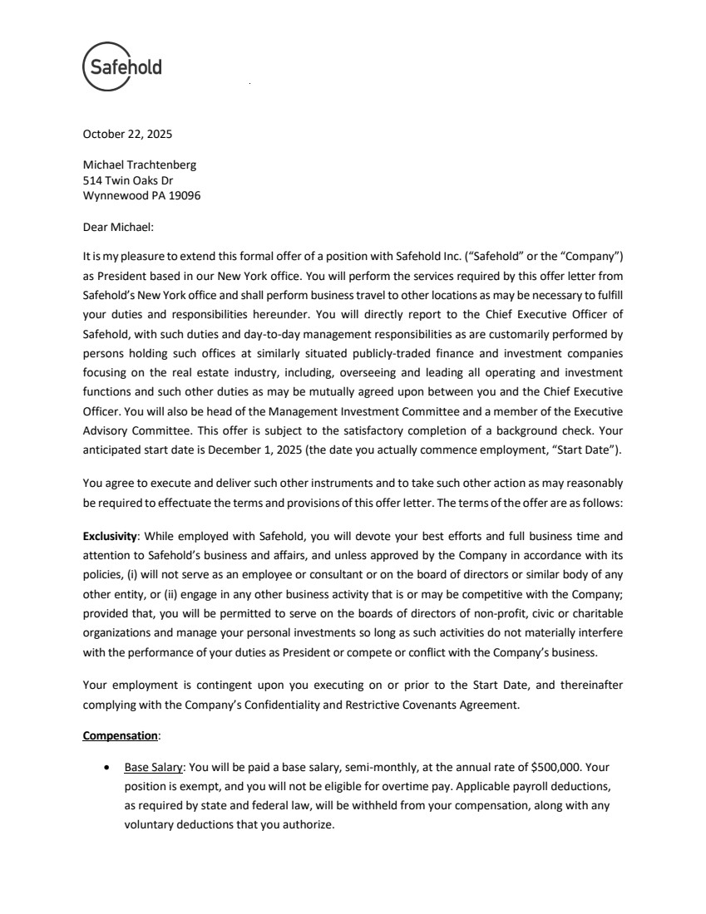 | October 22, 2025 Michael Trachtenberg 514 Twin Oaks Dr Wynnewood PA 19096 Dear Michael: It ismy pleasure to extend this formal offer of a position with Safehold Inc. (“Safehold” or the “Company”) as President based in our New York office. You will perform the services required by this offer letter from Safehold’s New York office and shall perform business travel to other locations as may be necessary to fulfill your duties and responsibilities hereunder. You will directly report to the Chief Executive Officer of Safehold, with such duties and day-to-day management responsibilities as are customarily performed by persons holding such offices at similarly situated publicly-traded finance and investment companies focusing on the real estate industry, including, overseeing and leading all operating and investment functions and such other duties as may be mutually agreed upon between you and the Chief Executive Officer. You will also be head of the Management Investment Committee and a member of the Executive Advisory Committee. This offer is subject to the satisfactory completion of a background check. Your anticipated start date is December 1, 2025 (the date you actually commence employment, “Start Date”). You agree to execute and deliver such other instruments and to take such other action as may reasonably be required to effectuate the terms and provisions of this offer letter. The terms of the offer are as follows: Exclusivity: While employed with Safehold, you will devote your best efforts and full business time and attention to Safehold’s business and affairs, and unless approved by the Company in accordance with its policies, (i) will not serve as an employee or consultant or on the board of directors or similar body of any other entity, or (ii) engage in any other business activity that is or may be competitive with the Company; provided that, you will be permitted to serve on the boards of directors of non-profit, civic or charitable organizations and manage your personal investments so long as such activities do not materially interfere with the performance of your duties as President or compete or conflict with the Company’s business. Your employment is contingent upon you executing on or prior to the Start Date, and thereinafter complying with the Company’s Confidentiality and Restrictive Covenants Agreement. Compensation: • Base Salary: You will be paid a base salary, semi-monthly, at the annual rate of $500,000. Your position is exempt, and you will not be eligible for overtime pay. Applicable payroll deductions, as required by state and federal law, will be withheld from your compensation, along with any voluntary deductions that you authorize.
 | 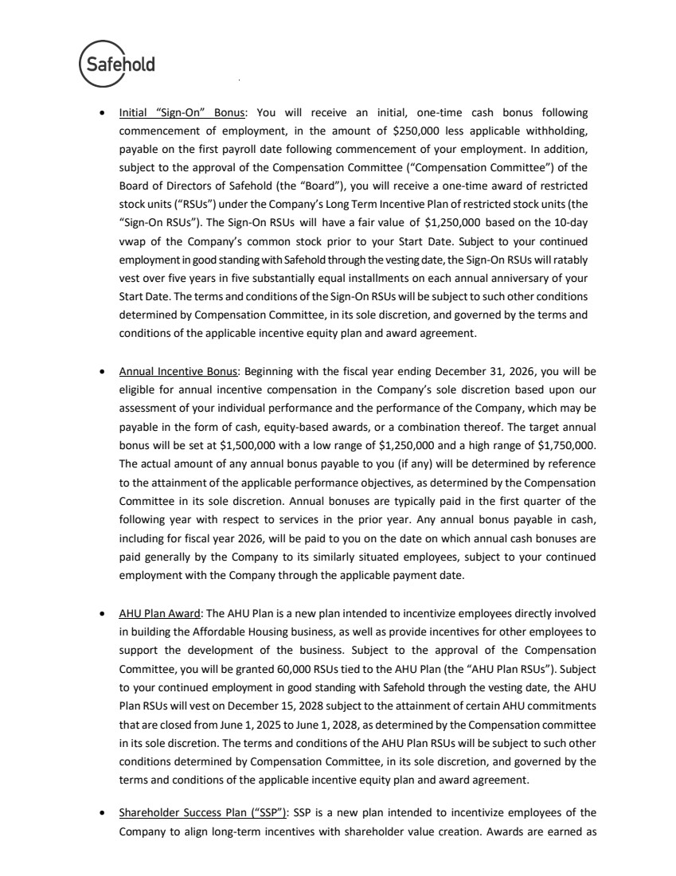 | • Initial “Sign-On” Bonus: You will receive an initial, one-time cash bonus following commencement of employment, in the amount of $250,000 less applicable withholding, payable on the first payroll date following commencement of your employment. In addition, subject to the approval of the Compensation Committee (“Compensation Committee”) of the Board of Directors of Safehold (the “Board”), you will receive a one-time award of restricted stock units (“RSUs”) under the Company’s Long Term Incentive Plan of restricted stock units (the “Sign-On RSUs”). The Sign-On RSUs will have a fair value of $1,250,000 based on the 10-day vwap of the Company’s common stock prior to your Start Date. Subject to your continued employment in good standing with Safehold through the vesting date, the Sign-On RSUs will ratably vest over five years in five substantially equal installments on each annual anniversary of your Start Date. The terms and conditions of the Sign-On RSUs will be subject to such other conditions determined by Compensation Committee, in its sole discretion, and governed by the terms and conditions of the applicable incentive equity plan and award agreement. • Annual Incentive Bonus: Beginning with the fiscal year ending December 31, 2026, you will be eligible for annual incentive compensation in the Company’s sole discretion based upon our assessment of your individual performance and the performance of the Company, which may be payable in the form of cash, equity-based awards, or a combination thereof. The target annual bonus will be set at $1,500,000 with a low range of $1,250,000 and a high range of $1,750,000. The actual amount of any annual bonus payable to you (if any) will be determined by reference to the attainment of the applicable performance objectives, as determined by the Compensation Committee in its sole discretion. Annual bonuses are typically paid in the first quarter of the following year with respect to services in the prior year. Any annual bonus payable in cash, including for fiscal year 2026, will be paid to you on the date on which annual cash bonuses are paid generally by the Company to its similarly situated employees, subject to your continued employment with the Company through the applicable payment date. • AHU Plan Award: The AHU Plan is a new plan intended to incentivize employees directly involved in building the Affordable Housing business, as well as provide incentives for other employees to support the development of the business. Subject to the approval of the Compensation Committee, you will be granted 60,000 RSUs tied to the AHU Plan (the “AHU Plan RSUs”). Subject to your continued employment in good standing with Safehold through the vesting date, the AHU Plan RSUs will vest on December 15, 2028 subject to the attainment of certain AHU commitments that are closed from June 1, 2025 to June 1, 2028, as determined by the Compensation committee in its sole discretion. The terms and conditions of the AHU Plan RSUs will be subject to such other conditions determined by Compensation Committee, in its sole discretion, and governed by the terms and conditions of the applicable incentive equity plan and award agreement. • Shareholder Success Plan (“SSP”): SSP is a new plan intended to incentivize employees of the Company to align long-term incentives with shareholder value creation. Awards are earned as
 | 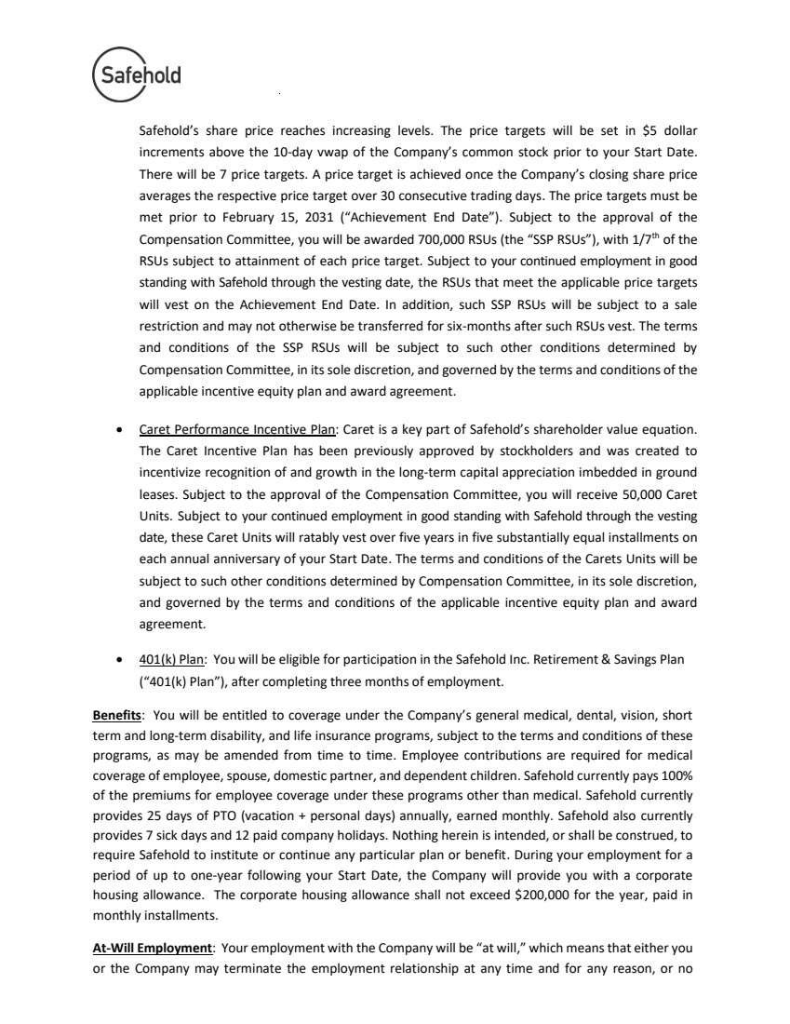 | Safehold’s share price reaches increasing levels. The price targets will be set in $5 dollar increments above the 10-day vwap of the Company’s common stock prior to your Start Date. There will be 7 price targets. A price target is achieved once the Company’s closing share price averages the respective price target over 30 consecutive trading days. The price targets must be met prior to February 15, 2031 (“Achievement End Date”). Subject to the approval of the Compensation Committee, you will be awarded 700,000 RSUs (the “SSP RSUs”), with 1/7th of the RSUs subject to attainment of each price target. Subject to your continued employment in good standing with Safehold through the vesting date, the RSUs that meet the applicable price targets will vest on the Achievement End Date. In addition, such SSP RSUs will be subject to a sale restriction and may not otherwise be transferred for six-months after such RSUs vest. The terms and conditions of the SSP RSUs will be subject to such other conditions determined by Compensation Committee, in its sole discretion, and governed by the terms and conditions of the applicable incentive equity plan and award agreement. • Caret Performance Incentive Plan: Caret is a key part of Safehold’s shareholder value equation. The Caret Incentive Plan has been previously approved by stockholders and was created to incentivize recognition of and growth in the long-term capital appreciation imbedded in ground leases. Subject to the approval of the Compensation Committee, you will receive 50,000 Caret Units. Subject to your continued employment in good standing with Safehold through the vesting date, these Caret Units will ratably vest over five years in five substantially equal installments on each annual anniversary of your Start Date. The terms and conditions of the Carets Units will be subject to such other conditions determined by Compensation Committee, in its sole discretion, and governed by the terms and conditions of the applicable incentive equity plan and award agreement. • 401(k) Plan: You will be eligible for participation in the Safehold Inc. Retirement & Savings Plan (“401(k) Plan”), after completing three months of employment. Benefits: You will be entitled to coverage under the Company’s general medical, dental, vision, short term and long-term disability, and life insurance programs, subject to the terms and conditions of these programs, as may be amended from time to time. Employee contributions are required for medical coverage of employee, spouse, domestic partner, and dependent children. Safehold currently pays 100% of the premiums for employee coverage under these programs other than medical. Safehold currently provides 25 days of PTO (vacation + personal days) annually, earned monthly. Safehold also currently provides 7 sick days and 12 paid company holidays. Nothing herein is intended, or shall be construed, to require Safehold to institute or continue any particular plan or benefit. During your employment for a period of up to one-year following your Start Date, the Company will provide you with a corporate housing allowance. The corporate housing allowance shall not exceed $200,000 for the year, paid in monthly installments. At-Will Employment: Your employment with the Company will be “at will,” which means that either you or the Company may terminate the employment relationship at any time and for any reason, or no
 | 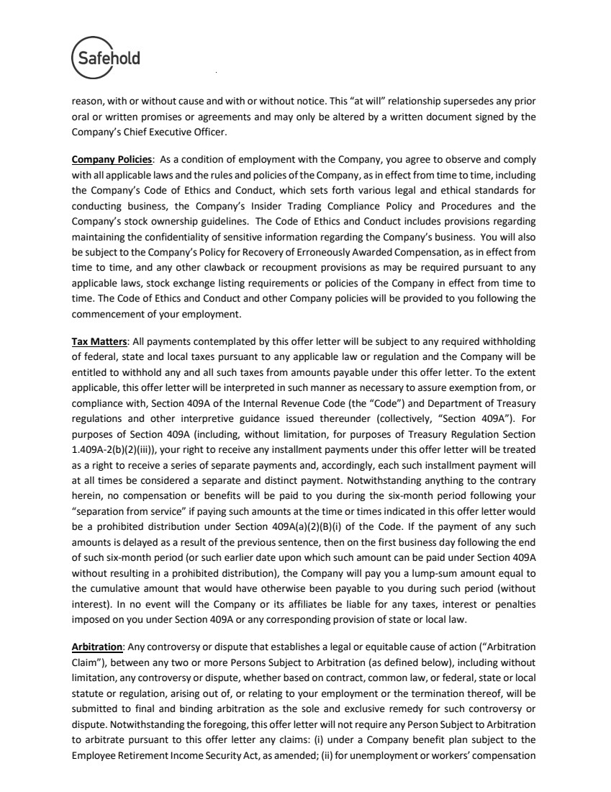 | reason, with or without cause and with or without notice. This “at will” relationship supersedes any prior oral or written promises or agreements and may only be altered by a written document signed by the Company’s Chief Executive Officer. Company Policies: As a condition of employment with the Company, you agree to observe and comply with all applicable laws and the rules and policies of the Company, as in effect from time to time, including the Company’s Code of Ethics and Conduct, which sets forth various legal and ethical standards for conducting business, the Company’s Insider Trading Compliance Policy and Procedures and the Company’s stock ownership guidelines. The Code of Ethics and Conduct includes provisions regarding maintaining the confidentiality of sensitive information regarding the Company’s business. You will also be subject to the Company’s Policy for Recovery of Erroneously Awarded Compensation, as in effect from time to time, and any other clawback or recoupment provisions as may be required pursuant to any applicable laws, stock exchange listing requirements or policies of the Company in effect from time to time. The Code of Ethics and Conduct and other Company policies will be provided to you following the commencement of your employment. Tax Matters: All payments contemplated by this offer letter will be subject to any required withholding of federal, state and local taxes pursuant to any applicable law or regulation and the Company will be entitled to withhold any and all such taxes from amounts payable under this offer letter. To the extent applicable, this offer letter will be interpreted in such manner as necessary to assure exemption from, or compliance with, Section 409A of the Internal Revenue Code (the “Code”) and Department of Treasury regulations and other interpretive guidance issued thereunder (collectively, “Section 409A”). For purposes of Section 409A (including, without limitation, for purposes of Treasury Regulation Section 1.409A-2(b)(2)(iii)), your right to receive any installment payments under this offer letter will be treated as a right to receive a series of separate payments and, accordingly, each such installment payment will at all times be considered a separate and distinct payment. Notwithstanding anything to the contrary herein, no compensation or benefits will be paid to you during the six-month period following your “separation from service” if paying such amounts at the time or times indicated in this offer letter would be a prohibited distribution under Section 409A(a)(2)(B)(i) of the Code. If the payment of any such amounts is delayed as a result of the previous sentence, then on the first business day following the end of such six-month period (or such earlier date upon which such amount can be paid under Section 409A without resulting in a prohibited distribution), the Company will pay you a lump-sum amount equal to the cumulative amount that would have otherwise been payable to you during such period (without interest). In no event will the Company or its affiliates be liable for any taxes, interest or penalties imposed on you under Section 409A or any corresponding provision of state or local law. Arbitration: Any controversy or dispute that establishes a legal or equitable cause of action (“Arbitration Claim”), between any two or more Persons Subject to Arbitration (as defined below), including without limitation, any controversy or dispute, whether based on contract, common law, or federal, state or local statute or regulation, arising out of, or relating to your employment or the termination thereof, will be submitted to final and binding arbitration as the sole and exclusive remedy for such controversy or dispute. Notwithstanding the foregoing, this offer letter will not require any Person Subject to Arbitration to arbitrate pursuant to this offer letter any claims: (i) under a Company benefit plan subject to the Employee Retirement Income Security Act, as amended; (ii) for unemployment or workers’ compensation
 | 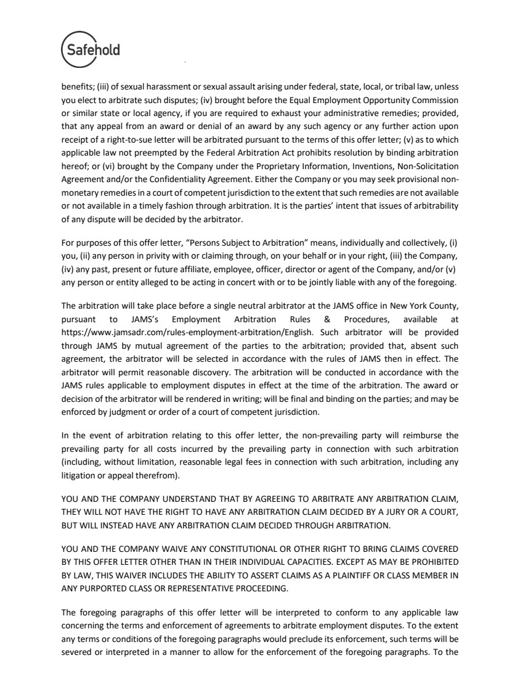 | benefits; (iii) of sexual harassment or sexual assault arising under federal, state, local, or tribal law, unless you elect to arbitrate such disputes; (iv) brought before the Equal Employment Opportunity Commission or similar state or local agency, if you are required to exhaust your administrative remedies; provided, that any appeal from an award or denial of an award by any such agency or any further action upon receipt of a right-to-sue letter will be arbitrated pursuant to the terms of this offer letter; (v) as to which applicable law not preempted by the Federal Arbitration Act prohibits resolution by binding arbitration hereof; or (vi) brought by the Company under the Proprietary Information, Inventions, Non-Solicitation Agreement and/or the Confidentiality Agreement. Either the Company or you may seek provisional non-monetary remedies in a court of competent jurisdiction to the extent that such remedies are not available or not available in a timely fashion through arbitration. It is the parties’ intent that issues of arbitrability of any dispute will be decided by the arbitrator. For purposes of this offer letter, “Persons Subject to Arbitration” means, individually and collectively, (i) you, (ii) any person in privity with or claiming through, on your behalf or in your right, (iii) the Company, (iv) any past, present or future affiliate, employee, officer, director or agent of the Company, and/or (v) any person or entity alleged to be acting in concert with or to be jointly liable with any of the foregoing. The arbitration will take place before a single neutral arbitrator at the JAMS office in New York County, pursuant to JAMS’s Employment Arbitration Rules & Procedures, available at https://www.jamsadr.com/rules-employment-arbitration/English. Such arbitrator will be provided through JAMS by mutual agreement of the parties to the arbitration; provided that, absent such agreement, the arbitrator will be selected in accordance with the rules of JAMS then in effect. The arbitrator will permit reasonable discovery. The arbitration will be conducted in accordance with the JAMS rules applicable to employment disputes in effect at the time of the arbitration. The award or decision of the arbitrator will be rendered in writing; will be final and binding on the parties; and may be enforced by judgment or order of a court of competent jurisdiction. In the event of arbitration relating to this offer letter, the non-prevailing party will reimburse the prevailing party for all costs incurred by the prevailing party in connection with such arbitration (including, without limitation, reasonable legal fees in connection with such arbitration, including any litigation or appeal therefrom). YOU AND THE COMPANY UNDERSTAND THAT BY AGREEING TO ARBITRATE ANY ARBITRATION CLAIM, THEY WILL NOT HAVE THE RIGHT TO HAVE ANY ARBITRATION CLAIM DECIDED BY A JURY OR A COURT, BUT WILL INSTEAD HAVE ANY ARBITRATION CLAIM DECIDED THROUGH ARBITRATION. YOU AND THE COMPANY WAIVE ANY CONSTITUTIONAL OR OTHER RIGHT TO BRING CLAIMS COVERED BY THIS OFFER LETTER OTHER THAN IN THEIR INDIVIDUAL CAPACITIES. EXCEPT AS MAY BE PROHIBITED BY LAW, THIS WAIVER INCLUDES THE ABILITY TO ASSERT CLAIMS AS A PLAINTIFF OR CLASS MEMBER IN ANY PURPORTED CLASS OR REPRESENTATIVE PROCEEDING. The foregoing paragraphs of this offer letter will be interpreted to conform to any applicable law concerning the terms and enforcement of agreements to arbitrate employment disputes. To the extent any terms or conditions of the foregoing paragraphs would preclude its enforcement, such terms will be severed or interpreted in a manner to allow for the enforcement of the foregoing paragraphs. To the
 | 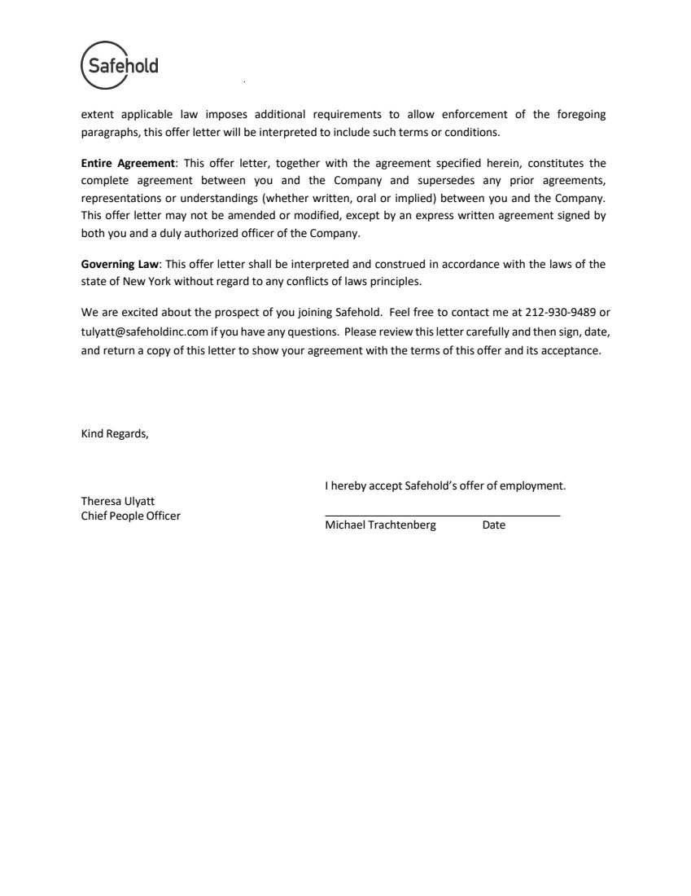 | extent applicable law imposes additional requirements to allow enforcement of the foregoing paragraphs, this offer letter will be interpreted to include such terms or conditions. Entire Agreement: This offer letter, together with the agreement specified herein, constitutes the complete agreement between you and the Company and supersedes any prior agreements, representations or understandings (whether written, oral or implied) between you and the Company. This offer letter may not be amended or modified, except by an express written agreement signed by both you and a duly authorized officer of the Company. Governing Law: This offer letter shall be interpreted and construed in accordance with the laws of the state of New York without regard to any conflicts of laws principles. We are excited about the prospect of you joining Safehold. Feel free to contact me at 212-930-9489 or tulyatt@safeholdinc.com if you have any questions. Please review thisletter carefully and then sign, date, and return a copy of this letter to show your agreement with the terms of this offer and its acceptance. Kind Regards, Theresa Ulyatt Chief People Officer I hereby accept Safehold’s offer of employment. Michael Trachtenberg Date
Exhibit 10.31
 | 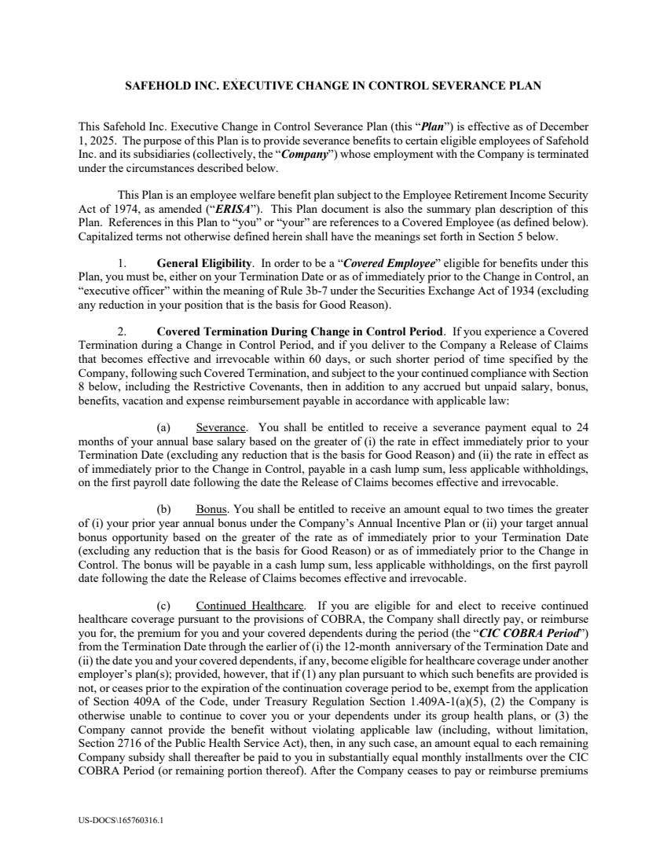 | US-DOCS\165760316.1 SAFEHOLD INC. EXECUTIVE CHANGE IN CONTROL SEVERANCE PLAN This Safehold Inc. Executive Change in Control Severance Plan (this “Plan”) is effective as of December 1, 2025. The purpose of this Plan is to provide severance benefits to certain eligible employees of Safehold Inc. and its subsidiaries (collectively, the “Company”) whose employment with the Company is terminated under the circumstances described below. This Plan is an employee welfare benefit plan subject to the Employee Retirement Income Security Act of 1974, as amended (“ERISA”). This Plan document is also the summary plan description of this Plan. References in this Plan to “you” or “your” are references to a Covered Employee (as defined below). Capitalized terms not otherwise defined herein shall have the meanings set forth in Section 5 below. 1. General Eligibility. In order to be a “Covered Employee” eligible for benefits under this Plan, you must be, either on your Termination Date or as of immediately prior to the Change in Control, an “executive officer” within the meaning of Rule 3b-7 under the Securities Exchange Act of 1934 (excluding any reduction in your position that is the basis for Good Reason). 2. Covered Termination During Change in Control Period. If you experience a Covered Termination during a Change in Control Period, and if you deliver to the Company a Release of Claims that becomes effective and irrevocable within 60 days, or such shorter period of time specified by the Company, following such Covered Termination, and subject to the your continued compliance with Section 8 below, including the Restrictive Covenants, then in addition to any accrued but unpaid salary, bonus, benefits, vacation and expense reimbursement payable in accordance with applicable law: (a) Severance. You shall be entitled to receive a severance payment equal to 24 months of your annual base salary based on the greater of (i) the rate in effect immediately prior to your Termination Date (excluding any reduction that is the basis for Good Reason) and (ii) the rate in effect as of immediately prior to the Change in Control, payable in a cash lump sum, less applicable withholdings, on the first payroll date following the date the Release of Claims becomes effective and irrevocable. (b) Bonus. You shall be entitled to receive an amount equal to two times the greater of (i) your prior year annual bonus under the Company’s Annual Incentive Plan or (ii) your target annual bonus opportunity based on the greater of the rate as of immediately prior to your Termination Date (excluding any reduction that is the basis for Good Reason) or as of immediately prior to the Change in Control. The bonus will be payable in a cash lump sum, less applicable withholdings, on the first payroll date following the date the Release of Claims becomes effective and irrevocable. (c) Continued Healthcare. If you are eligible for and elect to receive continued healthcare coverage pursuant to the provisions of COBRA, the Company shall directly pay, or reimburse you for, the premium for you and your covered dependents during the period (the “CIC COBRA Period”) from the Termination Date through the earlier of (i) the 12-month anniversary of the Termination Date and (ii) the date you and your covered dependents, if any, become eligible for healthcare coverage under another employer’s plan(s); provided, however, that if (1) any plan pursuant to which such benefits are provided is not, or ceases prior to the expiration of the continuation coverage period to be, exempt from the application of Section 409A of the Code, under Treasury Regulation Section 1.409A-1(a)(5), (2) the Company is otherwise unable to continue to cover you or your dependents under its group health plans, or (3) the Company cannot provide the benefit without violating applicable law (including, without limitation, Section 2716 of the Public Health Service Act), then, in any such case, an amount equal to each remaining Company subsidy shall thereafter be paid to you in substantially equal monthly installments over the CIC COBRA Period (or remaining portion thereof). After the Company ceases to pay or reimburse premiums
 | 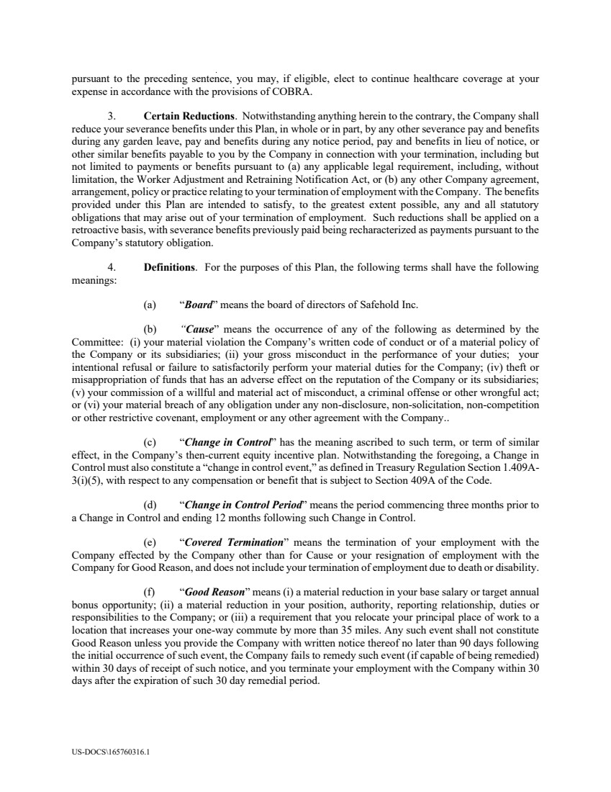 | US-DOCS\165760316.1 pursuant to the preceding sentence, you may, if eligible, elect to continue healthcare coverage at your expense in accordance with the provisions of COBRA. 3. Certain Reductions. Notwithstanding anything herein to the contrary, the Company shall reduce your severance benefits under this Plan, in whole or in part, by any other severance pay and benefits during any garden leave, pay and benefits during any notice period, pay and benefits in lieu of notice, or other similar benefits payable to you by the Company in connection with your termination, including but not limited to payments or benefits pursuant to (a) any applicable legal requirement, including, without limitation, the Worker Adjustment and Retraining Notification Act, or (b) any other Company agreement, arrangement, policy or practice relating to your termination of employment with the Company. The benefits provided under this Plan are intended to satisfy, to the greatest extent possible, any and all statutory obligations that may arise out of your termination of employment. Such reductions shall be applied on a retroactive basis, with severance benefits previously paid being recharacterized as payments pursuant to the Company’s statutory obligation. 4. Definitions. For the purposes of this Plan, the following terms shall have the following meanings: (a) “Board” means the board of directors of Safehold Inc. (b) “Cause” means the occurrence of any of the following as determined by the Committee: (i) your material violation the Company’s written code of conduct or of a material policy of the Company or its subsidiaries; (ii) your gross misconduct in the performance of your duties; your intentional refusal or failure to satisfactorily perform your material duties for the Company; (iv) theft or misappropriation of funds that has an adverse effect on the reputation of the Company or its subsidiaries; (v) your commission of a willful and material act of misconduct, a criminal offense or other wrongful act; or (vi) your material breach of any obligation under any non-disclosure, non-solicitation, non-competition or other restrictive covenant, employment or any other agreement with the Company.. (c) “Change in Control” has the meaning ascribed to such term, or term of similar effect, in the Company’s then-current equity incentive plan. Notwithstanding the foregoing, a Change in Control must also constitute a “change in control event,” as defined in Treasury Regulation Section 1.409A-3(i)(5), with respect to any compensation or benefit that is subject to Section 409A of the Code. (d) “Change in Control Period” means the period commencing three months prior to a Change in Control and ending 12 months following such Change in Control. (e) “Covered Termination” means the termination of your employment with the Company effected by the Company other than for Cause or your resignation of employment with the Company for Good Reason, and does not include your termination of employment due to death or disability. (f) “Good Reason” means (i) a material reduction in your base salary or target annual bonus opportunity; (ii) a material reduction in your position, authority, reporting relationship, duties or responsibilities to the Company; or (iii) a requirement that you relocate your principal place of work to a location that increases your one-way commute by more than 35 miles. Any such event shall not constitute Good Reason unless you provide the Company with written notice thereof no later than 90 days following the initial occurrence of such event, the Company fails to remedy such event (if capable of being remedied) within 30 days of receipt of such notice, and you terminate your employment with the Company within 30 days after the expiration of such 30 day remedial period.
 | 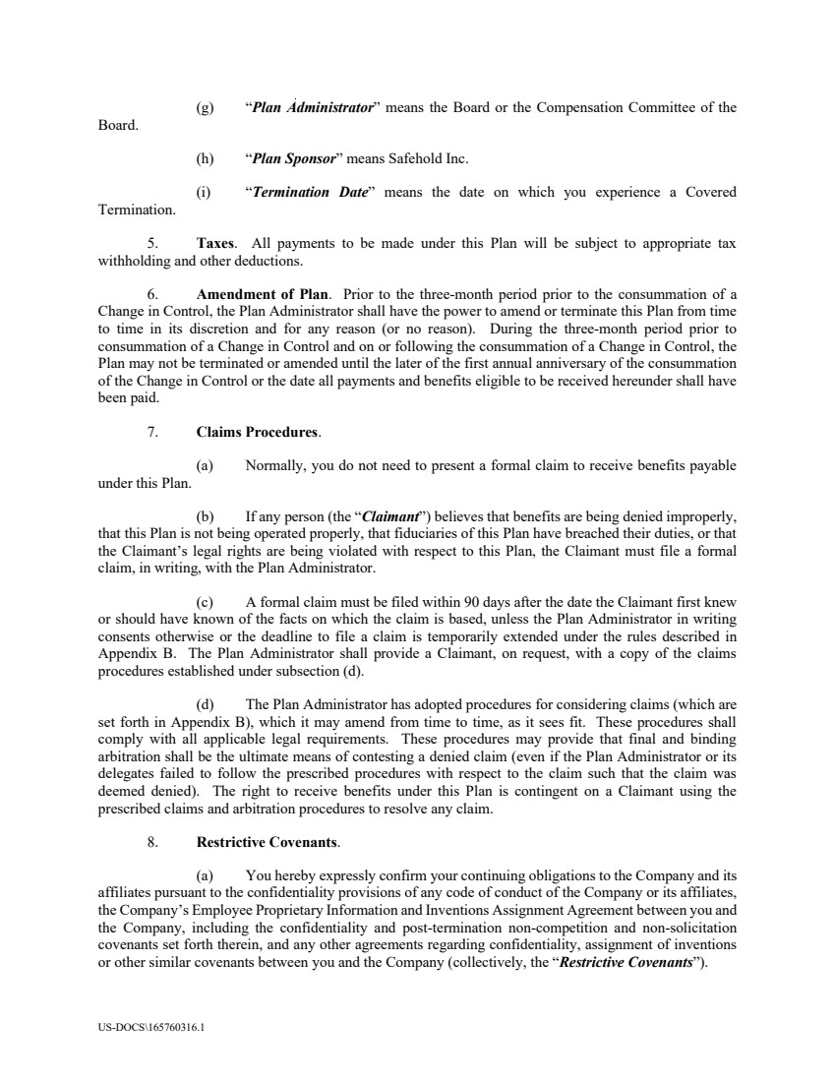 | US-DOCS\165760316.1 (g) “Plan Administrator” means the Board or the Compensation Committee of the Board. (h) “Plan Sponsor” means Safehold Inc. (i) “Termination Date” means the date on which you experience a Covered Termination. 5. Taxes. All payments to be made under this Plan will be subject to appropriate tax withholding and other deductions. 6. Amendment of Plan. Prior to the three-month period prior to the consummation of a Change in Control, the Plan Administrator shall have the power to amend or terminate this Plan from time to time in its discretion and for any reason (or no reason). During the three-month period prior to consummation of a Change in Control and on or following the consummation of a Change in Control, the Plan may not be terminated or amended until the later of the first annual anniversary of the consummation of the Change in Control or the date all payments and benefits eligible to be received hereunder shall have been paid. 7. Claims Procedures. (a) Normally, you do not need to present a formal claim to receive benefits payable under this Plan. (b) If any person (the “Claimant”) believes that benefits are being denied improperly, that this Plan is not being operated properly, that fiduciaries of this Plan have breached their duties, or that the Claimant’s legal rights are being violated with respect to this Plan, the Claimant must file a formal claim, in writing, with the Plan Administrator. (c) A formal claim must be filed within 90 days after the date the Claimant first knew or should have known of the facts on which the claim is based, unless the Plan Administrator in writing consents otherwise or the deadline to file a claim is temporarily extended under the rules described in Appendix B. The Plan Administrator shall provide a Claimant, on request, with a copy of the claims procedures established under subsection (d). (d) The Plan Administrator has adopted procedures for considering claims (which are set forth in Appendix B), which it may amend from time to time, as it sees fit. These procedures shall comply with all applicable legal requirements. These procedures may provide that final and binding arbitration shall be the ultimate means of contesting a denied claim (even if the Plan Administrator or its delegates failed to follow the prescribed procedures with respect to the claim such that the claim was deemed denied). The right to receive benefits under this Plan is contingent on a Claimant using the prescribed claims and arbitration procedures to resolve any claim. 8. Restrictive Covenants. (a) You hereby expressly confirm your continuing obligations to the Company and its affiliates pursuant to the confidentiality provisions of any code of conduct of the Company or its affiliates, the Company’s Employee Proprietary Information and Inventions Assignment Agreement between you and the Company, including the confidentiality and post-termination non-competition and non-solicitation covenants set forth therein, and any other agreements regarding confidentiality, assignment of inventions or other similar covenants between you and the Company (collectively, the “Restrictive Covenants”).
 | 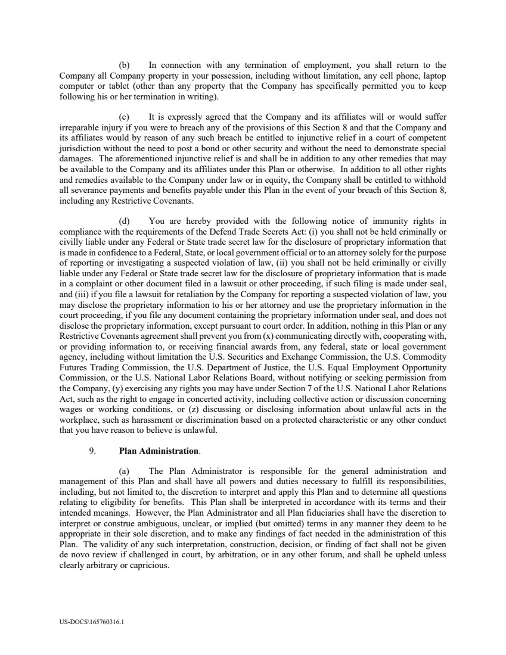 | US-DOCS\165760316.1 (b) In connection with any termination of employment, you shall return to the Company all Company property in your possession, including without limitation, any cell phone, laptop computer or tablet (other than any property that the Company has specifically permitted you to keep following his or her termination in writing). (c) It is expressly agreed that the Company and its affiliates will or would suffer irreparable injury if you were to breach any of the provisions of this Section 8 and that the Company and its affiliates would by reason of any such breach be entitled to injunctive relief in a court of competent jurisdiction without the need to post a bond or other security and without the need to demonstrate special damages. The aforementioned injunctive relief is and shall be in addition to any other remedies that may be available to the Company and its affiliates under this Plan or otherwise. In addition to all other rights and remedies available to the Company under law or in equity, the Company shall be entitled to withhold all severance payments and benefits payable under this Plan in the event of your breach of this Section 8, including any Restrictive Covenants. (d) You are hereby provided with the following notice of immunity rights in compliance with the requirements of the Defend Trade Secrets Act: (i) you shall not be held criminally or civilly liable under any Federal or State trade secret law for the disclosure of proprietary information that is made in confidence to a Federal, State, or local government official or to an attorney solely for the purpose of reporting or investigating a suspected violation of law, (ii) you shall not be held criminally or civilly liable under any Federal or State trade secret law for the disclosure of proprietary information that is made in a complaint or other document filed in a lawsuit or other proceeding, if such filing is made under seal, and (iii) if you file a lawsuit for retaliation by the Company for reporting a suspected violation of law, you may disclose the proprietary information to his or her attorney and use the proprietary information in the court proceeding, if you file any document containing the proprietary information under seal, and does not disclose the proprietary information, except pursuant to court order. In addition, nothing in this Plan or any Restrictive Covenants agreementshall prevent you from (x) communicating directly with, cooperating with, or providing information to, or receiving financial awards from, any federal, state or local government agency, including without limitation the U.S. Securities and Exchange Commission, the U.S. Commodity Futures Trading Commission, the U.S. Department of Justice, the U.S. Equal Employment Opportunity Commission, or the U.S. National Labor Relations Board, without notifying or seeking permission from the Company, (y) exercising any rights you may have under Section 7 of the U.S. National Labor Relations Act, such as the right to engage in concerted activity, including collective action or discussion concerning wages or working conditions, or (z) discussing or disclosing information about unlawful acts in the workplace, such as harassment or discrimination based on a protected characteristic or any other conduct that you have reason to believe is unlawful. 9. Plan Administration. (a) The Plan Administrator is responsible for the general administration and management of this Plan and shall have all powers and duties necessary to fulfill its responsibilities, including, but not limited to, the discretion to interpret and apply this Plan and to determine all questions relating to eligibility for benefits. This Plan shall be interpreted in accordance with its terms and their intended meanings. However, the Plan Administrator and all Plan fiduciaries shall have the discretion to interpret or construe ambiguous, unclear, or implied (but omitted) terms in any manner they deem to be appropriate in their sole discretion, and to make any findings of fact needed in the administration of this Plan. The validity of any such interpretation, construction, decision, or finding of fact shall not be given de novo review if challenged in court, by arbitration, or in any other forum, and shall be upheld unless clearly arbitrary or capricious.
 | 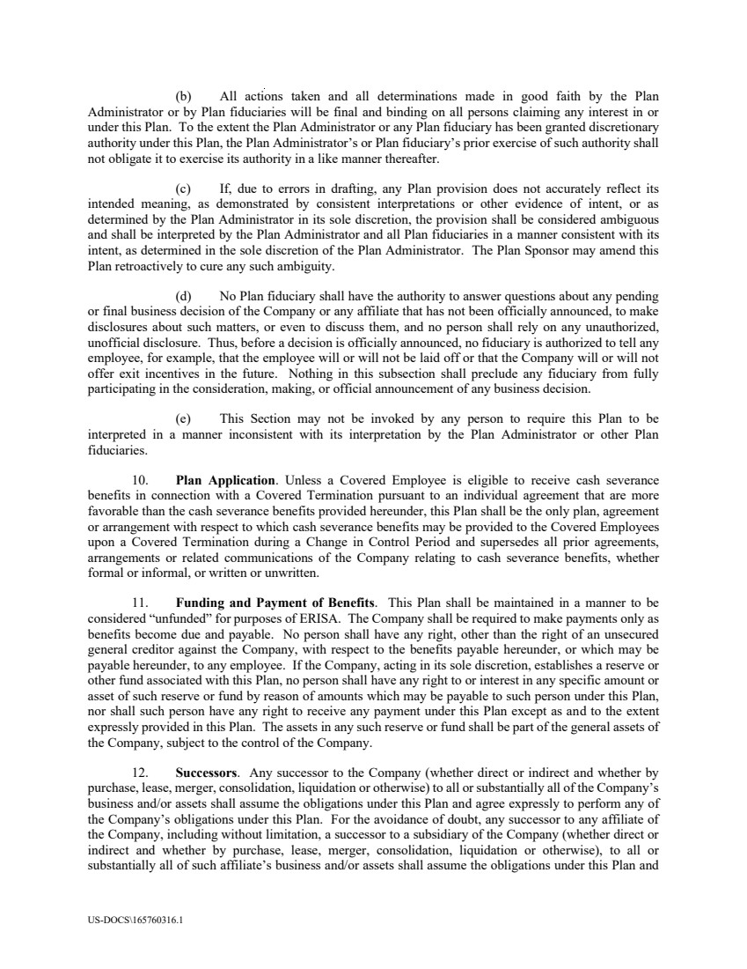 | US-DOCS\165760316.1 (b) All actions taken and all determinations made in good faith by the Plan Administrator or by Plan fiduciaries will be final and binding on all persons claiming any interest in or under this Plan. To the extent the Plan Administrator or any Plan fiduciary has been granted discretionary authority under this Plan, the Plan Administrator’s or Plan fiduciary’s prior exercise of such authority shall not obligate it to exercise its authority in a like manner thereafter. (c) If, due to errors in drafting, any Plan provision does not accurately reflect its intended meaning, as demonstrated by consistent interpretations or other evidence of intent, or as determined by the Plan Administrator in its sole discretion, the provision shall be considered ambiguous and shall be interpreted by the Plan Administrator and all Plan fiduciaries in a manner consistent with its intent, as determined in the sole discretion of the Plan Administrator. The Plan Sponsor may amend this Plan retroactively to cure any such ambiguity. (d) No Plan fiduciary shall have the authority to answer questions about any pending or final business decision of the Company or any affiliate that has not been officially announced, to make disclosures about such matters, or even to discuss them, and no person shall rely on any unauthorized, unofficial disclosure. Thus, before a decision is officially announced, no fiduciary is authorized to tell any employee, for example, that the employee will or will not be laid off or that the Company will or will not offer exit incentives in the future. Nothing in this subsection shall preclude any fiduciary from fully participating in the consideration, making, or official announcement of any business decision. (e) This Section may not be invoked by any person to require this Plan to be interpreted in a manner inconsistent with its interpretation by the Plan Administrator or other Plan fiduciaries. 10. Plan Application. Unless a Covered Employee is eligible to receive cash severance benefits in connection with a Covered Termination pursuant to an individual agreement that are more favorable than the cash severance benefits provided hereunder, this Plan shall be the only plan, agreement or arrangement with respect to which cash severance benefits may be provided to the Covered Employees upon a Covered Termination during a Change in Control Period and supersedes all prior agreements, arrangements or related communications of the Company relating to cash severance benefits, whether formal or informal, or written or unwritten. 11. Funding and Payment of Benefits. This Plan shall be maintained in a manner to be considered “unfunded” for purposes of ERISA. The Company shall be required to make payments only as benefits become due and payable. No person shall have any right, other than the right of an unsecured general creditor against the Company, with respect to the benefits payable hereunder, or which may be payable hereunder, to any employee. If the Company, acting in its sole discretion, establishes a reserve or other fund associated with this Plan, no person shall have any right to or interest in any specific amount or asset of such reserve or fund by reason of amounts which may be payable to such person under this Plan, nor shall such person have any right to receive any payment under this Plan except as and to the extent expressly provided in this Plan. The assets in any such reserve or fund shall be part of the general assets of the Company, subject to the control of the Company. 12. Successors. Any successor to the Company (whether direct or indirect and whether by purchase, lease, merger, consolidation, liquidation or otherwise) to all or substantially all of the Company’s business and/or assets shall assume the obligations under this Plan and agree expressly to perform any of the Company’s obligations under this Plan. For the avoidance of doubt, any successor to any affiliate of the Company, including without limitation, a successor to a subsidiary of the Company (whether direct or indirect and whether by purchase, lease, merger, consolidation, liquidation or otherwise), to all or substantially all of such affiliate’s business and/or assets shall assume the obligations under this Plan and
 | 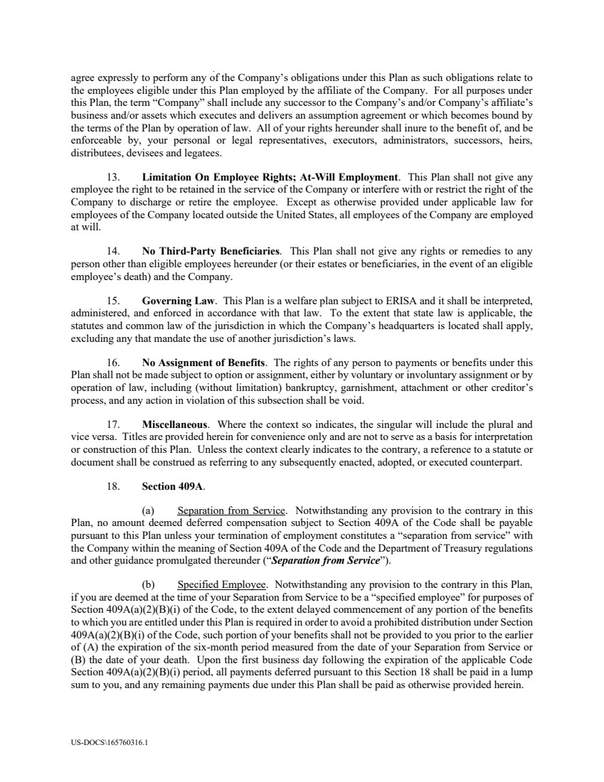 | US-DOCS\165760316.1 agree expressly to perform any of the Company’s obligations under this Plan as such obligations relate to the employees eligible under this Plan employed by the affiliate of the Company. For all purposes under this Plan, the term “Company” shall include any successor to the Company’s and/or Company’s affiliate’s business and/or assets which executes and delivers an assumption agreement or which becomes bound by the terms of the Plan by operation of law. All of your rights hereunder shall inure to the benefit of, and be enforceable by, your personal or legal representatives, executors, administrators, successors, heirs, distributees, devisees and legatees. 13. Limitation On Employee Rights; At-Will Employment. This Plan shall not give any employee the right to be retained in the service of the Company or interfere with or restrict the right of the Company to discharge or retire the employee. Except as otherwise provided under applicable law for employees of the Company located outside the United States, all employees of the Company are employed at will. 14. No Third-Party Beneficiaries. This Plan shall not give any rights or remedies to any person other than eligible employees hereunder (or their estates or beneficiaries, in the event of an eligible employee’s death) and the Company. 15. Governing Law. This Plan is a welfare plan subject to ERISA and it shall be interpreted, administered, and enforced in accordance with that law. To the extent that state law is applicable, the statutes and common law of the jurisdiction in which the Company’s headquarters is located shall apply, excluding any that mandate the use of another jurisdiction’s laws. 16. No Assignment of Benefits. The rights of any person to payments or benefits under this Plan shall not be made subject to option or assignment, either by voluntary or involuntary assignment or by operation of law, including (without limitation) bankruptcy, garnishment, attachment or other creditor’s process, and any action in violation of this subsection shall be void. 17. Miscellaneous. Where the context so indicates, the singular will include the plural and vice versa. Titles are provided herein for convenience only and are not to serve as a basis for interpretation or construction of this Plan. Unless the context clearly indicates to the contrary, a reference to a statute or document shall be construed as referring to any subsequently enacted, adopted, or executed counterpart. 18. Section 409A. (a) Separation from Service. Notwithstanding any provision to the contrary in this Plan, no amount deemed deferred compensation subject to Section 409A of the Code shall be payable pursuant to this Plan unless your termination of employment constitutes a “separation from service” with the Company within the meaning of Section 409A of the Code and the Department of Treasury regulations and other guidance promulgated thereunder (“Separation from Service”). (b) Specified Employee. Notwithstanding any provision to the contrary in this Plan, if you are deemed at the time of your Separation from Service to be a “specified employee” for purposes of Section 409A(a)(2)(B)(i) of the Code, to the extent delayed commencement of any portion of the benefits to which you are entitled under this Plan is required in order to avoid a prohibited distribution under Section 409A(a)(2)(B)(i) of the Code, such portion of your benefits shall not be provided to you prior to the earlier of (A) the expiration of the six-month period measured from the date of your Separation from Service or (B) the date of your death. Upon the first business day following the expiration of the applicable Code Section 409A(a)(2)(B)(i) period, all payments deferred pursuant to this Section 18 shall be paid in a lump sum to you, and any remaining payments due under this Plan shall be paid as otherwise provided herein.
 | 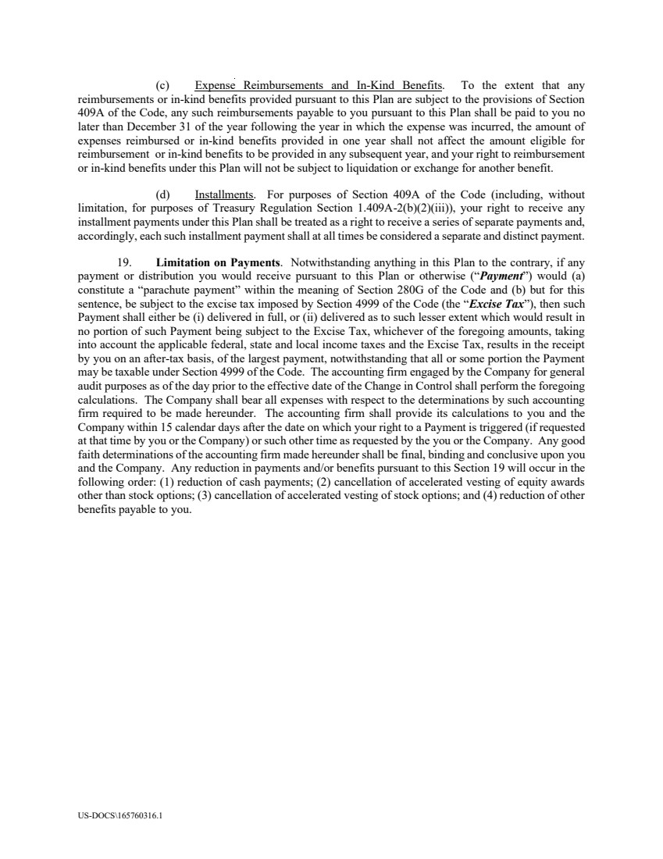 | US-DOCS\165760316.1 (c) Expense Reimbursements and In-Kind Benefits. To the extent that any reimbursements or in-kind benefits provided pursuant to this Plan are subject to the provisions of Section 409A of the Code, any such reimbursements payable to you pursuant to this Plan shall be paid to you no later than December 31 of the year following the year in which the expense was incurred, the amount of expenses reimbursed or in-kind benefits provided in one year shall not affect the amount eligible for reimbursement or in-kind benefits to be provided in any subsequent year, and your right to reimbursement or in-kind benefits under this Plan will not be subject to liquidation or exchange for another benefit. (d) Installments. For purposes of Section 409A of the Code (including, without limitation, for purposes of Treasury Regulation Section 1.409A-2(b)(2)(iii)), your right to receive any installment payments under this Plan shall be treated as a right to receive a series of separate payments and, accordingly, each such installment payment shall at all times be considered a separate and distinct payment. 19. Limitation on Payments. Notwithstanding anything in this Plan to the contrary, if any payment or distribution you would receive pursuant to this Plan or otherwise (“Payment”) would (a) constitute a “parachute payment” within the meaning of Section 280G of the Code and (b) but for this sentence, be subject to the excise tax imposed by Section 4999 of the Code (the “Excise Tax”), then such Payment shall either be (i) delivered in full, or (ii) delivered as to such lesser extent which would result in no portion of such Payment being subject to the Excise Tax, whichever of the foregoing amounts, taking into account the applicable federal, state and local income taxes and the Excise Tax, results in the receipt by you on an after-tax basis, of the largest payment, notwithstanding that all or some portion the Payment may be taxable under Section 4999 of the Code. The accounting firm engaged by the Company for general audit purposes as of the day prior to the effective date of the Change in Control shall perform the foregoing calculations. The Company shall bear all expenses with respect to the determinations by such accounting firm required to be made hereunder. The accounting firm shall provide its calculations to you and the Company within 15 calendar days after the date on which your right to a Payment is triggered (if requested at that time by you or the Company) or such other time as requested by the you or the Company. Any good faith determinations of the accounting firm made hereunder shall be final, binding and conclusive upon you and the Company. Any reduction in payments and/or benefits pursuant to this Section 19 will occur in the following order: (1) reduction of cash payments; (2) cancellation of accelerated vesting of equity awards other than stock options; (3) cancellation of accelerated vesting of stock options; and (4) reduction of other benefits payable to you.
 | 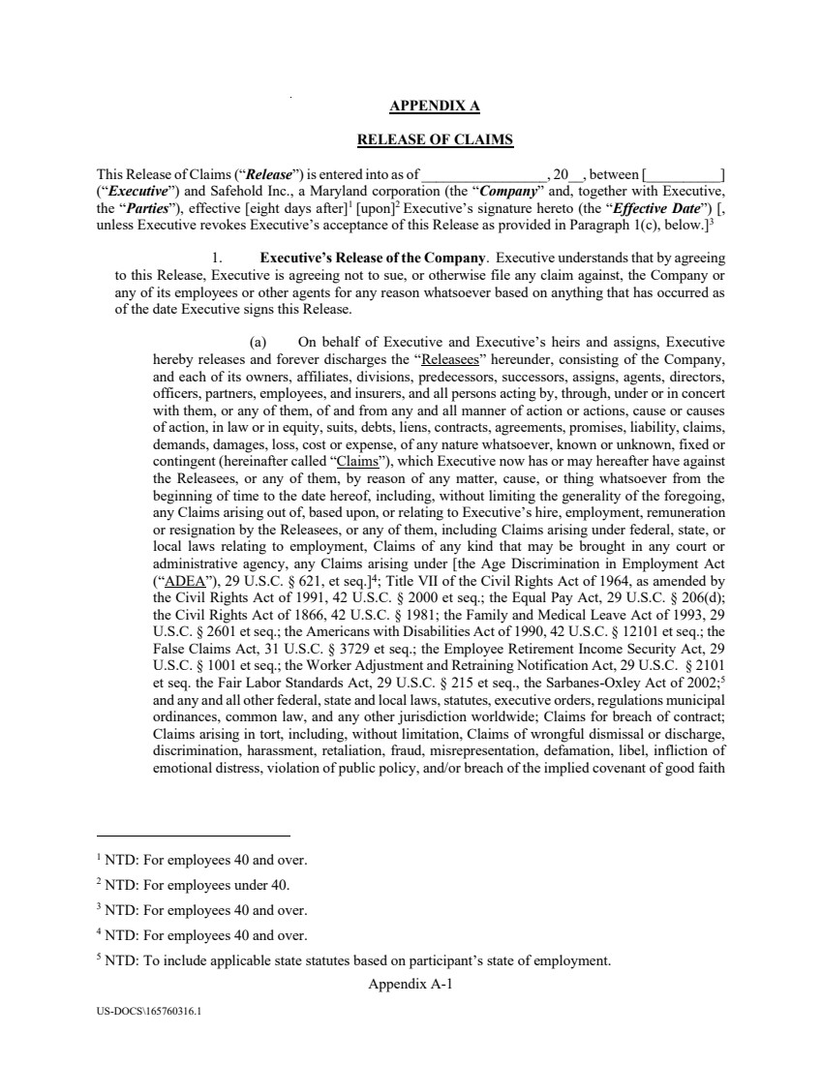 | Appendix A-1 US-DOCS\165760316.1 APPENDIX A RELEASE OF CLAIMS This Release of Claims (“Release”) is entered into as of _________________, 20__, between [__________] (“Executive”) and Safehold Inc., a Maryland corporation (the “Company” and, together with Executive, the “Parties”), effective [eight days after]1 [upon]2 Executive’s signature hereto (the “Effective Date”) [, unless Executive revokes Executive’s acceptance of this Release as provided in Paragraph 1(c), below.]3 1. Executive’s Release of the Company. Executive understands that by agreeing to this Release, Executive is agreeing not to sue, or otherwise file any claim against, the Company or any of its employees or other agents for any reason whatsoever based on anything that has occurred as of the date Executive signs this Release. (a) On behalf of Executive and Executive’s heirs and assigns, Executive hereby releases and forever discharges the “Releasees” hereunder, consisting of the Company, and each of its owners, affiliates, divisions, predecessors, successors, assigns, agents, directors, officers, partners, employees, and insurers, and all persons acting by, through, under or in concert with them, or any of them, of and from any and all manner of action or actions, cause or causes of action, in law or in equity, suits, debts, liens, contracts, agreements, promises, liability, claims, demands, damages, loss, cost or expense, of any nature whatsoever, known or unknown, fixed or contingent (hereinafter called “Claims”), which Executive now has or may hereafter have against the Releasees, or any of them, by reason of any matter, cause, or thing whatsoever from the beginning of time to the date hereof, including, without limiting the generality of the foregoing, any Claims arising out of, based upon, or relating to Executive’s hire, employment, remuneration or resignation by the Releasees, or any of them, including Claims arising under federal, state, or local laws relating to employment, Claims of any kind that may be brought in any court or administrative agency, any Claims arising under [the Age Discrimination in Employment Act (“ADEA”), 29 U.S.C. § 621, et seq.]4; Title VII of the Civil Rights Act of 1964, as amended by the Civil Rights Act of 1991, 42 U.S.C. § 2000 et seq.; the Equal Pay Act, 29 U.S.C. § 206(d); the Civil Rights Act of 1866, 42 U.S.C. § 1981; the Family and Medical Leave Act of 1993, 29 U.S.C. § 2601 et seq.; the Americans with Disabilities Act of 1990, 42 U.S.C. § 12101 et seq.; the False Claims Act, 31 U.S.C. § 3729 et seq.; the Employee Retirement Income Security Act, 29 U.S.C. § 1001 et seq.; the Worker Adjustment and Retraining Notification Act, 29 U.S.C. § 2101 et seq. the Fair Labor Standards Act, 29 U.S.C. § 215 et seq., the Sarbanes-Oxley Act of 2002;5 and any and all other federal, state and local laws, statutes, executive orders, regulations municipal ordinances, common law, and any other jurisdiction worldwide; Claims for breach of contract; Claims arising in tort, including, without limitation, Claims of wrongful dismissal or discharge, discrimination, harassment, retaliation, fraud, misrepresentation, defamation, libel, infliction of emotional distress, violation of public policy, and/or breach of the implied covenant of good faith 1 NTD: For employees 40 and over. 2 NTD: For employees under 40. 3 NTD: For employees 40 and over. 4 NTD: For employees 40 and over. 5 NTD: To include applicable state statutes based on participant’s state of employment.
 | 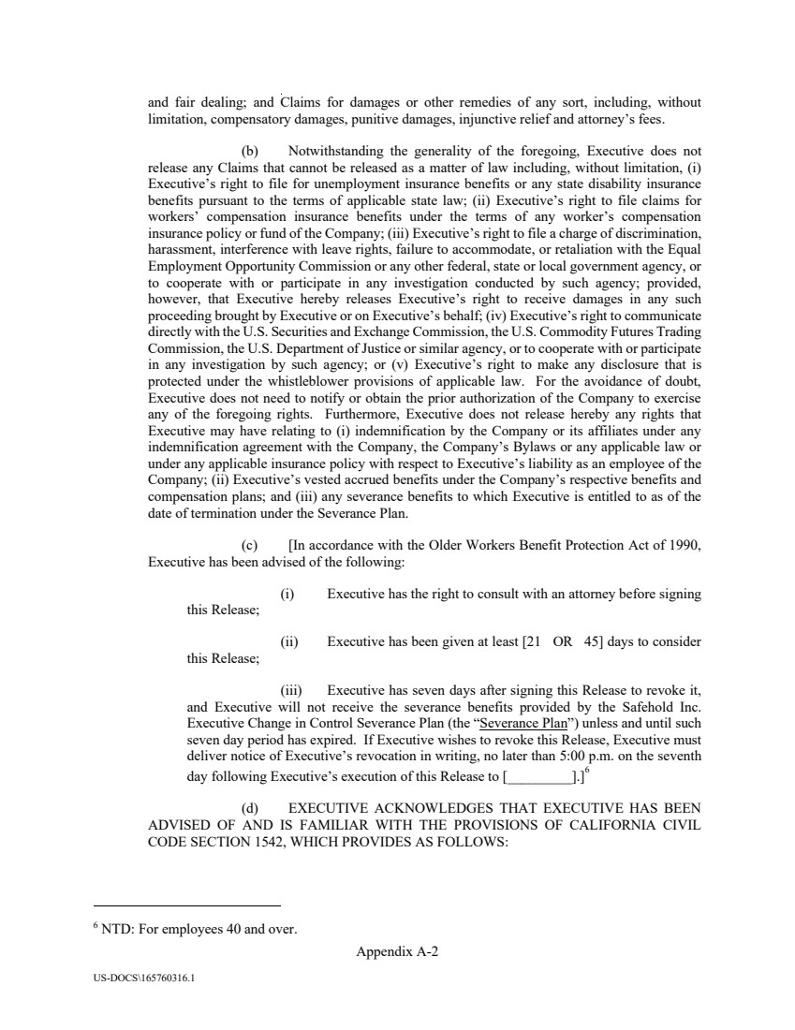 | Appendix A-2 US-DOCS\165760316.1 and fair dealing; and Claims for damages or other remedies of any sort, including, without limitation, compensatory damages, punitive damages, injunctive relief and attorney’s fees. (b) Notwithstanding the generality of the foregoing, Executive does not release any Claims that cannot be released as a matter of law including, without limitation, (i) Executive’s right to file for unemployment insurance benefits or any state disability insurance benefits pursuant to the terms of applicable state law; (ii) Executive’s right to file claims for workers’ compensation insurance benefits under the terms of any worker’s compensation insurance policy or fund of the Company; (iii) Executive’s right to file a charge of discrimination, harassment, interference with leave rights, failure to accommodate, or retaliation with the Equal Employment Opportunity Commission or any other federal, state or local government agency, or to cooperate with or participate in any investigation conducted by such agency; provided, however, that Executive hereby releases Executive’s right to receive damages in any such proceeding brought by Executive or on Executive’s behalf; (iv) Executive’s right to communicate directly with the U.S. Securities and Exchange Commission, the U.S. Commodity Futures Trading Commission, the U.S. Department of Justice or similar agency, or to cooperate with or participate in any investigation by such agency; or (v) Executive’s right to make any disclosure that is protected under the whistleblower provisions of applicable law. For the avoidance of doubt, Executive does not need to notify or obtain the prior authorization of the Company to exercise any of the foregoing rights. Furthermore, Executive does not release hereby any rights that Executive may have relating to (i) indemnification by the Company or its affiliates under any indemnification agreement with the Company, the Company’s Bylaws or any applicable law or under any applicable insurance policy with respect to Executive’s liability as an employee of the Company; (ii) Executive’s vested accrued benefits under the Company’s respective benefits and compensation plans; and (iii) any severance benefits to which Executive is entitled to as of the date of termination under the Severance Plan. (c) [In accordance with the Older Workers Benefit Protection Act of 1990, Executive has been advised of the following: (i) Executive has the right to consult with an attorney before signing this Release; (ii) Executive has been given at least [21 OR 45] days to consider this Release; (iii) Executive has seven days after signing this Release to revoke it, and Executive will not receive the severance benefits provided by the Safehold Inc. Executive Change in Control Severance Plan (the “Severance Plan”) unless and until such seven day period has expired. If Executive wishes to revoke this Release, Executive must deliver notice of Executive’s revocation in writing, no later than 5:00 p.m. on the seventh day following Executive’s execution of this Release to [_________].]6 (d) EXECUTIVE ACKNOWLEDGES THAT EXECUTIVE HAS BEEN ADVISED OF AND IS FAMILIAR WITH THE PROVISIONS OF CALIFORNIA CIVIL CODE SECTION 1542, WHICH PROVIDES AS FOLLOWS: 6 NTD: For employees 40 and over.
 | 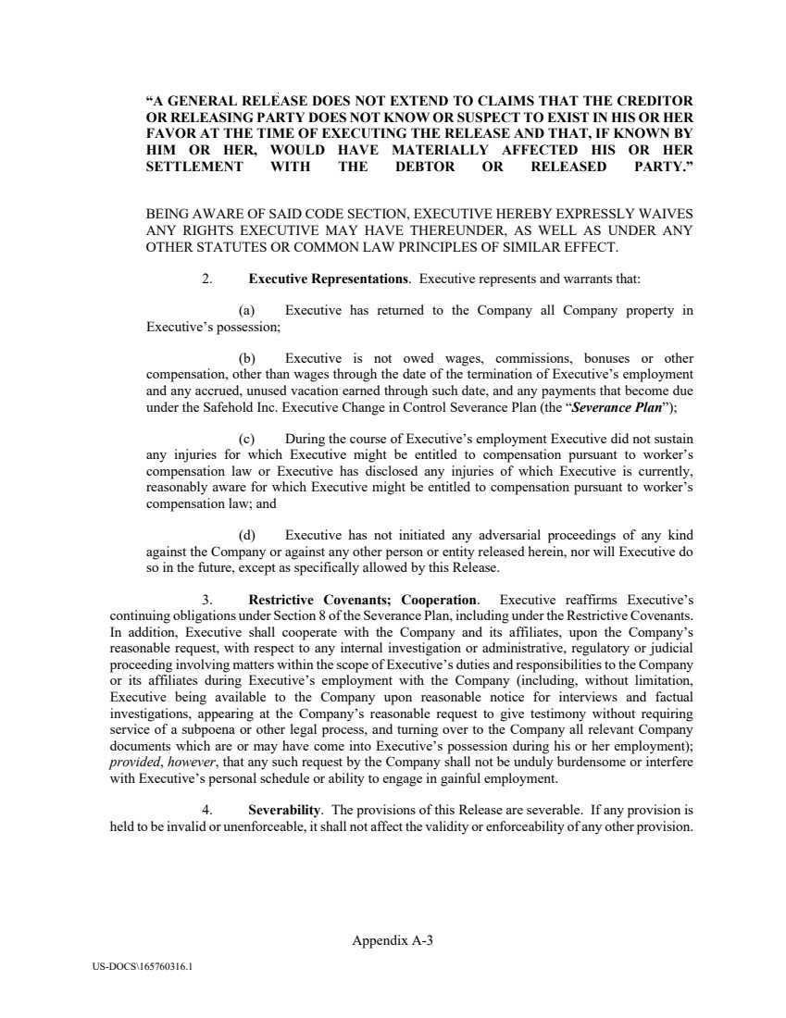 | Appendix A-3 US-DOCS\165760316.1 “A GENERAL RELEASE DOES NOT EXTEND TO CLAIMS THAT THE CREDITOR OR RELEASING PARTY DOES NOT KNOW OR SUSPECT TO EXIST IN HIS OR HER FAVOR AT THE TIME OF EXECUTING THE RELEASE AND THAT, IF KNOWN BY HIM OR HER, WOULD HAVE MATERIALLY AFFECTED HIS OR HER SETTLEMENT WITH THE DEBTOR OR RELEASED PARTY.” BEING AWARE OF SAID CODE SECTION, EXECUTIVE HEREBY EXPRESSLY WAIVES ANY RIGHTS EXECUTIVE MAY HAVE THEREUNDER, AS WELL AS UNDER ANY OTHER STATUTES OR COMMON LAW PRINCIPLES OF SIMILAR EFFECT. 2. Executive Representations. Executive represents and warrants that: (a) Executive has returned to the Company all Company property in Executive’s possession; (b) Executive is not owed wages, commissions, bonuses or other compensation, other than wages through the date of the termination of Executive’s employment and any accrued, unused vacation earned through such date, and any payments that become due under the Safehold Inc. Executive Change in Control Severance Plan (the “Severance Plan”); (c) During the course of Executive’s employment Executive did not sustain any injuries for which Executive might be entitled to compensation pursuant to worker’s compensation law or Executive has disclosed any injuries of which Executive is currently, reasonably aware for which Executive might be entitled to compensation pursuant to worker’s compensation law; and (d) Executive has not initiated any adversarial proceedings of any kind against the Company or against any other person or entity released herein, nor will Executive do so in the future, except as specifically allowed by this Release. 3. Restrictive Covenants; Cooperation. Executive reaffirms Executive’s continuing obligations under Section 8 of the Severance Plan, including under the Restrictive Covenants. In addition, Executive shall cooperate with the Company and its affiliates, upon the Company’s reasonable request, with respect to any internal investigation or administrative, regulatory or judicial proceeding involving matters within the scope of Executive’s duties and responsibilities to the Company or its affiliates during Executive’s employment with the Company (including, without limitation, Executive being available to the Company upon reasonable notice for interviews and factual investigations, appearing at the Company’s reasonable request to give testimony without requiring service of a subpoena or other legal process, and turning over to the Company all relevant Company documents which are or may have come into Executive’s possession during his or her employment); provided, however, that any such request by the Company shall not be unduly burdensome or interfere with Executive’s personal schedule or ability to engage in gainful employment. 4. Severability. The provisions of this Release are severable. If any provision is held to be invalid or unenforceable, it shall not affect the validity or enforceability of any other provision.
 | 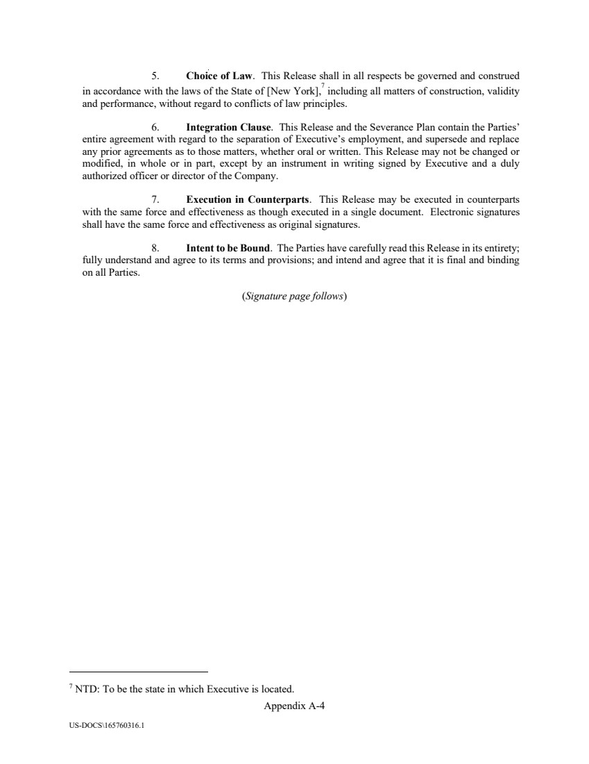 | Appendix A-4 US-DOCS\165760316.1 5. Choice of Law. This Release shall in all respects be governed and construed in accordance with the laws of the State of [New York], 7 including all matters of construction, validity and performance, without regard to conflicts of law principles. 6. Integration Clause. This Release and the Severance Plan contain the Parties’ entire agreement with regard to the separation of Executive’s employment, and supersede and replace any prior agreements as to those matters, whether oral or written. This Release may not be changed or modified, in whole or in part, except by an instrument in writing signed by Executive and a duly authorized officer or director of the Company. 7. Execution in Counterparts. This Release may be executed in counterparts with the same force and effectiveness as though executed in a single document. Electronic signatures shall have the same force and effectiveness as original signatures. 8. Intent to be Bound. The Parties have carefully read this Release in its entirety; fully understand and agree to its terms and provisions; and intend and agree that it is final and binding on all Parties. (Signature page follows) 7 NTD: To be the state in which Executive is located.
 |  | Appendix A-5 US-DOCS\165760316.1 The Parties have executed the foregoing on the dates shown below. EXECUTIVE SAFEHOLD INC. __________________________ __________________________ By: Title: Date: ______________________ Date: _____________________
 | 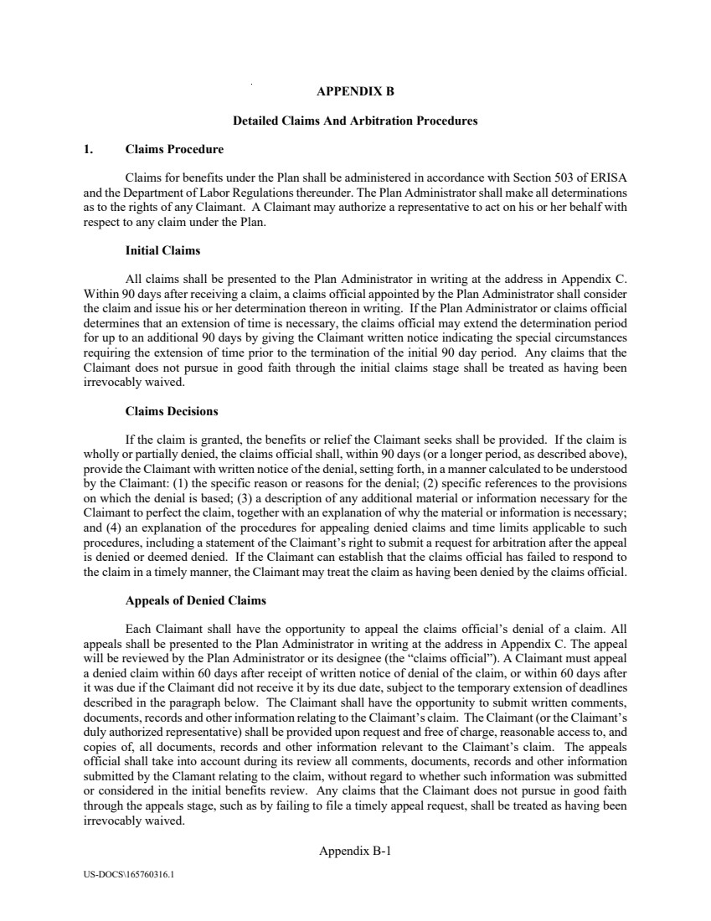 | Appendix B-1 US-DOCS\165760316.1 APPENDIX B Detailed Claims And Arbitration Procedures 1. Claims Procedure Claims for benefits under the Plan shall be administered in accordance with Section 503 of ERISA and the Department of Labor Regulations thereunder. The Plan Administrator shall make all determinations as to the rights of any Claimant. A Claimant may authorize a representative to act on his or her behalf with respect to any claim under the Plan. Initial Claims All claims shall be presented to the Plan Administrator in writing at the address in Appendix C. Within 90 days after receiving a claim, a claims official appointed by the Plan Administrator shall consider the claim and issue his or her determination thereon in writing. If the Plan Administrator or claims official determines that an extension of time is necessary, the claims official may extend the determination period for up to an additional 90 days by giving the Claimant written notice indicating the special circumstances requiring the extension of time prior to the termination of the initial 90 day period. Any claims that the Claimant does not pursue in good faith through the initial claims stage shall be treated as having been irrevocably waived. Claims Decisions If the claim is granted, the benefits or relief the Claimant seeks shall be provided. If the claim is wholly or partially denied, the claims official shall, within 90 days (or a longer period, as described above), provide the Claimant with written notice of the denial, setting forth, in a manner calculated to be understood by the Claimant: (1) the specific reason or reasons for the denial; (2) specific references to the provisions on which the denial is based; (3) a description of any additional material or information necessary for the Claimant to perfect the claim, together with an explanation of why the material or information is necessary; and (4) an explanation of the procedures for appealing denied claims and time limits applicable to such procedures, including a statement of the Claimant’s right to submit a request for arbitration after the appeal is denied or deemed denied. If the Claimant can establish that the claims official has failed to respond to the claim in a timely manner, the Claimant may treat the claim as having been denied by the claims official. Appeals of Denied Claims Each Claimant shall have the opportunity to appeal the claims official’s denial of a claim. All appeals shall be presented to the Plan Administrator in writing at the address in Appendix C. The appeal will be reviewed by the Plan Administrator or its designee (the “claims official”). A Claimant must appeal a denied claim within 60 days after receipt of written notice of denial of the claim, or within 60 days after it was due if the Claimant did not receive it by its due date, subject to the temporary extension of deadlines described in the paragraph below. The Claimant shall have the opportunity to submit written comments, documents, records and other information relating to the Claimant’s claim. The Claimant (or the Claimant’s duly authorized representative) shall be provided upon request and free of charge, reasonable access to, and copies of, all documents, records and other information relevant to the Claimant’s claim. The appeals official shall take into account during its review all comments, documents, records and other information submitted by the Clamant relating to the claim, without regard to whether such information was submitted or considered in the initial benefits review. Any claims that the Claimant does not pursue in good faith through the appeals stage, such as by failing to file a timely appeal request, shall be treated as having been irrevocably waived.
 | 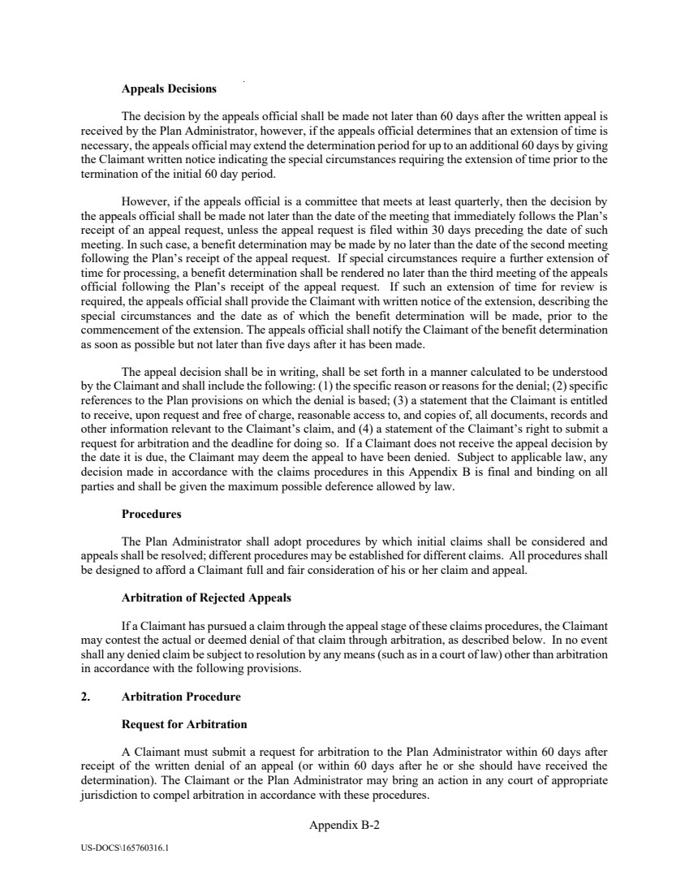 | Appendix B-2 US-DOCS\165760316.1 Appeals Decisions The decision by the appeals official shall be made not later than 60 days after the written appeal is received by the Plan Administrator, however, if the appeals official determines that an extension of time is necessary, the appeals official may extend the determination period for up to an additional 60 days by giving the Claimant written notice indicating the special circumstances requiring the extension of time prior to the termination of the initial 60 day period. However, if the appeals official is a committee that meets at least quarterly, then the decision by the appeals official shall be made not later than the date of the meeting that immediately follows the Plan’s receipt of an appeal request, unless the appeal request is filed within 30 days preceding the date of such meeting. In such case, a benefit determination may be made by no later than the date of the second meeting following the Plan’s receipt of the appeal request. If special circumstances require a further extension of time for processing, a benefit determination shall be rendered no later than the third meeting of the appeals official following the Plan’s receipt of the appeal request. If such an extension of time for review is required, the appeals official shall provide the Claimant with written notice of the extension, describing the special circumstances and the date as of which the benefit determination will be made, prior to the commencement of the extension. The appeals official shall notify the Claimant of the benefit determination as soon as possible but not later than five days after it has been made. The appeal decision shall be in writing, shall be set forth in a manner calculated to be understood by the Claimant and shall include the following: (1) the specific reason or reasons for the denial; (2) specific references to the Plan provisions on which the denial is based; (3) a statement that the Claimant is entitled to receive, upon request and free of charge, reasonable access to, and copies of, all documents, records and other information relevant to the Claimant’s claim, and (4) a statement of the Claimant’s right to submit a request for arbitration and the deadline for doing so. If a Claimant does not receive the appeal decision by the date it is due, the Claimant may deem the appeal to have been denied. Subject to applicable law, any decision made in accordance with the claims procedures in this Appendix B is final and binding on all parties and shall be given the maximum possible deference allowed by law. Procedures The Plan Administrator shall adopt procedures by which initial claims shall be considered and appeals shall be resolved; different procedures may be established for different claims. All procedures shall be designed to afford a Claimant full and fair consideration of his or her claim and appeal. Arbitration of Rejected Appeals If a Claimant has pursued a claim through the appeal stage of these claims procedures, the Claimant may contest the actual or deemed denial of that claim through arbitration, as described below. In no event shall any denied claim be subject to resolution by any means (such as in a court of law) other than arbitration in accordance with the following provisions. 2. Arbitration Procedure Request for Arbitration A Claimant must submit a request for arbitration to the Plan Administrator within 60 days after receipt of the written denial of an appeal (or within 60 days after he or she should have received the determination). The Claimant or the Plan Administrator may bring an action in any court of appropriate jurisdiction to compel arbitration in accordance with these procedures.
 | 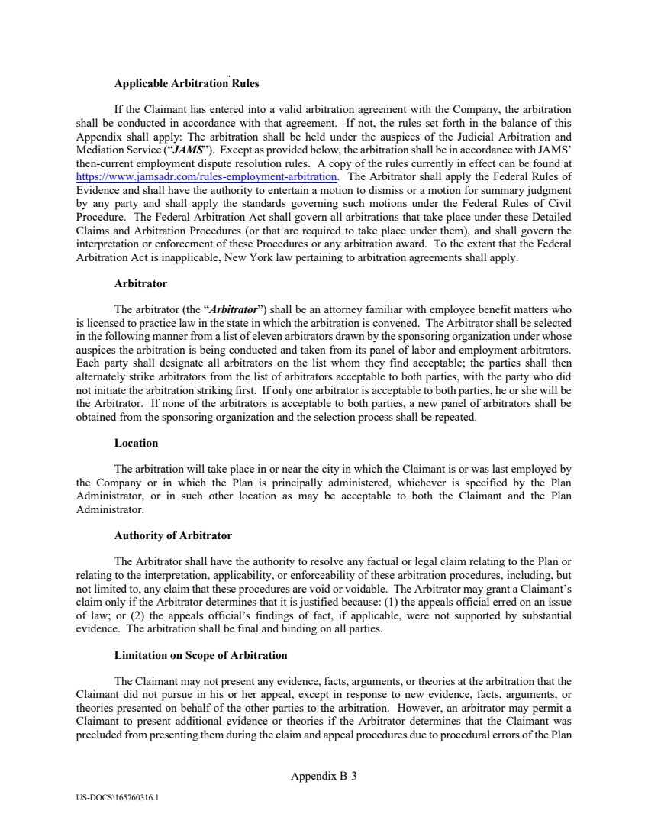 | Appendix B-3 US-DOCS\165760316.1 Applicable Arbitration Rules If the Claimant has entered into a valid arbitration agreement with the Company, the arbitration shall be conducted in accordance with that agreement. If not, the rules set forth in the balance of this Appendix shall apply: The arbitration shall be held under the auspices of the Judicial Arbitration and Mediation Service (“JAMS”). Except as provided below, the arbitration shall be in accordance with JAMS’ then-current employment dispute resolution rules. A copy of the rules currently in effect can be found at https://www.jamsadr.com/rules-employment-arbitration. The Arbitrator shall apply the Federal Rules of Evidence and shall have the authority to entertain a motion to dismiss or a motion for summary judgment by any party and shall apply the standards governing such motions under the Federal Rules of Civil Procedure. The Federal Arbitration Act shall govern all arbitrations that take place under these Detailed Claims and Arbitration Procedures (or that are required to take place under them), and shall govern the interpretation or enforcement of these Procedures or any arbitration award. To the extent that the Federal Arbitration Act is inapplicable, New York law pertaining to arbitration agreements shall apply. Arbitrator The arbitrator (the “Arbitrator”) shall be an attorney familiar with employee benefit matters who is licensed to practice law in the state in which the arbitration is convened. The Arbitrator shall be selected in the following manner from a list of eleven arbitrators drawn by the sponsoring organization under whose auspices the arbitration is being conducted and taken from its panel of labor and employment arbitrators. Each party shall designate all arbitrators on the list whom they find acceptable; the parties shall then alternately strike arbitrators from the list of arbitrators acceptable to both parties, with the party who did not initiate the arbitration striking first. If only one arbitrator is acceptable to both parties, he or she will be the Arbitrator. If none of the arbitrators is acceptable to both parties, a new panel of arbitrators shall be obtained from the sponsoring organization and the selection process shall be repeated. Location The arbitration will take place in or near the city in which the Claimant is or was last employed by the Company or in which the Plan is principally administered, whichever is specified by the Plan Administrator, or in such other location as may be acceptable to both the Claimant and the Plan Administrator. Authority of Arbitrator The Arbitrator shall have the authority to resolve any factual or legal claim relating to the Plan or relating to the interpretation, applicability, or enforceability of these arbitration procedures, including, but not limited to, any claim that these procedures are void or voidable. The Arbitrator may grant a Claimant’s claim only if the Arbitrator determines that it is justified because: (1) the appeals official erred on an issue of law; or (2) the appeals official’s findings of fact, if applicable, were not supported by substantial evidence. The arbitration shall be final and binding on all parties. Limitation on Scope of Arbitration The Claimant may not present any evidence, facts, arguments, or theories at the arbitration that the Claimant did not pursue in his or her appeal, except in response to new evidence, facts, arguments, or theories presented on behalf of the other parties to the arbitration. However, an arbitrator may permit a Claimant to present additional evidence or theories if the Arbitrator determines that the Claimant was precluded from presenting them during the claim and appeal procedures due to procedural errors of the Plan
 | 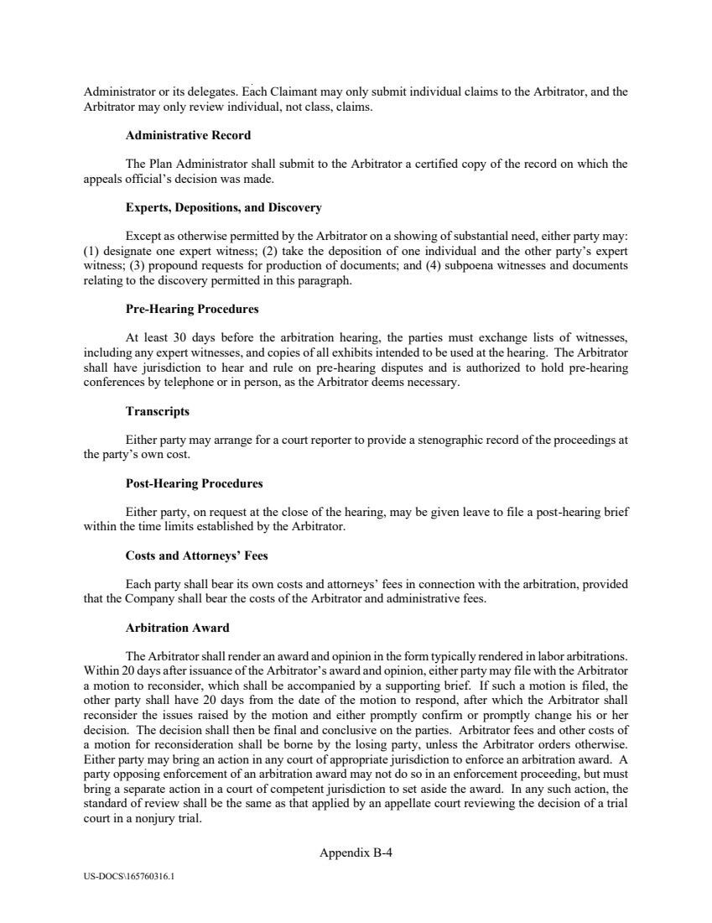 | Appendix B-4 US-DOCS\165760316.1 Administrator or its delegates. Each Claimant may only submit individual claims to the Arbitrator, and the Arbitrator may only review individual, not class, claims. Administrative Record The Plan Administrator shall submit to the Arbitrator a certified copy of the record on which the appeals official’s decision was made. Experts, Depositions, and Discovery Except as otherwise permitted by the Arbitrator on a showing of substantial need, either party may: (1) designate one expert witness; (2) take the deposition of one individual and the other party’s expert witness; (3) propound requests for production of documents; and (4) subpoena witnesses and documents relating to the discovery permitted in this paragraph. Pre-Hearing Procedures At least 30 days before the arbitration hearing, the parties must exchange lists of witnesses, including any expert witnesses, and copies of all exhibits intended to be used at the hearing. The Arbitrator shall have jurisdiction to hear and rule on pre-hearing disputes and is authorized to hold pre-hearing conferences by telephone or in person, as the Arbitrator deems necessary. Transcripts Either party may arrange for a court reporter to provide a stenographic record of the proceedings at the party’s own cost. Post-Hearing Procedures Either party, on request at the close of the hearing, may be given leave to file a post-hearing brief within the time limits established by the Arbitrator. Costs and Attorneys’ Fees Each party shall bear its own costs and attorneys’ fees in connection with the arbitration, provided that the Company shall bear the costs of the Arbitrator and administrative fees. Arbitration Award The Arbitrator shall render an award and opinion in the form typically rendered in labor arbitrations. Within 20 days after issuance of the Arbitrator’s award and opinion, either party may file with the Arbitrator a motion to reconsider, which shall be accompanied by a supporting brief. If such a motion is filed, the other party shall have 20 days from the date of the motion to respond, after which the Arbitrator shall reconsider the issues raised by the motion and either promptly confirm or promptly change his or her decision. The decision shall then be final and conclusive on the parties. Arbitrator fees and other costs of a motion for reconsideration shall be borne by the losing party, unless the Arbitrator orders otherwise. Either party may bring an action in any court of appropriate jurisdiction to enforce an arbitration award. A party opposing enforcement of an arbitration award may not do so in an enforcement proceeding, but must bring a separate action in a court of competent jurisdiction to set aside the award. In any such action, the standard of review shall be the same as that applied by an appellate court reviewing the decision of a trial court in a nonjury trial.
 |  | Appendix B-5 US-DOCS\165760316.1 Severability The invalidity or unenforceability of any part of these arbitration procedures shall not affect the validity of the rest of the procedures.
 | 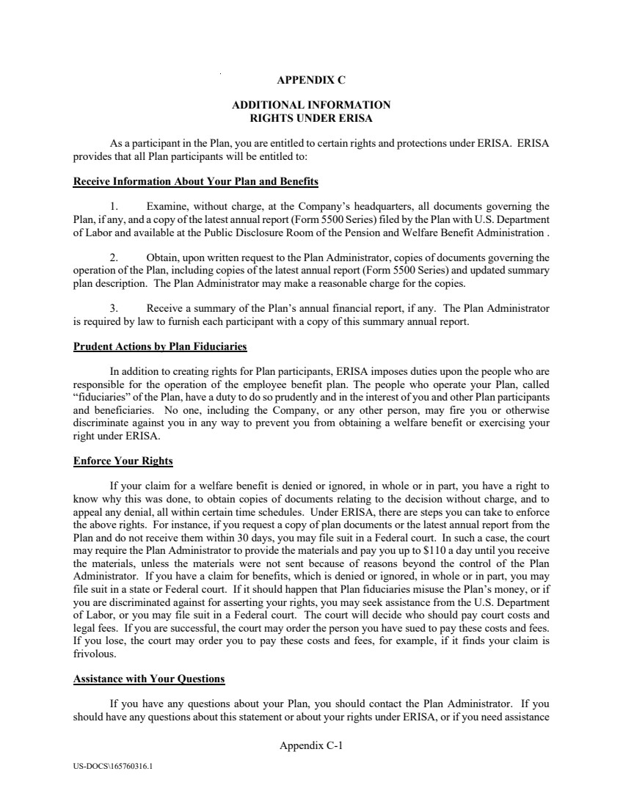 | Appendix C-1 US-DOCS\165760316.1 APPENDIX C ADDITIONAL INFORMATION RIGHTS UNDER ERISA As a participant in the Plan, you are entitled to certain rights and protections under ERISA. ERISA provides that all Plan participants will be entitled to: Receive Information About Your Plan and Benefits 1. Examine, without charge, at the Company’s headquarters, all documents governing the Plan, if any, and a copy of the latest annual report (Form 5500 Series) filed by the Plan with U.S. Department of Labor and available at the Public Disclosure Room of the Pension and Welfare Benefit Administration . 2. Obtain, upon written request to the Plan Administrator, copies of documents governing the operation of the Plan, including copies of the latest annual report (Form 5500 Series) and updated summary plan description. The Plan Administrator may make a reasonable charge for the copies. 3. Receive a summary of the Plan’s annual financial report, if any. The Plan Administrator is required by law to furnish each participant with a copy of this summary annual report. Prudent Actions by Plan Fiduciaries In addition to creating rights for Plan participants, ERISA imposes duties upon the people who are responsible for the operation of the employee benefit plan. The people who operate your Plan, called “fiduciaries” of the Plan, have a duty to do so prudently and in the interest of you and other Plan participants and beneficiaries. No one, including the Company, or any other person, may fire you or otherwise discriminate against you in any way to prevent you from obtaining a welfare benefit or exercising your right under ERISA. Enforce Your Rights If your claim for a welfare benefit is denied or ignored, in whole or in part, you have a right to know why this was done, to obtain copies of documents relating to the decision without charge, and to appeal any denial, all within certain time schedules. Under ERISA, there are steps you can take to enforce the above rights. For instance, if you request a copy of plan documents or the latest annual report from the Plan and do not receive them within 30 days, you may file suit in a Federal court. In such a case, the court may require the Plan Administrator to provide the materials and pay you up to $110 a day until you receive the materials, unless the materials were not sent because of reasons beyond the control of the Plan Administrator. If you have a claim for benefits, which is denied or ignored, in whole or in part, you may file suit in a state or Federal court. If it should happen that Plan fiduciaries misuse the Plan’s money, or if you are discriminated against for asserting your rights, you may seek assistance from the U.S. Department of Labor, or you may file suit in a Federal court. The court will decide who should pay court costs and legal fees. If you are successful, the court may order the person you have sued to pay these costs and fees. If you lose, the court may order you to pay these costs and fees, for example, if it finds your claim is frivolous. Assistance with Your Questions If you have any questions about your Plan, you should contact the Plan Administrator. If you should have any questions about this statement or about your rights under ERISA, or if you need assistance
 | 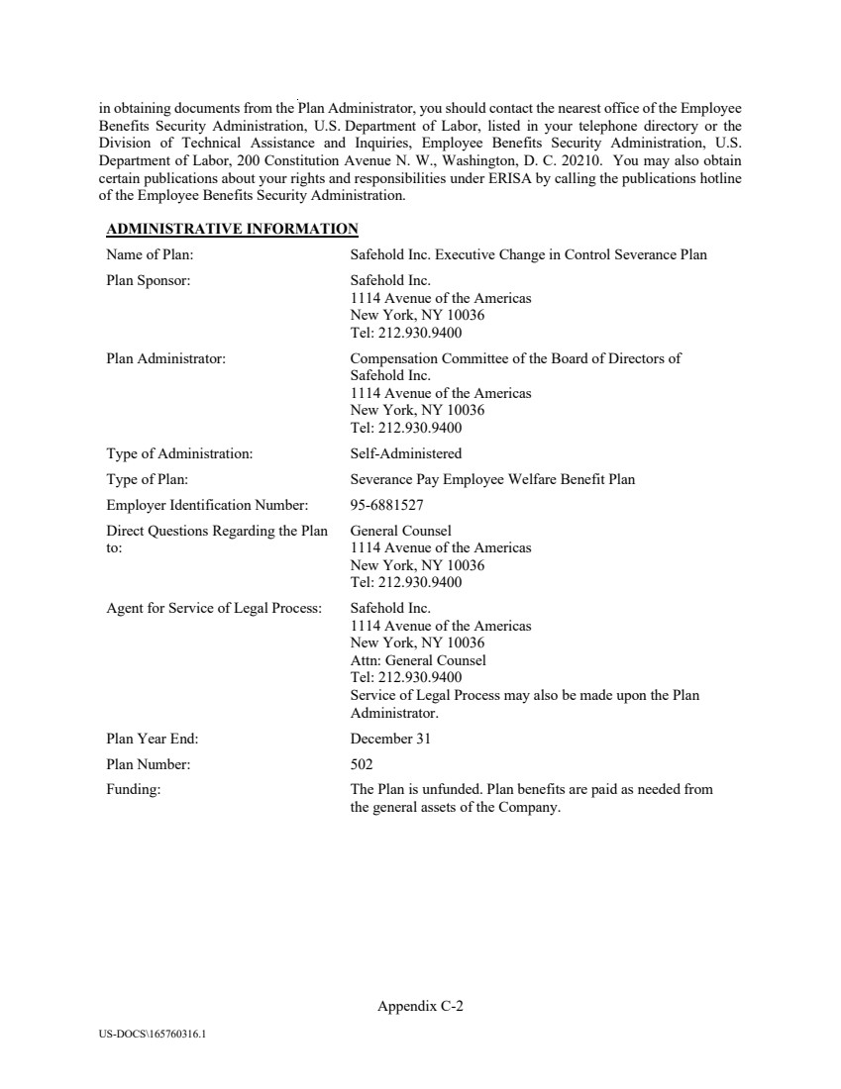 | Appendix C-2 US-DOCS\165760316.1 in obtaining documents from the Plan Administrator, you should contact the nearest office of the Employee Benefits Security Administration, U.S. Department of Labor, listed in your telephone directory or the Division of Technical Assistance and Inquiries, Employee Benefits Security Administration, U.S. Department of Labor, 200 Constitution Avenue N. W., Washington, D. C. 20210. You may also obtain certain publications about your rights and responsibilities under ERISA by calling the publications hotline of the Employee Benefits Security Administration. ADMINISTRATIVE INFORMATION Name of Plan: Safehold Inc. Executive Change in Control Severance Plan Plan Sponsor: Safehold Inc. 1114 Avenue of the Americas New York, NY 10036 Tel: 212.930.9400 Plan Administrator: Compensation Committee of the Board of Directors of Safehold Inc. 1114 Avenue of the Americas New York, NY 10036 Tel: 212.930.9400 Type of Administration: Self-Administered Type of Plan: Severance Pay Employee Welfare Benefit Plan Employer Identification Number: 95-6881527 Direct Questions Regarding the Plan to: General Counsel 1114 Avenue of the Americas New York, NY 10036 Tel: 212.930.9400 Agent for Service of Legal Process: Safehold Inc. 1114 Avenue of the Americas New York, NY 10036 Attn: General Counsel Tel: 212.930.9400 Service of Legal Process may also be made upon the Plan Administrator. Plan Year End: December 31 Plan Number: 502 Funding: The Plan is unfunded. Plan benefits are paid as needed from the general assets of the Company.

